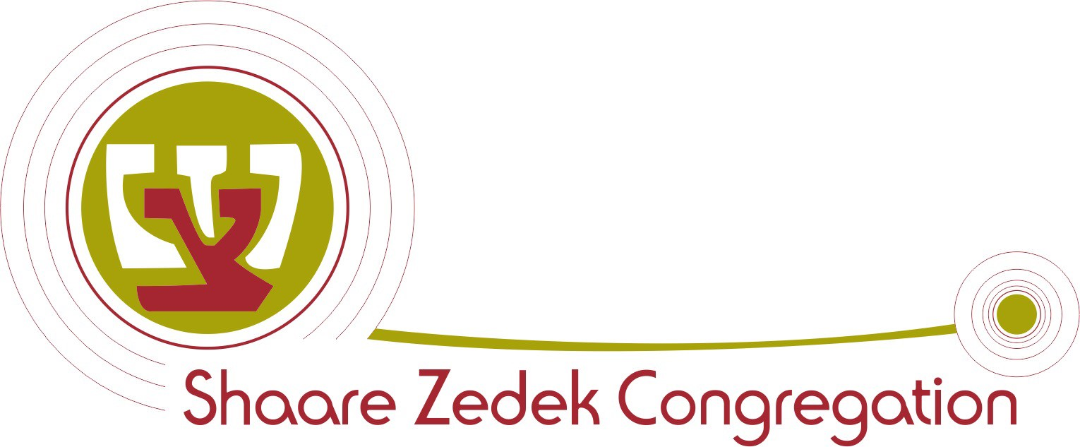 MEMBERSHIP APPLICATION
5305 Rosedale Avenue - Montreal QC H4V 2H7
^{Date:}Phone: [514] 484-1122 - Fax: [514] 484-1454 month day year www.shaarezedek.ca
/
/
We hereby apply for membership in the Shaare Zedek Congregation, Montreal. If accepted, we agree to abide by and conform to its Constitution and by-laws now existing or which may be enacted from time to time. We undertake to make payment in accordance with the present regulations or those which may be adopted in the future.
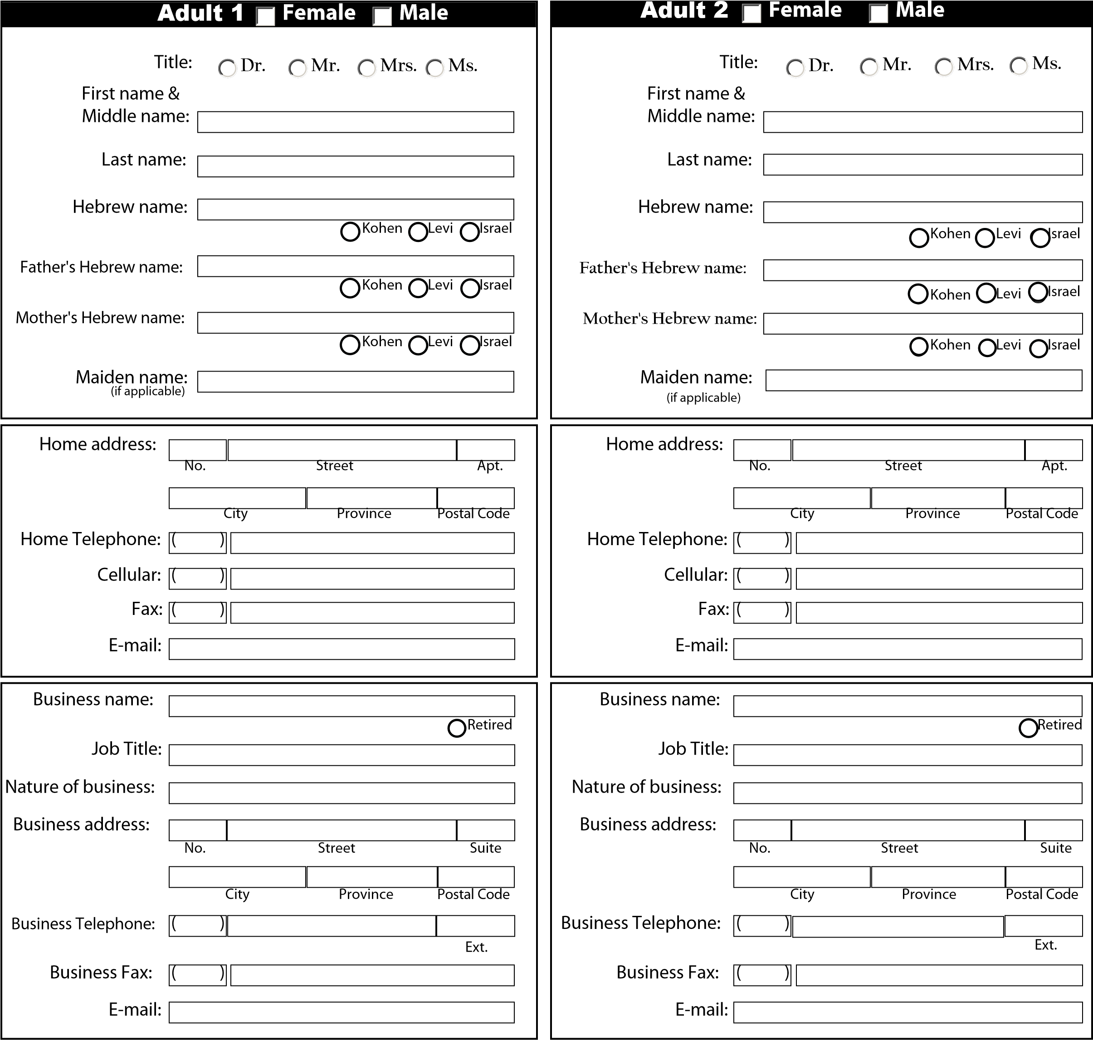
Marital status: divorced separated widowed  Date of birth:  month day year  /  /  married  single |  | Marital status: divorced separated widowed  Date of birth:  month day year  /  /  married  single
Wedding anniversary:
Name of Rabbi who performed marriage ceremony:
/
/
month
day
year
Of Congregation:
City:
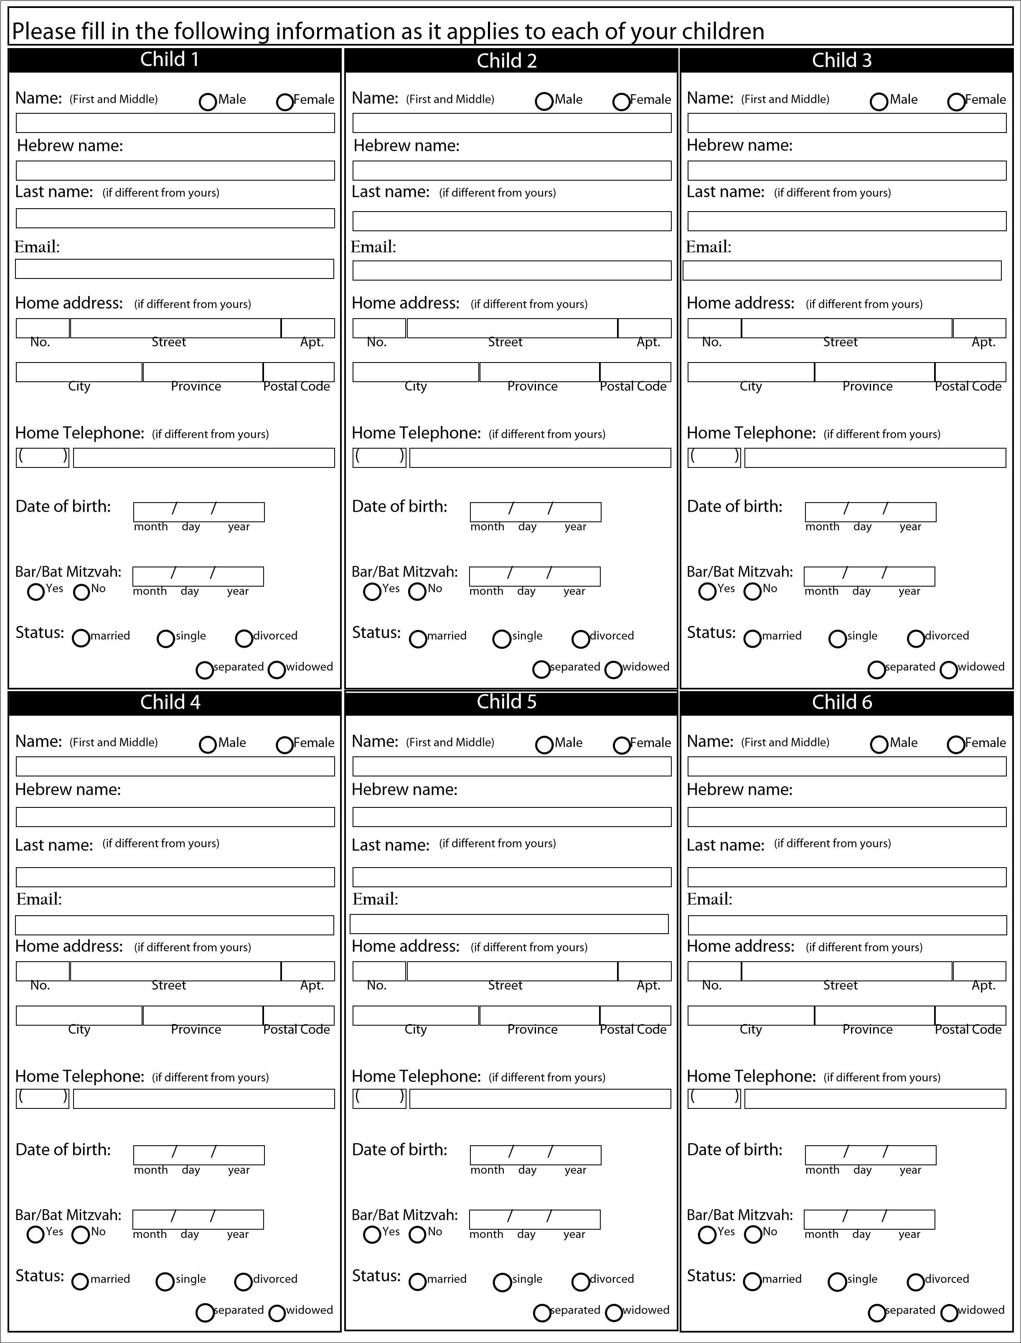
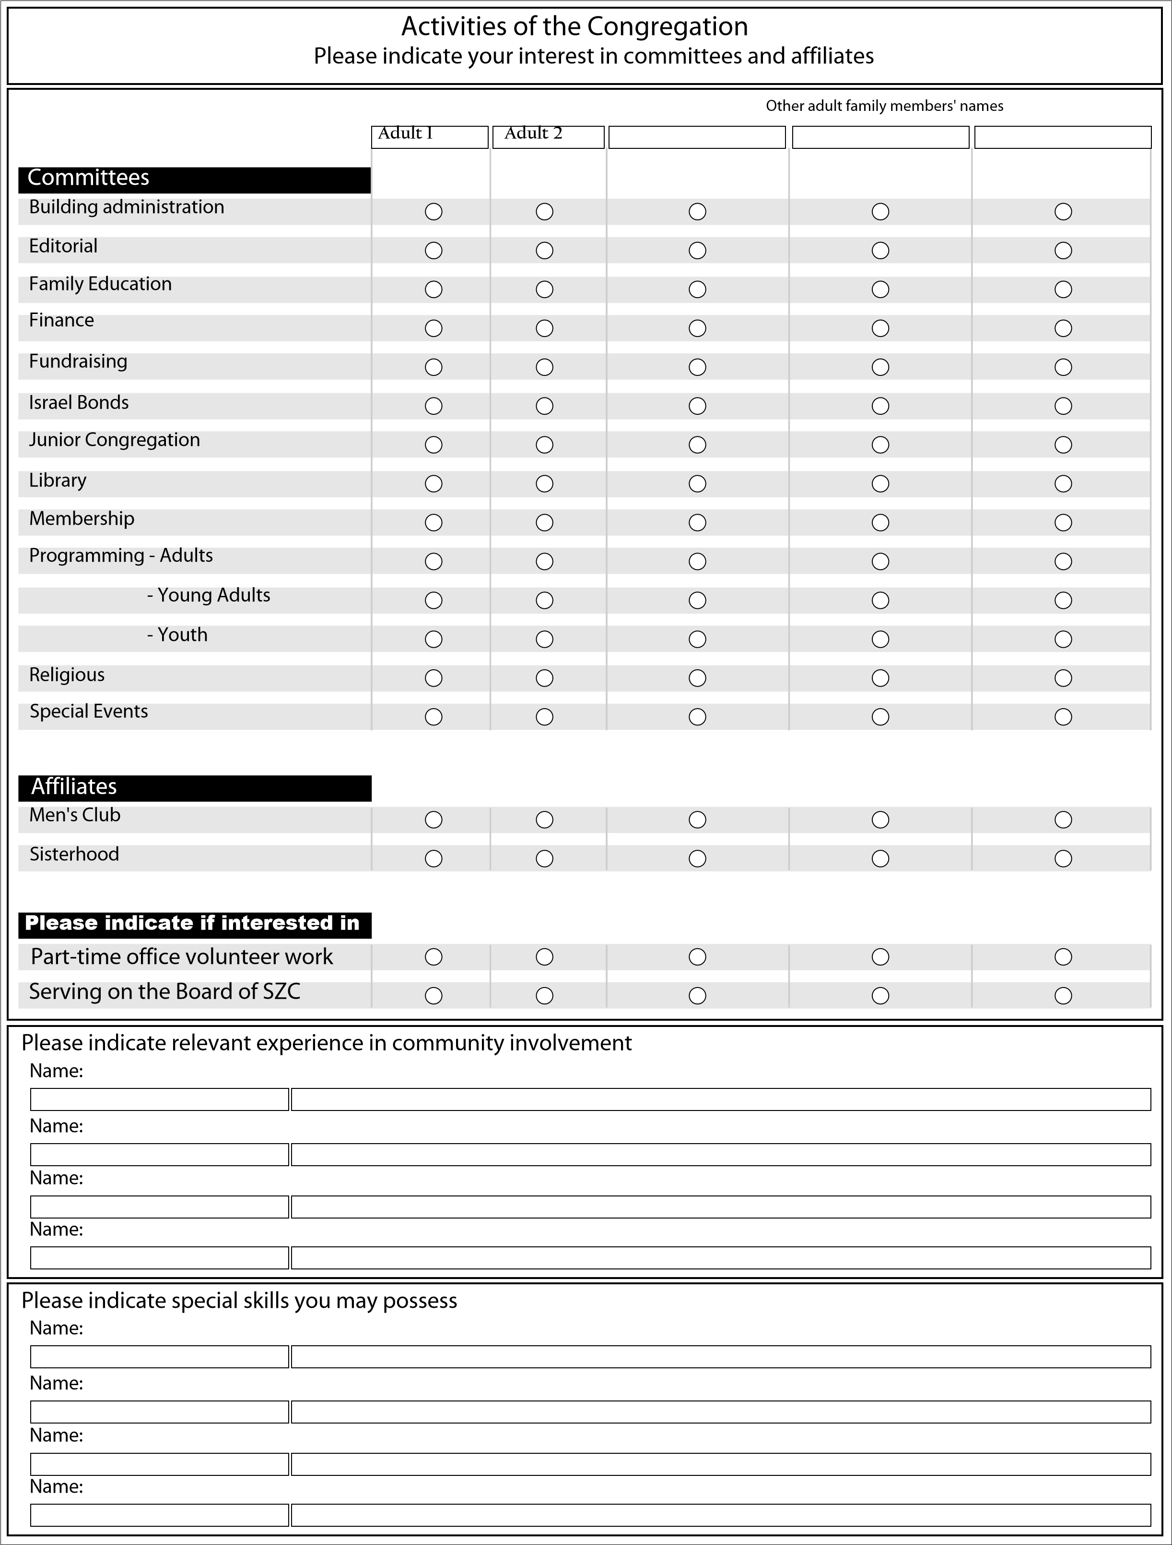

The following is necessary for processing your application for membership.
This information will be held in strict confidence.
Please feel free to call on the Rabbi to assist you.
Adult 1 |  | Adult 2
Jewish by birth
Adopted
Jewish by choice
Date:
City:
If so, conversion performed
by Rabbi or Beit Din:
/
/
month
day
year
/
/
month
day
year
(Kindly attach copy of conversion certificate)
Yhartzeit Information
Full name of departed: Hebrew name of departed Relationship To whom English date AM PM Hebrew date
and father of death of death
 | month | day | year
 | / | /
 | month | day | year
 | / | /
 | month | day | year
 | / | /
 | month | day | year
 | / | /
 | month | day | year
 | / | /
 | month | day | year
 | / | /
 | month | day | year
 | / | /
/ /
month day year
Je consents que cette application soit rédiger en Anglais.
I agree to this application being in English.
I request that all correspondence from your synagogue be in English.
Applicants' Signatures

FOR OFFICE USE ONLY
Date received:
Comments:
Approved by:
Date approved:

