Early Childhood School at B’nai Shalom of Olney
Challah Sale Order Form
(Holiday Version)

Name:________________________________________________
Child’s Class: __________________ Phone: __________________
Pick-up Location: ECS Office BSO Main Office

Available Products | Quantity | Price | Total Cost
Braided Challah (sliced) |  | $4.25
Round Challah Plain |  | $4.25
Braided Raisin Challah (sliced) |  | $5.00
Round Raisin Challah |  | $4.75
Round Poppy Challah |  | $4.25
Round Sesame Challah |  | $4.25
Round Water Challah |  | $4.25
Braided Water Challah (sliced) |  | $4.25
Round Whole Wheat Challah |  | $4.25
2 oz. Mini Rolls | Dozen | $5.00
3oz. Rolls | ½ Dozen | $4.00
Boomers x1 |  | $2.50
Boomers x2 | Pair(s) | $4.25
Jumbo Muffin |  | $2.00
Loaf Cake |  | $5.50
Honey Cake |  | $6.50
Chocolate Chip Muffins |  | $1.50
Cranberry Orange Muffins |  | $1.50
Blueberry Muffins |  | $1.50
Lemon Poppy Muffins |  | $1.50
Double Chocolate Muffins |  | $1.50
Banana Muffins |  | $1.50
Chocolate Chip Loaf Cakes |  | $6.00
Cranberry Orange Loaf Cakes |  | $6.00
Blueberry Loaf Cakes |  | $6.00
Lemon Poppy Loaf Cakes |  | $6.00
Double Chocolate Loaf Cakes |  | $6.00
Banana Loaf Cakes |  | $6.00
 |  | Total: | $

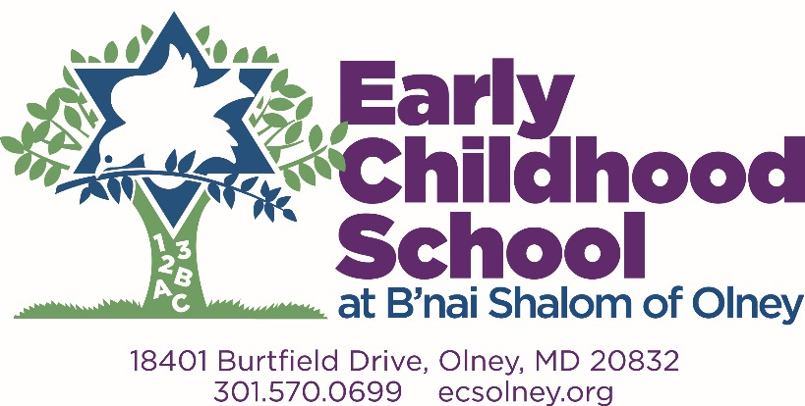

Thank you for supporting the Early Childhood school at B’nai Shalom of Olney!

Include a check only (no cash please) for the entire amount made payable to BSO ECS. Please return this form and payment to the ECS office by Monday morning for Thursday morning delivery. If you have any questions, changes, or concerns to your order, please email christine.nguyen@bnaishalomofolney.org.

