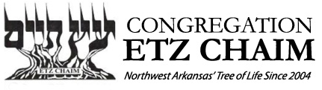
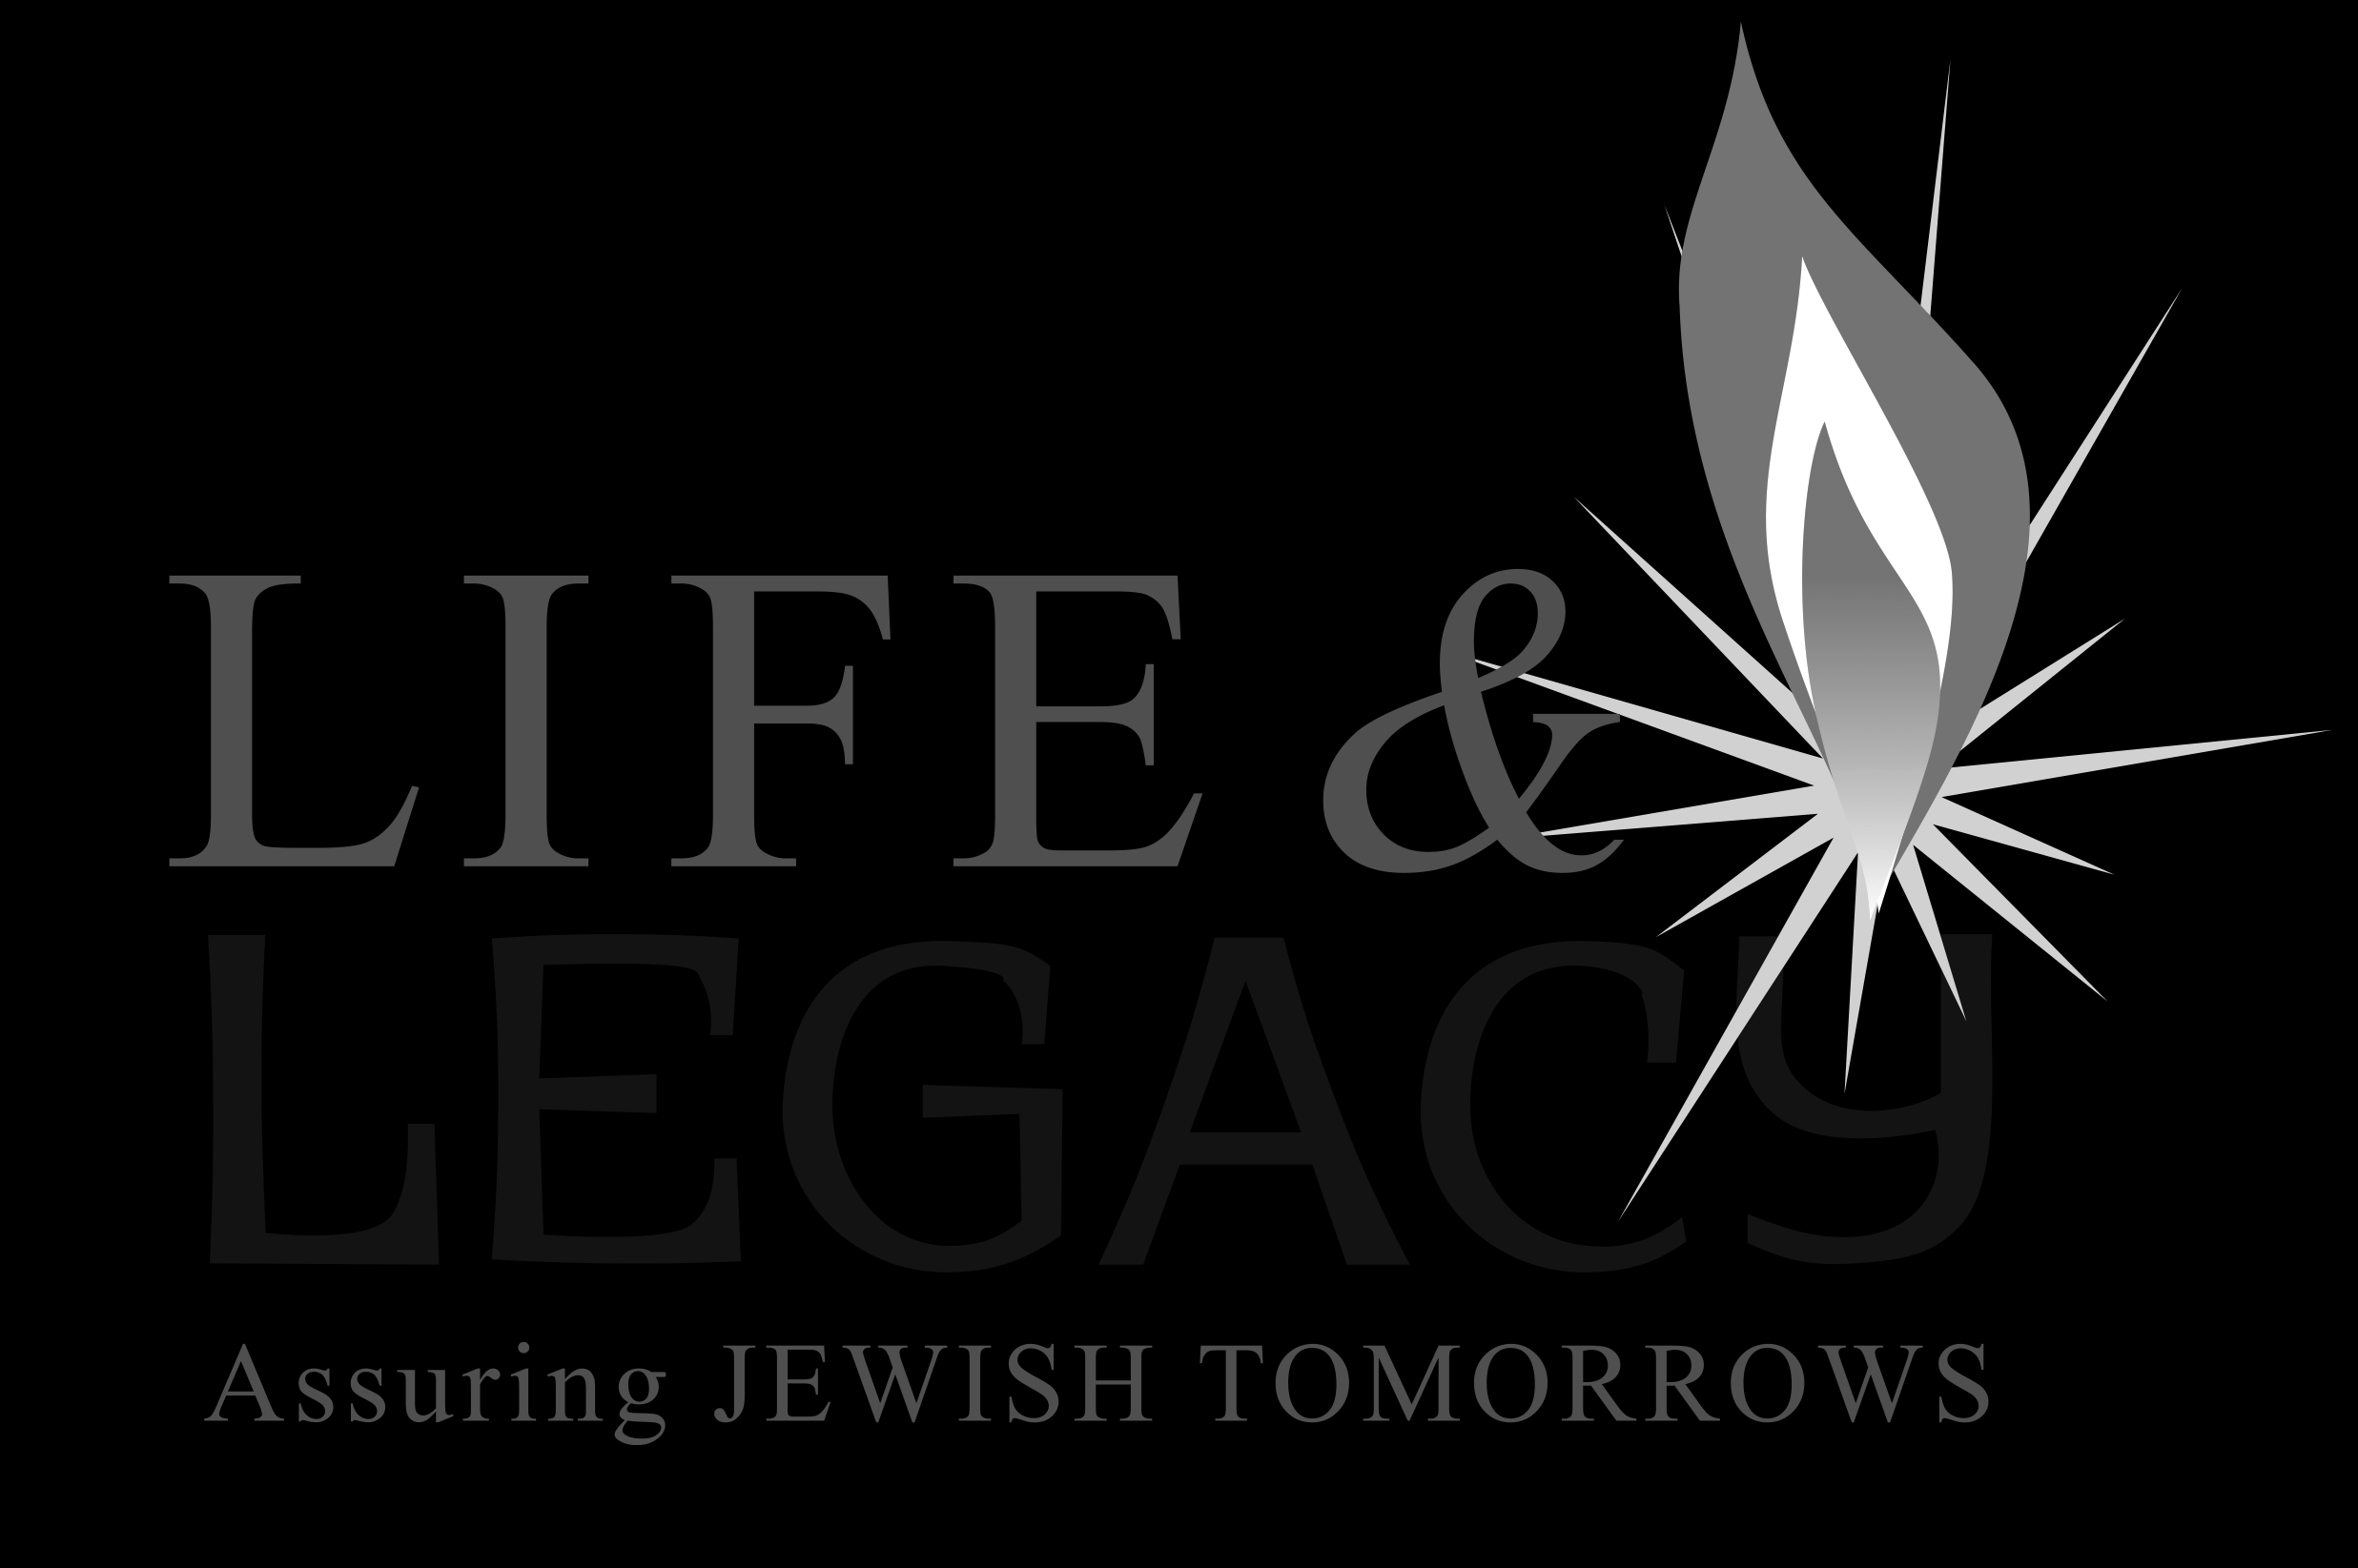

Arkansas Jewish Community
LETTER OF INTENT

In the tradition of our Jewish faith, I wish to share my blessings by declaring my intent to provide for the needs of future generations.

It is with deep satisfaction that:
I/We notify you that I/we have already made a legacy provision in my/our estate plan
I/We shall make a provision during the next months

I wish to support the following institutions: (check all that apply)

Congregation Agudath Achim (Little Rock)
___ Congregation B’nai Israel (Little Rock)
Congregation Etz Chaim (Bentonville)

Congregation House of Israel (Hot Springs)
Jewish Federation of Arkansas
Temple Shalom (Fayetteville)

With a legacy gift established through a:

Bequest in my will or trust
Remainder of IRA or other retirement plan
Gift of real estate, securities or other property
Charitable Gift Annuity
I wish to establish an endowment now with a current gift of cash or property
Life Insurance Policy
Charitable Remainder Trust
Donor-Advised Fund
Other

Amount of Gift – Please choose one of the following two options:

The approximate value of my/our commitment will be $______ or ___% of _____________________.
I/We prefer to keep the details of this commitment confidential.

Privacy Statement: To encourage others to make commitments
I/We permit my name to be listed in printed materials
I/We prefer to remain anonymous. (My name should appear as)

Name(s):
Address:
City/State/Zip:
Phone: Email: Birthday:__________________

I understand that this letter of intent is not a legal obligation and may be changed at my discretion at any time.

Signed Date

Signed Date

Congregation Etz Chaim
PO Box 477
Bentonville, Arkansas 72712
www.etzchaimnwa.org
Contact Ryan Malashock (rshock21@gmail.com)

