THE FIFTH CHILD
The Lubavitcher Rebbe (of blessed memory)
“Unfortunately, there is, in our time of confusion, another kind of a Jewish child: the child who is noticed by his absence from the Seder; the one who has no interest whatsoever in Torah and G-d's commandments... he is not even aware of the Seder, of the Exodus from Egypt and the revelation at Sinai.
This child presents a grave challenge, which should command our attention long before Passover and the Seder night, for no Jewish child should be forgotten and given up. We must make every effort to save also that “lost” child, and bring the absent one to the Seder table. Driven by a deep sense of compassion and responsibility, we need have no fear of failure...”
THE EVIL CHILD

If you look at the Four Sons, you see that three of the four are measures of intelligence or ability to use that intelligence. Yet, the second, the Evil Son, is NOT a measure of brainpower, but describes his personality.
In truth, the “Wicked son” is also very intelligent. Yet, instead of using his intelligence for GOOD purposes, he uses it for evil.
[Consider a modern day computer hacker. While he/she is quite intelligent insofar as the ability to break into someone else’s computer, but the intellect is being used for evil purposes.]
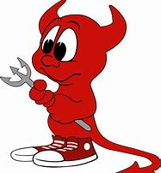

Hallel
- In our lowliness, he remembered us...
- and redeemed us from our oppressors
- He gives food to all flesh...
- Praise G-d of the heavens!
These last four phrases of "Hallel HaGadol" can be seen as parallels to the four cups we drink tonight.
- Over the first cup we make kiddush and declare, "You chose us from all the nations." Why did G-d choose us? The Sages explain that Hashem chose the Jewish people because of their humility. "In our lowliness" -- in our humility, "He remembered us" and chose us.
- The second cup goes together with the Haggadah, where we tell how Hashem "redeemed us from our oppressors."
- Bircat Hamazon, where we recognize that "He gives food to all flesh" is said over the third cup.
- And with the fourth cup we sing Hallel..."Praise Hashem of the heavens!"
Rabbi Yehuda Samet
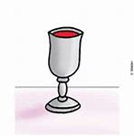

MAH NISHTANAH ON SUKKOS
Why do we recite a Mah Nishtanah only on the night of Pesach? Why not pose these questions on the holiday of Sukkot?
On all other nights of the year we sit in our warm and comfortable homes. Why on Sukkot when we leave our houses and eat, pray, sleep etc. into a temporary structure, do we not question anything? Surely this is puzzling to any child than the number of times we dip the vegetables!
The answer is brought down in Chasidic Wisdom;
During Sukkot, we pack up and leave our homes. Unfortunately, this is not “different” for us. This is something our people have had to do throughout the ages. Countless times, Jews both today and historically, have had to pack up at a moment’s notice and run for their lives to a different city, country or continent. Many times with nothing more than the shirts on their backs. They had to escape because of attacks, pogroms and Anti-Semitism.
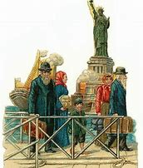

STEALING THE AFIKOMAN
Why do some families have the custom of “stealing” of the Afikomon on this holy and awesome night? How does such a “low” act as stealing fit in with Pesach Night’s Seder?
The Baal Shem Tov once said, that every single thing in this world can be used for good. Every object, every concept, every phenomenon, and every idea can somehow be used for the good of G-d in some way or another.
Normally stealing is forbidden, but we can “borrow” the idea of stealing, and use this idea for good. We want to make every aspect of life to be part of praise for Hashem. Why is it only on Leil HaSeder and Kol Nidrei Night the only 2 times we say, ” L’Shana Habah BiYerushalayim”?
NEXT YEAR IN JERUSALEM
Why is it only at the Seder and on Yom Kippor that we say, ” L’Shana Habah BiYerushalayim”?
One answer can be that on Pesach we find that although we have a night full of mitzvos, we nevertheless are missing THE MAIN mitzva of Yom Tov, namely the Korbon Pesach. Most of the mitzvot of Pesach revolve around the korbon pesach (over 50 mitzvot we cannot do – GR”A), Most of mesechta Pesachim deals with the Korbon Pesach.
On Yom Kippur, of course, the main mitsvah of Yom Tov should be the Avodah of the Kohen Gadol in the Kodesh HaKedoshim.
For all other Yomim Tovim the main mitzah still is in effect.
Rosh Hashana- we still have shofar
Sukkot- we still have Sukah and lulav and etrog.
Shavuot - we still have the torah.
So it’s really only these 2 times of the year, Passover and Yom Kippur, in which the MAIN AVODAH HAYOM (worship of the day) is missing because of the lack of the Bait Hamikdash (Temple). So it is specifically on these 2 occasions where we pray, “L’Shana Habah B’Yerushalayim” so that we may rebuild the Temple.
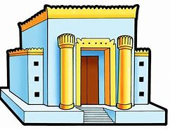

https://youtu.be/MSSNno7BWSw video on the plagues

