Beth El Hebrew Congregation
2019-2020 Support Statement

From: Full Name(s)

Address

City State Zipcode

For: Annual Sustaining Dues Commitment
Thank you for your generous support and for renewing your annual commitment to Beth El. We ask you to contribute based on what your household determines is consistent with your ability to support, sustain, perpetuate, and strengthen Beth El. The sustaining contribution level of $2,426 reflects the actual cost per member household to maintain our programs and facilities (see reverse). Some families will need to give less, so if you are able, consider increasing your support to sustain Beth El as a warm and welcoming community for all. Thank you again for your support!

Annual Sustaining Dues Commitment: $

Security Fee [$100 per member family] $

Facilities Fund [$375 for initial 8 years of membership; $100 per year thereafter.] $
I would also like to join / renew my membership with Beth El’s auxiliaries:
Note: memberships are paid/billed in full
Sisterhood/WRJ:
[Indicate Level: $36 Rachel/Leah; $54 Rebecca; $72 Sarah] $ Brotherhood:
[Indicate Level: $36 Double Chai; $54 Triple Chai; $72 Quadruple Chai] $

TOTAL: $

Payment Method: [ ] Check [ ] Bank Debit (attach voided check) [ ] Credit Card*
*Payment by credit card incurs a 3% merchant fee at the time of processing which will be added to your pledge.
Card Number Exp. Date Name on Card
Signature Choose your Payment Schedule:
[ ] Annually [ ] Semi-annually (July & Dec) [ ] Quarterly [ ] Monthly
My/Our Dues, Security, Facility Fund Pledge and WRJ/Brotherhood are shown above:
Name Signature Email or phone #

Sustaining Dues Calculation
Estimated Total Operating Budget FY 2019-2020 | 1,740,000
Security Budget FY 2019-2020 | 55,500
Less Religious School Fees | 144,000
Less Rentals | 260,000
Less Donations (Book Sale, Memorials, HHD) | 45,000
New Total | 1,346,500
Per Family Annual Sustaining Dues Amount | 2,426
Recognition and Appreciation Pledge Categories

Cornerstone $2700-4499:
- Complimentary pre-Friday Evening Services Dinners for Family (1x)
- Invitation to Giving Recognition Reception

Pillar $4500-6300:

-
- All of the above, plus
- 10% discount on Beth El rental fees
- Reserved parking for HHD

Guardian $6300 or more:

-
- All of the above, plus
- Reserved HHD seating

About Beth El’s Auxiliary Organizations

Sisterhood/WRJ
Membership in Women of Reform Judaism (WRJ) supports on-going programs within the synagogue and religious school as well as local and national Jewish organizations. Members receive a 10% discount in the Judaica shop and free or discounted attendance to WRJ paid-up member events.

Brotherhood
As a member of Beth El’s Brotherhood you are entitled to discounts at selected Brotherhood events. Remember
that your dues also support Beth El’s Religious School, the Brotherhood Youth Scholarship program, maintenance
of Beth El’s Chapel in the Woods, Carpenter's Shelter and George Mason University Hillel Shabbat dinners.

Please contact Beth El Hebrew Congregation at (703) 370-9400 or office@bethelhebrew.org with any questions regarding your annual sustaining dues commitment.

Adult #1 |  | Adult #2
 | Title & First Name
 | Middle Name
 | Last Name
Nickname
(I prefer people call me…)
 | Hebrew Name
Birth Date
(Month/Date/Year)
 | Religious Background
 | Email Address
 | Home Phone
 | Cell Phone
 | Oﬃce Phone
 | Occupation
 | Employer

Home Address:
_____________________________________ Marital Status: ______________________________

_____________________________________ Anniversary Date: ___________________________
Are you related to Month/Day/Year
other members? ___________________________________

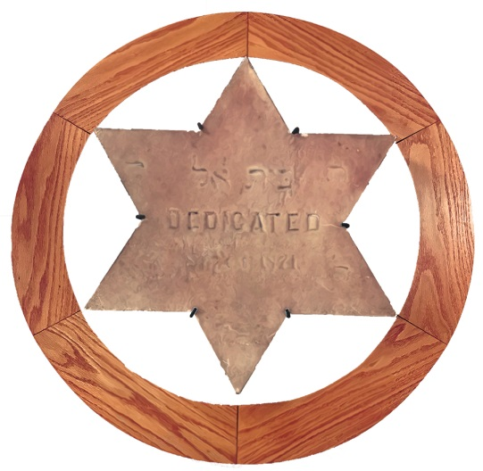

Beth El Hebrew Congregation

Membership Application

3830 Seminary Road  Alexandria, VA 22304
(703) 370-9400  office@bethelhebrew.org

Adult #1 |  | Adult #2
 | Title & First Name
 | Middle Name
 | Last Name
Nickname
(I prefer people call me…)
 | Hebrew Name
Birth Date
(Month/Date/Year)
 | Religious Background
 | Email Address
 | Home Phone
 | Cell Phone
 | Oﬃce Phone
 | Occupation
 | Employer

Home Address: Marital Status:
_____________________________________ _____________________________

_____________________________________ Anniversary Date:
_____________________________
Are you related to Month/ Day/ Year
other members? ___________________________________

Tell us about your children . . .
Full Name | Nickname | Birth Date | B’nei Mitzvah Date | Hebrew Name

. . . and the Yahrzeits you recognize . . .
Full Name | English or Hebrew Date  (Month/Date/Year) | Relationship

. . . and please let us know who to contact in the event of an emergency.
Full Name | Phone Number(s) | Relationship

How did you hear about Beth El Hebrew? ______________________________________________

Please indicate below the committees or activities in which you would be interested in participating.*
Please check those areas in which you have expertise.

Adult #

Administration Leadership Development Accounting/Finance
Adult Education Legal Counsel Computers
Archives Library & Learning Center Electrical/Mechanical
ARZA Marketing & Publicity Event Planning
Beth El House NVJCC Film Festival Screening Fundraising
Brotherhood Office Volunteers Gardening
Budget Religious Practices Graphic Design
Building and Grounds Religious School/Youth Health Insurance
Building Décor/Fine Arts Renaissance Group Human Resources
Bulletin Social Action Legal
Caring Community Social Seniors Marketing
College Synagogue Federation Relations Media Relations
Computer Support Ways and Means Mediation
Endowment Fund Website Office Management
Financial Management Women of Reform Judaism Web
Havurah Holocaust Memorial Writing

