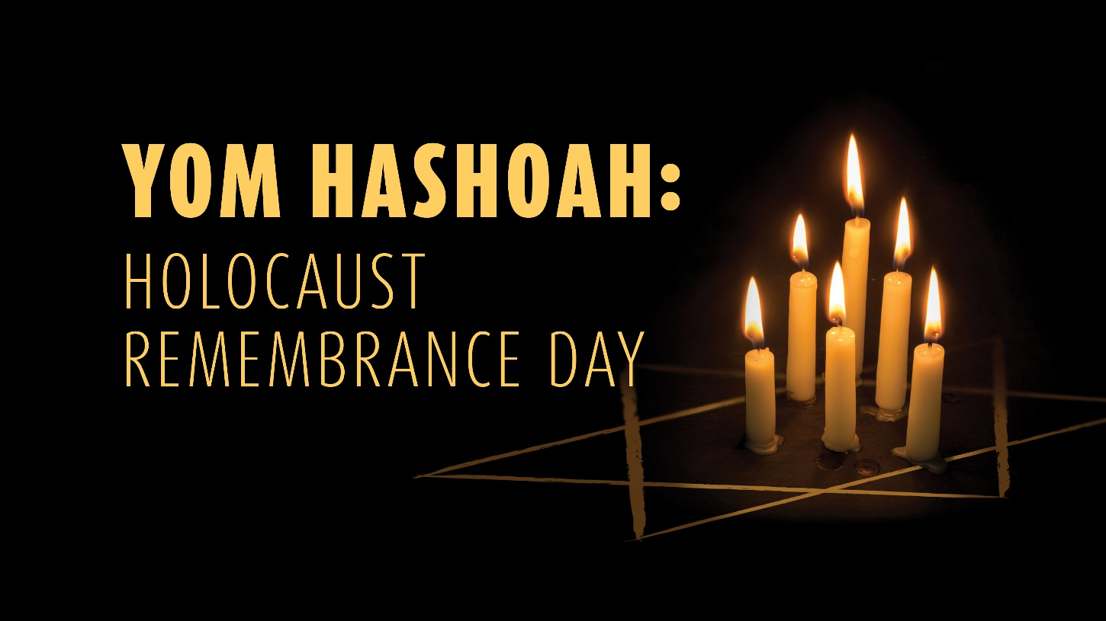

Temple Israel of Brevard
Thursday, April 28th at 6 pm
Join Rabbi Pat and Cantor Ray Hickman
and our own Monica Fishkin as she tells her family’s story of bravery and redemption.

