- Bamidbar 21
לג וַיִּפְנוּ, וַיַּעֲלוּ, דֶּרֶךְ, הַבָּשָׁן; וַיֵּצֵא עוֹג מֶלֶךְ-הַבָּשָׁן לִקְרָאתָם הוּא וְכָל-עַמּוֹ, לַמִּלְחָמָה--אֶדְרֶעִי. | 33 And they turned and went up by the way of Bashan; and Og the king of Bashan went out against them, he and all his people, to battle at Edrei.
לד וַיֹּאמֶר יְהוָה אֶל-מֹשֶׁה, אַל-תִּירָא אֹתוֹ--כִּי בְיָדְךָ נָתַתִּי אֹתוֹ וְאֶת-כָּל-עַמּוֹ, וְאֶת-אַרְצוֹ; וְעָשִׂיתָ לּוֹ--כַּאֲשֶׁר עָשִׂיתָ לְסִיחֹן מֶלֶךְ הָאֱמֹרִי, אֲשֶׁר יוֹשֵׁב בְּחֶשְׁבּוֹן. | 34 And the LORD said unto Moses: 'Fear him not; for I have delivered him into thy hand, and all his people, and his land; and thou shalt do to him as thou didst unto Sihon king of the Amorites, who dwelt at Heshbon.'
לה וַיַּכּוּ אֹתוֹ וְאֶת-בָּנָיו וְאֶת-כָּל-עַמּוֹ, עַד-בִּלְתִּי הִשְׁאִיר-לוֹ שָׂרִיד; וַיִּירְשׁוּ, אֶת-אַרְצוֹ. | 35 So they smote him, and his sons, and all his people, until there was none left him remaining; and they possessed his land.

- Devarim 3
ב וַיֹּאמֶר יְהוָה אֵלַי, אַל-תִּירָא אֹתוֹ--כִּי בְיָדְךָ נָתַתִּי אֹתוֹ וְאֶת-כָּל-עַמּוֹ, וְאֶת-אַרְצוֹ; וְעָשִׂיתָ לּוֹ--כַּאֲשֶׁר עָשִׂיתָ לְסִיחֹן מֶלֶךְ הָאֱמֹרִי, אֲשֶׁר יוֹשֵׁב בְּחֶשְׁבּוֹן. | 2 And the LORD said unto me: 'Fear him not; for I have delivered him, and all his people, and his land, into thy hand; and thou shalt do unto him as thou didst unto Sihon king of the Amorites, who dwelt at Heshbon.'
ג וַיִּתֵּן יְהוָה אֱלֹהֵינוּ בְּיָדֵנוּ, גַּם אֶת-עוֹג מֶלֶךְ-הַבָּשָׁן--וְאֶת-כָּל-עַמּוֹ; וַנַּכֵּהוּ, עַד-בִּלְתִּי הִשְׁאִיר-לוֹ שָׂרִיד. | 3 So the LORD our God delivered into our hand Og also, the king of Bashan, and all his people; and we smote him until none was left to him remaining.
יא כִּי רַק-עוֹג מֶלֶךְ הַבָּשָׁן, נִשְׁאַר מִיֶּתֶר הָרְפָאִים--הִנֵּה עַרְשׂוֹ עֶרֶשׂ בַּרְזֶל, הֲלֹה הִוא בְּרַבַּת בְּנֵי עַמּוֹן: תֵּשַׁע אַמּוֹת אָרְכָּהּ, וְאַרְבַּע אַמּוֹת רָחְבָּהּ--בְּאַמַּת-אִישׁ. | 11 For only Og king of Bashan remained of the remnant of the Rephaim; behold, his bedstead was a bedstead of iron; is it not in Rabbah of the children of Ammon? nine cubits was the length thereof, and four cubits the breadth of it, after the cubit of a man

- Nidda 61a
סיחון ועוג אחי הוו דאמר מר סיחון ועוג בני אחיה בר שמחזאי
Sihon and Og were brothers, as the Master said: Sihon and Og were sons of Ahijah, son of Shamhazai.
Rashi: בני אחיה - שבא משמחזאי ועזאל שני מלאכים שירדו בדור אנוש:
- Pirkei D’Rebbe Eliezer 23
ונמחו כל היקום שבארץ שנאמר וימח את כל היקום אשר על פני האדמה, חוץ מנח וכל אשר אתו בתבה שנאמר וישאר אך נח ואשר אתו בתיבה, וחוץ מעוג מלך הבשן שישב לו על עץ אחד מן הסולמות של התיבה ונשבע לנח ולבניו שיהיה להם עבד עולם מה עשה נח נקב חור אח' בתיבה והיה מושיט לו מזונו בכל יום ויום ונשאר גם הוא שנ' כי רק עוג מלך הבשן וגו'.
And all living things which were upon the face of the earth decayed, as it is said, "And every living thing was destroyed which was upon the face of the ground" (Gen. 7:23), except Noah and those who were with him in the ark, as it is said, "And Noah only was left, and they that were with him in the ark" (ibid.), except Og, king of Bashan, who sat down on a piece of wood under the gutter of the ark. He swore to Noah and to his sons that he would be their servant forever. What did Noah do? He bored an aperture in the ark, and he put (through it) his food daily for him, and he also was left, as it is said, "For only Og, king of Bashan, remained of the remnant of the giants" (Deut. 3:11)
- Bereishis 14:13
וַיָּבֹא֙ הַפָּלִ֔יט וַיַּגֵּ֖ד לְאַבְרָ֣ם הָעִבְרִ֑י וְהוּא֩ שֹׁכֵ֨ן בְּאֵֽלֹנֵ֜י מַמְרֵ֣א הָאֱמֹרִ֗י אֲחִ֤י אֶשְׁכֹּל֙ וַאֲחִ֣י עָנֵ֔ר וְהֵ֖ם בַּעֲלֵ֥י בְרִית־אַבְרָֽם׃
A fugitive brought the news to Abram the Hebrew, who was dwelling at the terebinths of Mamre the Amorite, kinsman of Eshkol and Aner, these being Abram’s allies.
Rashi: ויבא הפליט. לְפִי פְשׁוּטוֹ זֶה עוֹג, שֶׁפָּלַט מִן הַמִּלְחָמָה, וְהוּא שֶׁכָּתוּב כִּי רַק עוֹג נִשְׁאַר מִיֶּתֶר הָרְפָאִים (דבר' ג') וְזֶהוּ נִשְׁאַר, שֶׁלֹּא הֲרָגוּהוּ אַמְרָפֶל וַחֲבֵרָיו כְּשֶׁהִכּוּ הָרְפָאִים בְּעַשְׁתְּרוֹת קַרְנַיִם, תַּנְחוּמָא וּמִדְרַשׁ בְּ"רַ זֶה עוֹג, שֶׁפָּלַט מִדּוֹר הַמַּבּוּל; וְזֶהוּ מִיֶּתֶר הָרְפָאִים, שֶׁנֶּאֱמַר הַנְּפִלִים הָיוּ בָאָרֶץ וְגוֹ' (לְעֵיל ו') וּמִתְכַּוֵּן שֶׁיֵּהָרֵג אַבְרָם וְיִשָּׂא אֶת שָׂרָה:
According to the real meaning this was Og who had escaped from the battle with the Rephaim and it is to this that the text refers “For only Og king of Bashan was left of the remnant of the Rephaim”, and this is what is meant by נשאר “left”, for Amraphel and his allies did not kill him when they smote the Rephaim in Ashteroth Karnaim. But according to the Midrash Genesis Rabbah (42:8) it refers to Og in allusion to him as the only one of the generation of the Flood who escaped that catastrophe, and this is what is meant “of the remnant of the Rephaim”
His intention in telling Abraham was that Abraham should be killed so that he, himself, might marry Sarah.
- Brachos 54a
תָּנוּ רַבָּנַן: הָרוֹאֶה מַעְבְּרוֹת הַיָּם, וּמַעְבְּרוֹת הַיַּרְדֵּן, מַעְבְּרוֹת נַחֲלֵי אַרְנוֹן, אַבְנֵי אֶלְגָּבִישׁ בְּמוֹרַד בֵּית חוֹרוֹן, וְאֶבֶן שֶׁבִּקֵּשׁ לִזְרוֹק עוֹג מֶלֶךְ הַבָּשָׁן עַל יִשְׂרָאֵל, וְאֶבֶן שֶׁיָּשַׁב עָלֶיהָ מֹשֶׁה בְּשָׁעָה שֶׁעָשָׂה יְהוֹשֻׁעַ מִלְחָמָה בַּעֲמָלֵק, וְאִשְׁתּוֹ שֶׁל לוֹט, וְחוֹמַת יְרִיחוֹ שֶׁנִּבְלְעָה בִּמְקוֹמָהּ — עַל כּוּלָּן צָרִיךְ שֶׁיִּתֵּן הוֹדָאָה וָשֶׁבַח לִפְנֵי הַמָּקוֹם.
The Sages taught a list of places where one is required to recite a blessing due to miracles that were performed there: One who sees the crossings of the Red Sea, where Israel crossed; and the crossings of the Jordan; and the crossings of the streams of Arnon; the hailstones of Elgavish on the descent of Beit Ḥoron; the rock that Og, King of Bashan, sought to hurl upon Israel; and the rock upon which Moses sat when Joshua waged war against Amalek; and Lot’s wife; and the wall of Jericho that was swallowed up in its place. On all of these miracles one must give thanks and offer praise before God.
- Brachos 54b
אֶבֶן שֶׁבִּקֵּשׁ עוֹג מֶלֶךְ הַבָּשָׁן לִזְרוֹק עַל יִשְׂרָאֵל, גְּמָרָא גְּמִירִי לַהּ. אֲמַר מַחֲנֵה יִשְׂרָאֵל כַּמָּה הָוֵי — תְּלָתָא פַּרְסֵי, אֵיזֵיל וְאֶיעֱקַר טוּרָא בַּר תְּלָתָא פַּרְסֵי וְאִישְׁדֵּי עֲלַיְיהוּ, וְאִיקְטְלִינְהוּ. אֲזַל עֲקַר טוּרָא בַּר תְּלָתָא פַּרְסֵי וְאַיְיתִי עַל רֵישֵׁיהּ, וְאַיְיתִי קוּדְשָׁא בְּרִיךְ הוּא עֲלֵיהּ קַמְצֵי וְנַקְבוּהּ, וּנְחֵית בְּצַוְּארֵיהּ.
With regard to the rock that Og, King of Bashan, sought to throw upon Israel, there is no biblical reference, but rather a tradition was transmitted. The Gemara relates that Og said: How large is the camp of Israel? It is three parasangs. I will go and uproot a mountain three parasangs long and I will hurl it upon them and kill them. He went, uprooted a mountain three parasangs long, and brought it on his head. And The Holy One, Blessed be He, brought grasshoppers upon it and they pierced the peak of the mountain and it fell on his neck.
הֲוָה בָּעֵי לְמִשְׁלְפֵהּ, מָשְׁכִי שִׁינֵּיהּ לְהַאי גִּיסָא וּלְהַאי גִּיסָא וְלָא מָצֵי לְמִשְׁלְפֵהּ. וְהַיְינוּ דִּכְתִיב: ״שִׁנֵּי רְשָׁעִים שִׁבַּרְתָּ״. וְכִדְרַבִּי שִׁמְעוֹן בֶּן לָקִישׁ. דְּאָמַר רַבִּי שִׁמְעוֹן בֶּן לָקִישׁ: מַאי דִּכְתִיב ״שִׁנֵּי רְשָׁעִים שִׁבַּרְתָּ״ — אַל תִּקְרֵי ״שִׁבַּרְתָּ״ אֶלָּא ״שִׁרְבַּבְתָּ״.
Og wanted to remove it from his head; his teeth were extended to one side of his head and to the other and he was unable to remove it. And that is what is written: “You break the teeth of the wicked” (Psalms 3:8). And this is in accordance with the homiletic interpretation of Rabbi Shimon Ben Lakish, as Rabbi Shimon Ben Lakish said: What is the meaning of that which is written: “You break the teeth of the wicked”? Do not read it as: You break [shibarta], but rather as: You lengthened [shirbavta].
מֹשֶׁה כַּמָּה הֲוָה — עֶשֶׂר אַמּוֹת, שְׁקֵיל נַרְגָּא בַּר עֲשַׂר אַמִּין, שְׁוַור עֲשַׂר אַמִּין, וּמַחְיֵיהּ בְּקַרְסוּלֵּיהּ וְקַטְלֵיהּ.
The story concludes: How tall was Moses? He was ten cubits tall. He took an axe ten cubits long, jumped up ten cubits, and struck Og in the ankle and killed him.
- Rashba on Brachos 54b
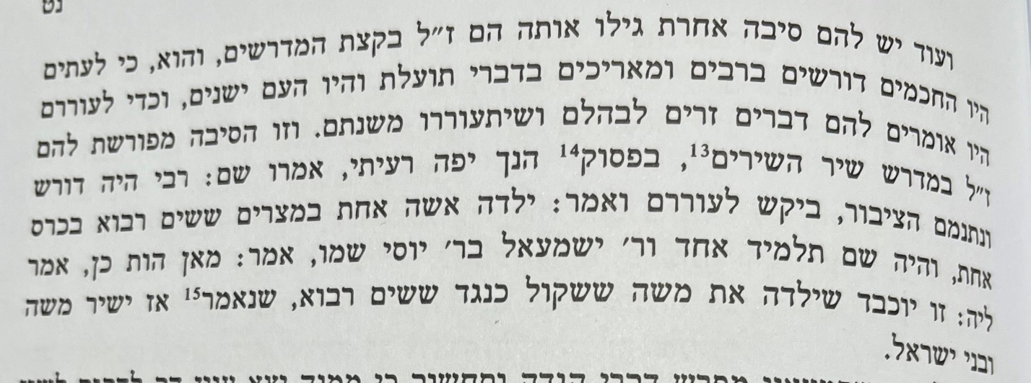
- Artscroll Ein Yaakov Tractate Brachos page 181
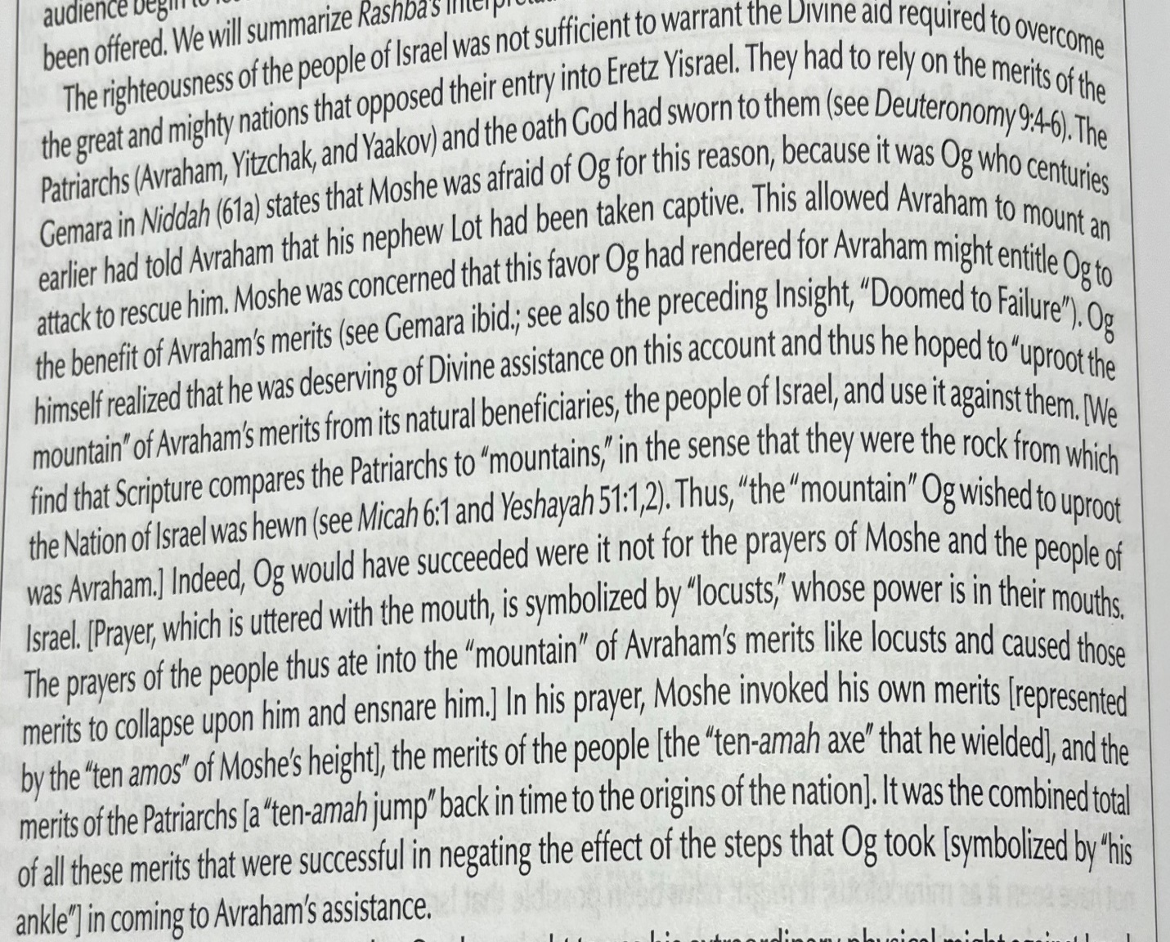

- https://www.ravkooktorah.org/DVARIM60.htm
The battle between Og and Moses is a metaphor for the struggle between the physical and spiritual realms. Og the giant viewed everything in terms of brute force and power. He was enraged seeing a small, weak people — the Israelites — take on and defeat the Midianites and the Amorites. Og decided he would demonstrate that spiritual power cannot compete against physical strength. He would use the ultimate symbol of brute force — a massive, inanimate mountain — to bury the Jews and all of their pretensions!
The giant lifted the mountain up, over his head. This indicated that the huge rock, as a symbol of brute power, was his crown, his glory, his ultimate value.
“But God brought ants that ate a hole in the mountain.” Significantly, Og’s downfall was not by means of an even greater physical force. Og’s faith in power and might was conclusively shattered by his defeat at the hands of the smallest and most fragile of creatures, the lowly ant.
At this point, the heavy rock weighed down heavily on Og’s shoulders. He began to realize that his trust in physical force was misplaced. His crown had become an oppressive burden. However, it was too late to escape. His teeth, symbolizing his aggressiveness and lust, had grown outwards. His traits of violence and rapacity, like his reliance on brute force, had become an integral part of his life and personality, at the expense of spiritual inclinations.
Such is the fate of an individual — or a people — addicted to the drug of physical force, living by the power of the fist. In hindsight, such a life of aggression will be a burden and a source of bitter discontent. Old and weak, even if he should now desire to change his ways to a more peaceful existence, he will not succeed. His teeth overgrown, his basic nature has been usurped by the lifelong habits of aggression and savage greed. Adapted from Ein Eyah vol. II, pp. 248-249

- The Rav’s Chumash Bamidbar page 177
