The Shofar's Voice
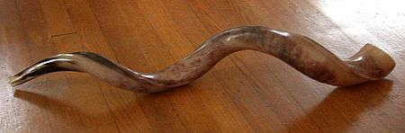
Samuel Waidenbaum, Rabbi B’Nai Israel Synagogue Cheshvan-Kislev
Jerome Gordon, President P.O. Box 9002 5779
Pensacola, Florida 32513-9002

Inside this issue:
Rabbi’s Message p. 2
President’s Message p. 3
Fund Raising Chair p.
Birthdays p. 7
Anniversaries p. 7
Yahrzeit p. 8
Donations p. 9 -11

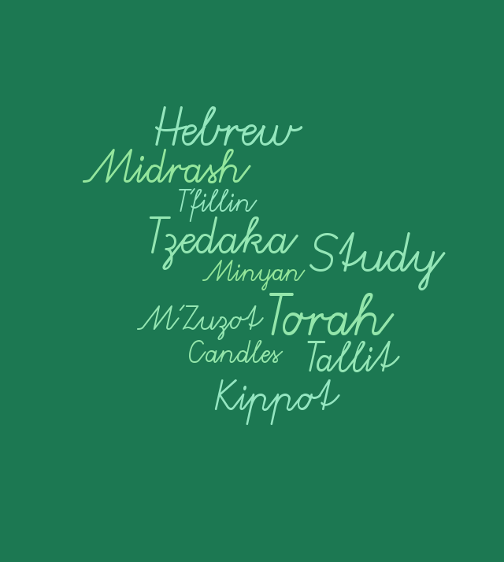

Newsletter Deadline 15th of Month
Send items to jerrimobley@gmail.com
From the Rabbi’s Desk
Now that the High Holy Days are behind us, I would like to take this opportunity to share with you how I see my commitment to B’nai Israel Synagogue as well as your commitment to B’nai Israel Synagogue. Being a rabbi is an exciting and rewarding profession. I would also like to explain how I see my role in the workings at B’nai Israel Synagogue. Simply put, there are many different types of rabbis. A Rabbi be may in a religious school, a Jewish agency, a hospital Chaplain, or on a college campus.
Despite the variety of roles, I decided to become a congregational rabbi. I made this choice partially because I believe that the synagogue is one of the most important institutions in the Jewish community. It helps us grow individually and collectively early in our lives. It also aids in the development of strong family and community ties. At the same time, it is by nature a grassroots organization, that can accomplish great social change when its Rabbi and members work together. The synagogue is a key part of our past and the bedrock of our future. I proudly tell everyone; that I am a congregational Rabbi in Pensacola, Florida. To me this means that my primary duty is to serve you, my congregants. Of course, it involves at every possible opportunity sharing my love of the Jewish tradition with you.
There are challenges. The only way to address challenges is to keep focusing on them to the best of my ability and never give up. We are making progress. For instance:
- Our kitchen at B’nai Israel is and has been KOSHER for almost a full year. And fully Kosher for Passover, as well.

- A few of our congregants now have kosher homes. Some have placed M’ZUZOT on the doorposts of their homes, and many of you are now lighting Shabbat candles every Friday night.

- The attendance during this High Holy Days; almost doubled last years. Participation at Friday night and Shabbat morning services are at an all-time high. (Please join us - stop by once a month if possible).

- Our Lunch & Learn study group is very popular (Lunch by Kate-Learn by Rabbi).

- Kever Avot, the burial of Shemot, and the Tashlich program at the ocean were attended by almost 40 of our congregants.

- We are continuing our successful adult education class on Wednesday’s at 6:30 PM (15-17 people attended weekly last year-we invite y’all to join us).

- More of our congregants are now observing the actual day of their Yahrtzeit and over 25 congregants are coming out to support them, as they recite the Mourner’s Kaddish over their loved ones.

- On Sunday morning, October 14th, we inaugurated two new programs for our congregation. I am very proud to let y’all know, that almost 15 members of our congregation came out to pray in our Bearman Building, with their Tallit & T’fillin (followed by breakfast of- course). Six individuals came to learn Hebrew. Just imagine, that in a few months, they will be reading Hebrew and completely participating in Shabbat Services. WOW!

I am of course very lucky to be surrounded by people who love and are committed to our synagogue; physically, spiritually, and monetarily. Starting with and certainly not limited to our incoming president, vice president and board; those who give their all in
the office, kitchen, and of-course our new Shofar editor. Everyone who participated in the Holiday services who facilitated smooth transitions and finally those individuals who made it possible for yours truly to be able to serve you for the next 3 years. G-d willing, we should all be healthy.
That is just part of the duty and responsibility of being a congregational rabbi. Please understand, when I say my primary role is to work for the improvement of the Synagogue and its programs. I also participate and represent our synagogue in events and programs in the community. We are incredibly fortunate to be witnessing this moment in our synagogue’s history. To make the most of this moment, we must be committed to B’nai Israel’s transformation into a vibrant, and flourishing congregation.
Thank you for giving me the opportunity to serve as your Rabbi at B’nai Israel Synagogue in this historic, transformative moment. May we all work together to make B’nai Israel Synagogue our number one concern; and may G-d help us to achieve that goal-AMEN!!

B’Shalom,
Rabbi Sam

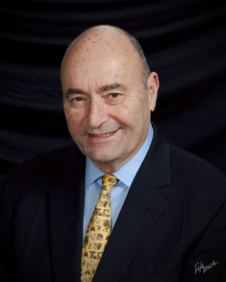

Hurricane Michael hit the Florida Panhandle on October 10, 2018 as a CAT 4 storm packing 155 MPH winds battering communities east of Pensacola: Panama City, Mexico Beach and Apalachicola. The landfall that afternoon on Rosh Chodesh Keshvan spared Pensacola and the surrounding Escambia and Santa Rose Counties. While we might be grateful, we cannot afford to forget the lives lost, communities laid waste and disrupted for those whose homes, businesses and houses of worship were damaged or destroyed.
While synagogues and temples in the Panama Beach area were spared experiencing minimal damages, many other churches were not. One of those was the First Assembly Ministries in Panama City. The sanctuary was damaged and flooded. That caused the cancellation of a Christians United for a Night to Honor Israel event scheduled for October 28, at which our Rabbi Sam Waidenbaum was to have spoken. The feature speaker was someone that both Rabbi Waidenbaum and the extended Gordon family in Long Island have known, Irving Roth – a Holocaust survivor and director of the Holocaust Memorial Museum in Roslyn, New York. We have reached out to Pastor Phil Edwards to determine what we could do to aid the worthy congregation.
Rabbi Waidenbaum inaugurated on Sunday October 14th a regular weekly tallit and t’fillin minyan followed by a bagel and lox breakfast. This event was well attended (see the news article in this edition of the Shofar’s Voice). Following the service, an adult Hebrew literacy class commenced. Torah study classes were renewed for 5779 on Wednesday October 17th. See Rabbi’s letter on page 2 in this edition.
On October 28th an unveiling of the headstone for the late Martha Miller, z”l, was held at B’nai Israel Cemetery with family and friends officiated by Rabbi Waidenbaum. The much revered ‘grandma’ Martha Miller passed at the venerable age of 102 and one half having been designated as an Emeritus Member of B’nai Israel Synagogue.
The annual meeting of the Congregation will be held on Sunday, November 4, 2018 at 1 PM EST. We will be voting on a slate of new members of the Board of Directors and a proposed budget for calendar fiscal year 2019. A discussion will also be held on possible changes to the By-laws and suggestions for the celebration of the 120th anniversary of the synagogue’s founding in 1899 as the second oldest Jewish house of worship in Florida.
Additionally, November 9, 2018, marks the 80th commemoration of the Nazi perpetration of Kristallnacht, “the night of broken glass”, when synagogues throughout Hitler’s Germany were burned, Torahs and holy books destroyed, hundreds were killed and more than 30,000 Jews were sent to concentration camps. Many historians consider this the first act of the final solution that saw six million European Jewish men, women and children murdered in unspeakable ways.
The date also coincides with the annual Veterans Day erev Shabbat event at B’nai Israel. We are most fortunate to have as a keynote speaker, Jewish American US Navy Lt. Cary Rickoff, a Member of the famed US Navy Blue Angels Aerobatic team, Class of 2019. Lt. Rickoff is an F/A-18 Hornet pilot currently assigned to the “Golden Eagles” of VT-

22. We, in Pensacola, Florida Jewish community are especially proud of Cary's achievement. He is the grandson of the late Dr. Nate and Greta Rickoff and nephew of Dr. Scott and Faye Rickoff, residents of Pensacola, members of B'nai Israel Synagogue. See news article this edition on page 6.
Sunday, November 11, 2018 is the 100th anniversary of Armistice Day that ended WWII on the “eleventh hour, eleventh day of the eleventh month” when American forces first fought and died for the liberation of Europe from then German aggression.

See you in shul.
Jerry Gordon

Picture from Panama City Beach
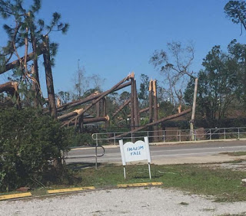

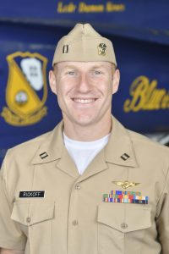
Navy Lt. Cary Rickoff
Blue Angels Aerobatic Team
Speaker at Veterans Day Event
November 9, 2018
Erev Shabbat
B’nai Israel Synagogue
Pensacola Florida

The famed US Navy Blue Angels announced the 2019 officers in August 2018. Among those selected was 31 year Jewish American Cary Rickoff of Atlanta, Georgia. Rickoff, a 2009 graduate of Duke University is an F/A-18 Hornet pilot currently assigned to the “Golden Eagles” of VT-22. We, in Pensacola, Florida’s Jewish community are especially proud of Cary's achievement. He is the grandson of the late Dr. Nate and Greta Rickoff and nephew of Dr. Scott and Faye Rickoff, residents of Pensacola, members of B'nai Israel Synagogue. Thirty one year Jewish American, Cary Rickoff of Atlanta, Georgia is a 2009 graduate of Duke University.

Happy Birthday
This Photo by Unknown Author is licensed under CC BY-NC

November

1 Blossom Davies Jamison
14 Jeffrey Kates
21 Deborah Wenc
27 Joan Kay
30 Rebekah Davies

Anniversaries

No Anniversaries this month

Yahrzeits 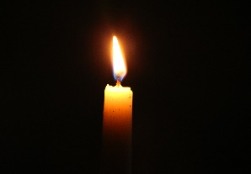 We Remember………
This Photo by Unknown Author is licensed under CC BY-SA
November

2 / 24 Cheshvan Samuel Bubis
4 / 26 Cheshvan Celia Berinhout
4 / 26 Cheshvan Carol Baron
9 / 1 Kislev Ellen Mary Hanreck
11 / 3 Kislev David J. Rosenberg
17 / 9 Kislev Charles Kapner
18 / 10 Kislev Isidore Feigenbaum
20 / 12 Kislev Betty Weiss
21 / 13 Kislev Max Levin
22 / 14 Kislev Bailey Goldfarb
23 / 15 Kislev Harry Abrams
23 / 15 Kislev Edward Chorney
27 / 19 Kislev Clara Goldstein
29 / 21 Kislev Sidney Kaiman
29 / 21 Kislev Harry Rickoff
29 / 21 Kislev Joyce Levin

Zichronam livracha- May their memories be for a blessing.
Amen.
Donations

High Holy Days Flower Donations
Esther Allen & Family:
Tzedaka
Thank you for your donations that beautified the synagogue during the High Holy Days, provided honor and loving memory to family members or friends, provided cemetery and rabbi discretionary fund support.

“Tzedaka may not save us, but it makes us worth saving.”
Professor Reuven Kimelman, “Tzedaka and Us.”

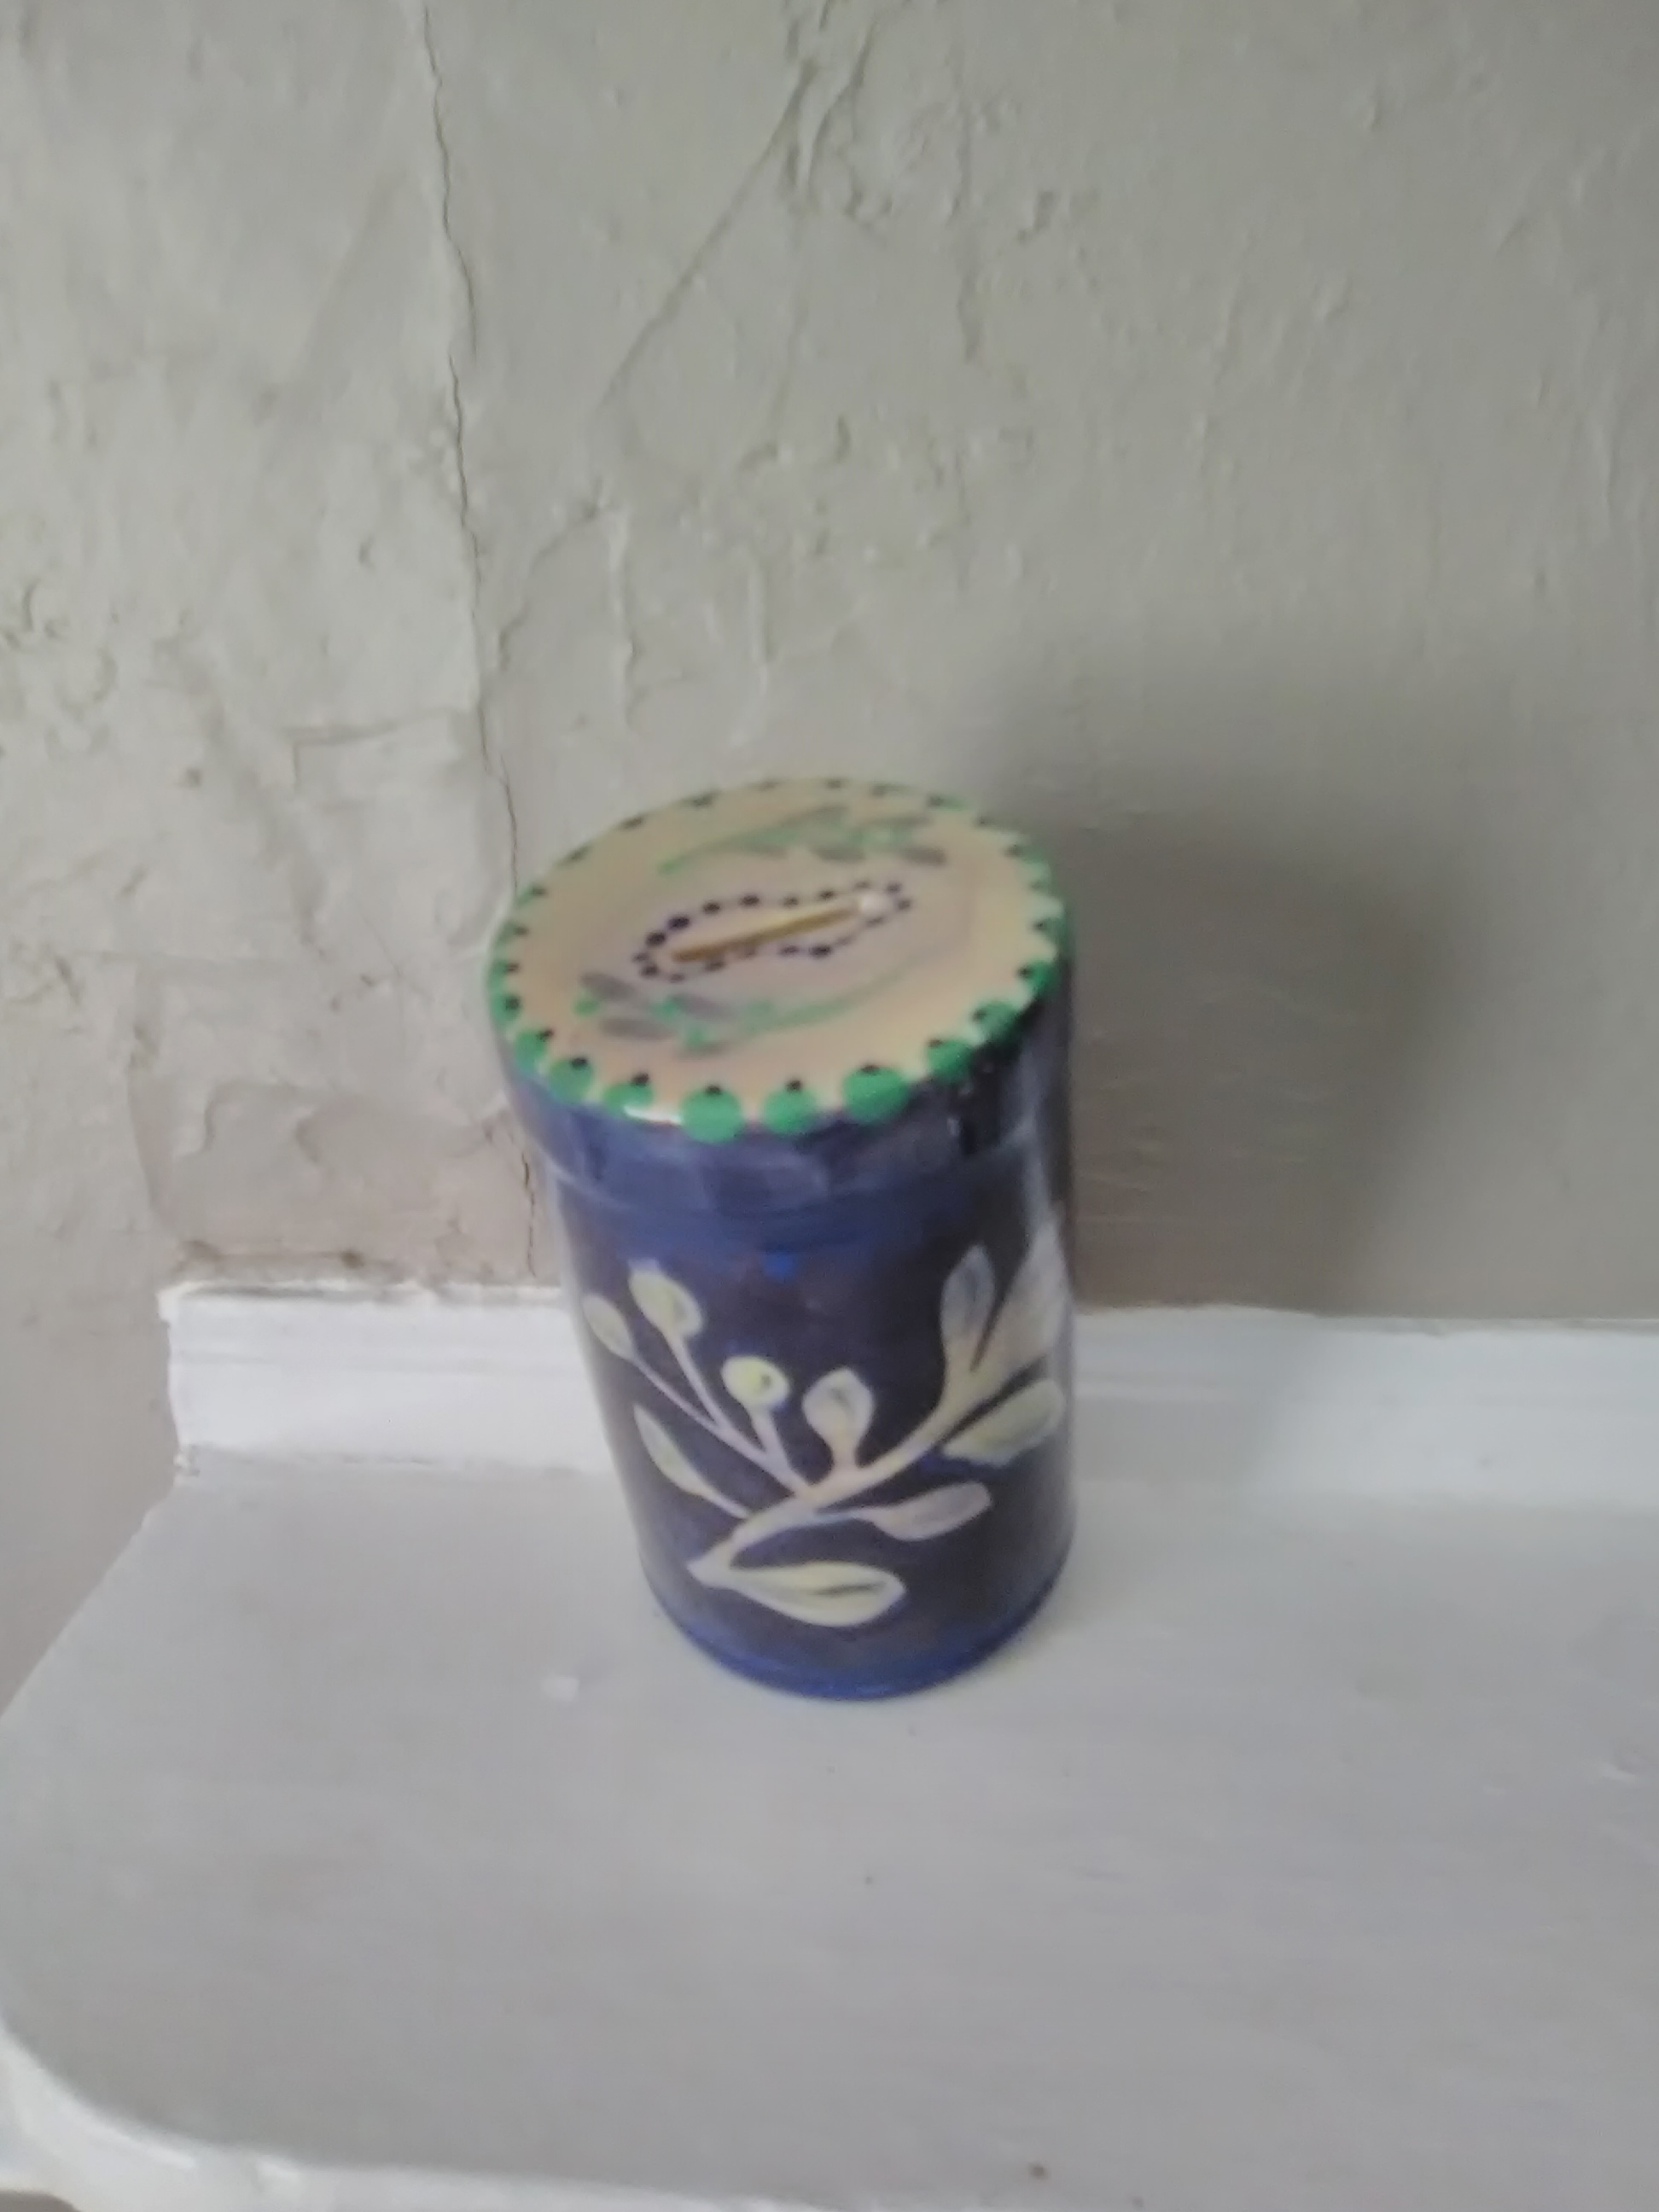

In loving memory of Bill Allen
In loving memory of Rachel Daves

Jean & Jerry Gordon:
In loving memory of Henry & Elizabeth Eigner Gordon
In loving memory of Col. E. Thomas, USMC, & Eleanor Miller Dorsey

Marty Libowsky:
In honor of his Grandchildren Noah, Dylan & Lanie Ann, Lila, Harrison & Charlie

Kate & Leonard Lollar:
In loving memory of Bill Allen
In loving memory of Ed Feigenbaum
In loving memory of Arny Pock
In loving memory of Martha Miller

Faye & Scott Rickoff:
In loving memory of Dr. Nathan and Greta Rickoff
In loving memory of Askol Steigman

Lori & Barry Ripps:
In honor of her Mother, Molly Gross
In loving memory of her Father, Leon Gross
In loving memory of his Parents, Beverly & SJ Ripps

Fay & Joe Rosenbaum and Gene Rosenbaum:
In loving memory of their Parents Leah & Jack Rosenbaum and Dottie & Buddy Bubis

Cemetery Fund
Roz Bendet

Rabbi's Discretionary Fund
Jay & Collen Deckelbaum
Delores Livingston

General Fund
Keith Stimmell

Memorial Donations for Estelle Kapner
Vicky Anderson
Vivian Anderson
Victor & Joyce Demarest
Norman & Josie Roberts
Gene Rosenbaum
Joe & Faye Rosenbaum
Donna Rawson

Memorial Donations for Elaine Wilson
Norman & Josie Roberts

Donation for Moroccan Cigars
Leonard & Doreen Swartz

High Holy Days Appeal

Ester Allen
Samuel & Phyllis Bearman
Sue Feigenbaum
Freda Glatt
Todah Rabah

תודה רבה

Jerry & Jean Gordon
Karyn Imrich
Charles & Janet Kahn
Jeffrey Kates
Shelly Landau
Marty Libowsky
Kate & Leonard Lollar
Jerri Mobley
Norman & Josie Roberts
Gene Rosenbaum
Joe & Faye Rosenbaum
Alan & Marci Shemaria
Lewis & Deborah Sims
Leonard & Doreen Swartz
Kenneth & Jodi Volmert
Rhonda Weiner

Annual Meeting
November 4, 2018 at 1 pm
Please plan to attend
Kosher Hot Dogs and fixins!

Membership Directory Update in Progress

You will be receiving and email from jerrimobley@gmail.com requesting verification of addresses, phone numbers, dates of birth, yahrzeits, anniversaries, and email addresses. We want to have a complete and directory. Please respond to the email and or contact Jerri to verify your information.

B’nai Israel Pensacola Inaugurates ‘heart healthy’ tallit and t’fillin minyan

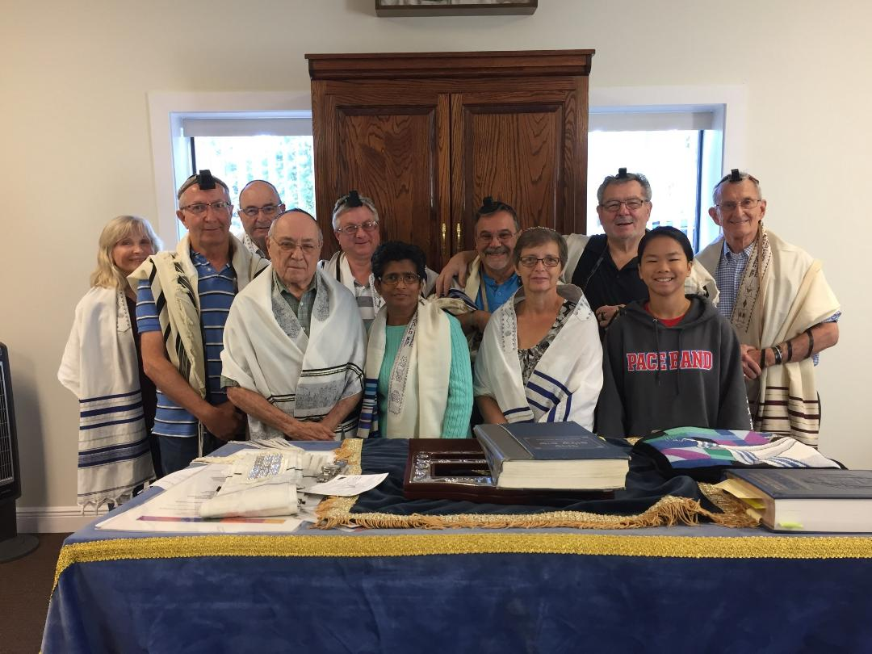

Inaugural Weekly Tallit and T’fillin Minyan
B’nai Israel Synagogue, Pensacola
Sunday, October 14, 2018

Under the dynamic spiritual leadership of Rabbi Samuel Waidenbaum, B’nai Israel Synagogue Pensacola October 14th inaugurated a weekly Sunday tallit and t’fillin minyan replete with a bagel, lox cream cheese breakfast. Rabbi Waidenbaum gave instructions on t’fillin wrapping, pointing out the significance and how different were the nusuf- tunes for the minyan service from Shabbat. That was followed by an adult Hebrew literacy class. This complements weekly Torah commentary classes on Wednesday and renewal of the successful conversion class of 2017 that added new members. Rabbi Waidenbaum hopes that the addition of the weekly minyan will be an attraction to Jewish visitors to Pensacola that was experienced during High Holy Days and Sukkot Festival.
The B’nai Israel initiative coincides with a jns.org report that tight t’ffilin arm wrapping may have some heart healthy benefits.
American Study shows tefillin wrapping may protect men from heart attack
The tight binding of the arm may offer protection against “acute ischemic reperfusion injury,” in which the heart is deprived of oxygen during a heart attack, then damaged by the reintroduction of oxygen.

October 15, 2018 / JNS) A new study published last month in the American Journal of Physiology-Heart and Circulatory Physiology shows that the act of Jewish men tightly wrapping tefillin straps around their arms in the morning may be helping to ward of heart attacks.

“We found people who wear tefillin in either the short or long-term, recorded a measurable positive effect on their blood flow. That has been associated with better outcomes in heart disease,” said study co-author Dr. Jack Rubinstein, a cardiologist and associate professor at the University of Cincinnati.

h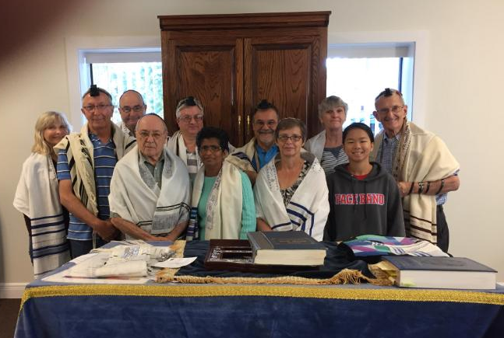
On a lighter note:

The first Jewish President is elected. He calls his Mother and says, “Mama, I’ve won the election. You’ve got to come to the inauguration.” “I don’t know, what should I wear?” “Don’t worry I’ll send you a dressmaker.” “But I only eat kosher food.” “Mama, I am going to be the president. I can get you kosher food.” “But how will I get there?” “I’ll send a limo. Just come mama.” “OK, OK, if it makes you happy.” The great day comes, and Mama is seated between the Supreme Court Justices and the future cabinet members. She nudges the gentleman on her right, “You see that boy, the one giving the speech? His brother’s a doctor!”

A Jewish man and a Chinese man were talking. The Jewish man commented upon what a wise people the Chinese are. “Yes,” replied the Chinese man, “Our culture is over 4,000 years old. But, you Jews are a very wise people, too.” The Jewish man replied, “Yes, our culture is over 5,000 years old.” The Chinese man was incredulous. “That’s impossible,” he replied. Where did your people eat for a thousand years?”

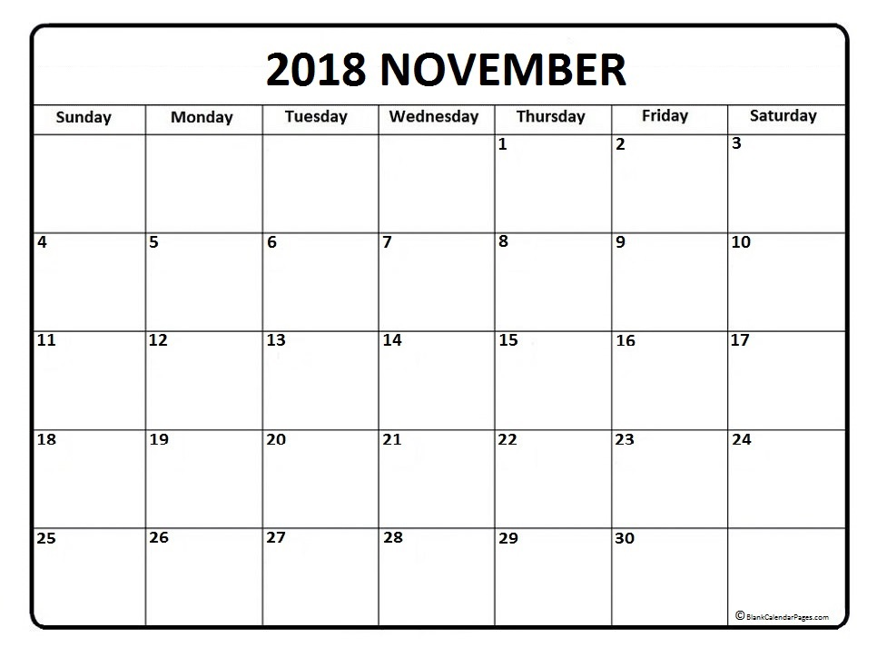
Cheshvan-Kislev
5779

Thanksgiving
Election Day
VOTE!
NO Torah Study
9a Tallit & T’fillin Minyan
10a Hebrew Class

9a Tallit & T’fillin Minyan
10a Hebrew Class

9a Tallit & T’fillin Minyan
10a Hebrew Class

9a Tallit & T’fillin Minyan
10a Hebrew Class

Torah Study 6:30 pm

Torah Study 6:30 pm

Torah Study 6:30 pm
Shabbat Services
6:30 pm

Shabbat Services
6:30 pm

Shabbat services
0930

Shabbat services
0930

Shabbat services
0930
0
Shabbat services
0930
Shabbat Services
6:30 pm

Shabbat Services
6:30 pm

Shabbat Services
7 pm

Candle Lighting Shabbat Ends

November 2, 2018 5:42 pm November 3, 3028 6:37pm
November 9, 2018 4:37 pm November 10, 2018 5:12 pm
November 16, 2018 4:33 pm November 17, 2018 5:29 pm November 23, 2018 4:31 pm November 24, 2018 5:27 pm
November 30, 2018 4:30 pm December 1, 2018 5:26 pm

FIRST CLASS MAIL
Published by:
B’Nai Israel Synagogue
Founded in 1899

1829 North 9th Avenue
P.O. Box 9002
Pensacola, FL. 32513-9002

Affiliated with
The United Synagogue of
Conservative Judaism

Rabbi: Samuel Waidenbaum
Acting President: Jerome Gordon
Acting Vice President: Karyn Imrich
Secretary: Stephanie Gaffney
Treasurer: Shelly Landau
Immediate Past President:
Benjamin Nettles

DONATIONS:
Please send this form along with your check to B’Nai Israel Synagogue, P.O. Box 9002, Pensacola, FL, 35213-9002.

- General Fund
- Cemetery Fund
- Building Fund
- Education and Scholarship
- Rabbi’s Discretionary Fund

In Memory of __________________________________________________________________________________

In Honor of ____________________________________________________________________________________

Acknowledge to ________________________________________________________________________________

Donated by ____________________________________________________________________________________

Address ___________________________________________________________ Zip ________________________

