The Shofar's Voice
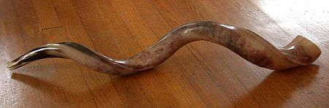
Samuel Waidenbaum, Rabbi B’Nai Israel Synagogue ADAR II-Nisan
Jerome Gordon, President P.O. Box 9002 5779
Pensacola, Florida 32513-9002 April 2019

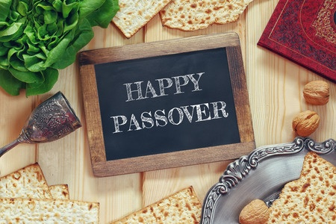

Newsletter Deadline 15th of Month
Send items to karenlewatc@gmail.com
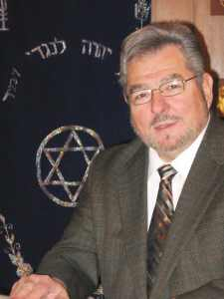
Rabbi Sam Waidenbaum
From the Rabbi’s Desk
PASSOVER
The Passover (Pesach) Seder
The Passover Seder (meaning order), is probably the most celebrated and beloved, of all Jewish home rituals. Most Jews have cherished memories, of past family times, spent at a Seder. The obligation to tell the story of the Exodus, was observed by our ancestors, ever since the actual Exodus itself. The scriptural command (Exodus 13:8) to tell the story of the exodus to our children, is interpreted as a positive commandment (Mitzva).
One of the four names for Passover-- and sometimes the one most emphasized is, Chag Ha-Cherut (The Festival of Freedom). Freedom is the primary theme of the Seder, with numerous other recurring themes, and motifs.
The Seder, permits Jews to worship G-d, through prayer, study, and learning; by taking part in what is essentially, a lesson of Jewish history, literature, and religion. Participation in the Seder, lets one symbolically and vicariously, re-live the Exodus, where past and present merge. There are some essential elements to the Seder, which, underlie the retelling of the Exodus.
The three fundamental patterns of the Seder, are; the individual, the family, and the nation. As a home event, involving the full family as well as guests, the Seder draws together all age groups. It requires the participation of the old and the young. On the individual level, the Seder requires every participant, to feel as though, he/she personally left Egypt. The family pattern of the Seder symbolizes, the first step toward the final redemption, from the slavery & the formation of the Jewish nation that did not exist as a nation, before the Exodus from Egypt. In order to tell the story, Jews have created an ingenious work of pedagogy.
The "script" for this central ritual of Passover, is the Haggadah (literally, "to tell"). It contains questions & answers, stories, show & tell, songs, food, symbols, suffering & suspense. Because every generation has managed to find its own significance in this wonderful teaching tool, there is now a plethora of Haggadot, with added stories, songs, games, & pictures, to suit every political, spiritual, & religious point of view. You can now find liberal, mystical, feminist, ecological, children's, and even atheist Haggadot.
The Seder is supposed to take place, at the Seder table, rich and poor are in-distinguishable, and all are free, and thus privileged to recline. It is also customary for the Seder leader, to wear a white/blue robe called a Kittle.
There are a number of symbols that occur throughout the Seder, but perhaps the focal point of the whole event, is the Seder plate. It contains a roasted shank bone, symbolizing the Pesach sacrifice in the Holy Temple, a Roasted Egg, symbolizing the spring season, & the mourning (for the destruction of Jerusalem), Maror (bitter herbs) to represent the bitter experience of the Hebrew slaves, Charoset (a mixture of apples, nuts, raisins, spices, cinnamon & wine) symbolizing the mortar the Hebrew slaves used to build for the Egyptians, and Karpas (parsley, celery, or another green vegetable) symbolizing the Green of Spring.
The table must also have three pieces of Matzah, each piece used for a different purpose, usually held in a special pouch made to be used during the Seder.
The Seder service has a clear order, with each of 14 steps representing a different phase of the Seder. Together, they serve to teach us the lesson of the Exodus; and G-d's saving the Jewish people from slavery. Much of the Seder discussion focuses on God's might and the Divine role of redemption. There are many instances of the number four throughout the Seder: four cups of wine, four sons, four matriarchs, four names for Pesach, four blessings. The most well-known example are the Arba Kushiyot, The four questions. These questions, usually recited by the youngest person at the table, are meant to highlight the main differences between this meal and all other meals of the year.
They are also a brilliant way of keeping young people interested and involved, in the events of the Seder. They include questions about why we recline, why we dip food, and why we eat certain types of food. Another special part of the Seder, is the extra cup of wine left on the table for Elijah. The suspense and excitement engendered by sending a child to open the door for the prophet who will be the harbinger of messianic times, is almost electric. Every Jew will have his or her own special memories of a past family Seder, but it is unquestionably among the greatest of our yearly rituals.
Please remember to sell your Chametz to me before Passover.

We hope you will join us for services on:

Fri. & Sat. Night - April 19 & 20 at 6:00 PM
Followed by our meaningful & delicious Seders.
(Please contact the synagogue office)
Sat. & Sun. morning services - April 20 & 21 at 9:30 AM

From my wife Susan & myself,
We Wish Y’all,
A Chag Kasher V’Sameach,
A Kosher & Happy Passover

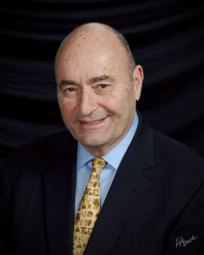

President’s Message, April 2019
To my fellow congregants:
The month of Nisan is time for spring cleaning, sale of chametz and koshering of your homes in anticipation of the eight days of Pesach with Seders on April 19 and 20th. It is a busy time for many of you and your families. We will be holding two communal Seders on those dates. We hope that you can attend on either or both. We will all join in the reading and songs of this holiday marking the birth of the nation of Israel, liberation from bondage and slavery in Egypt led by Moshe Rabbeinu with miracles and the outstretched arm of Ha Shem.

This past month we celebrated Purim with a large and appropriately boisterous attendance replete with wonderful Ma’ariv davening led by Morris “Moishe” Wohl and Queen Esther Megillah reading and interpretations by Karen Feirman. A bit of Purim Shpiel by yours truly added to the fun of the proceedings sparked by the noise of groggers at the mere mention of Haman. Who can forget those delicious and flavorful Hamentachen lovingly prepared by Kate Lollar, Shelly Landau, Faye Rosenbaum, Karen Feirman, Stephanie Gaffney. Yummy, just thinking about it.

March was the last of weekly successful Stanley Soup sales spearheaded by Kate Lollar, Faye Rosenbaum, Shelly Landau, Marci Goodman, Josie and Norman Roberts, Tony and Maria Martin and other community volunteers. The offerings included loaves of wonderful challah, delicious mandelbrot and tasty condiments. It was all towards a good end, the repair of the roof. Kate has announced that she will follow that with once a month Kosher Café offering.

The past month witnessed the beginnings of the 120th anniversary celebration of the founding of B’nai Israel synagogue. That will feature a gala concert of Jewish Music at the Mainstage Theater of the Center for Fine and Performance Arts at the University of West Florida. The event will feature hometown Cantor extraordinaire Martin “Moshe” Bear, tenor Nathaniel Bear and renowned cantor Amy Goldstein. Both Moshe Bear and Amy Goldstein have performed at Cantorial Assembly concerts staged by Moshe to great acclaim across the country. We have already begun fundraising for this event with sale of sponsorships and salutations for a journal to be published on the 120th anniversary. Rabbi Waidenbaum has already landed some important sponsors for the event. We will keep you informed of these and other activities leading up to the exciting events in June.

We have also begun through the efforts of Joe Rosenbaum, Marci Goodman and your President the staging of an exhibit on the history and artifacts of your synagogue through the Voices of Pensacola program of the University of West Florida Historic Trust and Chief Curator of Collections, Lowell Bassett. Prominent in the exhibit will be Joe Rosenbaum’s digitized 16 mm films of the building of B’nai Israel, installation of stained-glass windows in the sanctuary and the transfer of the torahs over the period 1952 to 1954.

As the month of March neared close we had an informative presentation by intrepid investigative journalist, Middle East war correspondent and author of New York Times best sellers, Kenneth R. Timmerman on March 28th.

Looking ahead to May, we have been selected by the Pensacola Jewish Federation to lead the annual Yom Ha’Zikaron – Yom Ha’atzmaut (Israel Remembrance and Independence Day). More on what is in store for that commemoration will come during the month of Nisan.
See you in shul.
Jerry Gordon
Jerome B. Gordon
President
A Message from Kate Lollar
Shalom y’all,
First of all, I’d like to give a big shout out to Karen and Dan for taking over the Shofars Voice!
Stanley’s Soups have been a great fundraising success. Our last soup for the season was a huge blowout! Everybody was saying, I don’t like butternut squash soup, until they tasted ours...it was delicious! A big thanks to all who bought and supported us with our soup endeavor. Stanley’s Soup will be back in October. It’s just too hot for soup this time of year. But have no fear, we will be doing a monthly luncheon in what I like to call the Kosher Kitchen. If we do well we might go to twice a month. Having said that, I would like to give a big, no, huge thank you to all who helped make this a success! Faye Rosenbaum, Shelley Landau, Marci Goodman, Esther Allen, Tony Martin, Maria Rosario, Josie Roberts, no relations to Julia, Carolyn Pock, Fran Kass and Karen and Dan Feirman. A special thanks to Gene Rosenbaum for getting volunteers for us, you are true Mensch! Oh, and how can I forget Joe Rosenbaum! Thanks Joe for coming in nightly to protect Faye and me from having to wash dishes!! You are my hero!
The best is yet to come, yes, I know I’m quoting a Frank Sinatra song, but this is a hint to our next crazy fundraiser.
Before I leave you, I’d like to share a little story with you;
All his life, Shloime hoped to win the lottery. Each week, he’d pray to G-d intently, pleading that this be the week he’d finally win.
For years he prayed for the lottery – but he never won.
Finally one day, in the middle of Shloime’s fervent prayers, a heavenly voice was heard in the synagogue: “Shloime, buy a ticket already!
Thank you to all who helped make Stanley's Soup Sales a Success
Esther Allen
Sue Feigenbaum
Karen & Dan Feirman
Chris Gilmore
Marci Goodman
Michelle & Shawn Johnson
Fran Kass
Mary Krinhop
Shelly Landau
Rosemary Lieberman - for the beautiful flyers
Kate Lollar - our head chef
Maria & Antonio Martin
Sarah Moses
Carolyn Pock
Josie Roberts
Faye & Joe Rosenbaum
Ciera Sanders
Cara Shemaria - our e-mail list maintainer

Celebrate the 120th Anniversary of B'nai Israel Pensacola
Please join us for a Special Concert With our own hometown Cantor Moshe Bear, Cantor Amy Goldstein and Tenor Nathaniel Bear.
Sunday June 30 2pm at the UWF Fine Arts Theater
Visit the shul webpage www.bnaiisraelpensacola.org or call the synagogue office to purchase tickets, make a donation, or become an event sponsor.

B’nai Israel Celebrates Purim, March 20, 2019

.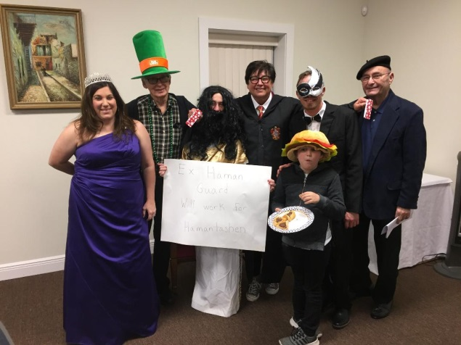

Here's a group of Purim celebrants at B'nai Israel Pensacola Esther Megillah reading and Purim Trivia and Shpiel. From left to right we have Queen Esther, Karen Lew Feirman, Joe Rosenbaum, Stephanie Gaffney in disguise bearing a sign saying" ex- Haman Guard willing to work for Hamantashen", Kate Lollar in disguise as a Hogwarts grad with her grandson Brodie Brown munching on a delectable assortment of, you guessed it, Hamentaschen, Kaleb Cale in classy mask disguise and, Jerry Gordon, in Beret. Special thanks for the picture goes to Helen Adamson and to Morris "Moish" Wohl fordavening Ma’ariv and a terrific reading of the griping story of Esther and Mordechai saving the Jews from Haman, the agagite with the unwitting assistance of tipsy Persian king Ahasuerus.
Both Karen Lew Feirman and Moish Wohl led the audience of grogger mavens in blotting out Haman's name during the Megillah Reading. As the late Leonard Nimoy might say as Spock on "Star Wars": "set those groggers for stun, when you hear the name of Haman".

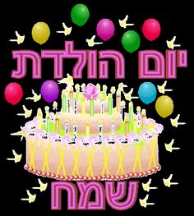

April Birthdays

1 Marci Goodman
1 Mitzi Goldstein
1 Nathan Kahn
2 Nikki Epstein
4 Phillip Davies
5 Benjamin Rosenbaum
6 Sarah Davies
6 Joseph Davies
8 Cara Kailey Faith Shemaria
11 Norman Roberts
18 Lauren Allen
19 Marci Shemaria
19 Roy Masters
21 Jackie Goodman
22 Jean-Ellen Gordon
24 Alex Lollar
30 Rabbi Sam Waidenbaum

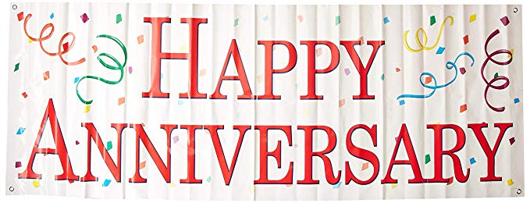

April 14 Mitzi & Gerry Goldstein

April Yahrzeits
As long as we live, they too will live; for they are now are a part of us; as we remember them.

April 3 / 27 Adar 2 Jon Davies
April 14 / 9 Nissan Zinaida Y. Reznitskii
April 15 / 10 Nissan Meyer Ellis
April 18 / 13 Nissan Frank Dreyfus
April 18 / 13 Nissan Jack Goldstein
April 19 / 14 Nissan Marilyn Safer
April 21 / 16 Nissan Stanley Levin
April 29 / 24 Nissan Hyman Soclof

Zichronam livracha- May their memories be for a blessing. Amen.

DONATIONS FROM THOUGHTFUL PEOPLE
THANK YOU TO THOSE WHO MADE
DONATIONS DURING MARCH!

Memorial Donations for Sherlee Aronson
Josie & Norman Roberts

In Honor of Raquel Kottler's 99th Birthday Celebration
Gene, Joe & Faye Rosenbaum

Siddur Chadash Donations
Anonymous
Elizbeth Cahela
Karen & Dan Feirman
Mitch & Lisa Goldstein
Marci Goodman
Fran & Jeff Kass
Angela & Eric Koury
Jerri Mobley
Carolyn Pock
Paul Unterweger

Rabbi's Discretionary Fund
Arnyce & Gary Adams - in memory of Dr. Arnold Pock
Delores Livingston

Kosher Kitchen
Marci Goodman

General Fund
Angel Koury
Keith Stimmell
Marci Goodman

Candle Lighting Times for Pensacola, Florida
Shabbat services 090
0
Calendar of Events: April 2019

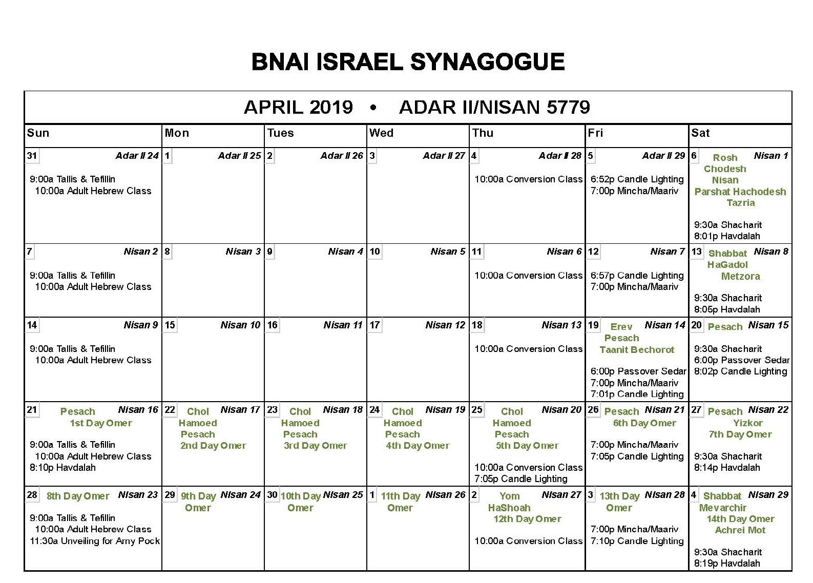
Monthly Announcements:
- 120th Anniversary tickets are on sale now, please call the office or purchase online
- We encourage everyone to join, like and follow the B’Nai Israel Facebook Group https://www.facebook.com/BnaiIsraelPensacola/
- Oneg and Kiddush sponsorships are available for April and May, please call the office if you are interested in sponsoring a Kiddush or Oneg.
- If you have not attended Friday night or Shabbat morning services recently, you are missing out. Please join us every Shabbat for a wonderful Shabbos experience.
- Looking for Passover food: check on the Publix on 9th Ave, Fresh Market, the Publix on University near UWF, all Winn Dixie Stores in Pensacola, and the Corry Station Commissary. All of these stores have some Pesach offerings.

FIRST CLASS MAIL
Published by:
B’Nai Israel Synagogue
Founded in 1899

1829 North 9th Avenue
P.O. Box 9002
Pensacola, FL. 32513

Affiliated with
The United Synagogue of
Conservative Judaism

Rabbi: Samuel Waidenbaum
President: Jerome Gordon
Vice President: Karyn Imrich
Secretary: Paul Unterweger
Treasurer: Shelly Landau
Immediate Past President: Benjamin Nettles

DONATIONS:
Please send this form along with your check to B’nai Israel Synagogue, P.O. Box 9002, Pensacola, FL, 32513.

- General Fund
- Cemetery Fund
- Building Fund
- Education and Scholarship
- Rabbi’s Discretionary Fund

In Memory of __________________________________________________________________________________

In Honor of ____________________________________________________________________________________

Acknowledge to ________________________________________________________________________________

Donated by ____________________________________________________________________________________

Address ___________________________________________________________ Zip ________________________

