Religious Zionism and Anti-Zionism

Part Two



January 24, 2022

Rav Yosef Dov Halevi Soloveichik (1820-1892) Bais Halevi

“They are a new sect like that of Shabtai Zvi, may the names of evildoers rot”

Rav Chaim Soloveitchik (Brisk 1853-1918)

-Son of Rav Yosef Dov Soloveitchik

-Founder of the “Brisker method” of studying Talmud

“Regarding the Zionist sect, which has now banded and united together by force…Have they not a bad reputation in their own places and is not their purpose to uproot the fundamentals of our religion – and to this end also to take control of all the Jewish communities?…The people of Israel should take care not to join a venture that threatens their souls, to destroy religion, and is a stumbling block to the House of Israel.” "Or Layesharim," 1900

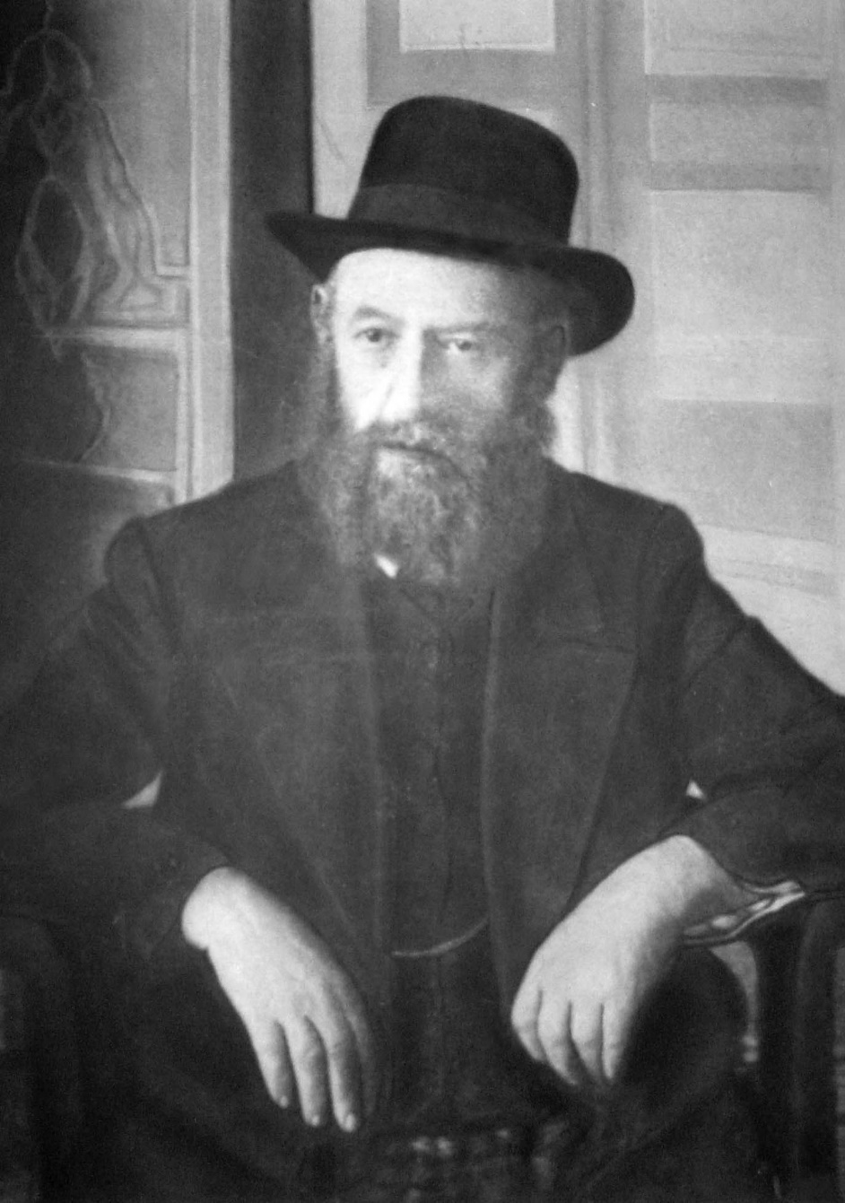

**Rabbi Shalom Dov Baer Schneerson (1860-1920, Russia)**

Rabbi Shalom Dov Baer Schneerson was the fifth Rebbe of the Chabad Lubavitch Chasidic movement. He is known as "the Rebbe Rashab" (for Reb Sholom Ber). His teachings represent the emergence of an emphasis on outreach that later Chabad Rebbes developed into a major theme.

Zionism was, in his view, a denial of messianism because

1. Zionism arrogantly seeks to bring redemption through human efforts
2. Zionism stops far short of the perfection of the original messianic vision
3. Zionism seeks to realize messianic expectations, i.e., ingathering of the exiles and liberation from gentile subjugation, whose fulfillment should depend only on the miraculous intervention of Hashem.
4. Zionism is a betrayal of the religious norm of exile, i.e., to wait patiently and passively until the End of Days.
5. The Zionist’s desire to throw off the yoke of passive messianism has kindled a desire to liberate the Jewish people from the strictures of religion

Rabbi Ḥayim Eleazar Shapira of Munkach (1872-1937)

The Munkatcher cited the warning issued by Rav Meir of Rothenberg (12th century) to every Jew who wished to travel to the land of Israel:

a)Let him be abstinent in the land and beware of any transgression, for if he sins there, he will be punished most severely, for Hashem supervises the land and watches over its inhabitants.

דברים י״א:י״ב

אֶ֕רֶץ אֲשֶׁר־יְהוָ֥ה אֱלֹהֶ֖יךָ דֹּרֵ֣שׁ אֹתָ֑הּ תָּמִ֗יד עֵינֵ֨י יְהוָ֤ה אֱלֹהֶ֙יךָ֙ בָּ֔הּ מֵֽרֵשִׁית֙ הַשָּׁנָ֔ה וְעַ֖ד אַחֲרִ֥ית שָׁנָֽה׃

It is a land which the LORD your God looks after, *on which the LORD your God always keeps His eye*, from year’s beginning to year’s end.

b) He who rebels against the kingdom from within the king's palace is not the same as he who rebels outside it. This is the meaning of 'a land that consumes its inhabitants’

במדבר י״ג:ל״ב

וַיּוֹצִ֜יאוּ דִּבַּ֤ת הָאָ֙רֶץ֙ אֲשֶׁ֣ר תָּר֣וּ אֹתָ֔הּ אֶל־בְּנֵ֥י יִשְׂרָאֵ֖ל לֵאמֹ֑ר הָאָ֡רֶץ אֲשֶׁר֩ עָבַ֨רְנוּ בָ֜הּ לָת֣וּר אֹתָ֗הּ אֶ֣רֶץ אֹכֶ֤לֶת יוֹשְׁבֶ֙יה הִ֔וא וְכָל־הָעָ֛ם אֲשֶׁר־רָאִ֥ינוּ בְתוֹכָ֖הּ אַנְשֵׁ֥י מִדּֽוֹת׃

Thus, they spread calumnies among the Israelites about the land they had scouted, saying, “The country that we traversed and scouted is one that consumes its inhabitants. All the people that we saw in it are men of great size.

**Rabbi Yoel Moshe Teitelbaum of Satmar
Rabbi Yoel Moshe Teitelbaum of Satmar (1887-1979)**

Key elements of the Satmarer Rebbe’s position (Ravitzky, 1993):

1. An uncompromising struggle against the Jewish State
2. An insistence on self-segregation (‘holy communities’) by the new “remnant of Israel”
3. The delegitimization of those who falsely consider themselves part of the Jewish people, from the secularists to the Agudas Yisrael.
4. The classical fear of “Forcing the End” grew into a demonization of the Zionist enterprise as the ongoing anti-messianic work of the Satan.
5. The Holocaust and the establishment of the State of Israel were not contrary developments, destruction versus construction, but a single continuous process, the final eruption of the forces of evil as a prelude to redemption.

He made as central to his thinking the importance of the Three Oaths:

1.שיר השירים ג׳:ה׳

השְׁבַּ֨עְתִּי אֶתְכֶ֜ם בְּנ֤וֹת יְרוּשָׁלִַ֙ם֙ בִּצְבָא֔וֹת א֖וֹ בְּאַיְל֣וֹת הַשָּׂדֶ֑ה אִם־תָּעִ֧ירוּ ׀ וְֽאִם־תְּעֽוֹרְר֛וּ אֶת־הָאַהֲבָ֖ה עַ֥ד שֶׁתֶּחְפָּֽץ

I urge you, O maidens of Jerusalem, by gazelles or by hinds of the field: Do not wake or rouse Love until it please!

2.שיר השירים ב׳:ז׳

הִשְׁבַּ֨עְתִּי אֶתְכֶ֜ם בְּנ֤וֹת יְרוּשָׁלִַ֙ם֙ בִּצְבָא֔וֹת א֖וֹ בְּאַיְל֣וֹת הַשָּׂדֶ֑ה אִם־תָּעִ֧ירוּ ׀ וְֽאִם־תְּעֽוֹרְר֛וּ אֶת־הָאַהֲבָ֖ה עַ֥ד שֶׁתֶּחְפָּֽץ׃

Song of Songs 2:7

I urge you, O maidens of Jerusalem, By gazelles or by hinds of the field: Do not wake or rouse Love until it please!

3.שיר השירים ח׳:ד׳

(דהִשְׁבַּ֥עְתִּי אֶתְכֶ֖ם בְּנ֣וֹת יְרוּשָׁלִָ֑ם מַה־תָּעִ֧ירוּ ׀ וּֽמַה־תְּעֹֽרְר֛וּ אֶת־הָאַהֲבָ֖ה עַ֥ד שֶׁתֶּחְפָּֽץ׃

Song of Songs 8:4

I urge you, O maidens of Jerusalem: Do not wake or rouse Love until it please!

These three sentences are cited in the Talmud:

כתובות קי״א א:ג׳-ד׳

ורבי זירא ההוא מיבעי ליה לכדרבי יוסי ברבי חנינא דאמר ג שבועות הללו למה? אחת שלא יעלו ישראל בחומה ואחת שהשביע הקדוש ברוך הוא את ישראל שלא ימרדו באומות העולם ואחת שהשביע הקדוש ברוך הוא את העובדי כוכבים שלא ישתעבדו בהן בישראל יותר מדאי

Ketubot 111a:3-4

The Gemara asks: And how does Rabbi Zeira explain the repetition of this oath in these verses? The Gemara explains: That verse is necessary for that which was taught by Rabbi Yosei, son of Rabbi Ḥanina, who said: Why are these three oaths (Song of Songs 2:7, 3:5, 8:4) needed? One, so that the Jews should not ascend to Eretz Yisrael as a wall, but little by little. And another one, that the Holy One, Blessed be He, adjured the Jews that they should not rebel against the rule of the nations of the world. And the last one is that the Holy One, Blessed be He, adjured the nations of the world that they should not subjugate the Jews excessively.

Rav Yoel Teitelbaum, Satmar Rabbi, in his book Vayoel Moshe (1959):

"Zionism is the greatest form of spiritual impurity. They have polluted the Jewish people with their heresy...if we place all the immodesty and promiscuity of the generation and the many sins of the world on one side of the scale, and the Zionist state on the other side of the scale by itself, it will outweigh them all.”

"It is no surprise that G-d's anger comes down from heaven. It is necessary to repent and escape from them (Zionists) more than from a lion that is chasing a person to kill him. It has been explained that before the coming of the Messiah, this regime (The State of Israel) will come to an end, as Mashiach cannot come any other way, since the Zionist state holds up the redemption of the world."

"We need G-d's mercies that divine intervention should bring about the end of the state. May G-d have mercy on us all."



**Responses to The Three Oaths**

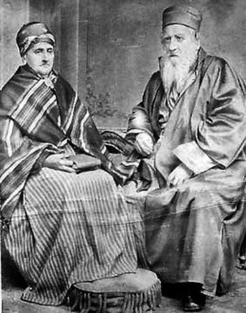

Rabbi Yehuda Alkalai (1798-1878, Serbia) Minchat Yehudah, 1843

“Therefore, He made us swear not to come (to Israel) all-together for two reasons (Babylonian Talmud: Ketubot 111a). First, we will need our brothers in the Diaspora to help those who come to settle, for it is written: “What shall one answer the messengers of the nation? That the Lord has founded Zion, and the poor of his people shall find shelter in it.” (Isiah 14:32) Second, the Holy One Blessed be He desires that this redemption come about through honor and therefore He made us swear not to come together so that we would not be spread across the fields like Bedouin, rather little by little (we will come) until this land is reclaimed and rebuilt speedily in our days.

**Rabbi Tzvi Hirsch Kalischer (1795-1874, Germany) Drishat Tziyon, Maamar Kadishin, 1862**

Regarding the oath of G-d, I will respond to you in two ways: Firstly, the warning “do not arouse or awaken” (Shir Hashirim 2:7) only means that we may not go up with a strong hand to the walls of Jerusalem, as it is explicitly stated in the Gemara there (Kesubos 111a) “that they must not go up as walls” and Rashi explains “with strength”; and also that they must not rebel against the nations; but rather they must wait for the kindness of Hashem, that He turn His eye of mercy to us, if He is pleased with the work of our hands. He only made us swear not to engage in forceful immigration, to go up to the mountain with strength, but to desire its stones and to settle the land is fine, and there is no greater mitzvah than this, as I have explained at length.

**Rabbi Meir Simcha Hakohen of Dvinsk (1843-1926, Lithuania)**

“In this century, rays of light shone forth with a great awakening by people of action such as Montefiore and rabbis such as R. Tzvi Hirsch [Kalischer] of Torun …to build and restore Jerusalem and remove its destruction … Many rabbis opposed their efforts and even those who wanted to join, placed their hands over their mouths because they feared … [violating] the Three Oaths of the daughters of Jerusalem … Now, however, [we have experienced] Divine providence in the gathering of the League of Nations in San Remo (1920) and a pronouncement was made that the Land of Israel will belong to the Jewish people. Since the fear of the oaths has passed with permission of the nations, the mitzvah to settle the Land of Israel — which is equal in weight to all other mitzvot in the Torah combined — is now restored. Everyone should do what they can to help fulfill this mitzvah.”

**Rabbi Menachem Mendel Kasher (1895-1983, author of Torah Shleima)**

“A Torah Viewpoint on the Oath not to Ascend to Israel as a Wall” (1977)

"The Three Oaths are well-known. God caused Israel to swear that they would not rebel against non-Jewish rule or try to force the end of days. However, the third oath is that at the same time, God caused the leaders of the non-Jewish nations to swear that they would not oppress the Jews excessively and would allow the Jews to live under their protection...The law in Shulchan Aruch is that if two people take an oath to each other and one of them violates the oath, the second is permitted to violate the oath as well. Thus, if the non-Jewish governments violated their oath by persecuting and enslaving the Jews, it would then be permitted for the Jews to violate their oaths as well...At the present time, after the terrible Holocaust, where the blood of Jews was spilled like water, and all of the nations remained silent and did not give the Jews a place to flee to in their countries...it should be clear to all who wish to understand the truth that the Three Oaths have no further applicability and are completely annulled."

**Rabbi Shaul Yisraeli (Student of Rav Kook, 1909-1995, Jerusalem)**

“The recognition by the United Nations of Israel's rights is certainly sufficient for it not to be considered, ‘taking it by force,’ even though the neighboring Arab nations and the Arabs living in the land were opposed to it. Since they (the United Nations) decided that the establishment of a state by the Jews living in Israel was legal and since it was done with the permission of those in charge of the land, necessarily it is legal according to the viewpoint of the Torah as well. From this point forward, even if the nations should subsequently change their minds, it would be of no consequence. We have already taken possession of the land, and only taking the land by force [would be a violation of the three oaths], not protecting what we already have.” (Eretz Chemdah, vol. 1, 1:6.4, 1957)

Rabbi Amram Blau (1894-1974)


**R. Amram Blau (1894-1974)**

Neturei Karta means “Guardians of the City” (Talmud Yerushalmi, Mishna Chagiga, 1:7).

רִבִּי יוּדָן נְשִׂייָא שְׁלַח לְרִבִּי חִייָה וּלְרִבִּי אַסִּי וּלְרִבִּי אִמִּי לְמִיעֲבוֹר בַּקִּרֵייָתָא דְּאַרְעָא דְּיִשְׂרָאֵל לִמְתַקְנָא לוֹן סָֽפְרִין וּמַתְנִייָנִין. עֲלוֹן לְחַד אֲתַר וְלָא אַשְׁכְּחוֹן לָא סְפַר וְלָא מַתְנִייָן. אָֽמְרִין לוֹן. אַייתוֹן לָן נְטוּרֵי קַרְתָּא. אַייְתוֹן לוֹן סַנְטוּרֵי קַרְתָּא. אָֽמְרוּן לוֹן. אֵילֵּין אֵינּוּן נְטוּרֵי קַרְתָּא. לֵית אֵילֵּין אֶלָּא חָרוּבֵי קַרְתָּא. אָֽמְרוּן לוֹן. וּמָאן אִינּוּן נְטוּרֵי קַרְתָּא. אָֽמְרוּן לוֹן. סַפְרַייָא וּמַתְנִייָנַיָּא. הָדָא הִיא דִּכְתִיב אִם י֙י לֹא־יִבְנֶ֬ה בַ֗יִת וגו׳.

“Rabbi Judah the Prince sent Rabbi Ḥiyya, Rabbi Assi, and Rabbi Immi to tour the towns of the Land of Israel to give them Bible and Mishnah teachers. They came to one place where they found neither Bible nor Mishnah teachers. They said to them, “bring us the watchmen of the town.” They brought them the officials of the town. They told them, “these are not the watchmen of the town, they are the destroyers of the town.” They asked them, “and who would be the watchmen of the town?” They told them, “the Bible and Mishnah teachers, for without them a city is fated to destruction.”

“Neturei Karta”, therefore are teachers of Torah, by virtue of whom, despite their small number, the rest of the population survives.

Rabbi Amram Blau: "Over Israel there have arisen Zionists who adopt gentile notions to force the End, using a false idea of worldly redemption through power and the kindness of the other nations.. they have come to the Holy Land and raised the flag of rebellion against the kingdom of heaven.. They have connived by the most horrendous means to uproot our holy Torah, as well as all human morality... They have become entangled with our Arab neighbors to the point where the Yishuv is being subjected to riots and Jewish blood is being shed, heaven forfend... Our holy Torah teaches that we should take no interest in the political realm while in exile, until the coming of the Mashiach, may he come speedily and in our own day, and there is nothing in this position to antagonize our Arab neighbors. While in exile we wish only to live and to fulfill the commandments of our Creator, may His name be blessed; and we have no interest in living in our Holy Land except to imbibe its holiness and to fulfill the commandments which can only be fulfilled here.”

From Neturei Karta's website:

The People of Israel oppose the so-called "State of Israel" for four reasons:

FIRST -- The so-called "State of Israel" is diametrically opposed and completely contradictory to the true essence and foundation of the People of Israel. The only time that the People of Israel were permitted to have a state was two thousand years ago when the glory of the creator was upon us, and likewise in the future when the glory of the creator will once more be revealed, and the whole world will serve Him, then He Himself (without any human effort or force of arms) will grant us a kingdom founded on Divine Service. However, a worldly state, like those possessed by other peoples, is contradictory to the true essence of the People of Israel. Whoever calls this the salvation of Israel shows that he denies the essence of the People of Israel, and substitutes another nature, a worldly materialistic nature, and therefore sets before them, a worldly materialistic "salvation," and the means of achieving this "salvation" is also worldly and materialistic i.e., to organize a land and army. However, the true salvation of the People of Israel is to draw close to the Creator. This is not done by organization and force of arms. Rather, it is done by occupation to Torah and good deeds.

SECOND -- Because of all of this and other reasons the Torah forbids us to end the exile and establish a state and army until the Holy One, blessed He, in His Glory and Essence will redeem us. This is forbidden even if the state is conducted according to the law of the Torah because arising from the exile itself is forbidden, and we are required to remain under the rule of the nations of the world, as is explained in the book VAYOEL MOSHE. If we transgress this injunction, He will bring upon us (may we be spared) terrible punishment.

THIRD -- Aside from arising from exile, all the deeds of the Zionists are diametrically opposed to the Faith and the Torah. The foundation of the Faith and Torah of Israel is that the Torah was revealed from heaven, and there is reward for those who obey it and punishment for those who transgress it. The entire People of Israel is required to obey the Torah, and whoever doesn't want to, ceases to be part of the congregation of Israel.

FOURTH -- Aside from the fact that they themselves do not obey the Torah they (the Zionists) do everything they can to prevent anyone they get under their power from fulfilling the commands of the Torah. Their claims to freedom of religion are lies. They fight with all their strength to destroy the Faith of Israel.