Religious Zionism and Anti-Zionism
Part One

David Jacobowitz
Congregation Torah Ohr
Boca Raton, Florida
(djacobow@gmail.com)

January 17, 2022

Unmistakably the most important movement in contemporary Jewish life, Zionism has its passionate proponents as well as detractors. We will explore the factors and personalities fueling the religious Zionist movement from the 19th century through the present day. At the same time, we will seek to understand the motives and perspectives of our co-religionists who oppose Zionism.

Messianism, Zionism and Jewish Religious Radicalism, Prof. Aviezer Ravitzky, 1993.

“It was a dream of utter perfection: the day would come when the entire Jewish people would reassemble as one in an undivided Land of Israel. The Jewish people would free itself completely from its subjugation to the great powers. It would then be a source of blessing for all nations….Compared with this dream, the actual historical realization that has taken place in our own time seems truncated. Only a part of the Jewish people has gathered together into a Jewish state….only some of the returnees observe the precepts of the Torah. Political and military strife has not vanished from the land….What is the status of this imperfect reality in Jewish religious consciousness? ... Is this the beginning of the End, a step toward the fulfillment of the prophetic promises, or is it rather a violent betrayal of those promises in all their perfection?

Traditional Jewish sources generally speak in terms of two polar concepts: exile and redemption….. Can Jewish religious thought now acknowledge an intermediate or hybrid model that is neither? Can a Jewish people once more sovereign in the Holy Land still be said to be in exile? On the other hand, can we speak of a redemption or even “beginning of a redemption” that is not founded on the Torah and religious repentance and not the result of supernatural intervention? …… Can the return to Zion and the recovery of Jewish independence be conceived in terms that deviate completely from the classical conceptual framework?”

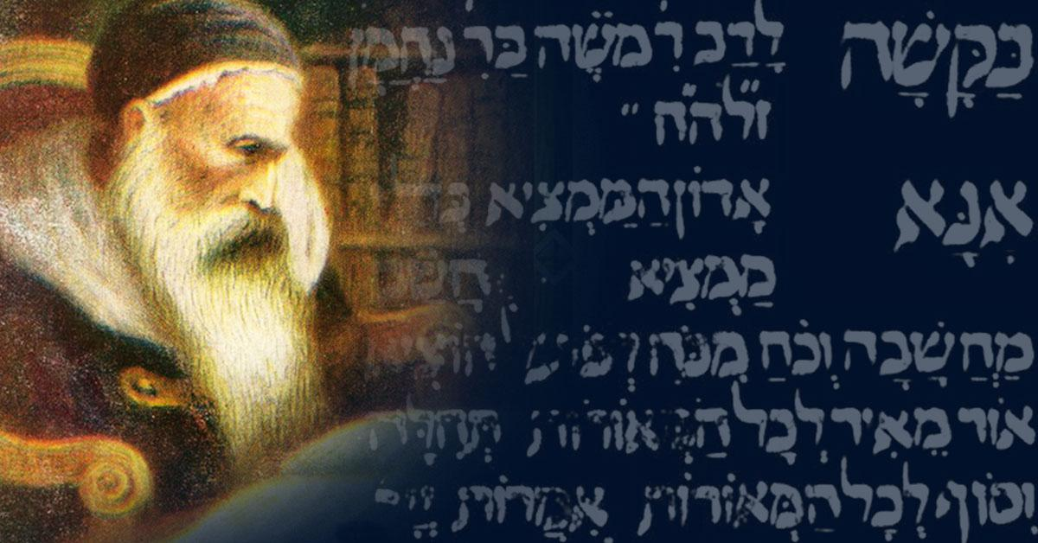
Rabbi Moshe ben Nachman (Ramban 1194-1270)

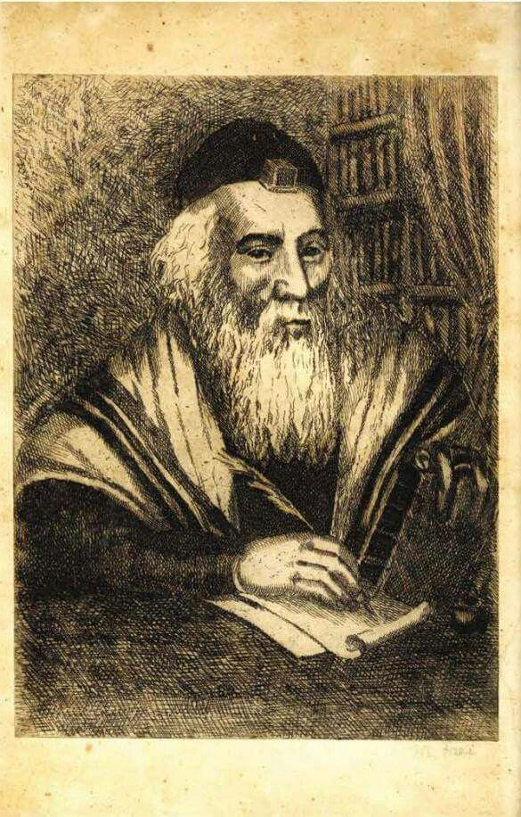
Rabbi Eliyahu of Vilna (1720-1797)
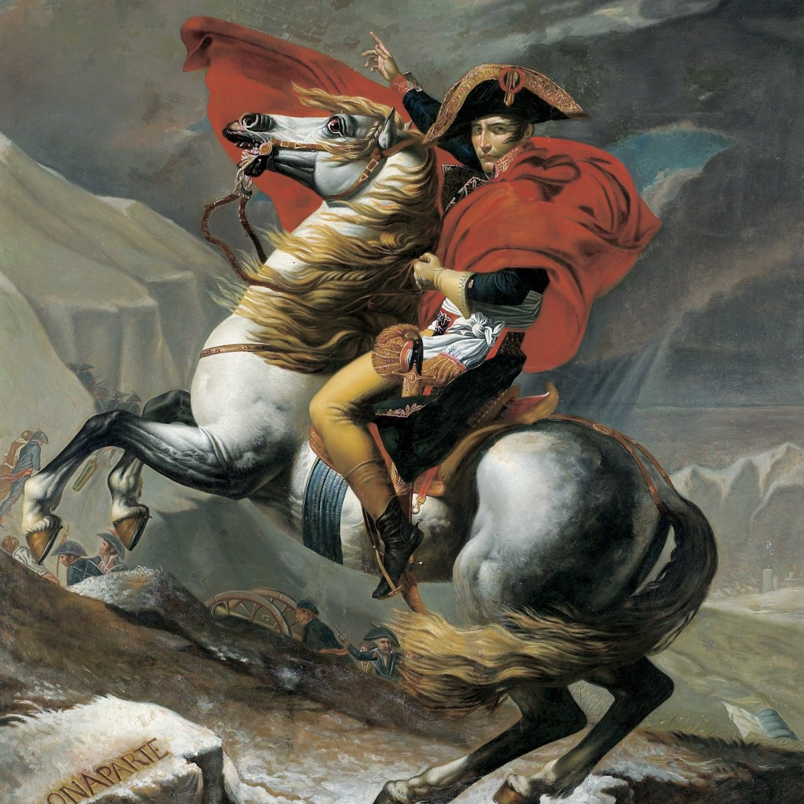

Napoleon Bonaparte (1769-1821)
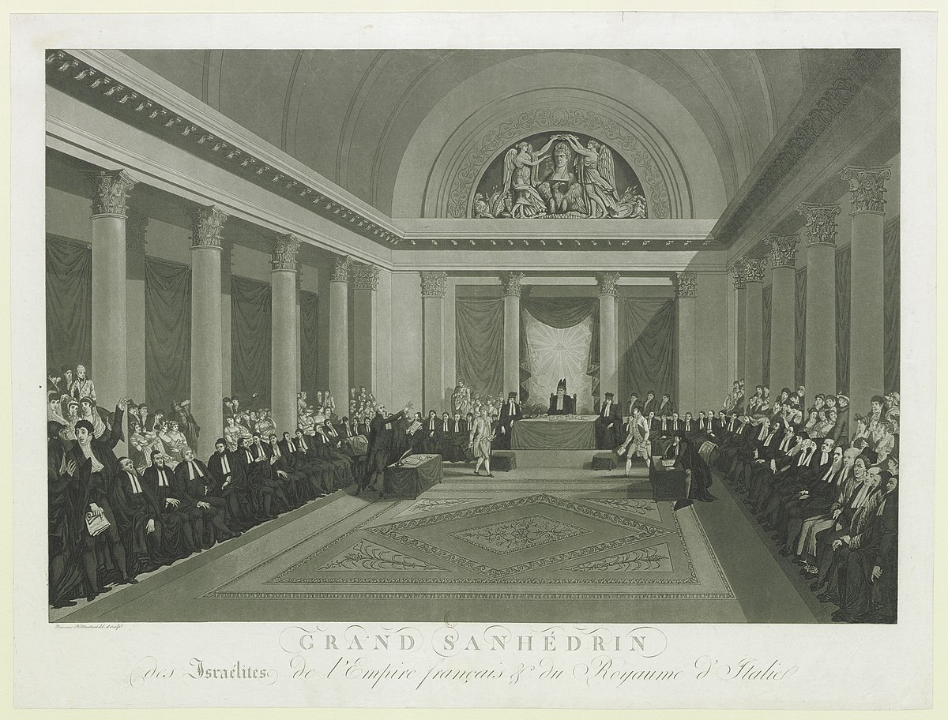

Napoleon’s Sanhedrin (1807)

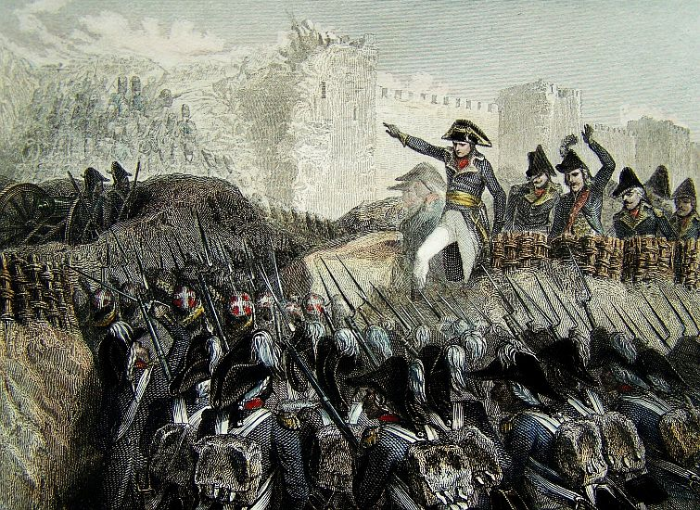

“The great nation (i.e., France) which does not trade in men and countries as did those which sold your ancestors unto all people, calls on you indeed only to take over that which has been conquered and with that nation’s warranty and support, to remain master of it to maintain it against all comers.” Napoleon’s Declaration of 1799

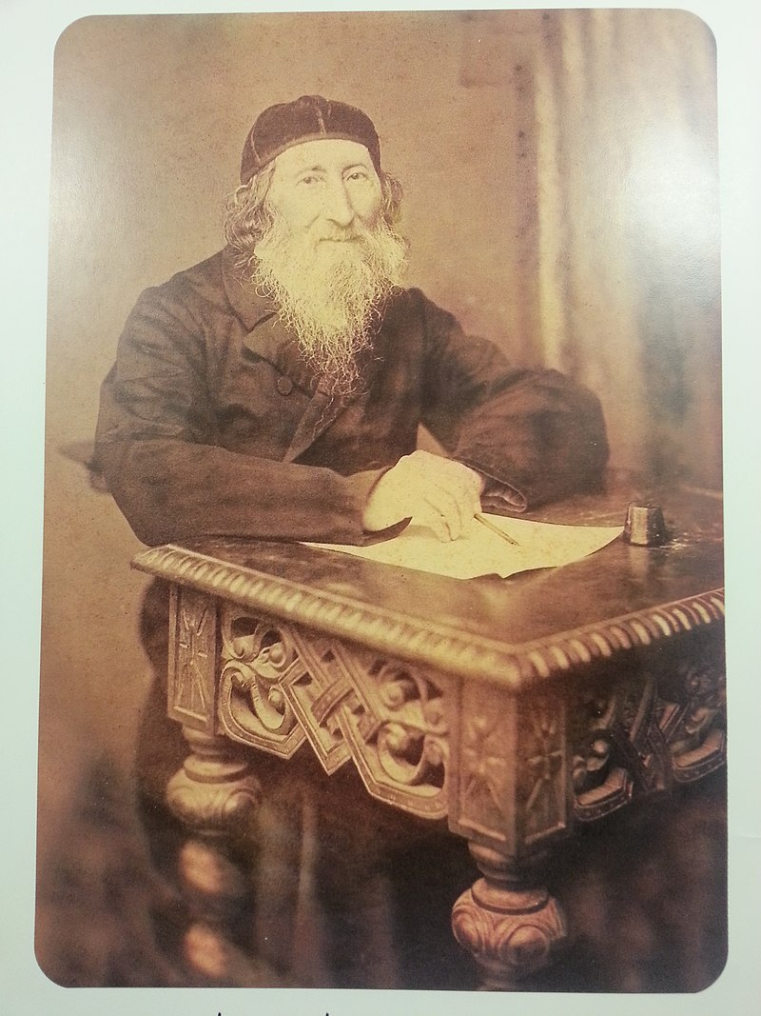
Rabbi Zvi Hirsch Kalischer (1795-1874, Prussia)
“The Redemption of Israel, for which we long, will not be a sudden miracle. The Almighty, blessed be His Name, will not suddenly descend from on high and command His people to go forth. He will not send the Messiah from heaven in a twinkling of an eye, to sound the great trumpet for the scattered of Israel and gather them into Jerusalem. He will not surround the Holy City with a wall of fire or cause the Holy Temple to descend from the heavens. The bliss and the miracles that were promised by His servants, the prophets, will certainly come to pass – everything will be fulfilled – but we will not run in terror and flight, for the Redemption of Israel will come by slow degrees and the ray of deliverance will shine forth gradually…The Redemption will begin by awakening support among the philanthropists and by gaining the consent of the nations to the gathering of some of the scattered of Israel into the Holy Land.
…Why do the people of Italy and of other countries sacrifice their lives for the land of their fathers, while we, like men bereft of strength and courage do nothing? Are we inferior to all other peoples, who have no regard for life and fortune as compared with love of their land and nation? Let us take to heart the examples of the Italians, Poles, and Hungarians, who laid down their lives and possessions in the struggle for national independence, while we, the children of Israel, who have the most glorious and holiest of lands as our inheritance, are spiritless and silent. We should be ashamed of ourselves! All the other peoples have striven only for the sake of their own national honor; how much more should we exert ourselves, for our duty is to labor not only for the glory of our ancestors but for the glory of God who chose Zion!”

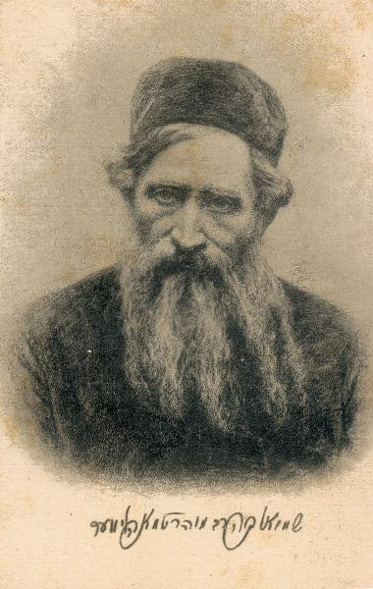
Rabbi Shmuel Mohilever (1824 – 1898, Belarus)

“The Jewish People is divided into different parties, and they do not debate with each other calmly and in a relaxed mode. Each is distinct in his opinions from the other and what one opts for, the other will reject and no-one is concerned for the people as a whole.”

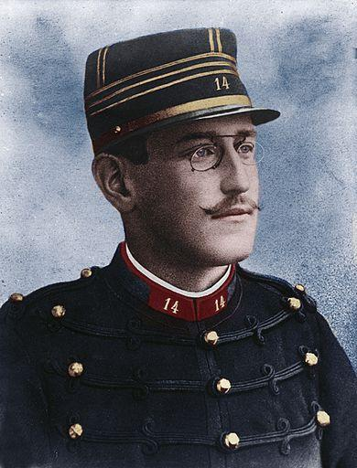

Captain Alfred Dreyfus, falsely convicted of treason in 1894

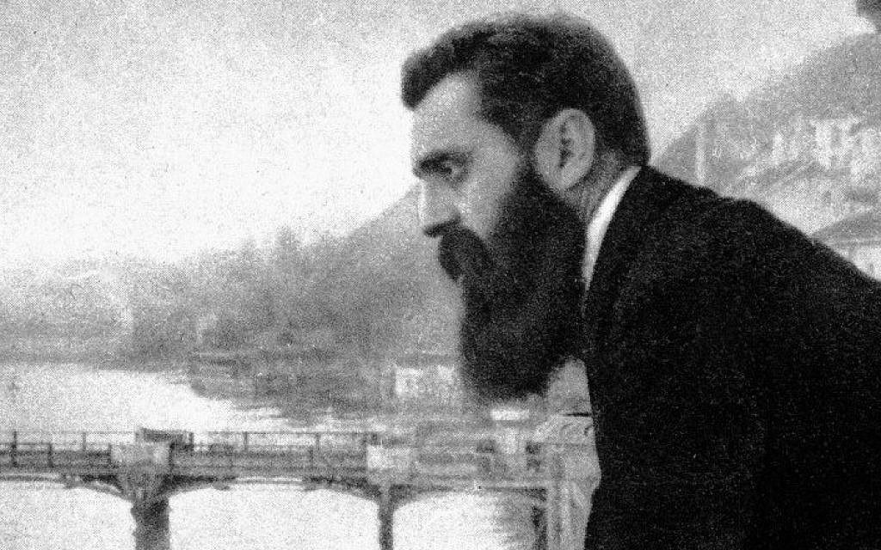

Theodore (Binyami Ze’ev) Herzl (1860-1904)

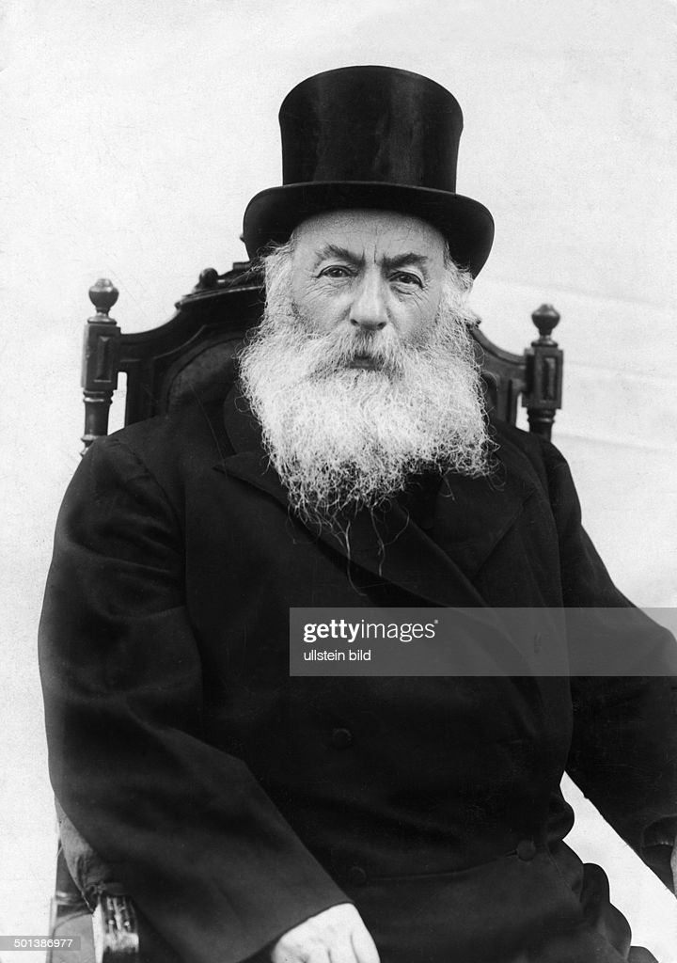
Rabbi Yitzchak Yaacov Reines (1839 – 1915, Lithuania)

“Anyone who thinks the Zionist idea is somehow associated with future redemption and the coming of the Messiah and who therefore regards it as undermining our holy faith is clearly in error. Zionism has nothing whatsoever to do with the question of redemption. The entire point of this idea is merely the improvement of the condition of our wretched brethren. In recent years, our situation has deteriorated disastrously, and many of our brethren are scattered in every direction, to the seven seas, in places where the fear of assimilation is hardly remote. [The Zionists] saw that the only fitting place for our brethren to settle would be in the Holy Land.” (Hamelitz newspaper, 1900)

“One of the basic foundations of our faith is the belief in the return of Israel to its land, for it is not possible to conceive that our nation is meant to be scattered and separated forever among the other nations in the world without its own land. Therefore ‘nationalism’ is the first and basic part of the faith of Israel…For a unique people with its unique religion can only be fulfilled at the time when it has its own land or, at the very least, a hope that it can return to its land.” (Shaare Orah on Hagadah)

It is most interesting to note that Rabbi Reines had endorsed the Uganda Plan. In a letter to Herzl, he wrote:

“We agreed to the African proposal because we paid attention to the needs of the nation that is dearer to us than the Land of Israel, and the needs of the nation that is deteriorating both physically and spiritually requires a secure refuge wherever it may be” (Haaretz, Herzl and the Rabbis, 2010)

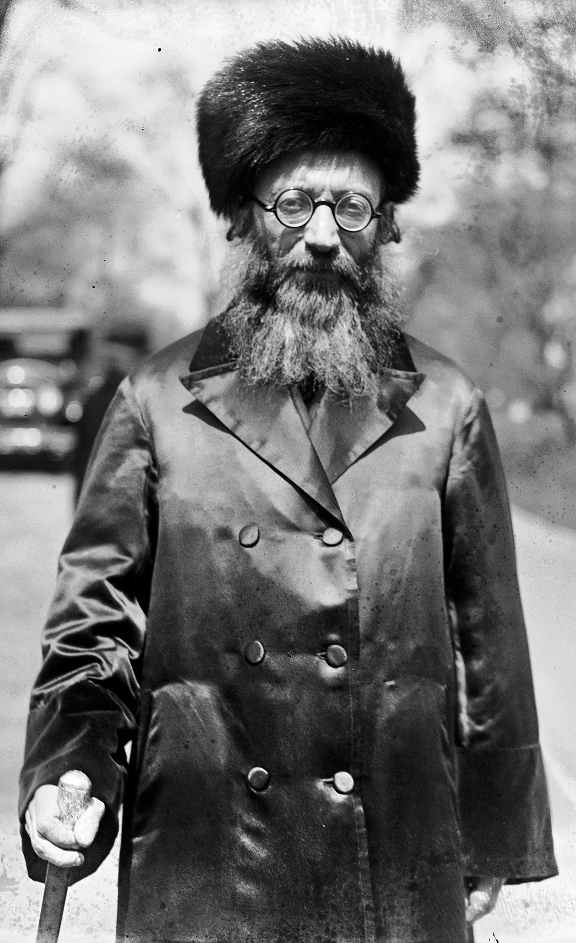
Rav Abraham Isaac Kook (1865-1935)

“Eretz Yisrael is not something apart from the soul of the Jewish people; it is no mere national possession, serving as a means of unifying our people and buttressing its material, or even its spiritual, survival. Eretz Yisrael is part of the very essence of our nationhood; it is bound organically to its very life and inner being. Human reason, even at its most sublime, cannot begin to understand the unique holiness of Eretz Yisrael; it cannot stir the depths of love for the land that is dormant within our people. To regard Eretz Yisrael as merely a tool for establishing our national unity—or even for sustaining our religion in the Diaspora by preserving its proper character and its faith, piety, and observances—is a sterile notion; it is unworthy of the holiness of Eretz Yisrael.
There is an eternal covenant which assures the whole House of Israel that it will not ever become completely unclean. Yes, it may be partially corroded, but it can never be totally cut off from the source of divine life. Many of the adherents of the present national revival maintain that they are secularists. If a Jewish secular nationalism were really imaginable, then we would, indeed, be in danger of falling so low as to be beyond redemption.
Jewish secular nationalism is a form of self-delusion: the spirit of Israel is so closely linked to the spirit of God that a Jewish nationalist, no matter how secular his intention may be, must, despite himself, affirm the divine. An individual can sever the tie that binds him to life eternal, but the House of Israel cannot do so. All its most cherished possessions--its land, language, history, and customs--are vessels of the spirit of the Lord. “ (Orot, The Land of Israel, 1920)
“Let heaven and earth attest the greatness of my love, literally my whole heart and my whole soul, to our whole people, its individuals and all its denominations… In each faction and each movement there are certainly things with which I cannot agree, but this cannot cause my love, full of that flame that burns within me for our people and all its individuals, to be diminished even by a hair's breadth. It is sustained within me, in equal measure, to those who respect me and those who despise me. I love all of them without limits.” (Igrot Rayah 555)

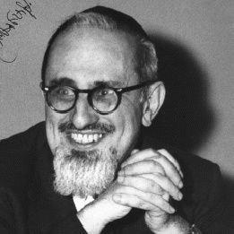
Rabbi Joseph B. Soloveitchik (1903-1993)

“I was not born into a Zionist household. My parents’ ancestors, my father’s house, my teachers, and colleagues were far from the Religious Zionists…The years of the Holocaust, the establishment of the State of Israel and the accomplishments of the Mizrachi in Israel have convinced me of the correctness of our movement’s path” (Address to Mizrachi, 1962)

“Let us not forget that the poison of Hitlerite antisemitism still permeates this generation, which looked with equanimity upon the horrible scene of the suffocation of millions in gas chambers as a normal event that need not be challenged. The antidote for this venom is the readiness of the State of Israel to defend the lives of its citizens. Listen! My Beloved Knocks!
How many times did the Beloved knock on the door of the Lover? It appears to me that we ‎can ‎count at least six knocks.‎
First, the knock of the Beloved was heard in the political arena. From the point of view ‎of ‎international relations, no one will deny that the rebirth of the State of Israel, in a political ‎sense, ‎was an almost supernatural occurrence.
Second, the knock of the Beloved was heard on the battlefield. The tiny defense forces of ‎‎[the ‎State of] Israel defeated the mighty Arab armies.
Third, the Beloved also began to knock on the door of the tent of theology, and possibly this is ‎the ‎strongest beckoning. I have, on several occasions, emphasized in my remarks concerning the ‎Land ‎of Israel that the theological arguments of Christian theologians to the effect that the Holy ‎One has ‎taken away from the Community of Israel its rights to the Land of Israel, and that all of the ‎biblical ‎promises relating to Zion and Jerusalem now refer in an allegorical sense to Christianity and ‎the ‎Christian Church, were all publicly shown to be false, baseless contentions by the ‎establishment of ‎the State of Israel.
Fourth, the Beloved knocks in the heart of the youth which is assimilated and perplexed. ‎The ‎period of hester panim in the 1940’s brought confusion among the Jewish masses ‎and ‎especially Jewish youth. Assimilation increased, and the urge to flee from Judaism and the ‎Jewish ‎people reached its apex. Suddenly, the Beloved began to beckon to the hearts ‎of the ‎perplexed, and His beckoning, the establishment of the State of Israel, at least slowed the ‎process ‎of flight. Many who were once alienated are now bound to the Jewish State with ties of ‎pride in its ‎mighty accomplishments.
The fifth knock of the Beloved is perhaps the most important. For the first time in the annals of ‎our ‎exile, Divine Providence has amazed our enemies with the astounding discovery that Jewish ‎blood ‎is not cheap! If the antisemites describe this phenomenon as being “an eye for an eye,” we ‎will ‎agree with them.
The sixth beckoning, of which we should also not lose sight, was heard at the time of the ‎opening ‎of the gates of the Land of Israel. A Jew escaping from an enemy’s land now knows that ‎he can ‎find refuge in the land of his forefathers. This is a new phenomenon in the annals of our ‎history.” (Kol Dodi Dofek, 1956)

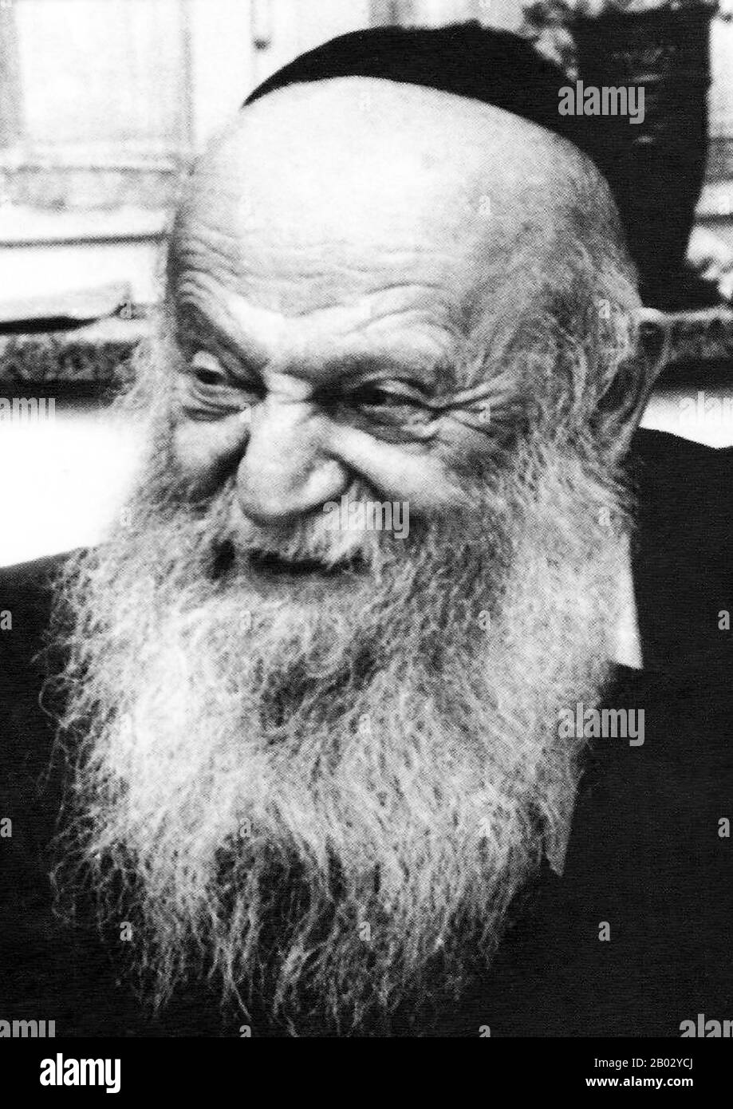
Rabbi Zvi Yehuda Kook (1891-1982)

“The State of Israel is divine…Not only can/must there be no retreat from a single kilometer of the Land of Israel, God forbid, but on the contrary, we shall conquer and liberate more and more, as much in the spiritual as in the physical sense. “The Glory of Israel does not deceive or change His mind.” [I Samuel 15:29.] We are stronger than America, stronger than Russia. With all the troubles and delays [we suffer], our position in the world, the world of history, the cosmic world, is stronger and more secure in its timelessness than theirs. There are nations that know this, and there are nations of uncircumcised hearts that do not know it, but they shall gradually come to know it! Heaven protects us from weakness and timidity…In our divine, world-encompassing undertaking, there is no room for retreat. There are those who speak of ‘the beginning of redemption’ in our own time. But we must perceive clearly that we are already in the midst of redemption. We are already in the throne room, not just in the antechamber. The beginning took place more than a century ago when Jewish settlement in the Land of Israel was renewed.”

