QPR stands for Question, Persuade and Refer — the 3 simple steps anyone can learn to help save a life from suicide. Just as people trained in CPR and the Heimlich Maneuver help save thousands of lives each year, people trained in QPR learn how to recognize the warning signs of a suicide crisis and how to question, persuade and refer someone to help.
Suicide Prevention Training
QPR (Question. Persuade. Refer.)
Register now: FREE for Howard County residents and workers

KEY COMPONENTS COVERED IN TRAINING:
- How to Question, Persuade and Refer someone who may be suicidal
- How to get help for yourself or learn more about preventing suicide
- The common causes of suicidal behavior
- The warning signs of suicide
- How to get help for someone in crisis
For more information about this evidence-based practice, go to qprinstitute.com
Cost: FREE to Howard County Residents/Employees

For more information, contact:
Amanda@grassrootscrisis.org or 443-538-9909

Go to www.grassrootscrisis.org/events/ to register

For Horizon Foundation Grantees – at least one member of your organization must attend a QPR training. Upcoming trainings and registration information is listed on the back.

Sponsored by
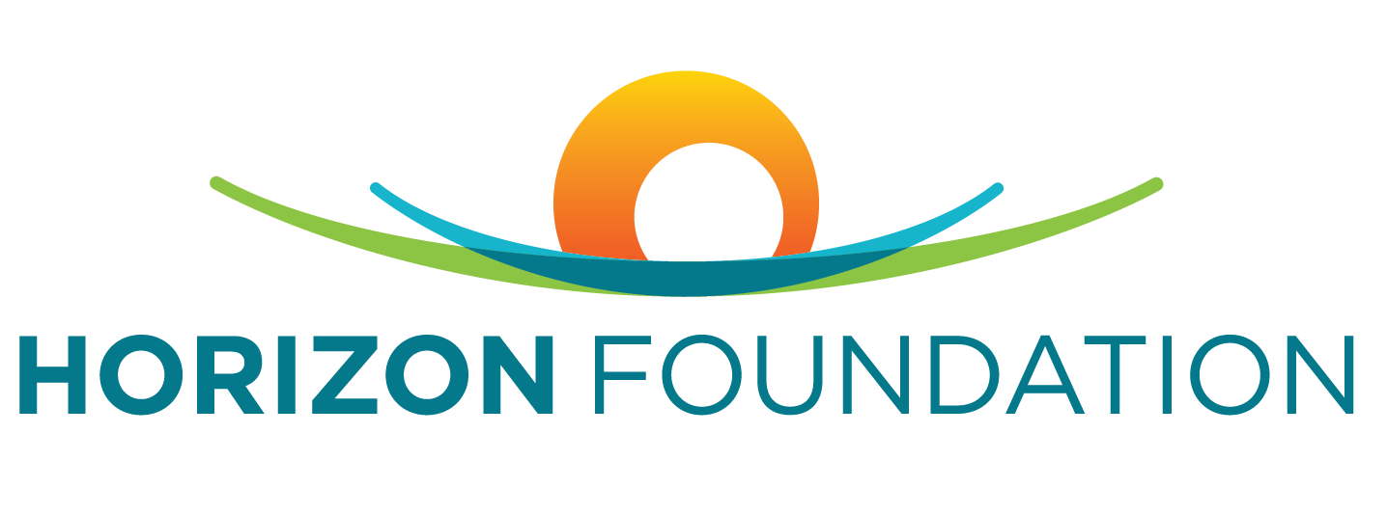

For the 2019 training schedule & to register, go to www.grassrootscrisis.org/events/

QPR Training Dates
(Subject to change – based on registration)

COST: FREE for all Howard County Residents & Employees
FOR QUESTIONS: Contact Amanda Ganoe at amanda@grassrootscrisis.org

When: March 9, 2019, from 2 -4 p.m.
Where: Miller Branch Library, Patapsco Room (9421 Frederick Rd, Ellicott City, Md 21042) - Max 50 registrants

When: March 21, 2019, from 5 -7 p.m.
Where: Grassroots Crisis Intervention Center (6700 Freetown Rd, Columbia Md 21044-parking can fill up quickly) - Max 20 registrants

When: April 1, 2019, from 7 -9 p.m.
Where: Grassroots Crisis Intervention Center (6700 Freetown Rd, Columbia Md 21044-parking can fill up quickly) - Max 20 registrants

When: April 13, 2019, from 11 a.m.-1 p.m.
Where: TBD

When: May 1, 2019, from 7 -9 p.m.
Where: Grassroots Crisis Intervention Center (6700 Freetown Rd, Columbia Md 21044-parking can fill up quickly) - Max 20 registrants

When: May 16, 2019, from 5 -7 p.m.
Where: Grassroots Crisis Intervention Center (6700 Freetown Rd, Columbia Md 21044-parking can fill up quickly) - Max 20 registrants

When: May 17, 2019, from 12 -2 p.m.
Where: Non Profit Collaborative (9770 Patuxent Woods Dr., Columbia, Md 21046) – Max 75 registrants

