Edith Cord – Holocaust Lessons Still Relevant

Speaking to an audience of more than 50 members and guests, congregant Edith Cord provided a chilling reminder of how swiftly and completely the shadow of Nazi ideology swept over the Jews of Europe. An Austrian child forced from her own country, Ms. Cord and her family tried to escape by fleeing to France and Italy. Only she and her mother survived.

Her presentation examined the roots of Nazi and overall European anti-Semitism, including the lingering medieval mythology about the “evil, different Jews” and the post-World War I mythology that Jews were the “stab in the back” that caused Germany’s defeat. In light of ongoing anti-Semitism today, lessons learned about the rise of Nazism and the ease with which ordinary Germans, Austrians and other Europeans followed them should be taken to heart. Among these lessons is the need to resist hate-mongers. Ms. Cord captivated her audience by blending historical and personal perspectives throughout the presentation, the Q&A and the informal discussions during the Oneg.

Today, our BC co-congregant is a successful scholar, educator and author. Her new book, Finding Edith: Surviving the Holocaust in Plain Sight from Purdue University Press, is now available at Amazon and other locations.

Please join us in thanking Edith for sharing her experiences, and in thanking our Shabbat Speaker Coordinator, Lynn Witkin-Weinstein, for arranging this important opportunity.

Edith Cord speaks to Bet Chaverim members and guests

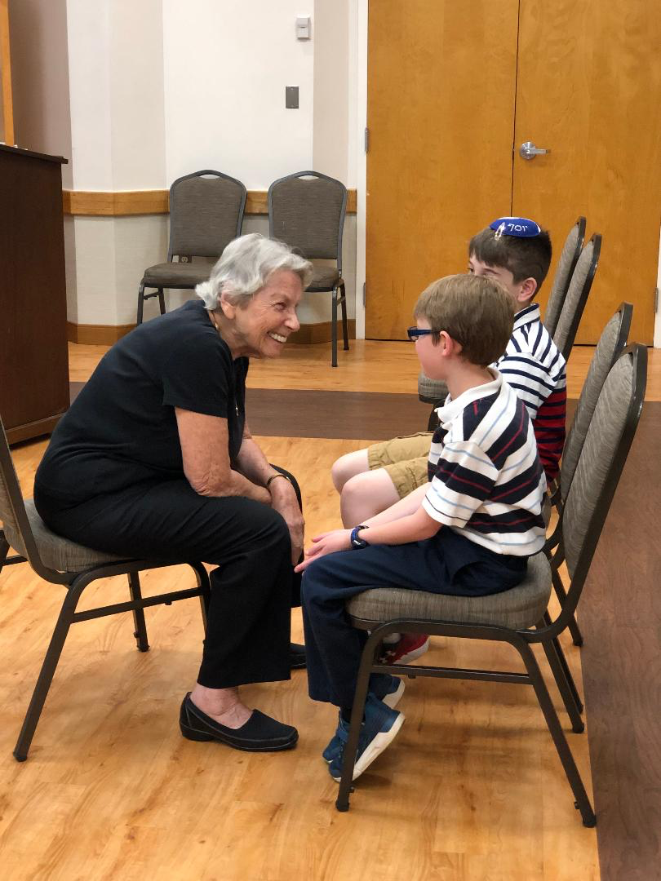
Edith Cord shares a moment with BCRS students

