BCRS Ends Successful Third Year – Plans Made For Exciting Year Four

Under the tutelage of Rabbi Cantor, Morah Jeanne and Morah Heather, our students have become comfortable with the prayers of a Shabbat service; explored wisdom from Pirkei Avot; studied in depth the seven core values upon which our curriculum is based;ℵ seen how these values are incorporated in our lives; made countless connections between Judaism and “the real world;” and learned compassion and empathy by example and by engaging in real world situations.

The younger group learned conversational Hebrew and it was inspiring to watch them using these phrases and words to communicate with each other in Hebrew. The older group honed their Hebrew reading and writing skills, and were given the opportunity to be “Hebrew Hotshots” based on their growth in these areas.

We finished the school year this past Sunday with a final culmination program held at Schooley Mill Park. After a rousing davening with students and parents, we had a special story-teller tie all of the values together with an interactive program. We finished with the students, parents and teachers creating very cool art that represented the values.

Rabbi Faith and the School Leadership Team will work over summer break to incorporate new ideas into our ever-evolving and innovative program. We have exciting things planned for year four!

Thank you to the Congregation for all of your support in creating and providing an indelible environment for our Jewish children who will be carrying the wisdom, knowledge and tradition imparted through BCRS to future generations. And thank you too to Jamie Biegeleisen and Jarrett Reid for their dedication, leadership and roll-up-your-sleeves hard work for BCRS.

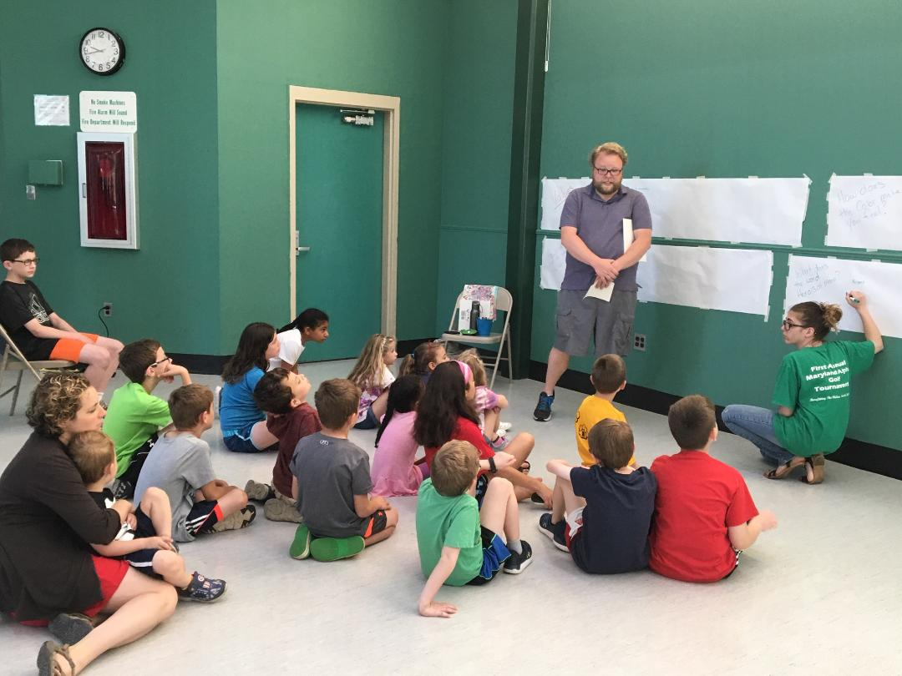

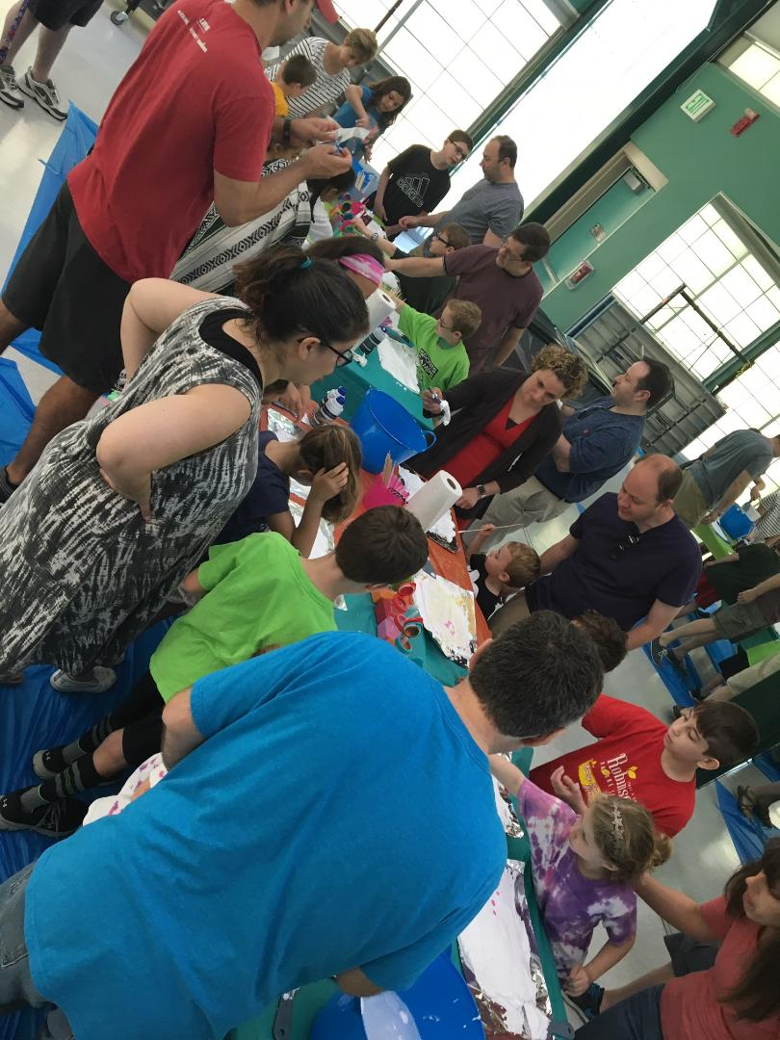

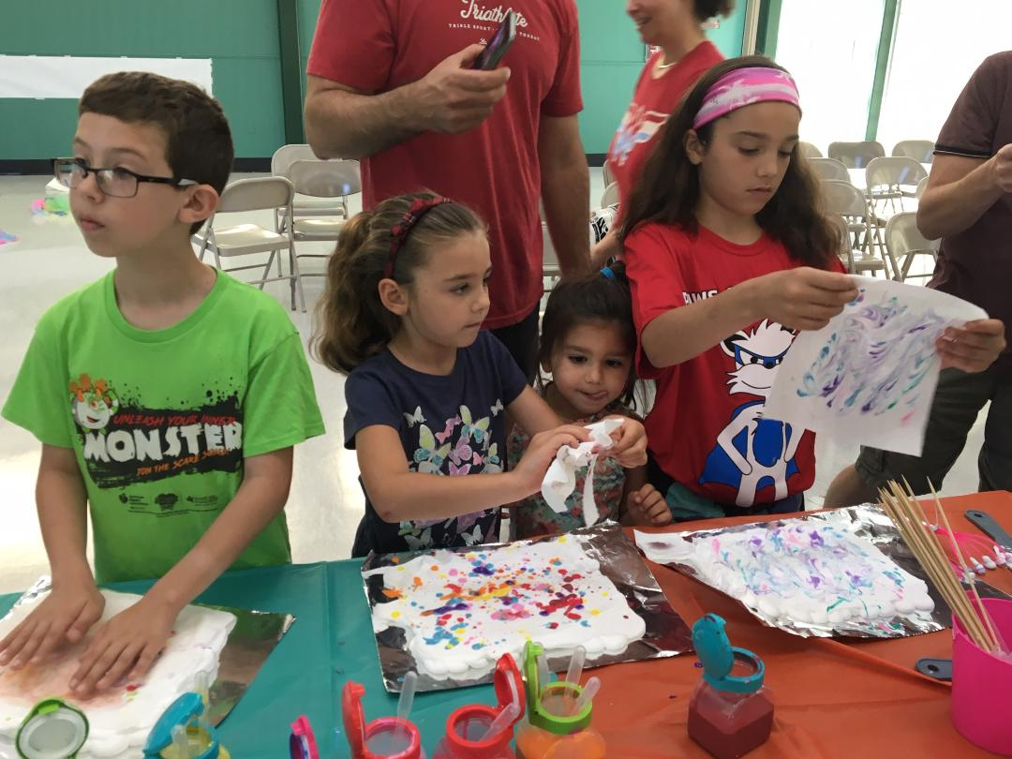

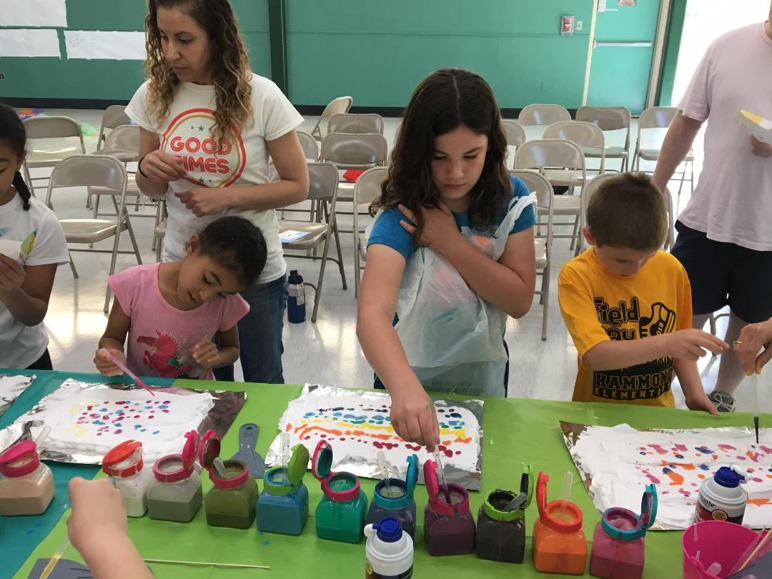

ℵTeshuvah - taking responsibility for one’s actions; B'Tzelem Elohim - honoring the image of G-d in ourselves; Gevurah - using one's inner strength and outer strength; Achrayut - doing what one can to make the world a better place; Hakarat Hatov - seeking joy and being grateful; Koach Hadibbur - understanding the power of words; Shalom - helping to create a more peaceful world.

