BC Hosts St. Andrew’s Episcopal Church Members

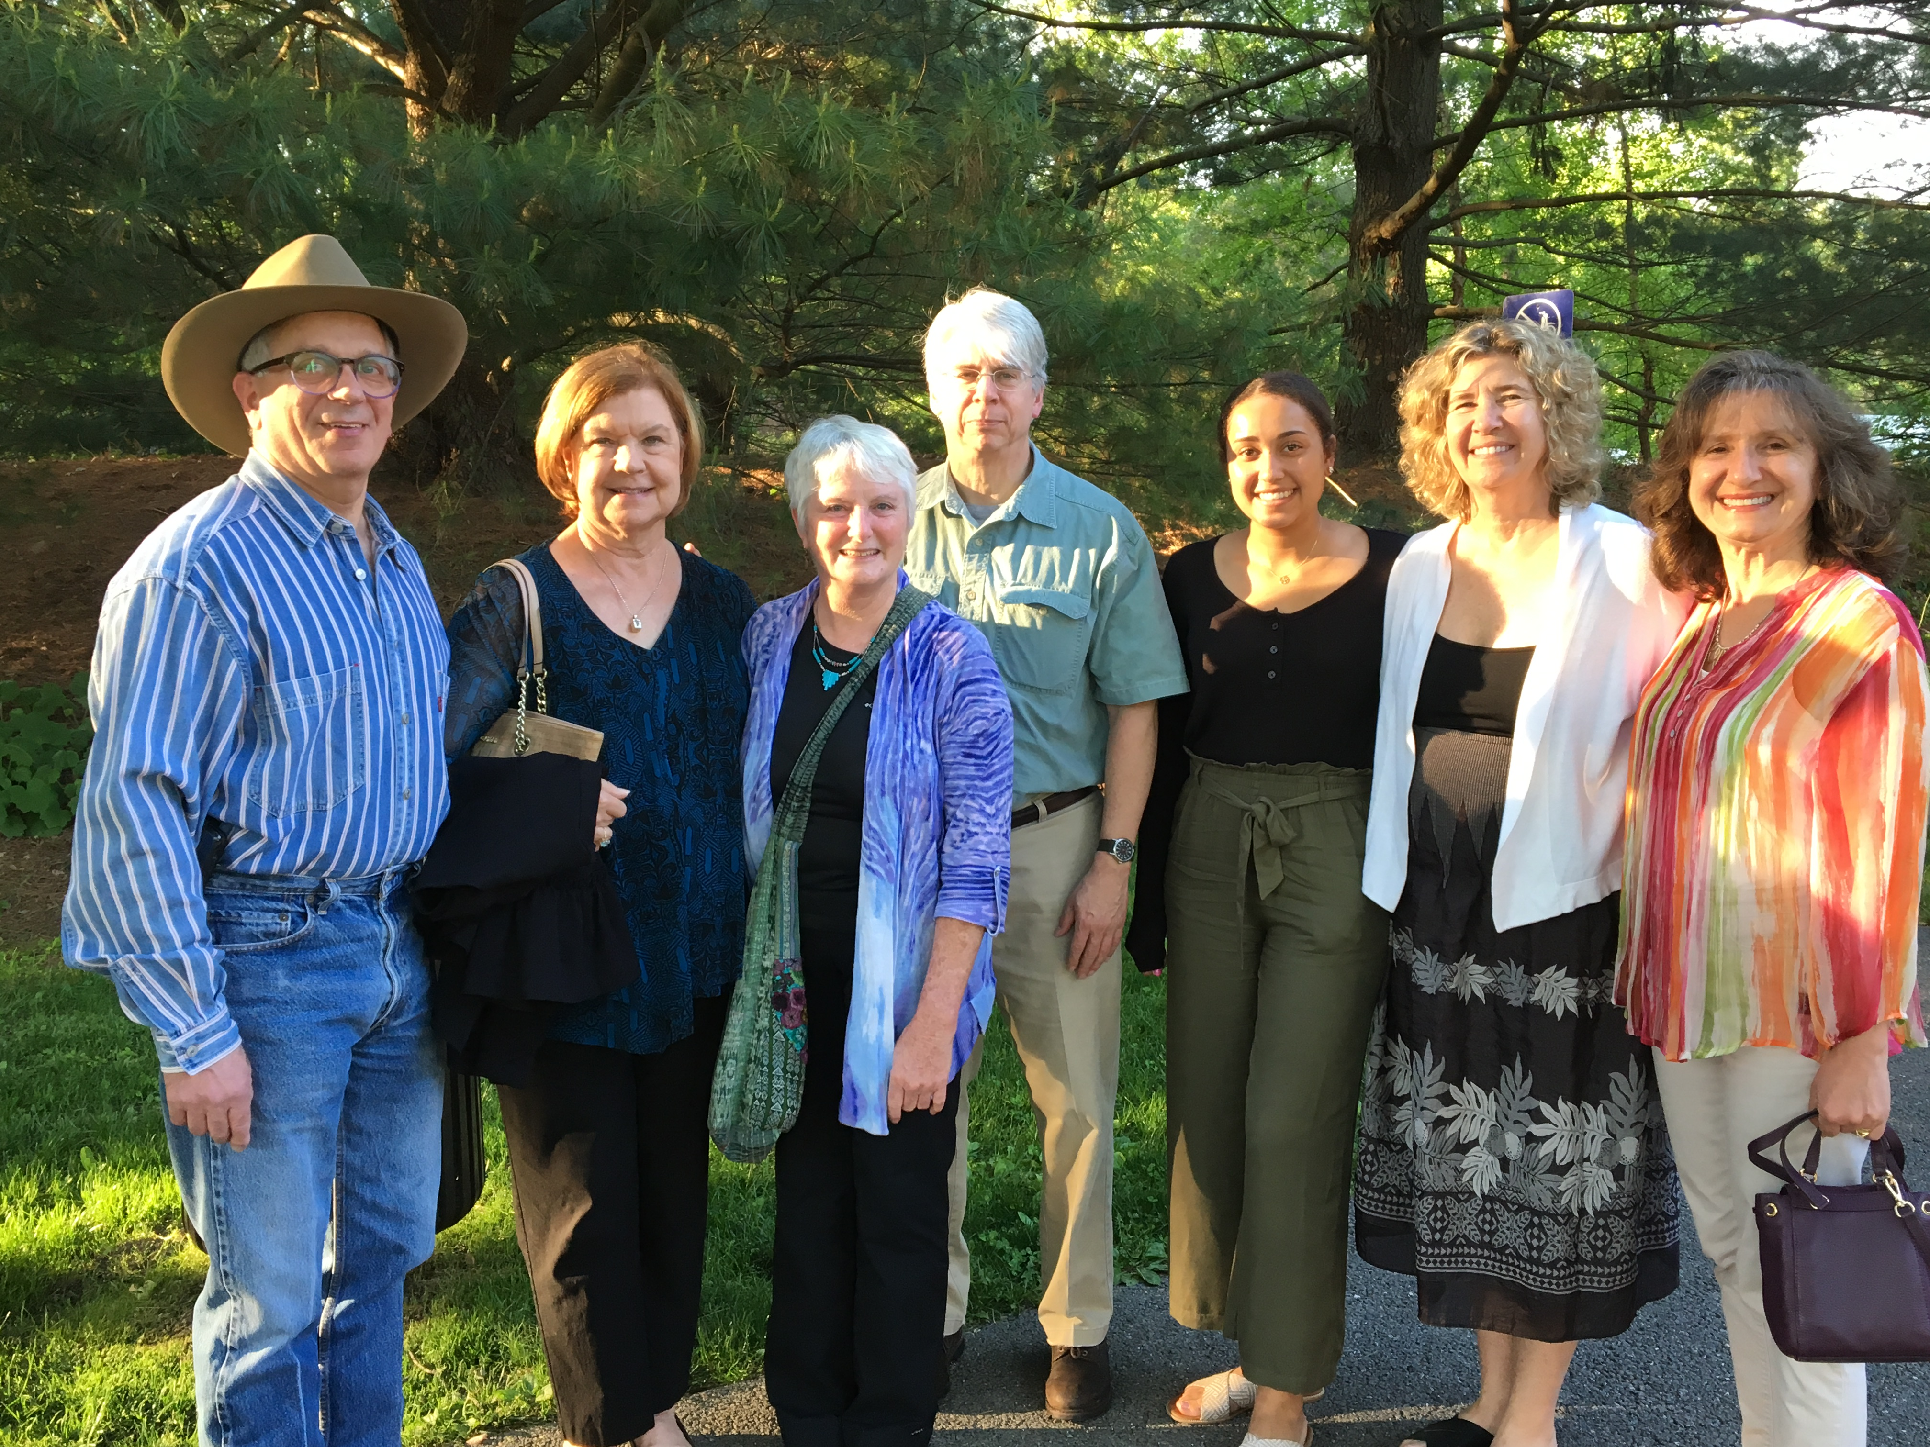
BC’s Robert and Colette Jacobs (far left and far right) along with guests from St. Andrew’s Episcopal Church, including Denise Sharp (to Robert’s left)

St. Andrew’s congregant, Denise Sharp, a long time friend of Robert’s, sent the following note to be shared with the entire BC family:

Dear Members of Bet Chaverim,

Many thanks for the warm welcome into your service last Friday evening. Your mentoring us through the service and engaging conversations afterwards made us feel right at home.
The evening could not have been more memorable especially with the presentation by Edith, a truly remarkable woman whose life is an inspiration to us all.

I appreciate Robert Jacobs' willingness and generosity in extending the invitation and your open arms in taking us in to your group, giving us insights into your faith's traditions.

I would like to extend the invitation to you to visit us whenever you would like. Simply give me a call and I will organize it.

In Peace,
Denise Sharp

Thank you Robert, Colette, Denise, all our guests and of course, Rabbi Blumenthal and our members.

