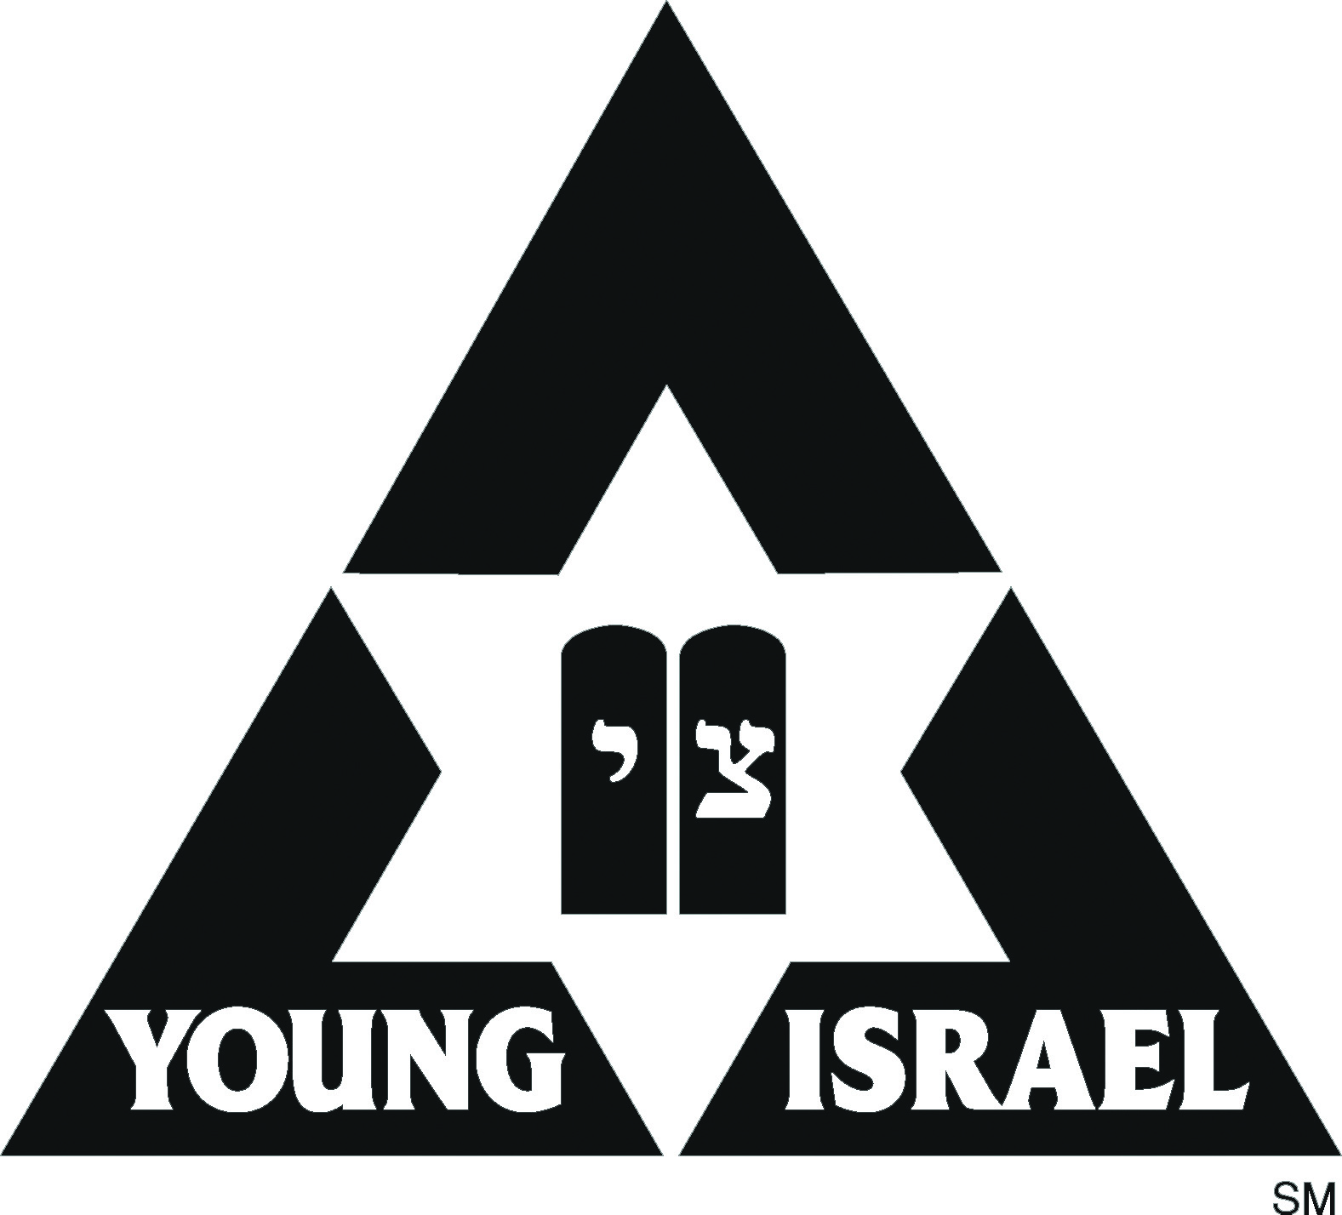
Young Israel Rabbinic Training Program

Hosted by Beis Medrash L’Talmud, an Affiliate of Lander College for Men
INTRODUCTION
As the Orthodox world continues its unprecedented growth in size and strength, the need for confident, professional and dynamic rabbinic leadership becomes all the more crucial. Rabbis today must possess the skills and talents to meet challenges, capitalize on opportunities and lead with wisdom and innovation. A broad range of skills and techniques, perspectives and vision are required in the contemporary American Jewish community.

The rabbinate of the Young Israel movement is ideally suited to address these needs. Young Israel rabbis are drawn from the broad spectrum of the yeshiva world. The Young Israel Council of Rabbis is the most inclusive segment of American Orthodoxy and the typical Young Israel synagogue provides the broadest range of family and community services.

The Young Israel synagogue has become the model of a vibrant and successful Orthodox community. It serves the needs of all members of the community with programs and services that convey the rewards of authentic Torah living, within the context of contemporary American society. National Council of Young Israel is therefore uniquely suited to enhance the competence and caliber of the young rabbis that are entering the complex and exciting field of the American Rabbinate.

THE CHALLENGE
Our community is blessed with many intelligent, passionate and academically-accomplished rabbinical students who are eager to dedicate their lives and the lives of their families to serve the Jewish people in the capacity of rabbi and rebbetzin. All too often, their formal rabbinic education does not train them in the specific set of skills and knowledge that such a calling requires. Rabbinic students generally are not given the opportunity to actually practice, officiate at, or perform the primary rituals of the Jewish life cycle and/or the functions of the pulpit rabbi. The Rabbinic Training Program endeavors to harness their latent talents and translate them from the theoretical to the practical. It provides the specific training, mentoring, networking opportunities and experiences that serious rabbis need to qualify for positions in the field. It equips young rabbis with the tools to be creative and innovative, professional and competent. It enables them to turn their dreams of community service into a reality.

THE GOALS
The goals of the Rabbinic Training Program include:

- Providing specific training and reference materials for aspiring pulpit rabbis.

- Providing varied perspectives on contemporary issues, challenges and opportunities from seasoned therapists, active lay-leaders and experienced rabbis.

- Establishing a continuing support and resource network of experienced and successful pulpit rabbis for all participants.

- Presenting opportunities for direct observation and hands-on experience in performing the basic tasks and skills of rabbinic service.

- Helping rabbinical students network and find internships to gain more experience and further their professional development.

- Creating a resource for placement for members of the program

- Providing rebbetzins an opportunity to better prepare themselves for their future role.

DETAILS OF THE PROGRAM
- The Rabbinic Training Program meets on 15 evenings (usually Thursdays), November 2018 to June 2019 at 5:00 – 10:00 p.m. Typically, it begins after Sukkot and ends after Shavuot. Some additional on-site presentations may be required.

- The program will meet at Lander College for Men in Kew Gardens Hills (Queens),
New York. In past years it has met in Lakewood, Brooklyn, and Baltimore.

- We will attempt, if interested, to match the rabbinic trainees with a Young Israel rabbi who will share his rabbinic experience and offer advice and direction.

- The program gives participants the opportunity for private consultation with National Council of Young Israel leadership regarding résumé writing and interviewing skills. In addition, search committees will advise participants about areas on which to focus during the interview and job search process.

- The Rabbinic Training Program is limited to a maximum of 40 participants. Each applicant will be contacted and letters of acceptance will be sent soon after the application is reviewed.

- Attendance at all sessions is mandatory. A post Graduate Certificate in Advanced Rabbinic and Synagogue Administration from Touro College and National Council of Young Israel will be awarded to participants who successfully complete the Rabbinic Training Program. Absences in more than two classes will result in an inability to become certified by the program.

- Tuition is $600 for the entire course study. A $50 non-refundable application/program fee must be included with your application, this fee will be applied to your tuition. Checks are payable to Young Israel Programs and, in the memo, indicate Rabbinic Training. The fee includes all materials and a fleishig dinner. Post-dated checks are acceptable.

- Attendance at the Young Israel Council of Rabbis Rabbinic Conference held bi-yearly is a requirement of the course.

Possible Topics for Rabbis
- “From Shtender to Pulpit” – An introduction to real world rabbanut.
- “Thinking Out of the Box” – Creative ways to maximize your shul’s potential
- “Drashot/Sermonics” – How to address a diverse audience.
- “How to Pasken if you are not a Posek” – Methodological approaches to
answering shailos.
- “Officiating at Life-Cycle Events I & II” – A review of the guidelines and
techniques of officiating at a bris, bar/bat-mitzvah, wedding and funeral.
- “Ensuring a Bayis Neeman B’Yisrael” – What rabbanim should be aware of and prepared for when dealing with domestic strife and marital discord – in conjunction with Shalom Task Force.
- “Professional Development and Career Preparation”– How to make yourself a more
desirable candidate.”
- “Building the Rabbinic Résumé” – Practical advice for résumé preparation and the
interview process.
- “The Rabbi and the Gabbai: Knowing Around-the-Year Minhagim and Preparing the Shul Luach” – Star-K Kosher Certification, Rabbi Dovid Heber
- “Pesach Issues. Around the year in the Rabbi’s Seat” – A look at the shailos that
are specific to different times of the year, with a focus on Nissan.
- “Halacha and Infertility” – in conjunction with “A T.I.M.E.(A Torah Infertility Medium of Exchange”).
- “Preparing ourselves for Strong Halachic Leadership” – How to address the needs of your congregants within the framework of halacha.
- “The Out-of-Town Rav” – Challenges that are unique for out-of town
rabbonim, with a focus on Kashrus & Kiruv.
- “Mikvaot, Eruvin, Safrus & Milah” – Crucial halachot and practical guidance on
these complex and sensitive communal institutions.
- “The Rabbi and His Finances: Parsonage, Non-Profit Status & Tax Exemptions.”
- Contemporary Halachik Issues i.e.:End-of-Life Issues, Womens’ Issues, State of Israel.
- “Rabbinic Counseling” – An overview of common mental health issues, in conjunction with OHEL Children’s Home and Family Services.
- One-on-one interaction with the country’s top Rabbanim
- Practical hands-on guidance you won’t find in Seforim
- Eretz Yisrael/Medinat Yisrael: Appreciating our connection to Israel – the Land and State

Possible Topics for Rebbetzins
- “Rebbetzin, Wife, Mother, Professional – Balancing the Roles”
- “Reality of the Rebbetzin: Naches & Frustration”
- “Rebbetzin as Mentor: Friend, Guide or Counselor?”

