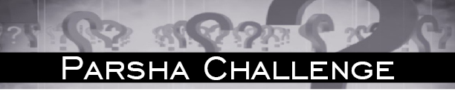

פרשת ויקרא תשע''ח

- Name eight completely different types of קרבנות? (For example עולה, חטאת וכו')
- What is normally אסור to eat but if it is a קרבן it is מותר to eat? ²
- Which of the "נקודות" is also an עבודה?
- Name two עבירות במזיד, mentioned in this week’s פרשה, for which a קרבן can be brought. ³
- What two things in this week’s פרשה are אסור to separate?
  - What three things were אסור to separate/rip in the משכן / בגדי כהונה?
- I a אסור to eat,
He is מותר to eat,
If he completely covers me,
then I become מותר and he becomes אסור,
We are both mentioned in this week’s פרשה,
Who am I? Who is he?
- Although I wasn’t directly slighted,
I am part of the group who was slighted,
Therefore in this weeks פרשה I was given a זכות,
Perhaps greater than those of whom we were envious,
Even today when there is no ב''ה,
Recognition to me is still given.
Who am I?⁴
- עולה, שלמים, מנחה, חטאת,אשם, פסח, מעשר, ובכור. (These answers aren’t absolute. You may have come up with your own list. עולה ויורד and תודה were not listed because an עולה ויורד is a form of חטאת and a תודה a form of שלמים)
- A bird that had מליקה done to it.
- קמץ
- שבועת העדות and שבועת ממון.
- 1) The body of a bird that is brought as a קרבן.
(שסע אתו בכנפיו לא יבדיל א,יז)
2) Not two separate both סמנים of a חטאת העוף.
(ומלק את ראשו ממול ערפו לא יבדיל ה,ח)
  - 1) The חושן from the אפוד 2) The neck of the מעיל. 3) The poles of the ארון.
- Who am I? Meat Who is he? Salt.
- Although I wasn’t directly slighted,
I am part of the group who was slighted, - The lower waters
Therefore in this weeks פרשה I was given a זכות, - All קרבנות must have salt
Perhaps greater than those of whom we were envious,
Even today when there is no ב''ה,
Recognition to me is still given. - Bread is dipped/eaten with salt
Who am I? מלח

לרפואה שלמה יהודה בן אידל
שרה יוכבד בת חנה מאשה
לע''נ ברכה בילה בת דוד יעקב ז''ל
יצחק דוד בן אלימלך הכהן ע''ה
For questions, to subscribe or to submit your own שאלה, send an email to parshachallenge@gmail.com
Feel free to forward or distribute the Parsha Challenge.
©כל הזכויות שמורות

Hint? . ע' פרק איזהו מקומם 2. It is a מעשה that normally makes an animal טרייף. 3. One עבירה brings a עולה ויורד and one brings an אשם 4. I am not a person

