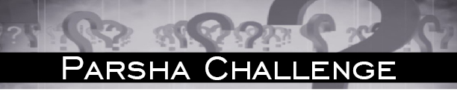

פרשת כי תשא תשע''ח

- List three לאוים related to עבודת המשכן in this weeks פרשה.
- When was there "מחלת" (dancing) in this weeks פרשה? Where else in the תורה do we find"מחלת"?
- What two reasons does משה give to ה', to forgive כלל ישראל?
  - When else does משה use one of these reasons?
- Which two parts of this week’s פרשה are used as תפילות?
- What in this week’s פרשה is 3,000?
- Who covered his face in this week’s פרשה? Name two other people in the תורה that cover their face.
- I am a precious gem,
I am the remainder of something great,
I made my owner wealthy.
Who am I?
- My uncles were a great צדיקים,
I played a crucial role in a great battle,
Like my father I took a stand when it wasn’t popular,
My grandson was famous for his divine wisdom,
Not only am I mentioned in this week’s פרשה,
My name is also found in the מגילה.
Who am I?

- Not to make or smear שמן המשחה on a person, and not to make קטורות.
- a) By the עגל b) By שירת מרים.
- 1) The מצריים will say you took the yidden out of מצרים inorder to kill them. 2) The promise to the אבות.
a) By the חטא המרגלים.
- ושמרו בני ישראל and ה' ה'.
- The amount of people משה and the לוים killed after the חטא העגל.
- רבקה and תמר
- סנפרינון – Safire
- My uncles were a great צדיקים, - משה ואהרן
I played a crucial role in a great battle, - I held משה’s arm
Like my father I took a stand when it wasn’t popular, - I confronted the yidden by the עגל
My grandson was famous for his divine wisdom, - בצלאל
Not only am I mentioned in this week’s פרשה,
My name is also found in the מגילה. - חור כרפס ותכלת
Who am I? - חור

Last week’s Riddle:
He and I are identical words but with different נקודות,
Although I am not allowed in the משכן,
He is allowed on top of the ארון, - זֵר
I am mentioned in this week’s פרשה.
Who am I? -זָר

לרפואה שלמה יהודה בן אידל
שרה יוכבד בת חנה מאשה
לע''נ ברכה בילה בת דוד יעקב ז''ל
יצחק דוד בן אלימלך הכהן ע''ה
For questions, to subscribe or to submit your own שאלה, send an email to parshachallenge@gmail.com
Feel free to forward or distribute the Parsha Challenge.
©כל הזכויות שמורות

Regarding קטורת ושמן המשחה
ע' רש''י פרק לד,א

