The Sun at Night – Handout

# Genesis 1:7

And God made the firmament, and divided the waters which were under the firmament from the waters which were above the firmament; and it was so.



# Bereishit Rabbah 4:1

And God said, "Let there be a firmament" - It is written (Psalms 104:3), "Who layest the beams of Thine upper chambers in the waters." It is the custom of the world that a king of flesh and blood constructs a palace and makes a roof for it out of stones and wood and dirt. But the Holy One Blessed Be He made a roof for his world out of water, as it says "Who layest the beams of Thine upper chambers in the waters."

Our Rabbis said the following in the name of R. Hanina, while R. Phinehas and R. Jacob b. R. Bun said it in the name of R. Samuel b. Nahman: When the Holy One, blessed be He, ordered, "Let there be a firmament in the midst of the waters", the middle layer of water solidified, and the nether heavens and the uppermost heavens were formed. Rav said: God's handiwork was in fluid form, and on the second day it congealed. Rav said, '"Let there be (*yechi*) a firmament" - let the firmament be strengthened (*yechazek*);' Rabbi Yehuda Berebi Shimon said, 'the firmament (*rakiya*) should form like a cloth…

# Bereishit Rabbah 4:3

R. Phinehas said in R. Oshaya's name: As there is a void between the earth and the firmament, so is there a void between the firmament and the upper waters, as it is written, “And God said: 'Let there be a firmament in the midst of the waters, and let it divide the waters from the waters.'” (Gen 1:6), meaning, midway between them.

R. Tanhuma said: I will state the proof. If it said, “And God made the firmament, and He divided between the waters... which are upon the firmament”, I would say that the water lies directly upon the firmament itself. Since, however, it is stated, ‘And between the waters which are above the firmament,’ it follows that the upper waters are suspended by the word of God. R. Aha said: It is like the flame of a lamp, and their fruits are the rain.

# Bavli – Hagigah 12a

What does ‘heaven’ [Shamayim] mean? R. Yose b. Hanina said: It means, ‘There is water’. In a Baraitha it is taught: ‘fire and water ;’ this teaches that the Holy One, blessed be He, brought them and mixed them one with the other and made from them the firmament.

# Pesikta D’Rav Kahana 1:3

R. Shimon ben Yochai taught: the sky is made of water and the stars of fire and they live with each other and do not harm each other

# Genesis 7:11

In the six hundredth year of Noah's life, in the second month, on the seventeenth day of the month, on the same day were all the fountains of the great deep broken up, and the windows of heaven were opened.

# Bavli – Shabbat 34b

Our Rabbis taught: As to twilight (Bein HaShemashot), it is doubtful whether it is partly day and partly night, or the whole of it day or the whole of it night: therefore it is cast upon the stringencies of both days.

And what is twilight? From sunset as long as the face of the east has a reddish glow: when the lower horizon is pale but not the upper, it is twilight; but when the upper horizon is pale and the same as the lower, it is night: this is the opinion of R. Judah. R. Nehemiah said: For as long as it takes a man to walk half a mil from sunset. R. Yosi said: Twilight is as the blink of an eye, one entering and the other departing, and it is impossible to determine it.

# Bereishit Rabbah 6:8

How do the orbs of the sun and the moon set? R. Judah bar Ilai and the Rabbis disagree. R. Judah said: Behind the vault and above it. The Rabbis maintained: Behind the vault and below it.

R. Jonathan said: The view of R. Judah bar Ilai that it is behind the vault and above it is preferable in respect of summer, when the whole world is hot while the wells are cold; and the opinion of the Rabbis that it is behind the vault and below appears correct in respect of winter, when the whole world is cold and the wells are tepid.

R. Shimon b. Yochai said: We do not know whether they fly through the air, glide in the heaven, or travel in their usual manner. It is an exceedingly difficult matter, and no person can fathom it.

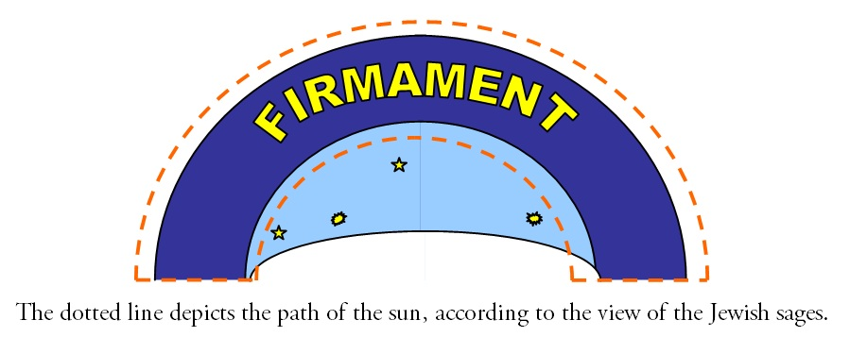

# Bereishit Rabbah 6:7

R. Levi said: The voice of three things travels from one end of the world to the other, yet no creature hears it: the day [i.e. the sun], the rain, and the soul when it departs from the body. Whence do we know it of the day? Said R. Judah bar Ilai: You may think that it glides in heaven, but it is not so, being rather like a saw which saws through wood.

# Babylonian Talmud – Pesahim 94b

Our Rabbis taught: The Sages of Israel maintain: The Galgal is stationary, while the mazalot revolve; while the Sages of the nations of the world maintain: The Galgal revolves and the mazalot are stationary. Rabbi observed: This disproves their view; we never find the Wain in the south or Scorpio in the north. To this R. Aha b. Jacob strongly objected: Perhaps it is like the pivot of a millstone, or like the door socket?

The Sages of Israel maintain: The sun travels beneath the sky by day and above the sky at night; while the Sages of the nations of the world maintain: It travels beneath the sky by day and below the earth at night. Said Rabbi: And their view is preferable to ours, for the wells are cold by day but warm at night.

# Bereishit Rabbah 6:7

R. Joshua said: [The earth drinks] from the upper waters, for it is written, And drinks water as the rain of heaven comes down (Deut. 11:11); the clouds, however, mount up to heaven and receive them [the waters] as from the mouth of a bottle, for it is written, *He gathers up the waters in His thick clouds* (Job 26:8).

R. Eliezer said: From the waters of the Ocean, for it is written, *but there went up a mist from the earth, and watered the whole face of the ground* (Gen 2:6) Said R. Joshua to him: But surely the waters of the ocean are salty! They are sweetened in the clouds, replied he, for it is written, *which the skies distill* (Job 36:28): where are they distilled [i.e. sweetened]? In the skies [clouds].

# Bereishit Rabbah 4:5

The firmament is like a lake, and above the lake is a vault, and through the heat of the lake the vault exudes moisture; it exudes heavy drops of water, which descend into the salt water yet do not combine with it.

It has been taught: R. Eliezer says that the world is like an exedra, and the north side is not enclosed, and so when the sun reaches the north-west corner, it bends back and returns to the east above the firmament. R. Joshua, however, says that the world is like a tent, and the north side is enclosed, and when the sun reaches the north-west corner it goes round at the back of the tent till it reaches the east…

# The Guide for the Perplexed 2-8

It is one of the ancient beliefs, widespread among both the philosophers and ordinary people, that the motions of the spheres produce mighty and fearful sounds... This belief is also well known in our nation. Thus the Sages describe the greatness of the sound produced by the sun in the daily circuit in its sphere... Aristotle, however, rejects this, and explains that they produce no sound... You must not find it far-fetched that Aristotle differs from the opinion of our Sages in this. For this theory—that is, of the sounds of the spheres—stems from the belief that the sphere is fixed and the constellations revolve within it; and you already know that in such matters of astronomy, the matter has been decided in favor of the gentile scholars over the Sages. Thus, it is explicitly stated, “The wise men of the nations have defeated them.” And this is appropriate; for with speculative matters everyone speaks according to the results of his own investigation, and everyone accepts that which appears to him established by proof.