Jews, Tattoos and Burial Views – Handout

Leviticus 19:28
וְשֶׂרֶט לָנֶפֶשׁ לֹא תִתְּנוּ בִּבְשַׂרְכֶם, וּכְתֹבֶת קַעֲקַע לֹא תִתְּנוּ בָּכֶם אֲנִי ה’
You shall not make cuts in your flesh for the dead;
You shall not etch a tattoo on yourselves. I am the Lord

Leviticus 19:27
A You shall not round off the side-growth of your head,
B And you shall not destroy the side-growth of your beard

Rashi on Leviticus 19:28
cuts for the dead: This was the practice of the Amorites: to make cuts in their flesh when a person related to them died.
etch a tattoo: וּכְתֹבֶת קַעֲקַע, an inscription etched (מְחֻקֶּה) and sunken (שָׁקוּע), never to be erased, for one etches it with a needle, and it remains permanently black. 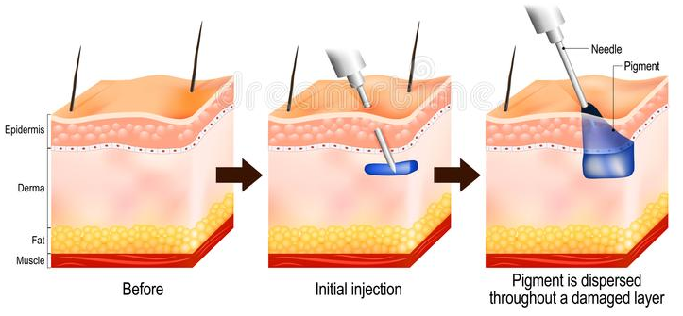

Mishnah - Makkot 3:6
One who incises a tattoo: If he inscribes but does not puncture, or punctures but does not inscribe, he is not liable until he inscribes and punctures with ink, or with kohl, or with anything that leaves a permanent mark. Rabbi Shimon ben Yehudah says in the name of Rabbi Shimon bar Yohai: He is not liable until he writes there the name, as it says: “You shall not make any tattoo on yourselves, I am the Lord”

Gemara – Makkot 21a
Said R. Aha the son of Raba to R. Ashi: [Does it mean, not] until he has actually inscribed the words, “I am the Lord”? — No, replied he, it means, as Bar Kappara taught: He is not liable until he inscribed the name of some profane deity, as it is said: “Nor put on you any written-imprint, I am the Lord”; ‘I am the Lord’ and no other.

Mishneh Torah, Negative Mitzvot 41
NOT TO WRITE ON THE BODY LIKE IDOL WORSHIPPERS
The etched-in writing against which it is spoken of in the Torah is, not to make an incision in one's flesh and fill in the incision with paint, or ink, or any other dyes which enface. This was an idolatrous custom, to make themselves to idolatry, proclamatory that every one of them is a sold slave to it, and indentured in its service.
And, from the moment one will enface with any kind of dye which enfaces, after making an incision in any place of the body, whether it be done by man or by woman, he or she, is lashed. If one wrote but did not enface with dye, or if he did enface with dye but did not write in the incision, he is not guilty; for he must do both, write by incision and etch-in with dye, even as it is said: "And any etched-in writing shall you not fix on yourselves" (Lev. 19. 28).

Other Bible Verses

Isaiah 44:5
זֶ֤ה יֹאמַר֙ לַֽה' אָ֔נִי וְזֶ֖ה יִקְרָ֣א בְשֵֽׁם־יַעֲקֹ֑ב וְזֶ֗ה יִכְתֹּ֤ב יָדוֹ֙ לַֽה' וּבְשֵׁ֥ם יִשְׂרָאֵ֖ל יְכַנֶּֽה
One shall say: ‘I am the LORD’S’; and another shall call himself by the name of Jacob; And another shall engrave on his hand unto the LORD, and nickname himself by the name of Israel.

Isaiah 49:16
הֵ֥ן עַל־כַּפַּ֖יִם חַקֹּתִ֑יךְ חוֹמֹתַ֥יִךְ נֶגְדִּ֖י תָּמִֽיד
Behold, I have graven thee upon the palms of My hands; Thy walls are continually before Me.

Mishneh Torah, Negative Mitzvot 41
This is to say against the one who does the writing, but he who upon whose flesh the etched-in writing was done is not guilty save if he assisted in a manner to constitute it an overt act; but if he contributed nothing to the work itself he is not lashed.

Gemara – Makkot 21a
R. Malkiah, as citing R. Adda b. Ahabah, said: It is prohibited to powder one's wound with burnt wood ash, because it gives the appearance of an incised imprint.

Shulchan Arukh, Yoreh De'ah 180:3
One is permitted to put ash on his wound.

II Kings 13:20-21
And Elisha died, and they buried him. Now the bands of the Moabites used to invade the land at the coming in of the year. And it came to pass, as they were burying a man, that, behold, they spied a band; and they cast the man into the sepulcher of Elisha; and as soon as the man touched the bones of Elisha, he revived, and stood up on his feet.

Sanhedrin 47a
AND THEY WOULD NOT BURY: Why? — Because a wicked man may not be buried beside a righteous one.

Shulchan Aruch - Yoreh Deah 362:5
They do not bury a wicked man beside a righteous one; even a grossly wicked person alongside a moderately wicked one. And likewise they do not bury a righteous person, and so much the more an average individual beside an extremely pious one. However, they may bury a repentant sinner beside a perfectly righteous person.

