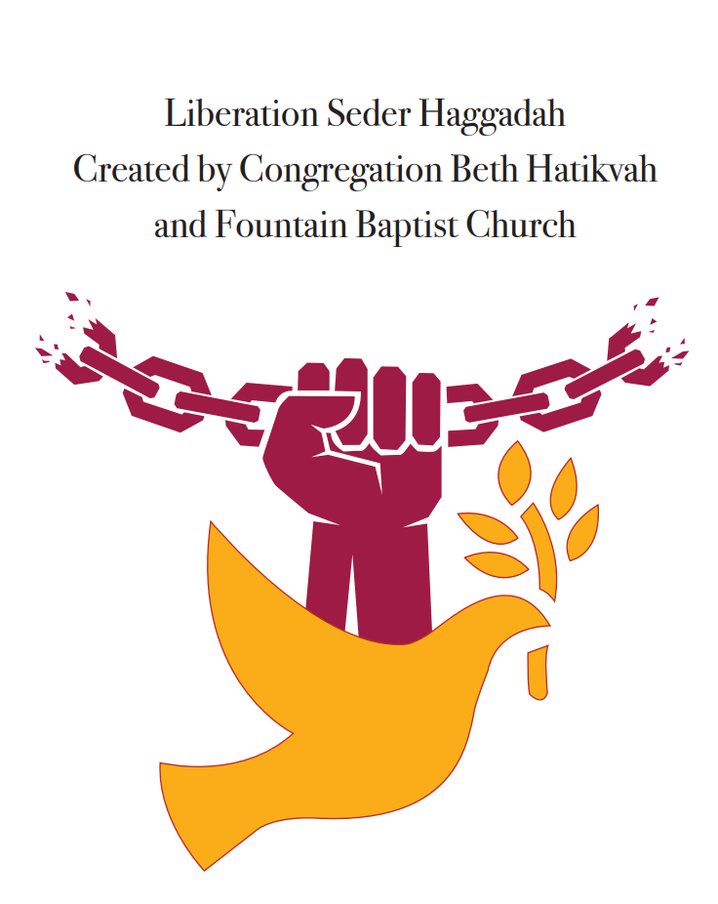

Welcome

Hinei Mah Tov/How Good It Is (psalm 133)
Hinei mah tov u’ma na’im How good it is.
Shevet achim gam yachad. How sweet it is to be together on this day.

Blessing for Lighting Candles – (From The MLK + 50 Interfaith Freedom Seder created by Rabbi Arthur Waskow and The Shalom Center.)
Leader: It is our task to make from fire not an all-consuming blaze, but the light in which we see each other— Each of us different, All of us made in One Image, glowing with One Spark.
Entire Room: Blessed are you, Spirit of the World, who makes us holy through connections with each other, and connects us through the kindling of these candles so that we may light up the path toward peace and freedom, justice and healing, for all peoples and our planet.

Introductions at tables

Blessing for wine/juice – The Cup of Awareness

Unison at Tables: We come first to the recognition of slavery, of degradation, or narrowness. Until we know the ways in which we are enslaved, we can never be free. We drink this first cup in honor of awareness.
Unison at Tables: We bless the spirit of the world, who creates the fruit of the vine.

Our Stories Before we were Enslaved (Take turns reading at tables)
Participant: “These are the names of the sons of Israel who went to Egypt with Jacob, each coming with his own household. Reuben, Simeon, Levi and Judah; Issachar, Zebulun and Benjamin; Dan and Naphtali; Gad and Asher. The total number of persons that were of Jacob’s issue came to seventy, Joseph being already in Egypt. Joseph died, and all of his brothers, and all their generation. But the Israelites were fertile and prolific; they multiplied and, increased greatly, so that the land was filled with them.” (Exodus 1:1-7)

Our Rich Heritage
Participants take turns reading one paragraph at tables:
- Africa, the cradle of civilization, home to great civilizations such as Kush, and Ancient Mesopotamia. Africa was known for its empires Ghana, Mali, and Songhai, and for philosophers like Imhotep, and Ptahhotep. Indeed, Africa was civilized, technologically advanced, and its economy flourished.

- Ancient empires with its vast resources attracted people globally to engage in education and trade. Ghana (800 CE) had an economy based trade of copper, gold, ivory, salt and agriculture. Mali’s (1235 CE) university located in Timbuktu was famous for spectacular architecture. Songhai (CE 1375) was considered one of the greatest African empires, due to the rich trade with Arabs.

- From the 15th to the 19th century several important kingdoms emerged in Western Africa. These Kingdoms were known for their implementation of checks and balances to the power of the King and for their organization of women into renowned fighting units.

- The Oyo and Dahomey kingdoms were known for their highly-developed political organization, and military prowess

Discuss: Why is it important to share our history?
(Wrap up when you hear Olawa Ko-le-ba je wo – Translation: What God has created no one can destroy)

Royal Kingdoms – Entire Room
By Sounds of Blackness
Kingdoms, Ghana, Mali and Songhai, Royal Kingdoms (Royal Kingdoms)
Whose names of history books pass by
Glorious Kingdoms (Glorious Kingdoms)
Their greatness no one can deny
Mighty Kingdoms (Mighty Kingdoms)
We’ll never let your memory die
Kingdoms (Kingdoms)

Ethiopia and Egypt Land
Builders of the Pyramids, 4,000 years and still they stand
Knowledge of the universe, view (or through?) the stars and the heavens of (or in?) earth
All the people of the earth (All the people of the earth)
Need to know who we’re singing of
Kingdoms, blessed beyond imagination

Zimbabwe, Timbuktu, and Ashanta nation
Birthplace of humanity, cradle of civilization
Africa the Motherland (Africa the Motherland)
Kingdoms
Since the dawn of creation
Power and majesty yet remain
Bountiful Kingdoms (Bountiful Kingdoms)
Their royal blood flows through our veins
Beautiful kingdoms, alive in us waiting to ascend
(Marvelous Kingdoms) Marvelous kingdoms

(Call for us) Call For Us To Build Them Again

Karpas
Pass around parsley. Each person take one piece.
Participants take turns reading one paragraph at tables:
- “Karpas represents spring and new growth, rebirth and the beginning of new life. We taste in this fresh vegetable all the potential in nature and in ourselves. Tonight we celebrate our growth, the flowering of our spirit and of our voices.
- We do not taste the parsley alone. We dip it into salt water, recalling the tears our ancestors shed during their long years in slavery. We mix bitterness with sweetness, slavery with freedom, past with future. We live with the contrasts because we know that no moment exists without a multitude of combinations – sorrow and joy, pain and comfort, despair and hope.
Blessing for Karpas
Unison at Tables: We bless the spirit of the world, who creates fruit of the earth.
Dip parsley in salt water and eat.

The Middle Passage
Participants take turns reading one paragraph at tables:
- Africans stolen from their homeland and forced to endure a horrific journey of no return across the Atlantic is now known as the Middle Passage. African humanity packed tightly into the hulls of ships stripped of their dignity and identity treated as cargo rather than human beings. The Middle Passage became a journey in which many were forcibly brought to a strange land and millions more exterminated before reaching Western shores.

- The forced labor of Africans proved hugely profitable for Europe and its colonies during the Atlantic Slave Trade; also known as the Triangular Trade. The Portuguese, British, French, Spanish, and Dutch were the main slave traders.

- Our ancestors were taken predominantly from areas known today as Nigeria, Congo, Angola, Sierra Leone, Senegal and Ghana. They were taken to European colonies in South America and the Caribbean (including Buenos Aires, Rio de Janeiro Brazil). Brutal and inhumane conditions in the cargo holds of the slave ships lead to an estimated 40% of the Africans on the journey to the Americas dying before ever reaching land.

- Forced into slavery, Africans and their descendants carried rich spirituality, craftsmanship, communitarian values, strong cultural traditions, resiliency and resistance ethos that transformed and enriched the cultures they entered around the world, creating the African Diaspora.

Share: (each person at the table has 30 seconds to answer questions. Facilitators can choose whether to go around once and answer both questions or go around table and answer first question then go around second time and answer second question)
What do you shed tears for in today’s world? What are the green shoots that give you hope? (30 secs to answer)
(Wrap up when you hear Olawa Ko-le-ba je wo – Translation: What God has created no one can destroy)

Oluwa (Many Rains Ago) – Entire Room
By Letta Mbulu

Weeping willow tree, tell me what u know
River were u cryin’ many rains ago
(Ko-le-ba je wo)
Sacred baobab tree, lost your children to the sea
Taken from the land, many rains ago
(Ko-le-ba je wo)
Goodbye motherland
(Ko-le-ba je wo)

Sing me an old song from many rains ago
Goodbye motherland
(Ko-le-ba je wo)
Ko-le-ba je wo
(Ko-le-ba je wo)
When I die I’ll live on and on
For many rains to come

(Ko-le-ba je wo)
Goodbye motherland
(Ko-le-ba je wo)
Goodbye, goodbye motherland
(Ko-le-ba je wo)
Ko-le-ba je wo
(Ko-le-ba je wo)
Goodbye motherland

Yachatz

Participant: "Why do we eat this pressed-down bread? "Because it begins as the bread of affliction, the bread of a pressed-down people—but becomes the bread of Freedom when we hasten toward our freedom. Hasten to bake it without time for the bread to rise, For then we lived and now we live, as Dr. King taught, in the "fierce urgency of NOW!"—swiftly moving toward our liberation."
[Each person breaks the matzah and hands a piece to a neighbor.]
Participant: Why do we break and share the matzah? Because if we do not share it, it remains the bread of affliction; when we share it, it becomes the bread of freedom
Blessing for Matzoh
Unison at Tables: Blessed are You, Spirit of the world, who through sun and soil, seed and human sweat, brings forth this bread from the Earth.
[Eat a bite of the matzah]

Maror
Participant: Why do we eat it? To remind ourselves that the Egyptians made life bitter for our ancestors in Egypt, as it is written: “Ruthlessly, they made life bitter for them with harsh labor at mortar and bricks, and with all sorts of tasks in the field.” (Exodus 1:14)
Blessing for Maror
Unison at Tables: Blessed are you Eternal One our God, sovereign of all worlds, who has made us holy with mitzvot and commanded us to eat maror.
Eat Matzoh and Maror and Charoset together

Sometimes I Feel Like a Motherless Child – Solo
Sometimes I feel like a motherless child,
Sometimes I feel like a motherless child,
Sometimes I feel like a motherless child,
A long ways from home,
A long ways from home.
Sometimes I feel like I'm almost gone,
Sometimes I feel like I'm almost gone,
Sometimes I feel like I'm almost gone,
A long ways from home,
A long ways from home.

Life in The New Land
Participant reads whole page:

To Be Sold

On Thursday the Third Day of August
Great Bargain Sale
of
Cattle of Horse and Mule, Pigs and Chicken. Along with,

A Cargo

of 450 Prime Healthy Negroes

250 men
125 women
And
75 children

Just Arrived!

Participants take turns reading one paragraph at tables:
- They came from different lands, all facing an uncertain future. They were Ashante, Mendi, Ebou, Fante Angolan and Guyanes. They came in the belly of a vessel under forced bondage; they were bought and sold with no concern for life, liberty, or their happiness. No thought or care for child or adult. Their freedom, as they once knew it no longer belonged to them. America was a place, where to be black, meant to be a slave, and to be a slave, meant to be black. Slavery and freedom existed side-by-side. Together they would build a nation and struggle over the issue of slavery and freedom and create an America that we have inherited today.

- Immediately owners and their overseers sought to obliterate the identities of their newly acquired enslaved cargo. To break their wills and severe any bonds with families, their personal identities were stripped from them by changing their names and branding them with hot irons.

- “… Unto whom the prince of the eunuchs gave names: for he gave unto Daniel the name of Belteshazzar; and to Hananiah, of Shadrach; and to Mishael, of Meshach; and to Azariah, of Abednego.” (Daniel 1:7)

- The roots of racial oppression and slavery run deep into the American ideal. At the time of the writing of the Declaration of Independence, Thomas Jefferson held title to over 200 enslaved Africans. With his pen, Jefferson helped to create the intellectual foundation of American liberty. Through his slave dealings he would violate those principles daily. He was not alone in this practice, twelve U.S. Presidents in total owned slaves. George Washington, the first U.S. president; James Monroe, Andrew Jackson, Martin Van Buren, William Henry Harrison, John Taylor, James K. Polk, Zachary Taylor, Andrew Johnson, and Ulysses S. Grant; all supported slavery and its expansion.

- Our ancestors did not accept their slave status but longed for and fought (in various ways) for their freedom. For every attempted run to freedom, it was met with a counter control. For every uprising or attempt to secure the blessings of liberty, it was met with laws, black codes, statutes, physical punishment, and even death to maintain the racial system of inequality. Slavery was the heart and soul to American progress. Without it, many argued there would be no future.

- “From what authority do our masters assume the power to dispose of our lives. Freedom is the inherit right of the human species. We feel the dignity of human nature. We feel the passions and desires of other men. Give us the opportunity to events of the world. Our love of freedom by exerting ourselves into the cause of the country in which we ourselves been so oppressed. For the sake of injured liberty, for the sake of justice and the rights of mankind. May the name of slave be heard no more in a land gloriously in search of its own freedom.
Signed, Natives of Africa now detained in Slavery
Discuss: In what ways are we still enslaved individually and as a community/society?
(Wrap up when you hear Olawa Ko-le-ba je wo – Translation: What God has created no one can destroy)
Go Down Moses – Entire Room
When Israel was in Egypt Land,
Let my people go.
Oppressed so hard they could not stand,
Let me people go.

(Chorus)
Go down, Moses, way down in Egypt Land,
Tell ol’ Pharaoh
Let my people go.

Thus said the Lord, bold Moses said,
Let my people go.
If not I’ll smite your first-born dead.
Let my people go.

(Chorus)

Avadim Hayinu – Entire Room
Avadim hayinu, hayyinu
Atah b’nei chorin, b’nei chorin
Avadim hayinu,
Atah atah b’nei chorin, b’nei chorin

Blessing for Juice/Wine – Cup of Redemption
Participant: We continue the process of liberation as we drink the second cup of wine. We have experienced the awareness of degradation that compelled the Israelites to resist enslavement. We drink this second cup in honor of redemption, even as we acknowledge the continuing struggle and the unknown road through the desert.
Unison at Tables: We bless the spirit of the world, who creates the fruit of the vine.

Watch Night
Participants take turns reading one paragraph at tables:
- To preserve an unimaginable inhumane system of slavery, Southern states rebelled against the Union, setting the stage that if deliverance was going to be achieved for the African, it would come at great human cost to the country. These states and the economic machinery of our country chose war over against freeing Africans from their inhumane burden of chattel slavery in order to preserve their way of life.

- Chattel slavery for the African in the confederate states would end as a legal practice at 11:59 p.m., December 31, 1862. God had broken their yoke of injustice and for the moment their heavy burdens have been lifted and now they are going free.

- The signing of the Emancipation Proclamation decreed that at the stroke of midnight on January 1, 1863, freedom for the enslaved African would commence in the confederate states. When freedom’s call rang out throughout the land, Africans like the children of Israel were able to say, “… the Lord heard our plea and saw our plight, our misery, and our oppression. The Lord freed us …by a mighty hand ...” (Dt. 26:7b-8a).

- Recognizing that God is on the side of the oppressed we arise to the dawn of a new day with renewed vigor knowing that God stands with us as we struggle to force a nation to accept our humanity.

- The civil war and signage of the 13th, 14th and 15th amendments freed African Americans from the burden of legalized slavery. However, Black Codes and Jim Crow laws were soon enacted to restrict their freedom.

- No longer were we known as slave but Jim Crow. Still the humanity of the African American is not fully accepted by a nation resigned to their continued oppression.

- Just as God brought us out of the grip of the Pharaohs of chattel slavery, Black Codes and Jim Crow, he will break the chains of the resurgence of overt racism, economic oppression, voter suppression and police brutality we continue to endure today.

Discuss: What are ways Blacks and Jews can work together toward liberation for all people? What obstacles are in the way? How might we overcome these obstacles?
(Wrap up when you hear Olawa Ko-le-ba je wo – Translation: What God has created no one can destroy)

Blessing on Juice/Wine – The Cup of Gratitude – Entire Room
Leader: “We dedicated the first cup of wine to awareness – the first step taken in the journey toward liberation. We drank the second cup in celebration of the redemption from Egypt. We now drink this cup in gratitude for all the gifts we have been given. The seder reminds us of the gifts of relationships – of friends and family; and of our material possessions – good food and drink. Yet most of all we offer thanks for the greatest gift – the ability to challenge, to question, to choose, and therefore to strive for freedom.”
Entire Room: We bless the spirit of the world, who creates the fruit of the vine.

Amazing Grace – Entire Room
Amazing Grace, How sweet the sound
That saved a wretch like me
I once was lost, but now am found
T'was blind but now I see

T'was Grace that taught my heart to fear
And Grace, my fears relieved
How precious did that grace appear
The hour I first believed

Through many dangers, toils and snares
We have already come.
T'was grace that brought us safe thus far
And grace will lead us home,

When we’ve been there ten thousand years,
Bright shining as the sun,
We’ve no less days to sing God’s praise
Than when we first begun.

Praise God, Praise God

Seder Plate

The seder plate holds ritual items that are talked about during the seder: the shankbone, karpas, charoset, maror, and egg.
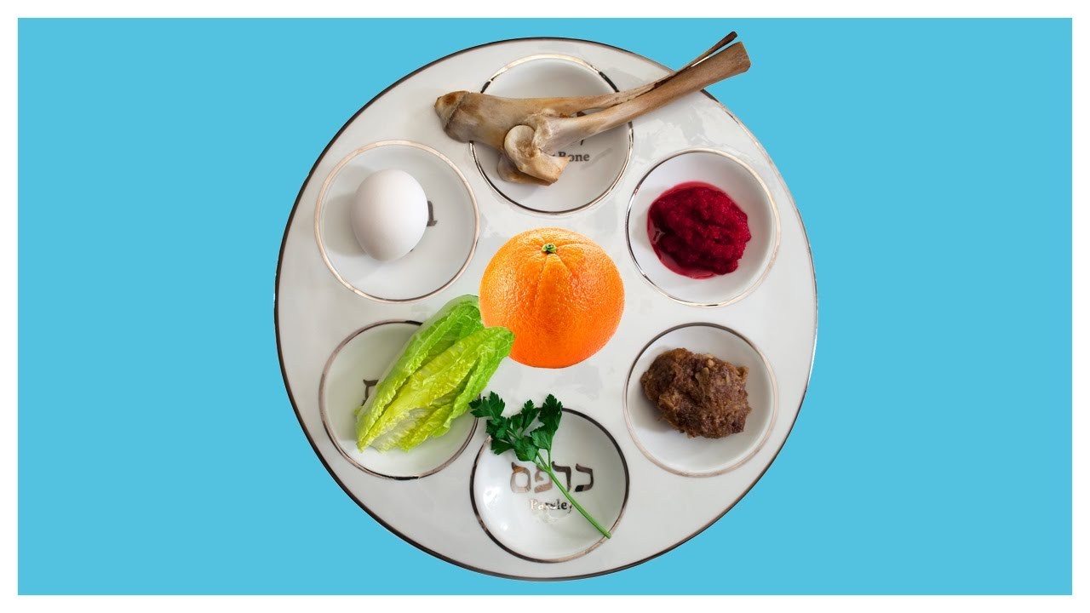

- Roasted lamb shankbone: One of the most striking symbols of Passover is the roasted lamb shankbone (called zeroah), which commemorates the paschal (lamb) sacrifice made the night the ancient Hebrews fled Egypt.
- Roasted egg: The roasted egg is a symbol in many different cultures, usually signifying springtime and renewal. Here it stands in place of one of the sacrificial offerings which was performed in the days of the Second Temple.
- Maror (“bitter herb”): Any bitter herb will work, though horseradish is the most common. Bitter herbs bring tears to the eyes and recall the bitterness of slavery.
- Charoset: Apple, or other fruit, nuts, and spices mixed together with wine are symbolic of the mortar used by Hebrew slaves to build Egyptian structures.
- Karpas: Karpas is a green vegetable, usually parsley (though any spring green will do). Karpas symbolizes the rebirth of spring.
- Orange: The custom of including an orange on a seder plate was started by Susannah Heschel in the 1980s. the orange represents inclusion of women, gay men, lesbians, and others who have traditionally been marginalized in Jewish life.

African American Seder Plate
By Michael Twitty

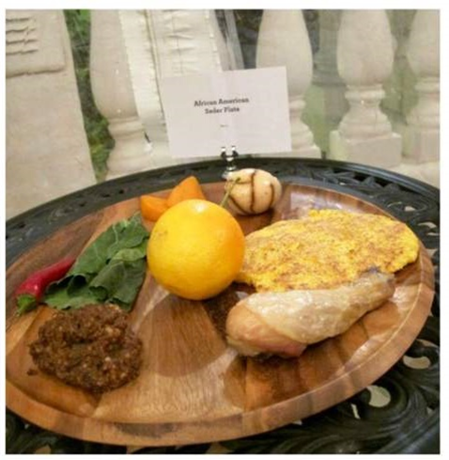

- First of all, in the place of bitter herbs, a reminder of the bitterness endured by the enslaved Israelites, Twitty places collard greens. Collards can certainly be bitter, and in slave days they kept us healthy and alive despite a diet mostly of salt pork and dried corn.
- The roasted lamb shank bone, which symbolizes the temple sacrifice, becomes a roasted chicken leg, the sort packed into shoe box lunches by Southern black travelers heading north by train on the Great Migration, sacrificing their homes for the promise of freedom. Chickens were also among the few types of livestock that black slaves were allowed to keep for their own meals.
- The horseradish, with its nose-opening bite, is another reminder of slavery's sting. On my Seder plate, it's replaced by a spicy red pepper.
- White corn hoecakes, the hardtack of slavery, replace matzoh (not on the seder plate).
- The spring vegetable is not parsley or white potato but a boiled sweet potato on a bed of fresh sweet potato leaves.
- Twitty’s version of charoset, a sweet paste of nuts and fruit that recalls the bricks from which the pyramids were built, is made from sorghum molasses and pecans, showing how my people married the gifts of Africa with the bounty of America to build a new culture of sweetness and strength.
- A couple of the traditional Seder items work as they are. The boiled egg recalls African creation myths, and the salt water, the waves of the Middle Passage.

