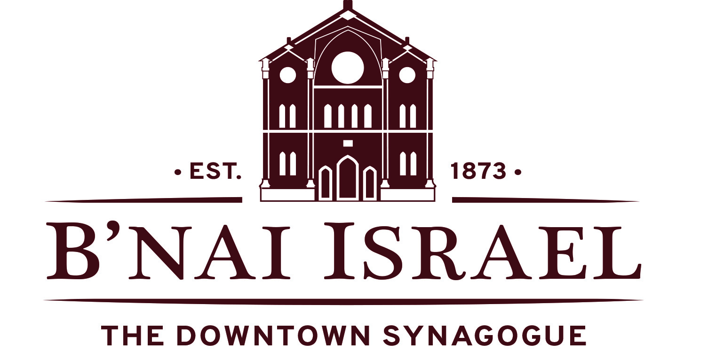
5783 Book of Remembrance

Each year B’nai Israel publishes a Book of Remembrance. This book gives you the opportunity to memorialize your departed loved ones and includes the Yizkor prayers that are used at all Yizkor services throughout the year, starting on Yom Kippur.

In order to have the book available for the Yom Kippur Yizkor service, we ask that you ﬁll out the Memorial Ad Form below and return it to the synagogue’s office no later than Monday, September 5th, 2022. Names received after that date cannot be guaranteed a place in the 2023/5783 Book of Remembrance.

The cost to include your loved ones in the 5783 Book of Remembrance is below. Please check off which option you are interested in.
$25 per name
or
$125 for a half-page ad, regardless of the number of names
or
$175 for full page ad, regardless of the number of names

Please send your Book of Remembrance order and check to: B’nai Israel Congregation, 27 Lloyd Street, Baltimore, MD 21202 with memo: “Book of Remembrance 5782.”

You may also email the form to office@jewishdowntown.org and pay online here. Under the “Type” menu, select the appropriate HH Book of Remembrance category.

If you have any questions or would like to verify receipt of your completed form, please email office@jewishdowntown.org or call 410-732-5454.

Check box if you want your Book of Remembrance page to be the same as last year

In Loving Memory of:

___________________________
___________________________
___________________________
___________________________
___________________________
By: (your name/s, and dedication if desired)

