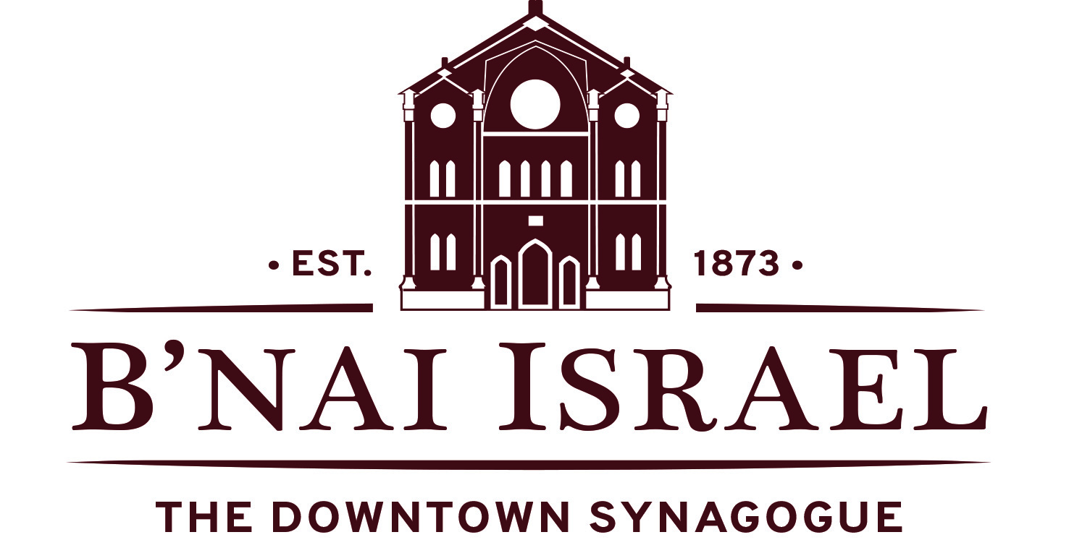
2017 – 2018 Membership Forms

If you are a current member of B’nai, your membership will automatically renew on
July 1, 2017 at the same level as last year. If you would like to upgrade your membership, please check off the new level and return this form.

Please choose a membership category and fill out the back of this form with your biographic information

*forms and payment can also be completed online at www.JewishDowntown.org
 | Lloyd Street Society Membership  In honor of the immense Jewish history contained on just one street. This category helps support the work of our holy congregation. Includes High Holiday seats for all of primary member’s immediate family at no extra charge. |  |  | $3,600/year
 | 1873 Society Membership  Named for the year we were incorporated, these members support 100% of our operating costs in a fair share per member unit model.  Includes 3 High Holiday seats at no extra charge. |  |  | $1,873/year
 | Sustaining Family Membership  The dues for this membership level sustain 70% of the synagogue’s operating budget in a fair share per member unit model.  Includes 2 High Holiday seats at no extra charge. |  |  | $1,260/year
 | Basic Family Membership |  |  | $685/year
 | Sustaining Single Membership  The dues for this membership level sustain 70% of the synagogue’s operating budget in a fair share per member unit model.  Includes 1 High Holiday seat at no extra charge. |  |  | $790/year
 | Basic Single Membership |  |  | $395/year
Associate Membership  For individuals who are full-time members of another congregation but wish to support the work and religious life of B’nai Israel |  | Student Membership  For individual full-time students not receiving stipends. If selecting this option, please write in the name of your college/ university here: ______  Includes 1 High Holiday seat at no extra charge | Alumni Membership  For individuals who were once members of B'nai Israel and have since moved from Baltimore, but wish to maintain a relationship with B'nai Israel and support our work. | $190/year

SERVICES OF B’NAI ISRAEL RABBI
B’nai Israel's rabbi is available for a full range of life cycle- and other services for synagogue members. These services include but are not limited to pastoral counseling, bris and baby-namings, Bar and Bat
Mitzvahs, weddings, hospital visits, and bereavement services.

SPECIAL MEMBERSHIP DISCOUNTS
- Reduced rental rates for synagogue and museum space
- Special negotiated rates with vendors including the MAC Fitness Center, 1840’s Ballroom,
- Pier 5 Hotel, Fairfield Inn, Holiday Inn Express

HIGH HOLIDAY SEATS
Members have a choice of preferred seating in our historic and breathtaking sanctuary. Children's services are also provided and babysitting will be available for those who would like to take advantage.

PROGRAMS FOR ALL AGES & STAGES
- Regular Shabbat, Sunday morning, and holiday services and programs
- Adult education classes
- BIYA – B’nai Israel Young Adults monthly Shabbat dinners and programs.
- Family programs including Tot Shabbat and holiday services
- Weekly Kiddush Reception

Primary Adult
English Name
Hebrew Name | Ben/Bat
Mailing Address
Email Address
Home Phone
Cell Phone
Names of Children

Secondary Adult
English Name
Hebrew Name | Ben/Bat
Mailing Address
Email Address
Home Phone
Cell Phone
Names of Children
Yahrzeit 1

English Name
Hebrew Name
English Date of Death
Death Occurred |  | Before Sunset After Sunset Unknown
Relationship to Member  Ex: Brother of Chaim Levinger |  | of

Yahrzeit 2

English Name
Hebrew Name
English Date of Death
Death Occurred | Before Sunset After Sunset Unknown
Relationship to Member  Ex: Brother of Chaim Levinger | of

