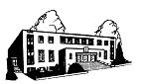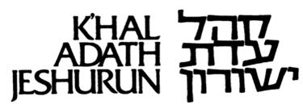

Shabbos PARaSHAS vayeshev

december 17, ‘22 / 23 kislev 5783

Kabolas Shabbos | 4:15
Hashkama | 6:40
Shacharis | 8:30
Mincha | 4:30
Motzoei Shabbos | 5:15
Shiur | Speaker | Time | Location
Mikro Lecture | Rabbi Kalman Strauss | After Davening | Shul
Mishna Berura (For men) | Rabbi Joel Stern | 3:30 PM | Shul
Daf Yomi | Rabbi Dr. Johny Hellmann | 3:30 PM | Sulzbach Shiur Room
Sisterhood Shiur | Miss Avigail Rosenberg | 3:30 PM | Classroom

AVOS UBANIM takes place Motzoei Shabbos at 6:30.
Sponsored this week by an anonymous donor and לז"נ הרב טובי' בו ר' יוסף הלוי. There will be pizza!
For information and sponsorships, please call Albert Blank 212-740-8751.

IN PERSON PIRCHEI AND B’NOS NOW TAKES PLACE AT 3:00 PM.
__________________________________________
PIRCHEI/B'NOS REMOTE.
Call (667) 770-1523 at 3:30 PM Erev Shabbos.
Put in PIN CODE: 781711.
When asked (after each part of the call), say YOUR LAST NAME, and then FIRST NAME.
__________________________________________

Weekday zemanei Tefilla
SUNDAY  Chanukah  1ST Night | MONDAY  Chanukah  2nd Night | TUESDAY  Chanukah  3rd Night | WEDNESDAY  Chanukah  4th Night | THURSDAY  Chanukah  5th Night | FRIDAY  Chanukah  6th Night
18 (24 Kislev)  Shacharis 7:30, 8:30a  Mincha Gedola 1:30p  Mincha/Maariv 4:40p | 19 (25 Kislev)  Shacharis 6:09, 7:00 & 8:00a  Z’man Tallis & Tefillin 6:16  Mincha Gedola 1:30p  Mincha/Maariv 4:40p  Maariv 8:00p | 20 (26 Kislev)  Shacharis 6:10, 7:00, 8:00a  Z’man Tallis & Tefillin 6:17  Mincha Gedola 1:30p Mincha/Maariv 4:40p  Maariv 8:00p | 21 (26 Kislev)  Shacharis 6:10,7:00, 8:00a  Z’man Tallis & Tefillin 6:17  Mincha Gedola 1:30p  Mincha/Maariv 4:40p  Maariv 8:00p | 22 (28 Kislev)  Shacharis 6:11,7:00, 8:00a  Z’man Tallis & Tefillin 6:18  Mincha Gedola 1:30p  Mincha/Maariv 4:40p  Maariv 8:00p | 23 (29 Kislev)  Shacharis 6:11,7:00, 8:00a  Zman Tallis & Tefillin 6:18  Mincha Gedola 1:30p  Kabolas Shabbos 4:19p
The next Holiday Shiur will be on Monday, December 26th after the second (8:30 AM) Shacharis. The Shiur will be given by Rabbi Nosson Lowenthal in 90 Bennett and sponsored by Rabbi and Mrs. Ronny Levy in memory of the 29th Yahrzeit of Kaila Bas Elyokim, Caroline Levy A"H, whose Yahrzeit is the 6th of Teves.

The following Holiday Shiur will be on Monday, January 2, 2023. The shiur will be given by Rabbi Levi Yosef Bechhofer and sponsored by Mr. and Mrs. Samson R. Bechhofer, L’Ilui Nishmas Mr. Jerry Bechhofer z”l, whose 14th Yahrzeit is the next day (Asoro B’Teves).

Weekday Shiurim

Day | Time | Topic | Speaker | Access
Sunday | 10:45 AM | Shivti | Rabbi Yisroel Stein | 646-558-6338, Passcode: 85932#
Sunday | No Shiur | Mishna Berura | Rav Mantel | Shul
Sunday | After Shacharis | Orchos Yosher | Rabbi Joel Stern | Sulzbach Shiur Room
Sun-Fri |  | Daf Yomi |  | Check our website.
Monday | After 8:00 Maariv | Masseches Taanis | Rabbi Avi Rogin | Via phone
Monday & Wednesday | 8:00 PM | Masseches Eruvin | Dr. David Bechhofer | For Zoom information contact Dr. Bechhofer at david.bechhofer@mssm.edu
Tuesday | 10:15 AM | Sefer Malachi | Rebbetzin Mantel | Agudah Shul
Tuesday | After 8:00 Maariv | Minchas Chinuch | Rav Mantel | Shul
Thursday | 8:30 PM | Chumash Shiur | Rabbi Efrayim Berger | 1-435-777-2200, then 85931#

Mazel Tov
- Mr. and Mrs. Allen Riselsheimer on the Bar Mitzvah of their grandson, Alter Hanoch Henoch, son of Rabbi and Mrs. Yitzchok Riselsheimer.
- Mr. and Mrs. Gidon Feigenbaum on the Bar Mitzvah of their son, Betzalel.
- Rabbi and Mrs. Yaakov Bechhofer and Mrs. Meta Bechhofer on the birth of a son to Aryeh Leib and Malka Deitz.
- Mr. Leon and Dr. Shiela Strauss on the birth of a daughter to their grandchildren, Shoshana and Moshe Gleich.
- Mr. and Mrs. Michael Cohn and Mrs. Liesel Cohn on the birth of a daughter to Yehuda and Frumi Strauss.
- Mrs. Judith Wolfe on the engagement of her son, Binyomin to Elana Lazarnick.

Looking for sponsors for next (and future) month’s SHABBOS MEVORACHIM KIDDUSH ($700).
Contact the office or the Shabbos Mevorachim Committee.

Subscriptions are available for Rabbi Reisman’s Navi Shiur which takes place each Motzoei Shabbos
Click https://www.kajinc.org/form/rabbi-reisman-nach-shiur-registration-5783.html

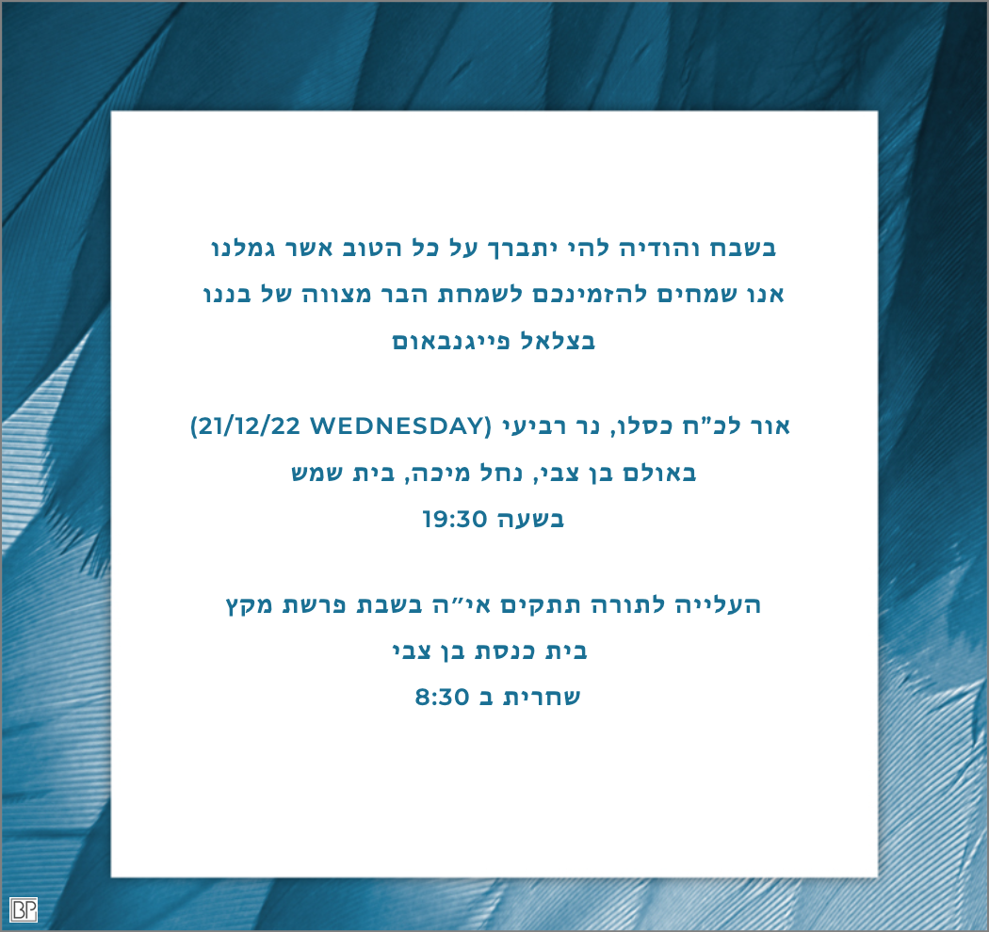
___________________________________________________________________________________________________________
►PUBLIC NOTICE◄
Any articles left over 30 days in Shul or in the office for Shatnez testing, in the Keilim Mikva or by Kashering are considered Hefker and will be disposed of.

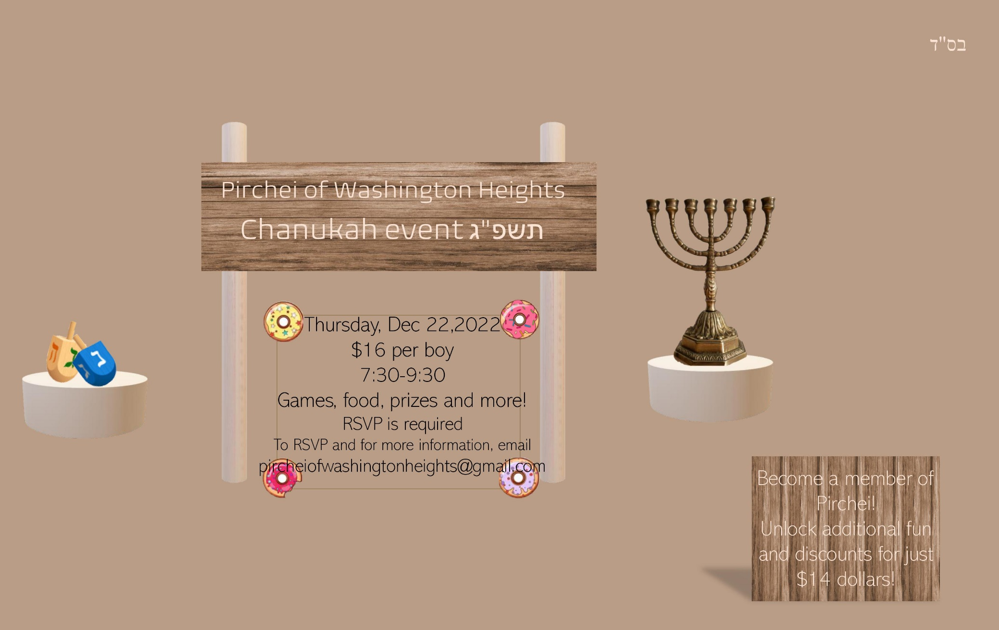
Novominsk on Chumash
Insights, perspectives, and life lessons from the Novominsker Rebbe, Rav Yaakov Perlow zt"l, on Bereishis and Shemos by Rabbi Yecheskel Ostreicher, a close talmid of Rav Perlow, is available at http://www.artscroll.com/linker/KHALADATH/ASIN/NOC1H.

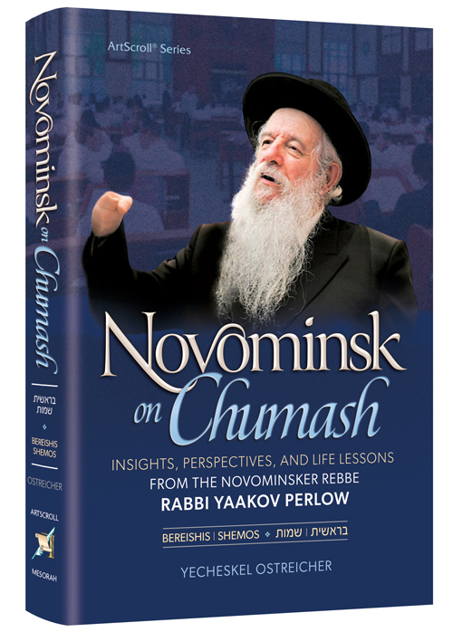

Rabbi Ronny Levy is offering notary services at no charge. To avail yourself of his offer,
please call 917-822-1686

CONTACT INFORMATION

Kehilla Office, 700 W. 186th Street | Rav Yisroel Mantel (Study) 212-781-1345
New York, NY 10033 212-923-3582 / 212-923-5936 | Rav Jacob Posen 732-905-0726
Fax 212-781-4275 | Rav Chaim Kohn 718-252-3343
E-mail office@kajinc.org | Email rabbikohn@gmail.com
 | Rabbi Moses Edelstein 845-425-9089 / Fax 845-356-2938
Mikveh - 4351 Broadway 212-923-1100 | Email kashrus@kajinc.org
Yeshiva Office 212-568-6200 | Mr. Victor Sussman 212-568-2867
YRSRH Executive Office 212-568-6250 | Kehilla Maintenance maintenance@kajinc.org
Mesivta Office 212-781-3399 | Moriah Luncheon Club 212-923-5715
Jewish Community Council 212-568-5450 | www.moriahseniorcenter.org
HATZOLOH EMERGENCY # 212-230-1000

Chevra Kadisha
When the services of the Chevra Kadisha are required - Bar Minon - kindly contact any of the following immediately:
OFFICE OF THE CONGREGATION
1-212-923-3582
LEON GERSTLE
Cell: 917-733-3639
PINCHAS KATZENSTEIN
201-399-4494
All levaya arrangements must be made verbally with the Chevra Kadisha or the Kehilla office. Family members should not contact Plaza Jewish Community Chapel. To avoid mix-ups, the Chevra Kadisha will communicate with the Plaza Jewish Community Chapel regarding levaya arrangements.

Have a Good Shabbos and a freilichen Chanukah!

