BSBI Academy of Adult Jewish Continuing Education
2018-2019 Schedule of Lectures and Courses
View our website at https://www.myshul.org/continuing-education.html
for up to date information and extra registration forms
Rabbi Randall J. Konigsburg Cantor Sarah Bolts Richard Plavin, Rabbi Emeritus

Lunch and Learn:
Exploring the Many Facets of the Bible
Tuesdays Beginning Oct. 16, Noon-1:30pm
Instructor: Rabbi Konigsburg
Bring your own kosher dairy lunch
Starting with Genesis, a weekly chance to explore the plain and hidden lessons of the Bible.
*$10 per class or $50 Hall Pass*

BSBI Academy
The Ethical Life: Jewish Values In An Age Of Choice
Tuesday evenings 7:30-8:30 pm
Instructor: Rabbi Konigsburg
What is the relationship between ethics and religion? If people can act ethically without believing in God, do they need Judaism to live a moral life? Join our quest to lead an ethical life with an understanding that the challenges posed by contemporary realities should be informed by the richness of the Jewish tradition.
*$10 per class or $50 Hall Pass*

Ethical Life Introduction Oct. 16
The Sources of our Ethics Oct. 30
Ethics of Food Production Nov. 6
Fracking & Neighborhood Relations Nov. 13
Mass Incarceration and Teshuva Nov. 20
Modern Day Slavery Dec. 4
Ethics of War and Torture Dec. 11
Ethics at the End of Life Jan. 8
Ethics of Inclusion Jan. 15
Surrogacy & Ethics in Relationships Jan 22
The Ethics of Enhancement Feb. 5
Is Lying Ever Ethical Feb. 12
Ethics In Our Lives Feb. 19

*For Lunch and Learn and BSBI Academy series: You may attend any of these sessions for $10 per class or purchase a Hall Pass to attend as many as you want. The pass is $50 per person, $75 if you sign up with a study partner. You may register in advance or just show up with your payment. One pass is good for both series.

Shabbat Programs:
Learner’s Minyan:
1st Saturday of the month, 10-11 am
Instructor: Michelle Konigsburg
Learn the structure and choreography of the Saturday service in a relaxed setting. Bring your questions.

Shirat HaLev:
2nd Saturday of the month, 10-11 am
Instructor: Cantor Bolts
Awaken your soul with a musical contemplative interpretation of the Shabbat Morning Service.

Meditation Service:
3rd Saturday of the month, 9:30-10:30 am
Instructor: Rabbi Konigsburg
Prepare for prayer with chanting of prayers and mindful meditation

Life, the Universe and Judaism:
4th Saturday of the month, 10-11 am
Instructor: Michael Chernicoff
Come learn what science has to say about our universe and life as we know it, then discuss Judaism’s views on the same subjects. Moderator

Shabbat Programming is free

January Mini Lecture Series
The Bible and the Ancient World
With Dr. Deena Grant, Associate Professor of Jewish Studies at Hartford Seminary

All Lectures at 7:30 PM
Jan. 7, 2019
Genesis and the Ancient Creation Myths
Jan. 14, 2019
The Biblical and Extra-Biblical Floods
Jan. 28, 2019
What Archeology has to teach us about Kings David and Solomon.
Snow date: Feb. 4
Fees:
$30 Full Series
$15 Student Full Series
$12 per lecture purchased at the door
$5 for student per lecture purchased at the door

Embracing Judaism
Instructor: Rabbi Richard Plavin and other Hartford areas Conservative rabbis
Begins October 18
Meets Thursday nights, 7:35 – 9:15 PM
At Beth El Temple in West Hartford

Whether you want to reboot your Judaism, satisfy your intellectual curiosity or consider Judaism as a new faith, you are invited to delve into the richness of the Jewish heritage.

Fee: This Program is offered in three semesters that can be taken in any order. Registration is $75 per semester. Student registering for all 18 sessions will pay $180. Significant Others, Full time students and IBJ Alumni will receive a 50% discount. For more information and to register, go to http://www.ibjewish.org/

There is also a connected but separate Beginners Hebrew class associated with this series beginning in December.

For complete information on this course, Contact Rabbi Plavin 860.573.4503, or email him at riplavin@gmail.com

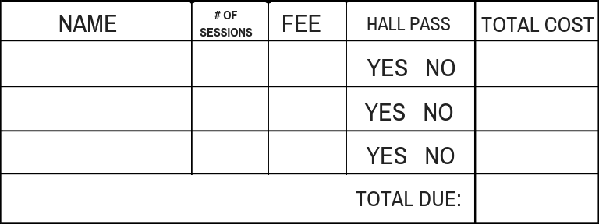

Sandals Lecture:
March 5, 2019 7:30 PM
featuring Rabbi Edward Feld
The Making of a Mahzor and a Siddur
What kinds of prayer books are needed in the twenty-first century? Do we pray in the same way our ancestors did? What might we expect from a new siddur? What has made the Lev Shalem series such a success?
Fee: TBA

Torah Study Shabbat:
Spirituality and The Brain: How Judaism Can Bring Us Peace Of Mind

April 5-7, 2019
Rabbi Mychal B. Springer
Founder of the Center for Pastoral Education at the Jewish Theological Seminary
Examining the place where the sacred can touch our lives, we will explore Vulnerability as a Path to the Divine; How Prayer Can Support Wellbeing and Cultivating Resilience
Fees: TBA

Adult Bar Mitzvah
Never had the chance to lead a service or chant an Haftara? If you can read Hebrew then this will open the service to you as you prepare with your class to take on the spiritual responsibilities of Judaism. Led by Cantor Bolts and Rabbi Konigsburg, we will work together to find the time and location for learning.

