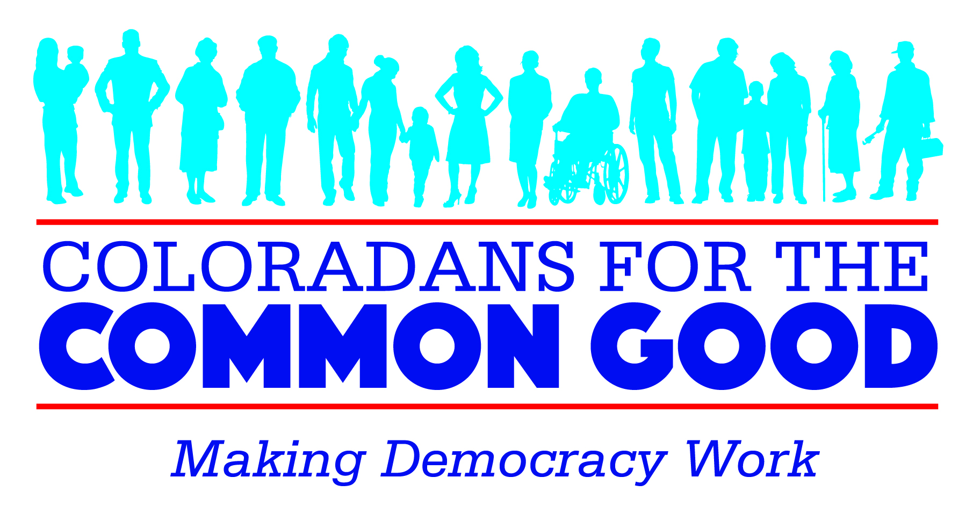
Coloradans for the Common Good (formerly Colorado IAF) is building a Broad-Based Organization in the Greater Denver Metro Area comprised of local institutions, including congregations, unions, educational institutions, non-profits, and neighborhood organizations who share a concern for families and a passion for democracy and are led by their convictions, values, and faith to act for the common good.

Coloradans for the Common Good is dedicated to:
- Creating a vehicle for ordinary people to have a powerful voice in the decisions that affect their lives and communities by increasing participation in public life, through relational meetings, house meeting campaigns, research actions and public actions
- Developing leadership and strengthening community within and between institutions
- Building bridges across longstanding divisions that isolate communities from each other
- The building of this network involves:
  - Identifying and recruiting institutions who share a passion for democracy and are led by their convictions, values, and faith to act for the public good
  - Building relationships of trust among people and institutions across the racial, denominational, economic, and geographic boundaries that divide our larger community
  - Strengthening member institutions by developing the skills and capacity of their leaders
  - Facilitating the formulation of a public agenda and action plan which is responsive to consensus interests of member institutions
How We Work:
- We are non-partisan and will not endorse any candidate or party
- We act on issues identified by the local community through the process of conducting individual relational meetings and house meetings
- We’re led by local leaders from member institutions, with support from professional IAF organizers to facilitate local leadership development
- Our funding comes primarily from member institution pledges, supplemented by individual and grant funding, and no government funding; we do not accept money that tries to direct who we are or what we do

