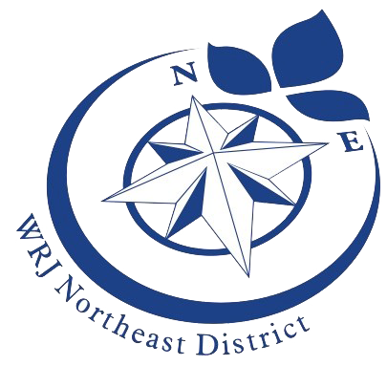
Women of Reform Judaism Northeast District
A WRJ Northeast District Area Event in Toronto

Kol Isha
The Voices of Women Together for Social Justice

Sunday, October 14, 2018
9:00 a.m. – 2:00 p.m.
Holy Blossom Temple, 1950 Bathurst Street, Toronto Ontario

Featured speakers include:
- Vivian Blumstein – President, WRJ Northeast District
- Eva Karpati - President, National Council of Jewish Women of Canada
- Barbara Weinstein – Associate Director of the Religious Action Center
- Fran Isaacs and Helen Poizner – speaking about the Canadian Brit Olam
- Centre for Israel and Jewish Affairs (CIJA)

This is an invitation to all women who want to meet, learn,
be empowered and empower others.

For more information, please contact Ruthe Schipper at sisterhood180@gmail.com
This program is subsidized by the WRJ Northeast District

YES, I want to attend the WRJ Northeast District Area Day on Sunday October 14, 2018

Name: _________________________________________

Phone: _________________________________________

Email: _________________________________________

Sisterhood/City: _________________________________________

Please send completed form (one for each participant) to Ruthe Schipper, 802-240 Heath Street West, Toronto, Ontario M5P 3L5. Cheque for $20.00 CAD payable to Holy Blossom Temple Sisterhood should be included with completed form.

