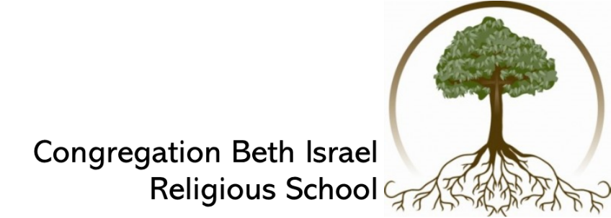
 | August/September 2019 |  | Holidays and Special Events
Aug 18th | 11:00-1:00 Teacher orientation  1:00 p.m. Ice Cream Social |  | Aug 18, Sun - Ice Cream Social
25th | First Day of Classes/Pre-K/PS
Sept 1st | No RS - Labor Day Weekend
8th | RS Classes/Pre-K
15th | RS Classes/PS |  | Sept 20-21 Selichot Scholar Weekend
22nd | RS Classes/6th Family Ed |  | Sept 22, Sun - 6th Grade Family Ed  Sept 27, Fri - 4th Grade Shabbat
29th | No RS - Erev Rosh Hashanah |  | Sept 29, Sun - Erev Rosh Hashanah  Sept 30, Mon - Rosh Hashanah
 |  | October |  |  | Holidays and Special Events
6th |  | RS Classes/Pre-K |  |  | Oct 8, Tues - Erev Yom Kippur  Oct 9, Wed - Yom Kippur
13th |  | RS Classes/PS/7th Family Ed |  |  | Oct 13, Sun - Erev Sukkot  Oct 13, Sun - 7th Grade Family Ed
20th |  | RS Classes/Pre-K |  |  | Oct 22, Mon - Simchat Torah
27th |  | RS Classes/PS
 |  | November |  |  | Holidays and Special Events
3rd |  | RS Classes/Pre-K |  |  | Nov 8, Fri - 3rd Grade Shabbat
10th |  | RS Classes/PS
17th |  | RS Classes/Pre-K/PS
24th |  | No RS - Thanksgiving
 |  | December |  | Holidays and Special Events
1st |  | No RS - Thanksgiving
8th |  | RS Classes/Pre-K/4th Family Ed |  | Dec 8, Sun - 4th Grade Family Ed
15th |  | CHANUKAH PAJAMAKAH |  | Dec 15, Sun - Chanukah Pajamakah
22nd |  | No RS - Teacher Training |  | Dec 22 - 30, Chanukah
29th |  | No RS - Winter Break

 | January 2020 | Holidays and Special Events
12th | RS Classes/PS/3rd Family Ed | Jan 12, Sun - 3rd Grade Family Ed
19th | RS Classes/Pre-K | Jan 24, Fri - 5th Grade Shabbat
26th | RS Classes/Pre-K/PS
 | February | Holidays and Special Events
2nd | RS Classes/Pre-K | Feb 1, Saturday – 6th Grade Shabbat  Feb 7, Fri 6:30 1st/2nd Grade Shabbat
9th | RS Classes/PS | Feb 9, Sun - K/1st/2nd Grade Family Ed  Feb 10, Mon - Tu Bishevat
16th | RS Classes/Pre-K
23rd | RS Classes/PS/5th Family Ed | Feb 23, Sun - 5th Grade Family Ed  Feb 28-March 2 - L’Taken - Confirmation
 | March | Holidays and Special Events
1st | RS Classes/Pre-K
8th | No RS - Spring Break | Mar 9, Mon - Erev Purim, CBI Purim Spectacular
15th | No RS - Spring Break
22nd | RS Classes/PS | Mar 27, Fri - 7th Grade Shabbat
29th | RS Classes/Pre-K | Mar 29, Model Seder
 | April | Holidays and Special Events
5th | No RS - GFC Spring Camp | Apr 8, Wed - First Night of Passover  Apr 9, Thurs - CBI 2nd Night Seder
12th | RS Classes/ Pre-K
19th | RS Classes/PS | Apr 21, Tues - Yom Hashoah
26th | RS Classes/Pre-K | Apr 28, Tues - Yom Hazikaron  April 29, Wed - Yom Ha’atzmaut
 | May | Holidays and Special Events
3rd | RS Classes  Israel Palooza  Israel Fair/Shark Tank | May 3, Sun - Israel Fair  May 8, Fri - Teacher Appreciation Shabbat
10th | No RS - Mother’s Day
17th | Last Day of Religious School/Pre-K/PS
 | HAVE A GREAT SUMMER | May 28, Thurs - Shavuot/Confirmation

