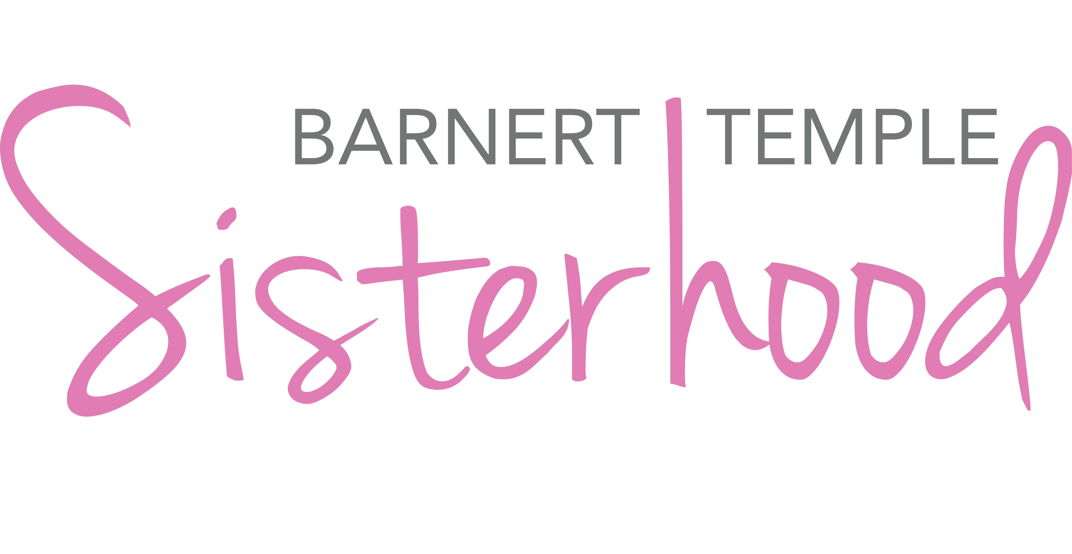
Barnert Temple Sisterhood
Chanukah “Churro” Challah Recipe

Ingredients:
For the dough…
- 2 packages dry active yeast
- 1 1/3 cup warm water
- 1 tsp sugar
- ½ Tbsp salt
- 2 eggs beaten plus 1 egg yolk (room temp). Keep egg white for the egg wash at the end.
- 1/3 cup oil
- 1 Tbsp vanilla extract
- 1/2 cup sugar
- 4 – 4 ½ cups flour

For the cinnamon & sugar…
- ½ cup granulated sugar
- 2-3 Tbsp cinnamon
- 1 Tbsp butter (melted) Optional

Supplies:
- 2 large bowls (glass, ceramic or metal)
- Parchment or Silpat
- Tea towel
- Baking sheet(s)
- Cooking spray
- Gallon Ziploc bag

Directions:
- Mix cinnamon and sugar for filling in a small bowl and set aside.
- In a bowl, dissolve yeast and 1 tsp sugar in warm water. Let stand for approximately 10-15 minutes (until bubbling and foaming).
- Mix the salt, egg, oil, vanilla, and remaining sugar. Mix well. Add to the yeast mixture.
- Gradually add flour, 1-2 cups at a time, mixing after each addition.
- Once combined, flour your hands and knead dough 10-15 min until smooth and elastic, but not too sticky.
- Cover with plastic wrap or towel.
- Let dough rise for 2 – 3 hours. (We will abbreviate this time during our virtual cooking session). Punch down approximately 1 hour into rising time.
- Divide into 3 pieces. (If you want to make 2 loaves, break into 6 pieces.). Roll into logs. Flatten each log. Optional: Brush each log with some butter. Sprinkle with cinnamon and sugar and seal each log.
- Braid and form dough as desired on Silpat/ parchment. Brush with egg whites and cover with cinnamon sugar mixture. Cover as lightly or as heavily as you wish.
- Let rise another 30 minutes. (After the dough rises again, you may want to fill in some of the newly formed gaps with additional cinnamon and sugar.)
- Bake in 350-degree pre-heated oven for 25-30 minutes, until golden brown.
**This recipe is an adapted version of “This Challah Tastes Just Like Churros” recipe found at https://www.myjewishlearning.com/the-nosher/this-challah-recipe-tastes-just-like-churros/

FAQs from Challah Bakes
All-Purpose, Bread, Whole Wheat…Which Flour to Use
Today’s teachers typically use all-purpose white flour. Rita Kron, one of our teachers has used a white whole-wheat flour. Rebecca has used all-purpose and bread flour. However, the general consensus was that all-purpose flour does the trick!
For those who want to use whole wheat flour, know that you can’t simply swap whole wheat for white flour. The whole wheat challahs you purchase from bakeries and stores are made from a blend of whole wheat and white flours. If you want to try a whole wheat challah, check out this recipe (https://www.chabad.org/recipes/recipe_cdo/aid/2742173/jewish/Fluffy-Whole-Wheat-Challah.htm)
Rapid, Instant, Regular…Which Yeast to Use?
Technically, these yeasts are a bit different and can be used differently in recipes. However, our challah bakes are all about removing the intimidation factor and so challah baking is easy and accessible. So, the short answer is this: They all work! Use what you have or can find in the store and follow the recipe.
To learn more about the different types of yeast, visit https://www.thekitchn.com/whats-the-difference-between-active-dry-yeast-and-instant-yeast-54252.
How Warm Should the Water Be to Proof My Yeast?
For some, dealing with the yeast is the scariest part of making challah or bread. Yeast won’t proof in yeast that is too cold, but water that is too hot will kill yeast.
Typically, hot water that is 105-115 degrees fahrenheit is ideal. However, most of us don’t have baking thermometers at home. You can use the good old-fashioned wrist method. If the water feels warm on your wrist, you should be fine.
To learn more about proofing yeast, visit https://www.bobsredmill.com/blog/baking-101/what-temperature-kills-yeast/
What’s an Egg Wash?
Love that shiny look of challah? That comes from the egg wash. An egg wash is typically made of a whole egg and water. An egg wash is typically a 3:1 ratio. For our challah, you can use 1 egg and approximately 1 tablespoon of water. If you want to sweeten your wash, you can add honey or agave. “How much honey or agave?” you ask. As Sheryl, one of today’s teacher offered, “One big squirt form your honey bottle.”
To learn more about the different types of egg wash, visit https://www.thespruceeats.com/egg-wash-yeast-breads-rolls-3057783.
When to Egg Wash
As you saw today, one question never seems to have one answer.
Two of today’s teachers apply their egg wash right before baking (after the second rise). Another liked to apply it after braiding, before the second rise.
The bottom line is, pick what works for you. Just don’t skip it. The egg wash adds the glossy brown coating that we have come to love on challah. However, it also helps apply moisture to the dough, which helps it rise.
Expedited Rising Process
Sometimes, we want to make challah but just don't have the time for 2 ½ hours of rising time. Furthermore, we could never do an in-person challah bake that lasted 3+ hours! That’s why we have an expediting rising process.
There are a few ways to expedite the rising process for your dough. The ones we presented on Sept. 13, 2020 are listed below.
Plastic Bag in Warm Water
Grease a gallon Ziploc bag with cooking spray or oil. Place your dough in the bag. Fill a bowl with warm water, and place your Ziploc bag with dough in the warm water and cover with a towel.
Nested Bowls with Warm Water
Grease a gallon Ziploc bag with cooking spray or oil. Place your dough in the bag. Fill a bowl with very warm water (hot but not boiling). Place another bowl inside the bowl with the water. Place your Ziploc bag with dough in the bowl, and cover with a towel.
Expedited vs. Standard Rising Process: Which is “Better?”
“Better” is a totally subjective thing when it comes to challah. Have you ever heard people argue over who makes the best challah? People have very strong opinions when it comes to this delicious bread.
One is not better. They are just different and produce slightly different results. When you have the time to let your dough rise, you will get a lighter challah bread in the end. When you use the expedited process, the end result is a little denser. However, they are both delicious and will surely be devoured by you or the hungry mouths in your house.
Note: Rebecca does a hybrid version of the rising processes when making challah. She fills a bowl with HOT water (not boiling, but pretty hot). Places a greased bowl inside the bowl with the water. Puts the dough in the greased bowl and covers with a tea towel.
Parchment vs. Oil
Is parchment paper better than greasing your baking pan? Can you guess what our answer will be? Not better or worse – different.
If you are making challah in a pan with sides (e.g., a round pan, a loaf pan, etc.) spraying the pan with cooking spray does the trick! If you are making a braded challah on an open pan, parchment paper works nicely and makes clean-up easy. The bottom line is that either works. Try both out, and pick which you prefer.
Room Temp vs. Cold Eggs
Does it matter? Yes. Baking typically calls for room temperature eggs. Room temperature egg yolks break more easily, allowing them to mix more evenly with the egg whites and other ingredients. (This is especially important when working with recipes with high fat content, like cheesecake.) Cold eggs can also lower the temperature of your batter, impacting your bake time.

Forgot to pull your eggs out of the fridge before starting your baking? No problem! Place your whole eggs in a bowl, and cover them with warm (not hot!) water. Allow them to sit for 10 to 15 minutes until no longer chilled. If you do this before prepping the rest of the recipe, they should be ready to go when you are.

Read more at https://www.tasteofhome.com/article/bake-with-room-temperature-eggs/
Neutral vs. Flavored Oils
We typically use vegetable oil in our challah recipe. However, it can be fun to experiment with flavored oils. For example, do you have a garlic oil or a rosemary oil that has been sitting in your closet for ages? Go for it! Flavored oils can add a fun variation to your standard challah.
How Dangerous is it to “Experiment” With the Recipe?
Not much. Want to add another egg or egg yolk? Want to replace the water with warm milk? Want to add a little garlic powder to the recipe? Why not! This recipe is a standard “go to” recipe that leaves room for experimentation and creativity.
“Taking Challah”/Hafrashat Challah – What Is It and Why Do We Do It?
Have you ever seen someone remove a piece challah dough and cook it separately? You are either saying, “Yes!” or “Huh?”
There is an ancient tradition associated with challah making called hafrashat challah. In the Torah, God tells Moses to instruct the Israelites to set aside the first loaf in their bread baking as a gift to God. In observance of this mitzvah, the Israelites set aside a portion of their dough for the kohanim (priests). The dough was considered part of their salary since the priests were essentially public servants.
Today there is no Temple in Jerusalem. But this practice of “taking challah” (in Hebrew, hafrashat challah) is still around. Instead of bringing dough to the kohanim, though, we separate a small piece of dough — about the size of an olive — and either burn it or dispose of it respectfully, rendering inedible the portion that God commanded be set aside.

Learn more about this tradition at https://www.myjewishlearning.com/article/ask-the-expert-taking-challah/
Braiding Doesn’t Have to be Scary
Most people can handle a 3-strand braid. If you have ever braided someone’s hair, you can braid challah. When you begin discussing 4, 6 and 8 strands, anxiety levels seem to rise. Here’s where YouTube will come to the rescue! Braiding/weaving round challahs is actually easier than braiding regular challahs. However, with a bit of practice, braiding won’t feel so daunting.
Below are links to two videos about creating braided round challahs.
- 4-Strand Round:
https://www.youtube.com/watch?v=dj8tuQ1RojM
- 4 & 6-Strand Round:
https://www.youtube.com/watch?v=u7D8PSBsy1M

Below are links to some other braiding videos for regular challahs.
- 12 Minutes of Braiding Techniques!
https://www.youtube.com/watch?v=T99q8NPLdYU
- 4-Strand Regular:
https://www.youtube.com/watch?time_continue=109&v=llhB1eNh580&feature=emb_logo
- 6-Strand Regular:
https://www.youtube.com/watch?v=BWSPfToKiYA

