BARNERT TEMPLE SISTERHOOD 2018-19

Knit/Crochet Projects

This year, we are making knitted hats and knitted/crocheted bears to benefit children fighting illness and disease. The bears will be donated to children around the world through Knitting Without Borders (http://www.knittingwithoutborders.jigsy.com). The hats will be distributed by the Emanuel Cancer Foundation (https://www.emmanuelcancer.org/).

HATS FOR CHILDREN WITH PEDIATRIC CANCER
(Distributed by the Emmanuel Cancer Foundation)
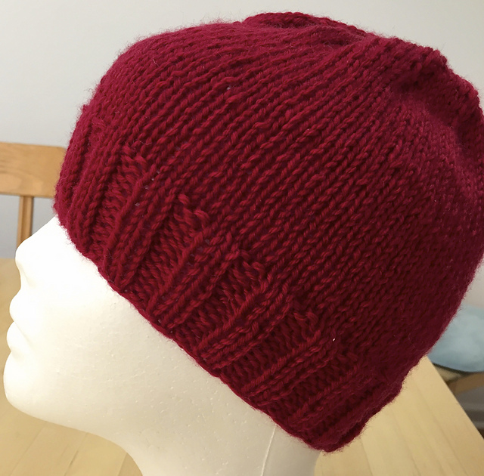

Use this pattern as a guide to knitting basic hats in 3 sizes, and 3 gauges. Choose your yarn and appropriate sized needles, as suggested below. Follow the instructions for the selected yarn weight and size that you choose to knit.

Where there are multiple numbers noted, they apply to small/medium/large.

Sizes
Small (Baby - Toddler)
Medium (Child - Teen)
Large (Adult)

Bulky weight version (3.5 sts per inch)
Materials: 90-130 yds bulky weight yarn
16” circular needles - size 9 (for ribbing) and size 10.5 (for body)
dpns - size 10.5 (for top shaping)

Worsted weight version (4.5 sts per inch)
Materials: 125-200 yds worsted weight yarn
16” circular needles - size 6 (for ribbing) and size 8 (for body)
dpns - size 8 (for top shaping)

DK weight version (5.5 sts per inch)
Materials: 175-250 yds worsted weight yarn
16” circular needles - size 4 (for ribbing) size 6 (for body)
dpns - size 6 (for top shaping).

Notes and Abbreviations
K - knit
P - purl
st(es) - stitch(es) rd(s) - round(s)
k2tog - knit 2 stitches together (decrease)
dpns - double pointed needles

The pattern can be adapted in a number of ways:
* You can adjust the length of the hat by knitting more or less rounds of ribbing, and/or knitting more or less rounds before top shaping begins.

* If you prefer a ‘slouchy’ hat, then work 3-5” in ribbing, and add 2-4” to recommended length of stockinette stitch section.

* If you’d like a folded up brim, double the recommended length of ribbing.

* Instead of ribbing, you can work bottom border in garter stitch or a rolled stockinette edge. Simply work the bottom edge on the smaller sized circular needle, in the edge stitch of your choice. For garter stitch, alternate 1 round of knit stitches and 1 round purl stitches. For stockinette stitch, knit all rounds.

- You may find the smallest size hats more comfortable to work entirely on double pointed needles.

Instructions
Using smaller size circular needles, loosely cast on:
Bulky 48/64/80 sts.
Worsted 64/80/96 sts.
DK 80/96/120 sts.

Place marker on right hand needle (to mark beginning of round) and join work in the round, being careful not to twist stitches.

Slip marker when you come to it, from the left to the right hand needle.

Work in ribbing (either K1P1 or K2P2) for 1-2”, or to desired length of ribbing.

Change to larger circular needles and work in stockinette stitch (knit all rounds), until hat measures approx. 4-5”/6-7”/9-10” or desired length from cast on edge.

Note: The remaining 11 rounds will add approximately 1-2” to total hat height.

Top Shaping

Begin decreasing as follows, switching to dpns when necessary.

- Round 1: (k6, k2tog), repeat around
- Round 2: knit around
- Round 3: (k5, k2tog), repeat around
- Round 4: knit around
- Round 5: (k4, k2tog), repeat around
- Round 6: knit around
- Round 7: (k3, k2tog), repeat around
- Round 6: knit around
- Round 9: (k2, k2tog), repeat around
- Round 10: (k1, k2tog), repeat around
- Round 11: (k2tog), repeat around

Cut yarn, leaving a 12” end. Thread yarn end onto tapestry needle, pull through remaining stitches and gather tightly. Weave ends in on wrong side of fabric.

ABOUT EMMANUEL CANCER FOUNDATION
https://www.emmanuelcancer.org/

The Emmanuel Cancer Foundation provides New Jersey families facing the crisis of pediatric cancer a place to turn for comfort and support through professional in-home counseling and a uniquely tailored package of assistance – all free-of-charge.
With over 30 years of experience, we have developed a proven method for delivering services to families with a child battling cancer. Since our grassroots inception, we now have a statewide reach and provide free tailored assistance to over 2,000 families in need.

Mission
The mission of the Emmanuel Cancer Foundation is to provide New Jersey families faced with pediatric cancer a place to turn for comfort and support through professional in-home counseling and a uniquely tailored package of assistance. We offer 24-7 counseling for the entire family, advocacy on behalf of the families with insurance companies, medical providers, landlords, etc.; material support such as food, clothing, toys, household items and birthday and holiday gifts; and emergency financial relief.
ECF is unique among the multitude of organizations focusing on cancer–while there are many searching for a cure for cancer and others that grant one-time wishes or provide support while in the hospital, we help families with their day-to-day needs, at home, where families feel isolated and miss the supportive network found in a medical setting. ECF recognizes that every one of our families has a unique experience so we offer a complete package of support tailored to each family’s needs.
Help put smiles on the faces of children with cancer while keeping their heads warm. Any size hat, any color! Hats will be delivered to and distributed by ECF. We would like to have hats ready by February 2019.

KNITTED/CROCHETED BEARS FOR CHILDREN IN TANZANIA & KENYA
(Distributed by the Knitting Without Borders)

The bears are being distributed by Knitting Without Borders to children around the world, including children in orphanages, schools, remote villages and hospitals, where children are undergoing medical tests or treatments. Barnert Temple Sisterhood will be working on bears, which will be sent to Tanzania (50 bears due February 1) and Kenya (70 bears due April 25).

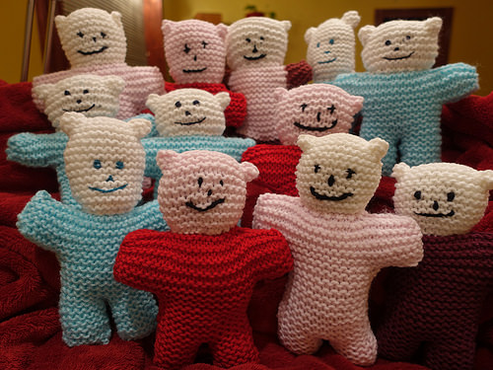

MATERIALS NEEDED FOR KNITTED BEARS

- Soft worsted weight yarn
- Poly-fill
- Knitting needles size 7 or 8
- Sewing needles and matching thread
- Pin

KNITTED BEAR PATTERN/DIRECTIONS

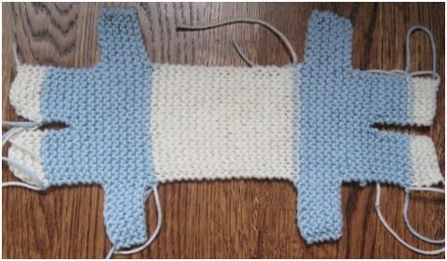
- Cast on 7 stitches (for the first leg), knit 14 rows and break off yarn.
- Cast on 7 stitches on the same needle (for the second leg) and knit 14 rows.
- Knit across both legs to join.
- Knit 7 rows.
- Cast on 7 more stitches (for the 1st arm) and knit to the end of the row.
- Cast on 7 more stitches (for the 2nd arm) and knit to the end of the row
- Knit 7 rows.
- Bind off 7 stitches to close the first arm and knit to the end of the row.
- Bind off 7 stitches to close the second arm and knit to the end of the row * Check! You should now have 14 stitches on your needle.
- Knit 34 rows.
- Cast on 7 more stitches (for the back of the 1st arm) and knit to the end of the row.
- Cast on 7 more stitches (for the back of the 2nd arm) and knit to the end of the row
- Knit 7 rows.
- Bind off 7 stitches to close the first arm and knit to the end of the row.
- Bind off 7 stitches to close the second arm and knit to the end of the row.
- Knit 7 rows.
- Knit only the first 7 stitches and then use a pin to temporarily hold the next 7 stitches.
- Knit 14 rows and then bind off.
- Return to the 7 stitches on temporary pin, knit 14 rows and bind off.
- FINISH
- Fold knitted piece in half lengthwise. The fold becomes the top head top. Embroider eyes, nose and smile with sewing needle and thread.
- Join seam around the bear leaving a small gap between the legs to insert the Poly-Fil. Turn right side out. Stuff the bear and sew opening close.
- Sew a string of yarn all around the neck, pull the yarn to shape the neck and secure the ends.
- Backstitch a diagonal line across each corner of the head to form the ears.
- To knit bear scarf, cast on 60 stitches, knit 4 rows and bind off. Tie around the bear's neck and secure in place so it doesn't get lost during transportation.
- For the children's safety, please do not attach buttons or any other objects. Use only yarn and Poly-fill.
- *Our pattern produces small bears because the more bears we can fit in a luggage the more little hearts we can touch. Thank you for following the pattern!

MATERIALS NEEDED FOR CROCHETED BEARS

- Soft worsted weight or lighter yarn
- Poly-fill
- Size F or G hook
- Sewing needles and matching thread
- Pin

CROCHETED BEAR PATTERN/DIRECTIONS

SC – Single Crochet CH – Chain
Use a size F or G hook with worsted weight or lighter yarn.
Finished Teddy should be approx. 7” tall.
The more bears we can fit in a luggage the more little hearts we can touch.

LEGS: Chain 8, SC in each stitch across (7 SC). Chain 1 at the end of each row except last.
Work 8 rows for each leg. End off and make another leg to match. On the second leg, do not end off. Position legs side by side and Chain 1 then crochet across top of both to join (14 SC).

BODY: Work 6 rows for body. Chain 1 at the end of each row except last.

ARMS: At end of 6thbody row, chain 8. Turn and SC in each stitch (7 SC)to the end of body (14 SC). Then Chain 8 more for the other arm. Turn and work across. SC a total of 5 rows. Chain 1 after each row. After 5 rows stop after (21 SC) to complete the first arm, chain 1 and SC back across and end after (14 SC) to complete the other arm

HEAD: CH 1, turn and SC. Work 24 rows for head (front and back). Chain 1 at the end of each row except last.

SECOND SET OF ARMS: At end of 24th head row, chain 8. Turn and SC in each stitch (7 SC)to the end of body (14 SC). Chain 8 more for the other arm. Turn and work across. SC a total of 5 rows. Chain 1 after each row. After 5 rows stop after (21 SC) to complete the first arm, chain 1 and SC back across and end after (14 SC) to complete the other arm

SECOND SIDE OF BODY: CH 1, turn and work 6 rows for body.

SECOND SET OF LEGS: CH 1, turn. (SC7) work a total of 8 rows. End off. Attach yarn at other side of body CH 1then (SC 7) and work second leg as first. End off.

FINISHING THE BEAR: Fold body in half, matching up arms and legs. Sew or crochet around, leaving opening for stuffing. Stuff, then whipstitch opening closed. Weave a length of yarn in and out around the neck, drawing up tightly and knotting securely, pull ends through bear so they disappear. Pinch the corners of the ears then weave yarn to form small triangle and tie yarn. Embroider eyes, nose and mouth in colors of your choice. Look at some of the cute faces we have on the Knitting without Borders website to get ideas. Make a cute scarf and secure it in one place to the bear so the child won’t be able to pull it off. And now you have a cute cuddly bear that will bring a smile to a child’s face!

For the safety of the children, please do not attach buttons or any other objects. Use only yarn and Poly-fil.

ABOUT KNITTING WITHOUT BORDERS
http://www.knittingwithoutborders.jigsy.com

Knitted and crocheted bears, voluntarily made by creative and generous people, are being donated to children across the world. They are reaching orphanages, schools, remote villages as well as hospitals where children are undergoing medical tests or treatments.
It is our hope that these small and easy-to-make toys will touch the hearts of many and provide joy to all.
This is the story of how the bear projects started by a woman named Loredana.
A little girl in Africa had AIDS and asked that she be buried with her bear because it was her only friend. The bear had been donated by the Mother Bear Project organization. Touched by the little girl's story, she made the decision to knit 250 bears as her first gift for hospitalized children at the Shoe4Africa hospital in Kenya - East Africa's first public children's hospital.
As months passed, she envisioned doctors prescribing bears to children about to undergo medical treatments. She knitted, while silently hoping that each stitch would retain her love and secretly wishing that each bear would deliver a cure. She knitted, while quietly dreaming that each bear would whisper to a child: “You’re precious! I’m here to make you smile.”
And then something beautiful happened: friends, co-workers, family members and others voluntarily joined the effort. Today, people in two continents are making bears and, project ambassadors are delivering them to children. So far, thanks to all of their combined efforts, more than 5000 bears have been distributed in over 20 countries.
Bears are voluntarily made with love.
- Project ambassadors experience joy distributing bears
- Children express happiness receiving the toys
- Participants are touched by the pictures they receive
- Many are inspired
It is our hope that these small and easy-to-make toys will touch the hearts of many and provide joy to all.

