Director of Lifelong Learning: Susan Cosden
(414) 228-7545 ☎ (414) 228-7884 FAX ☎ E-mail: SCosden@ceebj.org
www.ceebj.org ‘Like’ us on facebook! www.facebook.com/ceebj and join our private facebook group “CEEBJ Parents”

Lifelong Learning Office Hours:
The Lifelong Learning Office is located on the Synagogue’s first floor.

Monday/Tuesday /Thursday 8:30 am – 5:00 pm

Wednesday 8:30 am – 6:30 pm
Friday 8:30 am – 4:00 pm
Sunday 8:00 am – 1:30 pm

Class Hours:
Sun. (K-4 – Gr. 9): 9:30 am – 11:30 am
Wed. (Grades 3 – 6): 4:20 pm – 6:20 pm

Emergency School Closings:
Our general policy is to keep school open whenever possible. On Wednesdays if public schools are cancelled Religious School will be as well. On Sundays we connect with other synagogues and churches in the area and make the most informed decision possible. This year we are piloting a new emergency contact system through the app Remind. This is the same app that many public schools and the JCC use. If school is cancelled you will receive a text message through the remind app and it will be posted on the CEEBJ Parents Facebook group.

During the first week of school we will input the cell phone numbers on your child’s registration forms into the app. You will receive a message that you have been added. You do not need to download the app in order to receive alerts from the school. However if you do download the app you will have the opportunity to message other parents in the class or the class as a whole.

After Hours Procedures:
Parents may access our voice mail system by dialing our main phone number (above) and then entering one of the following extensions:
To leave a message for:
Susan Cosden: ext. 11
Lifelong Learning Office: ext. 24

IMPORTANT DATES
Sunday, Sept. 8th Kick off the new year by meet your teachers and classmates at the Congregation’s Annual Picnic
Sunday, Sept. 15th First Day of classroom instruction

The remainder of the religious school calendar can be found on the back page of this handbook!
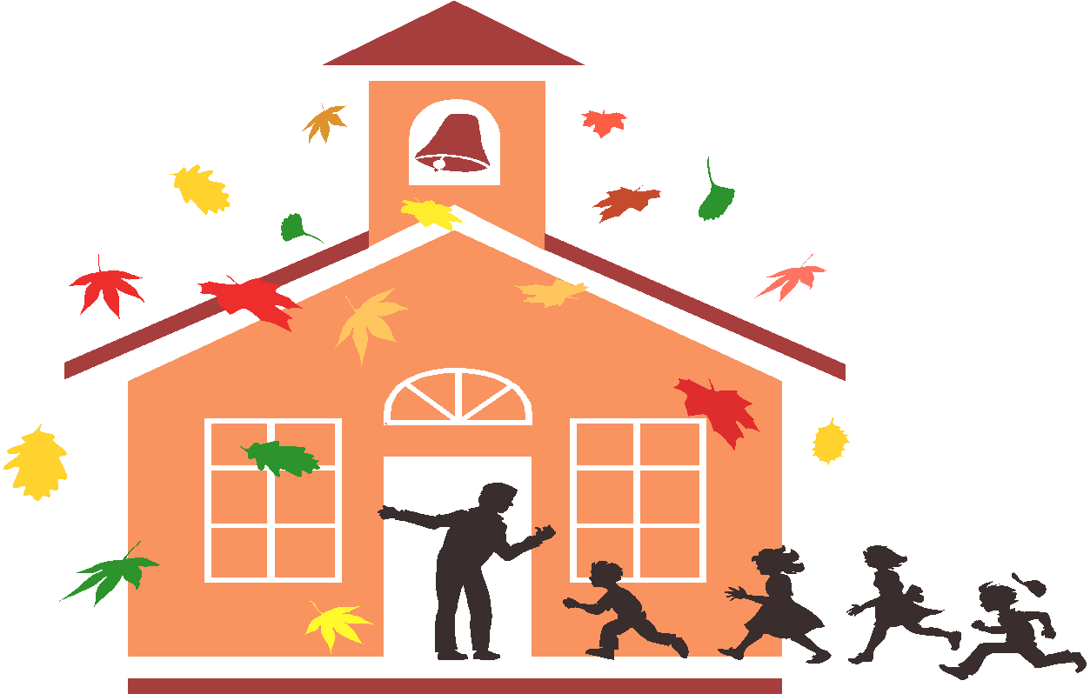

CEEBJ RELIGIOUS SCHOOL STATEMENT OF PHILOSOPHY

We focus on holistic education, combining the formal and informal, academic and social, cognitive and affective through integrated experiences. These experiences include text study, hands-on interactive learning, experiential activities, field trips, family education, youth groups, and camp and Israel programs. The result is young adults who see Judaism as an integral part of their lives, not something that is reserved for the synagogue. Through this approach, we strive to fulfill the mission of the congregation and to instill in our children a strong Jewish identity and a love of Jewish learning.

CEEBJ’S MISSION STATEMENT

We are a vibrant spiritual home and place of learning where all individuals can deepen their Jewish identity, engage with our community and give back to our world.

We will achieve our mission by being CLEAR
  - Caring for our community
  - Learning at all levels
  - Engaging our membership
  - Activism through social action & support for Israel
  - Religious and spiritual experiences

EDUCATIONAL PROGRAMS

General Information and Curriculum:
We focus on age appropriate study of many aspects of Jewish life and Jewish identity, including holidays and customs, history, Israel, life cycle events, comparative religion, Hebrew, Torah, and more, connecting each of these areas to Jewish values. Enrichment including art, library, music, assemblies, current events, social action projects, and field trips round out our program.

Textbooks and Materials: Textbooks and special curricular materials are chosen for use with each grade and are included in each student’s registration fee. Lost textbooks may be replaced by purchasing a new copy at cost through the Lifelong Learning office. Students who travel between two homes or who need extra help remembering to bring their books to class may also wish to purchase an extra set of books.

Tefilah (Prayer): Each week, students gather in the sanctuary for tefilah, a brief worship service. K4 through Grade 2 students use a prayer book that begins to familiarize the children with the Hebrew prayers and that uses English that is age appropriate. Students in grades 3 through 9 use Mishkan T’filah and regularly have the opportunity to lead services. Both traditional and contemporary melodies are used in all services, and our clergy often share a story or lead a discussion on some prayer-related or other relevant topic. This experience allows our students to become active participants in the worship service and helps them to feel more comfortable in the synagogue as a beit tefilah, a house of prayer.

School Trips: Throughout the school year, field trips may be scheduled. Parents and students will be notified of such trips in advance. A permission slip will be sent in advance of any such trip and only students with signed permission slips may participate. Parents may be requested to cover the costs of transportation or entrance fees.

Special Needs or Circumstances: Congregation Emanu-El B’ne Jeshurun is committed to meeting the individual needs of each student, whenever feasible. If your child has a learning disability, medical condition, behavioral disability, or if there has been a special circumstance (birth, death, divorce, etc.) in your family, it may affect your child’s learning experiences, informing the Director of Lifelong Learning will enable us to be sensitive to your child’s individual needs. Sharing this information will help us to provide your child with the best possible experience.

MADRICHIM AND TUTORS

Students in Grades 9 through 12 may be madrichim (teacher assistants), additionally, 7-12th graders are invited to join on Wednesdays as Hebrew tutors, or work in the library or Lifelong Learning Office. Madrichim serve as important role models and provide invaluable assistance to our teachers. In addition, it gives our teens the opportunity to serve the congregation and to continue close ties with the school. Please note that in order to be a madrich/madricha or tutor, one must be enrolled and participating in a formal Jewish education program, or working on an independent study in consultation with the Director of Lifelong Learning.
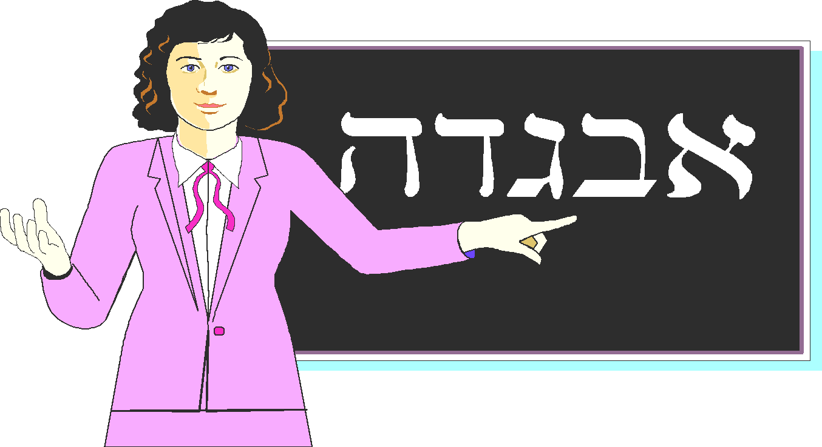
HEBREW PROGRAM – GRADES 3 THROUGH 6

The goals of our Hebrew curriculum are multi-faceted. The primary emphasis is on the study of the siddur (prayer book). We strive to balance the sometimes conflicting need for both keva (the what, when, and “how to” of our fixed liturgy) and kavanna (the spiritual dimension of prayer). In order to become fluent participants in a worship service, students learn to read Hebrew with accuracy and fluency, gain a working Hebrew vocabulary of approximately 100 words and some basic knowledge of root words, prefixes, suffixes, and sentence structure, and discuss the concepts expressed in many of the prayers. They learn to sing and chant the majority of the prayers in the morning and evening services.

Practice: Each child is expected to practice reading aloud at home for approximately 30 to 40 minutes per week.

Year End Evaluation/Promotion: Promotion to the next grade is based upon demonstrated mastery of the required material for the current grade level. Near the end of the school year, students are evaluated on their progress toward the goals for each particular class via both written and oral testing. Students and parents will be informed as to the specific items to be evaluated. Study guides will be provided. If results indicate that summer tutoring or other activities or projects are necessary in order to continue to the next grade, the Director of Lifelong Learning will work with the family to recommend a tutor and/or provide appropriate assignments. Promotion will be dependent on satisfactory completion of required tutoring and/or assignments. The best way to assure promotion to the next grade is to attend class consistently, complete homework and in-class assignments, and practice reading Hebrew at home between classes!

BAR/BAT MITZVAH PROGRAM

Bar/Bat Mitzvah is a significant life cycle event that is shared by the student, family, and synagogue community. Bar/Bat Mitzvah is not the culmination of formal Jewish education but rather one of many customs and ceremonies that are a part of Jewish upbringing. Traditionally, a Jew becomes Bar or Bat Mitzvah at age 13, but we believe this achievement is also available to anyone above the age of 13 who wishes to study the Jewish tradition and Hebrew language.

All students are required to complete four (4) years of Religious and Hebrew education or its equivalent prior to the celebration of Bar/Bat Mitzvah, including regular attendance at Sunday and mid-week classes and the satisfactory completion of all academic work. Students must be able to read Hebrew with a certain degree of proficiency. They must be enrolled and attend class consistently during the school year of Bar/Bat Mitzvah. Any student who cannot meet these requirements by age 13 and wishes to become a Bar or Bat Mitzvah is admitted into the religious school and celebrates this special occasion as soon as requirements are met.

Financial Obligations: A one-time Bar/Bat Mitzvah fee is assessed during the Bar/Bat Mitzvah year. All congregational financial obligations must be current prior to your child beginning Bar/Bat Mitzvah training and must remain current through the date of the Bar or Bat Mitzvah. Contact the Executive Director to discuss extenuating circumstances.

Continuing Jewish Study: At the age of 13, the student is not wholly able to grasp the true importance and significance of Jewish learning. Therefore, as a prerequisite for the celebration of Bar or Bat Mitzvah, an agreement is made by the child and parent(s) to continue formal Jewish studies at least through Grade 10. By continuing religious education, the Bar/Bat Mitzvah may prepare him/herself for the significant ceremony of Kabbalat Torah and hopefully much learning beyond that.

The emphasis of Jewish education is on learning that leads to a living Judaism. It is in this spirit that the process of acquiring the knowledge of Judaism leads from enrollment in the religious school, through Bar/Bat Mitzvah and Kabbalat Torah, to participation in high school and youth group activities to lifelong learning and living as a Jew within the congregation and community and in every area of human activity.

KABBALAT TORAH (formerly “Confirmation”)

Kabbalat Torah is translated as “receiving the Torah.” In our Reform tradition, Kabbalat Torah is a significant life cycle event that is shared by students, families and the congregation. This ceremony, which takes place at the end of Grade 10, marks an academic milestone in the students’ process of Jewish learning and their informed affirmation of their commitments as Jews. Kabbalat Torah has become firmly connected with the festival of Shavuot, with its dual celebration of first fruits and the giving of the Torah on Sinai. Our young people, these first and best of our fruits, accept their responsibility in Judaism on the same day that Israel accepted God’s Torah in mutual consent.

Taught by Berkson, the Kabbalat Torah class focuses on the basics of Judaism, customs and ceremonies, the Jewish idea of God, prayer, and ethics, all on the mature level that is appropriate for students in Grade 10. Kabbalat Torah is intended to be a spiritual quest, and the finding of direction and guidance, if not always precise answers.

The family of a student enrolled in Kabbalat Torah class must be a member in good standing of Congregation Emanu-El B’ne Jeshurun. To be eligible for Kabbalat Torah, a student must have attended religious school and/or Jewish day school without interruption, during his/her eighth, ninth, and tenth grade years. The s determine the student’s readiness for Kabbalat Torah. Every attempt is made by the s to make Kabbalat Torah available to students with special needs.

Special Fees: Kabbalat Torah students will have the opportunity to take a class trip. The class may sponsor one or more special projects to raise funds to offset the cost of the trip, and the families assume the remaining costs. In addition, families of Kabbalat Torah students help plan the celebration, including oneg, kiddush, and/or dinner, flowers, and related items. The fee for each family is determined by what is planned; a family meeting will be held to initiate the planning.

SPECIAL PROGRAMS

Temple Tots: Get your toddler ready for Sunday School by participating in our monthly family education program for toddlers. No registration necessary, just RSVP for each monthly event, come and learn about holidays and Jewish values with your child.

Children’s Choir: We have developed a very strong children’s choir that is open to all students. The choir meets weekly from 11:30 to 11:45 am as well as a monthly session until noon. Students in the children’s choir will perform at several synagogue and community events. Dates to be announced. Contact Cantor Barash with additional questions.

Family Education: Once each semester your child’s teacher will invite you to join the class for a special lesson that allows you and your child to explore the curricular topic together. Your teacher will announce the dates on the first day of class.

Life Cycle Celebrations – Please join us at each of the following Life Cycle Events which take place during the year:

NEW STUDENT CONSECRATION (Sunday, October 20, at 7:00 pm) - We mark each new student’s commencement of his/her Jewish studies on Simhat Torah evening, as we commence a new cycle of reading the Torah. All new students who have not been previously consecrated are welcome to participate in the Consecration ceremony. Contact the Lifelong Learning Office for more information.

SIYYUM HASEFER (Friday, May 15th, at 7:00 pm) - Literally “Completion of the Book.” We celebrate with our 3rd Grade Aleph students who have completed their first Hebrew book and the first step in unlocking the keys to the Hebrew language. Each 3rd grader will receive his/her own siddur at this service.

KABBALAT TORAH - As the Jewish people affirmed their faith in one God at Sinai, our 10th grade young men and women affirm their commitment to Judaism and Jewish learning on the holiday of Shavuot.
ABOUT THE LIBRARY

Our library offers you and your children an outstanding collection of fiction, non-fiction, reference, periodicals, and audio-visual resources. Students and adults will soon be able to access the library’s holdings on a computer catalog. Please reinforce our teaching of good library habits by making sure your child returns all books on time. Storytelling, games, and special projects support and enhance the Religious School curriculum. Parents are encouraged to use the library, as well. You are welcome at any time; the adult collection is housed in Surlow Hall and the children’s collection is upstairs in Room 202. In addition, the library’s bookmobile with books for all ages and interests, and the PJ Library are always stationed in our synagogue’s lounge with an easy check-out system. We have acquired many new books recently – be sure to come check out what’s here!

POLICIES AND PROCEDURES

Attendance at Religious School: Your child’s regular attendance is one of the most important factors determining the success of his/her educational experience. Each class is carefully planned and teachers use their classroom time to the fullest extent. When students miss a class, there is a break in the continuity of their learning. Regular attendance maintains this continuity and promotes positive social interaction. In addition, learning is a communal experience and everyone benefits from classroom participation by all who are present.

Excessive student absences and tardiness are disruptive to the flow, continuity, and dynamics of class. Although all students are expected to make up work in the event of absence, students who do not meet proficiency requirements due to excessive absence will need to obtain private tutoring and/or complete make-up assignments or a special project in order to be promoted to the next grade. If your child needs to be absent for any reason, please call the Lifelong Learning Office.

Unexpected lateness also creates disruption. Students are expected to arrive on time unless prior arrangements have been made with the Director of Lifelong Learning. Students arriving 15 or more minutes late are to check in the Lifelong Learning Office before going to class to be marked present and to gain assistance in finding their class in the event the class is away from their room.

Health and Safety: If it becomes apparent that a child is not feeling well during school hours, every effort will be made to contact a parent. No medication will be dispensed without the direct written permission of a parent or other authorized adult. If a child needs prescribed medication during school hours, parents are expected to advise the Lifelong Learning Office and make arrangements to have the medication available.

SECURITY: At this time of heightened awareness of security issues, we are exploring a number of different ways to make our facility more secure. The following policies and procedures prioritize the safety and security of your children.

- Early Dismissal: If a child must leave school early for any reason, a parent must notify the Lifelong Learning Office to inform us about who will pick up the child and at what time. The parent may do this in person, by note, or by telephone at least one hour in advance. When the parent or designee arrives, he/she must come into the Lifelong Learning Office to sign the child out. There are no exceptions. The child will then be called to come to the office. We have instructed teachers not to allow a student to wait by the door or to discharge a student to anyone unless first notified by the office.

- Early Arrival: Please do not drop off students at religious school more than 10 minutes prior to the start of class. Teachers are busy preparing for the class session and we are unable to provide supervision for your children. If you come inside and wait with them, early arrivals are no problem!

- Visitors in Our School:
Parents: Parents are welcome to visit the school and to observe in their children’s classes at any time. However, you must stop in the Lifelong Learning Office to sign in prior to going to your child’s classroom. Understand that our teachers’ attention is devoted to the children during school hours. Please be respectful of the class and do not use your visit as an opportunity to discuss the class, your child, or a particular concern with the teacher. If you wish to have a conference with the teacher, we would be happy to help you arrange for it in advance.

Friends: We strongly discourage our students from bringing friends to class with them, except in extenuating circumstances or for a specific purpose. Occasional visitors will be considered only when requests are initiated by the parent to the Education Director at least 48 hours prior to the intended visit. Visitors who attend without the advance knowledge and consent of the Director may be asked to leave.

Electronic Media: Although students are permitted to bring electronic media (e.g., cell phones, iPods) into the building, in order to reduce distractions, these devices must be turned off once class begins. Teachers are permitted to confiscate these devices from students making use of them during school hours; they can then be picked up after school. Please reinforce this policy with your children. Someone is always available to answer the synagogue phone if you need to get in touch with your child.

Traffic: For the safety of our children, we ask all parents to abide by all of the following traffic procedures. The main door at the west (covered) entrance is the only entrance to the building during religious school.

Drop-Off
- Turn right from the driveway into the south parking lot. Follow around the lot and form a car line along the sidewalk. Children should exit your car only when your car reaches the covered entry on the west side of the synagogue. Please stay in line and do not attempt to jump ahead or double-park to unload. If your drop-off includes more than a quick goodbye, please park your car in the lot and walk your child into the building.
- Cars will then proceed to turn in the circle and exit the lot onto Brown Deer Road.
- Once inside the building, children should go to their classrooms.

Pick-Up
- Cars will follow the same traffic pattern as for the drop-off, and line up along the sidewalk.
- Please remember: In order to be able to better supervise children as they leave the building, the exit to the carpool line will be ONLY from the west doors at the covered area. Parents who park and come inside will be permitted to leave through the doors to the south or the west.
- Once you have picked up your child(ren), please use caution as you pull away from the curb and find your way out of the parking lot.
- If you are going to be late, please call the Lifelong Learning office. Your child will either wait with a school staff member at the main entrance or will wait in the school office until you arrive for pick-up.

Please see the map on the inside back cover for a diagram of our religious school traffic pattern.
You are always welcome to park and come inside! We have hot beverages in the Soref lounge, a wireless network, frequent adult education classes, social gatherings and the Judaica Shoppe is usually open when school is in session.

Homework: It is the policy of our school that teachers may assign homework, provided assignments are realistic, interesting, and important to the curriculum. Given that our in-school time is so limited, Hebrew reading practice, workbook materials, and textbook chapter reading are all appropriate assignments for the home setting.

You should expect approximately 15 to 20 minutes of Hebrew homework each week in addition to regular reading practice, and occasional assignments in religious studies subjects. Homework is not assigned frivolously; therefore, your child will be expected to do his/her best in completing assignments.

Academic Expectations: Promotion is contingent upon a child’s satisfactory completion of the class requirements as determined by the teacher, the Director of Lifelong Learning, and the Lifelong Learning Committee. If a child does not meet academic expectations due to excessive absence, the child will not be promoted until or unless he/she receives private tutoring and meets grade level expectations. Special needs will be considered individually.

Student Evaluation: Teachers are available to discuss any challenges or share any joys, by phone or in person, and there will be two written reports during the year. During conference days, teachers will have examples of student progress available for discussion. Please feel free to contact your child’s teacher or the Director at any time should you have any questions or concerns between conference dates.

Attitude and Discipline Policy: Our building is not only a house of study, but also a house of worship. As such, it deserves an attitude of respect. Likewise, our teachers transmit to our pupils not only a body of information but also a religious heritage. They deserve, from parents and students alike, the regard that is proper and in keeping with the traditional Jewish respect for teachers and people of learning.

Please reinforce with your child(ren) that religious school is indeed both a school and a place where religion is taught and practiced. Students are expected to respect others and themselves. Behavior should be consistent with Jewish values and the synagogue setting. Mentschlekeit (being a good person/doing the right thing) and derech-eretz (well-mannered behavior) are important goals of Jewish education. Your support in helping us achieve these goals is appreciated.

If a child’s behavior consistently disturbs a class and interferes with the learning experience, the child may be removed from the classroom and the parents attend a conference with the teacher and the Director of Lifelong Learning. Occasionally, the parent(s) may be required to attend class with the child until such time as it is no longer necessary.

We are committed to each and every one of our students. When discipline problems occur, we will work them out with both student and parents. Our philosophy is to never give up and to ultimately achieve a positive learning situation.

Bullying Policy: Bullying is defined as the intimidation of one child by another or by a group of children. The intimidation may be by action or by words and cause fear or emotional distress in the person being bullied.

All forms of bullying are unacceptable at CEEBJ. If someone is being bullied or sees someone else being bullied, he/she should report it to the teacher or Director of Lifelong Learning. Of course, the source of all reports remains confidential.

The person doing the bullying will be spoken with first by the teacher and then by the -Director of Lifelong Learning. If the behavior continues, the parents will be contacted and appropriate discipline will be enforced. This includes, but is not limited to, suspension and/or expulsion where the child will have to be tutored at the family’s expense to continue in the Religious School. All efforts will be made to help the person who is doing the bullying understand the effects of the words or actions and then help change their behavior. We want our school to be a safe, friendly environment for all students.

Communication: The Director of Lifelong Learning’s door is always open to you. To be sure to find her in the building, call to let us know you are coming. Please let us know when you are pleased as well as when you have concerns. We will try to keep you informed as to all school activities without bombarding you with unnecessary mail to read. Please tell us if you have a suggestion regarding how communication might be improved.

Phone Calls: We want to hear from parents and be responsive to your needs. However, just before and during school hours, the Director of Lifelong Learning and teachers’ attention must be focused entirely on the students. Except for emergencies, we cannot take phone calls during school hours. The Administrative Assistant in the Lifelong Learning Office is available to assist parents and students during school hours. We will make every effort to return phone messages as soon as possible. A telephone is available in the Lifelong Learning Office for students who need to call their parents during school hours.

Dress Code: When dressing for religious school, your child’s choice of clothing should reflect the nature of what is being taught (Torah, prayer, etc.). Students are encouraged to wear comfortable clothing; however, in an effort to create an atmosphere of kedusha, holiness.

Snacks: There will be a short break during each session, at which time students are welcome to have a snack. Some teachers may choose to set up a rotation for families to share the responsibility of providing snack for the class. We ask that you send healthy snacks. Fresh fruit is always a simply and delicious snack to share. You will be notified if there are students in your child’s class with food allergies, and we appreciate your cooperation in keeping all of our students safe. For students in our K-2nd grade classrooms we introducing a new program called “Snack and a Guest”.

We are excited to implement “Snack and a Guest” this year in the kindergarten through 2nd grade classrooms! Our “Snack and a Guest” initiative will provide a great opportunity to foster intergenerational learning and family engagement, to offer our students a variety of role models for Jewish living and show them that Religious School connected to their lives and community. It will offer a chance for each student to invite a special guest to Sunday school and together read a book, tell a story, bring in an item to show/talk about, or any combination of these. Each student will have the opportunity to do this twice throughout the year.

Who can my child invite to be their special guest? A special guest is anyone that you and your child know. The special guest could be a parent, grandparent, older sibling, neighbor, cousin, aunt, uncle, adult from temple etc. You and your child should feel comfortable asking this person to join your child at Sunday school to read a favorite Jewish book, tell a Jewish story, share a memory/picture from a Jewish experience in their live, or bring an object that helps them share they way they love to celebrate a Jewish holiday. Your guest does not necessarily need to be Jewish, as we know many of our non-Jewish friends and relatives love PJ library books or celebrating holidays with us. Special guests are required to stay for 20/30 minutes though if they’d like to stay the entire time to help the class they are welcome to. Room parents for each class will help to organize sign ups for the snack and will send periodic reminders.

Tzedakah: Tzedakah is a cornerstone of what it means to be a Jew: the giving of one’s possessions to help those in need. In Jewish tradition, giving tzedakah is not a choice but an obligation for every Jew. Unlike charity, we do not give merely when we are able, willing, or “in the mood.” Instead, we make tzedakah a regular habit as well as seeking out special occasions, moments of joy, or memory as additional times for acts of righteousness.

Students in each class will decide as a group to whom they will contribute the money they bring. Please support our efforts each week by encouraging your child to bring contributions to class on Sunday morning, Wednesday afternoon, and Tuesday evening. Parents can encourage even our youngest students to bring their own money for weekly tzedakah contributions. Parents can also devise ways in which children can earn small amounts of money from which to draw when giving tzedakah. It is better for a child to bring 25 cents each week than to give $5 once a month; in that way, the child learns that tzedakah is a constant obligation, not a sporadic “good deed.”

Lost and Found: Although we cannot be held responsible for items left behind or lost at school, we make every effort to return items to their rightful owners. Parents are asked to label clothing and school items with their child’s name.

PARENT SUPPORT

ROOM PARENTS: The CEEBJ Religious School aims to provide all students with a foundation for lifelong Jewish study in childhood. Serving as a CEEBJ Religious School Room Parent is a wonderful opportunity to demonstrate the importance of Jewish education to your child.

Room Parents support the efforts of their child’s Religious School teacher in a variety of ways, principally by acting as a liaison between the teacher and the parents of your child’s classmates. The expectation is that no more than 1 hour of time per week (though some will certainly have less and some a little more) will be required to fulfill all of the duties of Room Parent in your child’s classroom.

While the duties of the Room Parent will vary with the needs of the teacher and desire of the parent, we anticipate the following to be among the activities Room Parents will coordinate this year.

- Attend the first day of Religious School with your child. The other parents in your child’s class want to get to know you! You will have the opportunity to meet with other parents and get to know them too.
- Introduction letter. Send a letter to other parents in your child’s class describing your role and providing your contact information. If you would like, members of the Lifelong Learning Committee would be happy help you with this effort.
- Welcome new families. Personally reach out to new families and welcome them to our school.
- Parent communication during the year. Support the teacher in parent communication. For example, seeking volunteers for special projects, requesting feedback, reminding parents of conferences and so forth. On three different occasions during the school year, we will ask you to reach out to other parents either in writing or by phone to inquire about how they feel the Religious School year is going.
- Snack. Coordinate snack (grade 3 and up), or “snack and a guest” (grades K-2). This will involve signing up parents to bring snack each week and reminding them when it is their week.
- Special projects as needed. If you are able, assist with any special projects the teacher requests during the year.

The Room Parents will not need to be present at the Religious School more often than the other parents.

YAHAD: Meaning “together” YACHAD gives families of elementary school aged children the opportunity to get together outside of religious school in fun ways for everyone in the family. From Kids Club activities for K-5th graders to and Havdalah and a movie for the whole family, to book club and parents night-outings just for adults, Yachad has a program for you. We are looking for volunteers to help coordinate one event during the year. Dates and events can be found in Ha-Kol and on the synagogue website. Contact Susan Cosden if you are interested!

PURIM CARNIVAL: our community Purim Carnival takes a great deal of work to pull off and is one of the largest fundraisers for religious school we have. We need your help both the planning and the day of the event.

If you would like to get more involved, but you aren’t sure how, contact Susan Cosden and she would be happy to help you find a match.

PASSPORT TO ISRAEL PROGRAM

Passport to Israel is a savings plan whereby three partners: the congregation, the participating family, and the Milwaukee Jewish Federation, contribute annually to an account that will help to fund an educational trip to Israel during the student’s high school or college years. A student can be enrolled at any time from the start of third grade through the tenth grade and is eligible to receive funds for a total of eight years. Should your child decide not to go to Israel, the family’s and congregation’s contributions are both fully refundable. Studies and experience have shown that the teen years are the most critical years for identity-building and that a peer group Israel experience is a transformative experience impacting positively on Jewish identity. We encourage you to participate in this worthwhile program. Detailed information will be mailed in the winter.

A WORD TO PARENTS IN AN INTERFAITH MARRIAGE

Congregation Emanu-El B’ne Jeshurun welcomes all who wish to draw closer to Judaism. To that end, we affirm the position of the CCAR, articulated in 1983, as follows:

The Central Conference of American s declares that the child of one Jewish parent is under the presumption of Jewish descent. This presumption of the Jewish status of the offspring of any mixed marriage is to be established through appropriate and timely public and formal acts of identification with the Jewish faith and people. The performance of these mitzvot serves to commit those who participate in them, both parent and child, to Jewish life.

Depending on circumstances, mitzvot leading towards a positive and exclusive Jewish identity will include entry into the covenant, acquisition of a Hebrew name, Torah study, Bar/Bat Mitzvah and Kabbalat Torah (Confirmation). For those beyond childhood claiming Jewish identity, other public acts or declarations may be added or substituted after consultation with their .

This is the official position of Reform Judaism in America. We recognize the child of interfaith parents as fully Jewish provided that the parents have agreed to raise their child as a Jew and are following up on that decision.

We assume that any child registered in our religious school gets the message from both parents that he/she is Jewish because that is the parents’ joint decision. If you are struggling with this decision or uncertain of its implications, we urge you to speak with the Director of Lifelong Learning before registering your child in religious school, or whenever it becomes an issue.

2019-2020 CEEBJ Tentative Religious School Calendar

We will have class from 9:30 - 11:30 on Sundays and 4:20 - 6:20 on Wednesdays unless otherwise noted below. Check synagogue website and your email regularly for more information and updates.
bold=no school or abbreviated school
Red = parents come to RS too!

September
- Sept. 8th - Congregation Picnic (11:30 - 2:00) AND “Meet the Teachers” combined event
- Sept. 15th - First official Sunday of school
- Sept. 18th - First Wednesday of school
- Sept. 22nd - Mom’s invited to Women of Emanu-El Brunch 9:30 - 11:30

October
- Oct. 9th - No School Yom Kippur
- Oct. 20th - Family Simchat Torah Program begins in the morning and continues in the evening with Simchat Torah Celebration and New Student Consecration
- Oct. 27th - Blood Drive

November
- Nov. 27th - No School Thanksgiving Break

December
- Dec. 1st - No School Thanksgiving Break
- Dec. 15th - Parent Teacher Conferences
- Dec. 25th - January 1st No School Winter Break

January
- Jan. 5th - Religious School resumes
- Jan. 11th - 6th Grade Shabbaton
- Jan. 19th - No School

February
- Feb. 1st - 5th Grade Shabbaton
- Feb. 9th - Debbie Cater Berkson Blood Drive
- Feb. 16th - No School (Community Wide Staff Development Day)
- Feb. 22nd - 4th Grade Shabbaton

March
- March 9th - Purim Carnival and Spiel
- March 15th - Community Wide Salute to Jewish Educators (JCC)
- March 22nd - 29th No School (Spring Break)
- March 1st - Religious School Resumes

April
- April 5th - Teacher Appreciation Breakfast
- April 8th - April 15th No School (Passover Break)
- April 19th - Religious School Resumes

May
- May 3rd - Parent Teacher Conferences and Storyteller
- May 15th - Siyyum Ha Sefer Celebration for 3rd Grade
- May 17th - Mitzvah Day (Last Day of Religious School)

