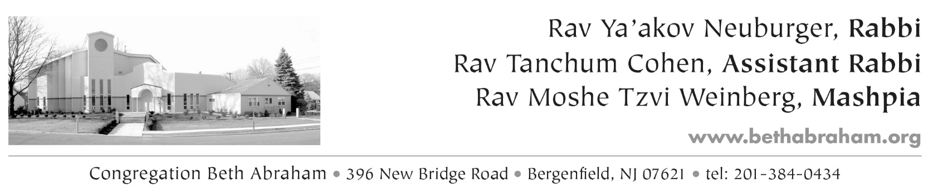

Membership Application

Please provide a family picture along with this form * May the picture be shared with our membership? ___ (Y/N)

Date _____________

Family

Last Name __________________________ Wife’s last name (if different) ________________________

Address ____________________________ Town ________________________Zip _______________

Home Phone ______________ Married Single

Male Kohen Levi Yisrael Female

First Name ______________Date of Birth __ / ___ / ___ First Name _______________Date of Birth __ / ___ / ___

Middle Name______________________ Title________ Middle Name__________________________Title_______

Hebrew Name________________________________ Hebrew Name ___________________________________

Father’s Hebrew Name _________________________ Father’s Hebrew Name ____________________________

Mother’s Hebrew Name _________________________ Mother’s Hebrew Name ____________________________

Cell# _________________ Email _____________ Cell# _______________ Email _________________

Occupation ___________________________________ Occupation ______________________________________

Company ____________________________________ Company _______________________________________

Synagogue Skills: Daven Read the Torah / Haftorah Gabbai

Children
If children are married, please include spouse’s name in appropriate field below

1 - Name ____________________________ Hebrew name _____________________________________

M or F____ DOB ____/_____/____ Hebrew date DOB (יום / חדש) _________________________

Grade_____ School __________________ Spouse’s name____________________________________

2 - Name ____________________________ Hebrew name _____________________________________

M or F____ DOB ____/_____/____ Hebrew date DOB (יום / חדש) _________________________

Grade_____ School __________________ Spouse’s name____________________________________

3 - Name ____________________________ Hebrew name _____________________________________

M or F____ DOB ____/_____/____ Hebrew date DOB (יום / חדש) _________________________

Grade_____ School __________________ Spouse’s name____________________________________

4 - Name ____________________________ Hebrew name _____________________________________

M or F____ DOB ____/_____/____ Hebrew date DOB (יום / חדש) _________________________

Grade_____ School __________________ Spouse’s name____________________________________

5 - Name ____________________________ Hebrew name _____________________________________

M or F____ DOB ____/_____/____ Hebrew date DOB (יום / חדש) _________________________

Grade_____ School __________________ Spouse’s name____________________________________

Yahrzeit Information

1. Relative of Wife Husband 3. Relative of Wife Husband

Relationship____________________________ Relationship____________________________________

Hebrew Date __________________________ Hebrew Date ___________________________________

Name________________________________ Name ________________________________________

Hebrew Name______________________________ Hebrew Name__________________________________

2. Relative of Wife Husband 4. Relative of Wife Husband

Relationship____________________________ Relationship____________________________________

Hebrew Date __________________________ Hebrew Date ___________________________________

Name________________________________ Name ________________________________________

Hebrew Name___________________________ Hebrew Name__________________________________

Some Opportunities to get involved - In which area would you be willing to serve?

1. ___ Helping to prepare a meal for a member who is sitting shiva, is ill or recently had a child

2. ___ Providing transportation for a new mother or someone undergoing a personal difficulty

3. ___ Bikur Cholim

4. ___ Welcoming new members

5. ___ Adult Education Committee

6. ___ Youth Department

7. ___ Fundraising

8. ___ Dinner Committee

9. ___ High Holiday seating

10. ___ Other
_________________________________________________________________________________________________

Opt Out

Members’ children and their birthdates are automatically listed in the shul directory. Additionally, Congregation Beth Abraham may take pictures at shul events and make those pictures public viewable. We understand the importance of keeping some information out of the “public eye”. If you do not want your child(ren) listed or shown in photos, please check the appropriate boxes below.

Please do not list the name(s) of our child(ren) in the shul directory.
You may list our child(ren), but may not list the birthdate(s) of our child(ren) in the shul directory
You may not use any digital images of our child(ren) in brochures, web sites or other published material.

All members are automatically listed in the shul directory, put on our automated dialer and email list for important announcements. You may check the boxes below if you wish to opt-out of any of these features:

We do not wish to receive calls from the automated dialer.
We do not wish to be automatically subscribed to Beth Abraham email distribution list.
Do not include my email address(es) in published shul directories.
Do not include my name in any shul directories.

Full Membership Affiliate Membership

I understand that full membership at Congregation Beth Abraham is $1000 per year plus a $36 Mikvah assessment and a $18 Eruv assessment. I also understand that there is an obligatory building fund of $10,000. I intend to pay the building fund in the following manner:  One full payment  Ten annual payments of $ 1,000 each | I understand that affiliate membership at Congregation Beth Abraham is $ 300 per year, and to maintain affiliate membership, I must be listed as a full member of another shul.  We maintain full member status at:  Name of Shul _______________________________________
Previous Shul Attended

Shul_________________________________ City, State____________________

Rabbi _______________________________ Phone # ____________

Shul ________________________________ City, State____________________

Rabbi _______________________________ Phone # ____________

