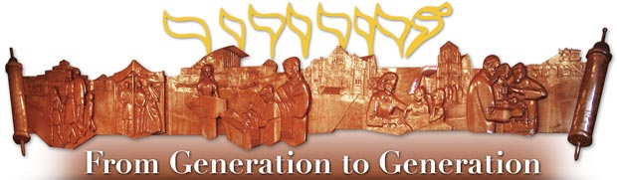

How B’nai Amoona Came into Being and Its First Rabbi
Around October of 1883 Aaron Levy was engaged by Sheerith Israel to be its Rabbi. His election was hotly contested and, as I will explain later in this article, was considered irregular by many longtime members of the Congregation who, from the beginning, thought he was too progressive, not sufficiently Orthodox, and did not chant the prayers in a familiar way. By July 1884, the president of Sheerith Israel, who was one of those who did not like Rabbi Levy, set a congregational meeting for Sunday, July 6th to decide whether or not to re-engage Rabbi Levy for the next year. To insure that the vote would go against Rabbi Levy, the president called a special meeting for a week earlier and “admitted” 46 new anti-Levy voting members to the Shul without requiring them to pay dues. The members who supported Rabbi Levy were outraged, to say the very least, and threatened to make their displeasure known at the meeting the following week when the vote on Rabbi Levy would take place. The president, as a precaution, arranged to have two St. Louis policemen at that meeting. As you can imagine, the meeting was very raucous and there were heated exchanges by the opponents and the supporters of Rabbi Levy. The supporters, seeing that they would lose the vote, bolted from the meeting and declared that they would start a new Shul (to become B’nai amoona) with Rabbi Levy as their spiritual leader. The remaining members of Sheerith Israel elected L. Rosenblatt to be the Rabbi of their Shul.
The information for the paragraph above is based on interviews with supporters of Rabbi Levy, by a newspaper reporter, for an article in the Post-Dispatch published July 7, 1884 headlined, A DIVIDED CHURCH, A Rabbi’s Method of Chanting Prayers Causes a Split. The information for the paragraph below is based on interviews with opponents of Rabbi Levy, by a newspaper reporter, for an article in the Post-Dispatch published July 8, 1884 headlined, THAT DIVIDED CHURCH, The Gentlemen Who Oppose Rabbi Levy Tell Their Story.
Mr. D. Lyons, secretary of Sheerith Israel reported that the main objections to Rabbi Levy were based on some financial transactions with Mr. Harris, the president of the congregation. Rabbi L. Rosenblatt, the newly elected Rabbi, reported that he had organized Sheerith Israel some years earlier as an Orthodox congregation (apparently he had left the congregation prior to Rabbi Levy being engaged). He said that Rabbi Levy brought in a liberal element that was not in keeping with the sentiments of the membership. He further said that the supporters of Rabbi Levy only came to services once or twice a year and yet wanted to dictate Shul policy. He also said that in order to get Rabbi Levy elected originally, his supporters packed the meeting with reduced dues new members who would vote for Rabbi Levy so it was only fair for the president to do the same thing, nine months later, to get him voted out. He further told the newspaper reporter that it was a good thing there were two policemen at the meeting because the supporters of Rabbi Levy raised a real disturbance.
Clearly there are at least two sides to most controversies.
On July 11, 1884, the Post-Dispatch published an article with the headline, A NEW HEBREW CONGREGATION, that read:
Last night thirty members of the Sheereth Israel congregation met…and organized the Bnai Amune congregation. Rabbi Levy was elected to take charge of the congregation.
Ironically, it turns out that Rabbi Levy was our rabbi for only one year, July 1884-June 1885. He was replaced by Adolph Rosentreter who was our Rabbi from 1885 to 1912.

