RABBI SHLOMO ZUCKIER
Shavuot Scholar in Residence
Brief Bio
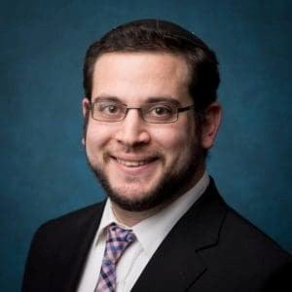

Rabbi Shlomo Zuckier is a PhD candidate in Ancient Judaism at Yale University, a member of Yeshiva University’s Kollel Elyon, and a Lecturer at YU’s Isaac Breuer College. A Founding Editor at The Lehrhaus, he previously served as Director of the Orthodox Union’s Jewish Learning Initiative on Campus at Yale University. Shlomo is an alumnus of Yeshivat Har Etzion and Yeshiva University (BA, MA, Semicha), as well as of the Wexner, Tikvah, and Kupietzky Kodshim Fellowships. He has lectured and taught widely across North America, and is excited to share Torah and Jewish scholarship on a broad range of issues. Shlomo serves on the Editorial Committee of Tradition, is co-editor of Torah and Western Thought: Intellectual Portraits of Orthodoxy and Modernity, and is editing the forthcoming Contemporary Forms and Uses of Hasidut.

