COVID-19 Status Update: NYS and Albany County

Positive COVID-19 tests 4/1/2021 – 11/28/2021

Week comparisons for Albany County
Week of | Total Tested Positive | Total Number of People Tested | Percent Positive | Total Cases per 100,000
11/7-11/13/2020 | 490 | 20,227 | 2.42% | 159.6
11/7-11/13/2021 | 668 | 14,525 | 4.60% | 208.3
11/14-11/20/2021 | 722 | 14,277 | 5.06% | 235.1
11/21-11/27/2021 | 685 | 12,506 | 5.48% | 223.0

Determining Transmission Risk (per CDC)
 | Low | Moderate | Substantial | High
New cases per 100K persons over 7 days | <10 | 10-49.99 | 50-99.99 | >100

Capital Region Schools Positive Cases 9/13 - 11/12/2021
 | Students Tested Positive, age 5-17 | Teachers/Staff Tested Positive | Total Positive Cases
9/13-11/12/2021 | 3,999 | 777 | 4,776
9/13-11/26/2021 | 5,221 | 1,026 | 6,247

Vaccine Effectiveness Data and Cases/Hospitalizations by Vaccination Status

In comparing the rates of laboratory-confirmed COVID-19 cases between fully-vaccinated and unvaccinated people, fully-vaccinated New Yorkers continue to be strongly protected against infection.
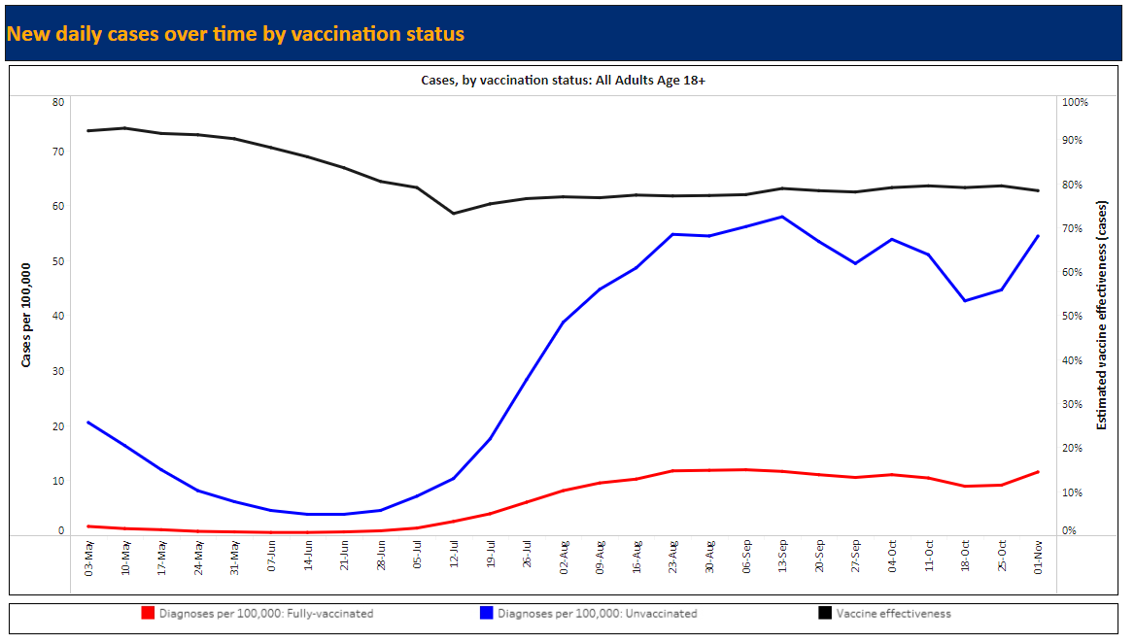
(Source: NYS Department of Health)

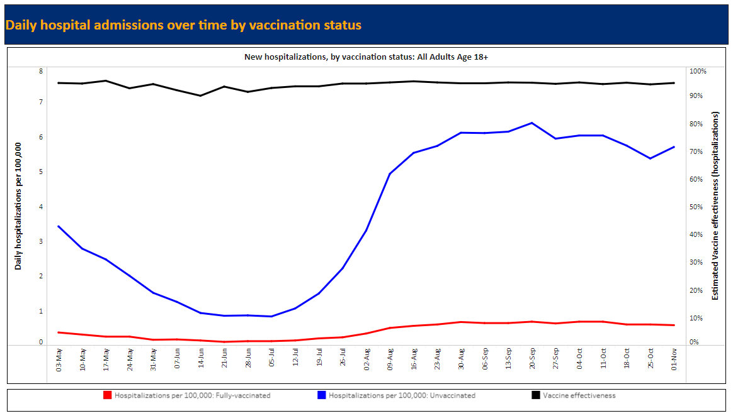
(Source: NYS Department of Health)

COVID-19 Vaccinations for 5-11 Year-Olds

Get a COVID-19 vaccine for your child as soon as you can. (source: NYS Department of Health)
- COVID-19 vaccines are safe, effective, and free.
- COVID-19 vaccines have undergone – and will continue to undergo – the most intensive safety monitoring in U.S. history.
- Vaccinating children will help protect them from getting COVID-19 and reduce their risk of severe disease, hospitalizations, or developing long-term COVID-19 complications.
- COVID-19 cases in children can result in hospitalizations, deaths, MIS-C (inflammatory syndromes) and long-term complications, such as “long COVID,” in which symptoms can linger for months.
- According to the CDC, the spread of the Delta variant resulted in a surge of COVID-19 cases in children throughout the summer.
- Similar to what was seen in adult vaccine trials, the vaccine was nearly 91 percent effective in preventing COVID-19 among children aged 5-11 years in vaccine trials.
- In clinical trials, vaccine side effects were mild, self-limiting, and similar to those seen in adults and with other vaccines recommended for children. The most common side effect was a sore arm.
Get the facts about the COVID-19 vaccine for children.
- Your child will need a second shot of the Pfizer-BioNTech COVID-19 vaccine 3 weeks after their first shot.
- Your child can't get COVID-19 from any COVID-19 vaccine, include the Pfizer-BioNTech vaccine.
- The vaccine cannot cause fertility issues for your child, and the vaccine cannot change their DNA.
- Your child may get a COVID-19 vaccine and other vaccines at the same visit or at separate visits without any waiting period between vaccines.
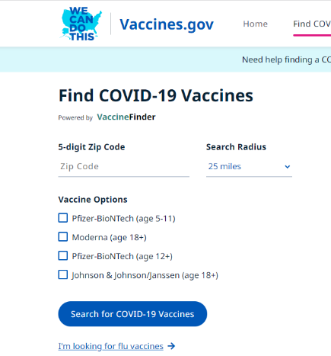
Where to get the COVID-19 Vaccine
- Contact your child’s pediatrician or family physician

- Go online https://www.vaccines.gov/search/

- Text your zip code to 438829

- Call 1-800-232-0233

Resources
Videos
University of Michigan’s All About Coronavirus: A Video for Kids and Their Families
https://www.youtube.com/watch?v=6lJQ123_4e8

Unicef’s COVID-19 Vaccines Explained in 4 Levels of Difficulty
https://www.youtube.com/watch?v=n5CLKOnfBuM

Websites
New York State Department of Health - The COVID-19 Vaccine and Children Ages 5 – 11
https://covid19vaccine.health.ny.gov/frequently-asked-questions-about-5-11-year-olds-and-covid-19-vaccine

CDC – COVID-19 Vaccines for Children and Teens
https://www.cdc.gov/coronavirus/2019-ncov/vaccines/recommendations/children-teens.html?CDC_AA_refVal=https%3A%2F%2Fwww.cdc.gov%2Fcoronavirus%2F2019-ncov%2Fvaccines%2Frecommendations%2Fadolescents.html

The American Academy of Pediatrics
The Science Behind COVID-19 Vaccines: Parent FAQs https://www.healthychildren.org/English/health-issues/conditions/COVID-19/Pages/The-Science-Behind-the-COVID-19-Vaccine-Parent-FAQs.aspx

Getting Your Child Ready for the COVID-19 Vaccine
https://www.healthychildren.org/English/health-issues/conditions/COVID-19/Pages/Getting-Your-Child-Ready-for-the-COVID-19-Vaccine.aspx

