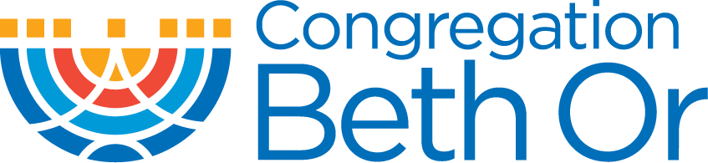 | 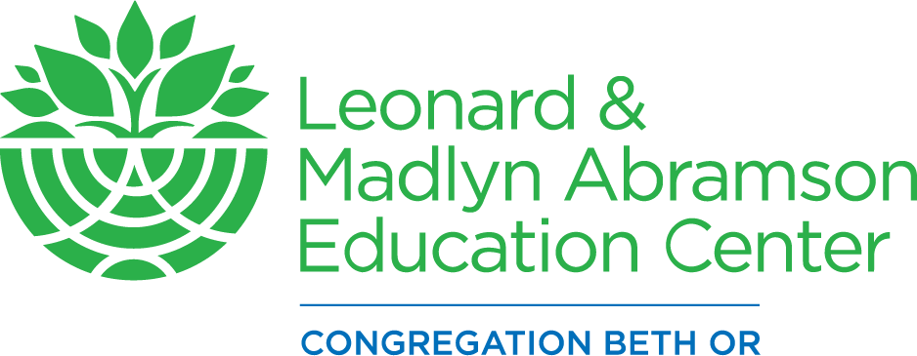
Registration At-A-Glance

This guide will give you a quick look at registration for the 2022-2023 school year. For more details and course descriptions refer to our website and look for “Education Programs at Congregation Beth Or.”

Kindergarten through 2nd Grade
Our youngest learners come to class only on Sunday mornings.

Register for Sunday:
- Sunday In Person (9:30am – 11am)

3rd Grade
Hebrew education begins in earnest in 3rd grade, so an extra learning session is added.

Choose  Register for Sunday School  - Sunday In Person (9:30am – 11am) | And  Register for Hebrew  - Sunday In Person (11:15am – 12:45pm)  OR  - Monday In Person (4:30pm – 6pm)  OR  - Tuesday In Person (4:30pm – 6pm)

4th through 6th Grade
Students in 4th-6th grade continue to come two sessions a week.

Choose  Register for Sunday School  - Sunday In Person (9:30am – 11am) | And  Register for Hebrew  - Sunday In Person (11:15am – 12:45pm)  OR  - Monday In Person (4:30pm – 6pm)  OR  - Tuesday In Person (4:30pm – 6pm)  OR

7th Grade YOBO (Youth of Beth Or)
7th grade students return to a once-a-week study of Judaic topics.

Register for YOBO:
- Sunday Evenings In Person (5pm – 7pm)

8th and 9th Grade YOBO (Youth of Beth Or)
In 8th and 9th grades students can choose among a number of class options.

Choose  Register for YOBO  - Sunday Evenings In Person (5pm – 7 pm) | AND/OR  Register for alternative In-Person options  - Songleading Lab  - Madrichim  - Chai Notes

10th Grade: Confirmation
Students in 10th grade spend the year learning about Judaism—history, culture, and theology—and discussing what Judaism means to them.

Register for Confirmation Class
- Sunday Night In Person (5pm - 7pm)

11th and 12th Grade YOBO (Youth of Beth Or)
Our 11th and 12th grade classes are designed to keep students engaged in meaningful ways. There is no tuition for 11th and 12th grade.

Choose  Register for YOBO  - Sunday Evenings In Person (5pm – 7pm) | AND/OR  Register for alternative In Person options  - Songleading Lab  - Madrichim  - Chai Notes

