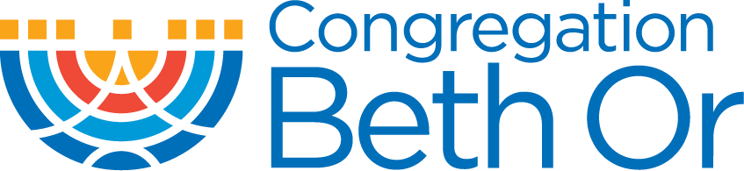 | 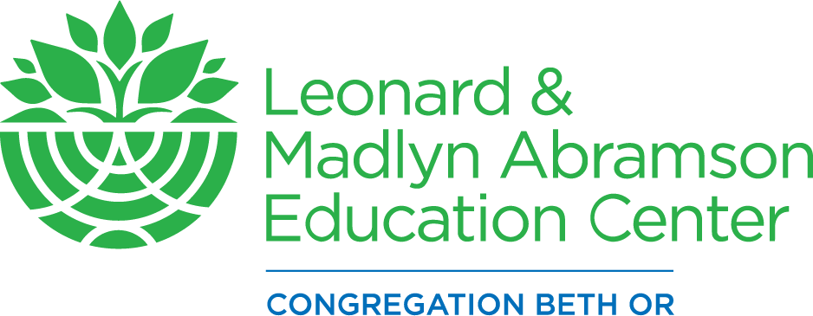

Education Programs at Congregation Beth Or

K-12th grade education at Congregation Beth Or develops Judaic and Hebrew knowledge, and we divide the school into three major categories:

Keren (K-3rd grades) | Eych (4th-6th grades) | Yedah (7th-12th grades)
Keren means a foundation, and our youngest students will study the WHAT of Judaism, the foundational knowledge that goes into being educated Jews. | Eych is Hebrew for HOW, and students put their knowledge into action to learn how we are Jewish, through topics like Torah, Israel, Jewish Values, Prayer/worship, and God. | Yedah means knowledge, and these students examine the WHY of Judaism in classes on Jewish living for maturing, young adult Jews.

Our classes at Congregation Beth Or focus on hands-on learning, where students discover the information they need with the guidance and expertise of their teachers. Congregation Beth Or becomes the KEY to your child’s positive, meaningful Jewish education!

Judaics
We use ShalomLearning as the platform for our Judaics education. This values-based curriculum takes students on a grade-level appropriate exploration of seven Jewish values:

Teshuvah (taking responsibility for our actions)
B’tzelem Elohim (being made in the image of Gd)
Gevurah (using our inner strength)
Achrayut (being responsible in the world)
Hakarat Hatov (recognizing the good)
Koach Hadibbur (using the power of words)
Shalom (making peace)

Each value is divided into several units, and teachers use videos, discussion questions, art activities, online games, and other tools to help students grasp the concepts and connect with these Jewish values.

Hebrew
Our Hebrew program incorporates both a phonics and a whole-language approach toward Hebrew prayer literacy. By teaching sound decoding and word recognition in context, students gain important skills for reading Hebrew. 3rd grade focuses on basic Hebrew literacy. Students use the Siddur, technology, and primary sources to build a prayer vocabulary, explore prayer meaning, and work towards prayer fluency.

Kindergarten through 2nd Grade
Our youngest learners come to class only on Sunday mornings.

Register for Sunday:
- Sunday In Person (9:30am – 11am)

3rd Grade
Hebrew education begins in earnest in 3rd grade, so an extra learning session is added.

Choose  Register for Sunday School  - Sunday In Person (9:30am – 11am) | And  Register for Hebrew  - Sunday In Person (11:15am – 12:45pm)  OR  - Monday In Person (4:30pm – 6pm)  OR  - Tuesday In Person (4:30pm – 6pm)

4th through 6th Grade
Students in 4th-6th grade continue to come two sessions a week.

Choose  Register for Sunday School  - Sunday In Person (9:30am – 11am) | And  Register for Hebrew  - Sunday In Person (11:15am – 12:45pm)  OR  - Monday In Person (4:30pm – 6pm)  OR  - Tuesday In Person (4:30pm – 6pm)  OR

Our 7th-12th grade program is also called YOBO, Youth Of Beth Or

7th Grade YOBO
7th grade students return to a once-a-week study of Judaic topics.

Register for YOBO:
- Sunday Evenings In Person (5pm – 7pm)

8th and 9th Grade YOBO
In 8th and 9th grades students can choose among a number of class options.

Choose  Register for YOBO  - Sunday Evenings In Person (5pm – 7 pm) | AND/OR  Register for alternative In-Person options  - Songleading Lab  - Madrichim  - Chai Notes

Madrichim (Sundays, 9:30am-12:45pm; mid-week Hebrew 4:30pm – 6pm)
This YOBO class places students in Sunday school classrooms as assistant teachers, or madrichim. Madrichim report to their assigned class every Sunday during the year for their classroom duties. They may also receive further training and development in our monthly Madrichim workshop sessions from 1 pm to 2:30 pm. These workshops provide teens with information on organization, classroom management, teaching responsibilities, and leadership. Madrichim registration is based on approval from the Director of Religious School.

Songleading Lab (Sundays, 9:30am-12:45pm)
If you have always dreamed of being a Songleader, this is your chance to learn how to do it! Students will meet with Cantor Murley to learn songleading skills and then they will assist in teaching music classes to grades K-6th. Each session will end with the students getting the chance to lead music classes ON THEIR OWN to practice what they've learned. This class will give students the confidence and skills to stand up in front of a group in any situation. It will also increase their knowledge of Jewish music. Note: This will NOT be a music instruction class, so students must already play an instrument from which they can lead a group (guitar, ukelele, piano, etc).

Chai Notes (Sundays, 5pm-7pm)
This singing group will be open to students in grades 7-12 and will serve as an elective in our YOBO program. Chai Notes will have two hour rehearsals once a month while students are already in the building for YOBO. Chai Notes will sing more complex musical compositions along with awesome Jewish A Capella tunes, to match their growing musical tastes and abilities. This group will also share a meal with peers, providing much needed social time with friends.

10th Grade: Confirmation
Students in 10th grade spend the year learning about Judaism—history, culture, and theology—and discussing what Judaism means to them.

Register for Confirmation Class
- Sunday Night In Person (5pm - 7pm)

Confirmation is for our 10th grade students and meets 3 times a month on Sundays from 5 - 7pm. Taught by Rabbi Marx and the Director of Religious School, Aaron Nielsenshultz, the class focuses on big events in Jewish history and Jewish theology. It includes several optional experiential learning trips: a social justice lobbying program to Washington, D.C., a trip to the lower East Side of New York City, and a once-in-a lifetime trip to Israel. The class culminates in the Confirmation service during Shavuot.

11th and 12th Grade YOBO
Our 11th and 12th grade classes are designed to keep students engaged in meaningful ways. There is no tuition for 11th and 12th grade.

Choose  Register for YOBO  - Sunday Evenings In Person (5pm – 7pm) | AND/OR  Register for alternative In Person options  - Songleading Lab  - Madrichim  - Chai Notes
Madrichim (Sundays, 9:30am-12:45pm; mid-week Hebrew, 4:30 – 6pm)
This YOBO class places students in Sunday school classrooms as assistant teachers, or madrichim. Madrichim report to their assigned class every Sunday during the year for their classroom duties. They may also receive further training and development in our monthly Madrichim workshop sessions from 1 pm to 2:30 pm. These workshops provide teens with information on organization, classroom management, teaching responsibilities, and leadership. Madrichim registration is based on approval from the Director of Religious School.

Songleading Lab (Sundays, 9:30am-12:45pm)
If you have always dreamed of being a Songleader, this is your chance to learn how to do it! Students will meet with Cantor Murley to learn songleading skills and then they will assist in teaching music classes to grades K-6. Each session will end with the students getting the chance to lead music classes ON THEIR OWN to practice what they've learned. This class will give students the confidence and skills to stand up in front of a group in any situation. It will also increase their knowledge of Jewish music. Note: This will NOT be a music instruction class, so students must already play an instrument from which they can lead a group (guitar, ukelele, piano, etc).

Chai Notes (Sundays, 5pm-7pm)
This singing group will be open to students in grades 7-12 and will serve as an elective in our YOBO program. Chai Notes will have two hour rehearsals once a month while students are already in the building for YOBO. Chai Notes will sing more complex musical compositions along with awesome Jewish A Capella tunes, to match their growing musical tastes and abilities. This group will also share a meal with peers, providing much needed social time with friends.

