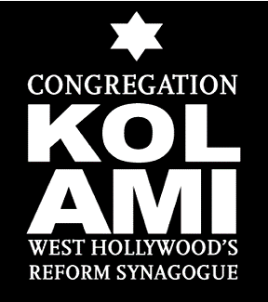
Congregation Kol Ami
Semi-Annual Congregational Meeting
Wednesday, November 30, 2022
7:00 PM
Proxy/Ballot Form

All proxy forms must be returned by 3:00 PM,

Tuesday, November 29, 2022

Please fill in this form and return it to the synagogue office by one of the following:

Scanning and emailing your proxy to membership@kol-ami.org.

Faxing it to us at 323-606-0997.

Mailing it to us at Congregation Kol Ami, 1200 N. La Brea Ave., West Hollywood, CA 90038.

Please be sure to sign, print your name clearly, and date this form below.

If you assign your proxy to anyone other than Peter Mackler, please note they must be present at the meeting and in good standing to vote on your behalf. Individual members are allowed to hold two (2) proxies.

---------------------------------------------------------------------------------------------------------------------

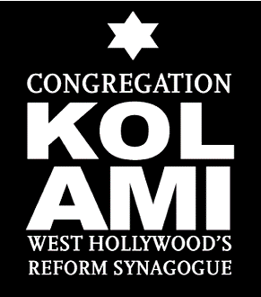
As a voting member of Congregation Kol Ami, I appoint Peter Mackler Board President, or _________________________, as my proxy to vote on the items contained in the agenda, including approving the second half of FY 2022-23 proposed budget, and to vote on other issues that may be properly raised during the meeting at the members' discretion.

Signed: ___________________________________________________________

Printed Name: _____________________________________________________

Date: _____________________________________________________________

