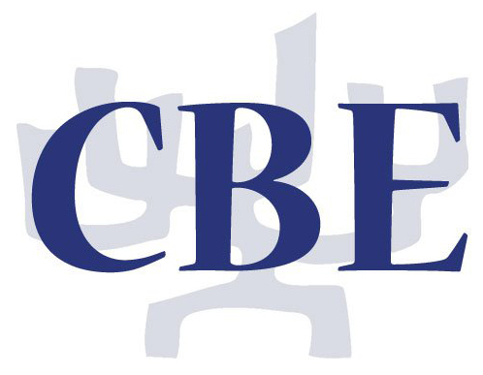

BAR/BAT MITZVAH

INFORMATION AND GUIDELINES

Congregation Beth Emeth
12523 Lawyers Road
Herndon, Virginia 20171
(703) 860-4515

April 2018

(revised 4/25/2018)

Dear Bar & Bat Mitzvah Families,

Mazel tov on your upcoming simchah (joyous event)! While tradition teaches us that each child becomes a Bar/Bat Mitzvah upon reaching age thirteen (age twelve for girls in some communities), we also know that having a Bar/Bat Mitzvah celebration is an important milestone in the life of your child and of your entire family.

We are excited and honored to help you plan for this significant moment in your child’s life and in your life as well. As you begin to organize a Bar/Bat Mitzvah celebration there are many things to keep in mind. Among the many things to think about are the tutoring process, Jewish ritual garb (tallit, tefillin, kippot), assigning honors, the seudat mitzvah (kiddush or luncheon after the event), etc. It is our hope that this guide will help make planning your simchah as easy and stress-free as possible.

Of course, if you have any additional questions, please do not hesitate to ask.

B’shalom,

Rabbi Michelle “Mina” Goldsmith
Susan Dilles, Ritual, Lifecycle Director

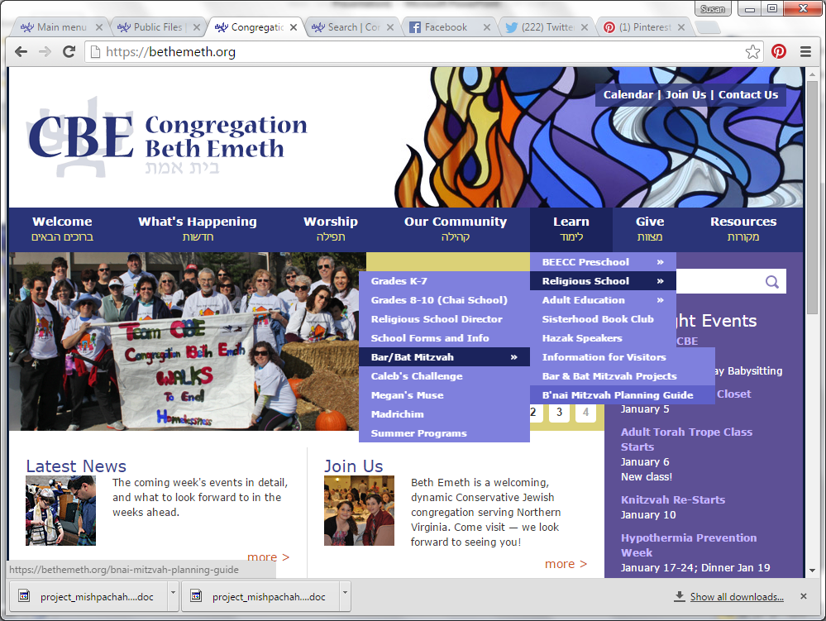
The B’Nai Mitzvah Planning Guide is Online!
1. Search on the word “Mitzvah” OR
2. Learn > Religious School > Bar/Bat Mitzvah > B’nai Mitzvah Planning Guide

TABLE OF CONTENTS

FIRST STEPS
1 SETTING THE DATE 2
2 ELIGIBILITY REQUIRMENTS 2
3 MEMBERSHIP AND FEES 2
4 USHERING POLICY 2

RITUAL OBSERVANCE
5 SHABBAT OBSERVANCE 3
6 FRIDAY EVENING SERVICE PARTICIPATION 3
7 SEUDAT MITZVAH POLICY 3
8 WEARING OF KIPPOT, TALLITOT, AND TEFILLIN 3

FAMILY INVOLVEMENT
9 BAR/BAT MITZVAH TRAINING 4
10 WORSHIP SERVICE – STUDENT EXPECTATIONS 5
11 WORSHIP SERVICE – FAMILY PARTICIPATION/HONORS 5
12 PHOTOGRAPHS ON THE BIMAH 6
13 PARENTS’ PRAYER 6
14 TORAH READERS 7
15 hAGBAH (LIFING THE TORAH) 7
16 BROCHURES, KIPPOT, FLOWERS, TREE OF LIFE, SHOFAR 7

pROJECT mISHPACHA
17 PROJECT MISHPACHA 8

IN CONCLUSION
18 IN CONCLUSION 8

FIRST STEPS

SETTING THE DATE

At CBE we schedule bar/bat mitzvah services on Shabbat mornings or Sunday Rosh Chodesh (new month) when school is not is session.

According to tradition, a bar/bat mitzvah is held on the Shabbat immediately following the thirteenth anniversary of the child's Hebrew date of birth. Our goal is to assign each student a date, which is on or after his/her thirteenth birthday according to either the Hebrew or secular calendar, and within two months after the birthday.

Each year the dates available on which to schedule a bar/bat mitzvah are reviewed. Some dates are set aside as unavailable due to Jewish holidays and other congregational observances and practices. Families are then given a list of available dates, and each family is requested to select three specific dates on which they would prefer to have the service, indicating an order of preference. The CBE office will then assign a date to each family. Once all dates have been assigned, any requests for changes are handled by the Rabbi, the VP for Ritual, and the Religious School Director.

ELIGIBILITY REQUIRMENTS

Every child who is called to the Torah as a bar/bat mitzvah must have progressed to the seventh grade of Beth Emeth's Religious School program, or its equivalent, as determined by the Religious School Director. The child must be enrolled in and must be maintaining satisfactory attendance in the Beth Emeth Religious School, the Beth Emeth Chai School, or a Jewish day school, at the time of the Bar/Bat Mitzvah.

Please note that a student is not required to lead services on the day of his/her bar/bat mitzvah, and that he/she will not be permitted to lead any service unless he/she has attended at least twenty-two (22) services at which Torah is read in the twelve months preceding his/her bar/bat mitzvah date. Please fill out the Service Attendance Log Sheet and submit it to the Religious School Director.

Special arrangements may be requested to accommodate unusual conditions and situations. In the case of a bar/bat mitzvah candidate born to a non-Jewish mother, the family must consult with the Rabbi regarding proper conversion procedures.

MEMBERSHIP AND FEES

The family must be in good standing with regard to membership and financial obligations at the time the date of the ceremony is set and on the actual date of the service. If this condition is not met, the bar/bat mitzvah date may be canceled. The family shall also be responsible for payment of a bar/bat mitzvah fee in the amount set by the Congregation.

USHERING POLICY

Prior to your child’s bar/bat mitzvah, you are required to usher at several Shabbat morning services, or at other services in which a bar/bat mitzvah is being celebrated. The Ushering Coordinator will contact you regarding the process for signing up for ushering, which is done using SignUp Genius link provided by the Ushering Coordinator. Once you receive the link, please make sure you sign up as soon as possible to choose your best dates. Every Family is responsible to usher on their dates and if scheduling conflicts occur, it is the family's responsibility to arrange substitutes to cover those dates. Please review the Ushering Duties and Guidelines document and contact the ushering coordinator with any questions.

RITUAL OBSERVANCE

SHABBAT OBSERVANCE

Shabbat is a day of sanctity and rest from certain actions, beginning at sun down on Friday evening and ending when three stars can be seen in the sky on Saturday night. We therefore ask that while at the synagogue, you and your guests refrain from telephone use, photography, writing, smoking, videotaping, and handling money. Families are requested to include in their invitations a letter detailing these observances. Please review our sample “Dear Friends” letter. Finally, nothing can be brought into or taken out of the synagogue on Shabbat. All items needed for Shabbat morning services must be delivered to the synagogue by noon on Friday. This includes flowers, kippot, and brochures.

FRIDAY EVENING SERVICE PARTICIPATION

Student participation in the Friday Evening Service is encouraged. Please contact the Rabbi for further information.

SEUDAT MITZVAH POLICY

All services at which a child may be called to the Torah as a bar/bat mitzvah are open to the entire congregation. The celebration that follows the bar/bat mitzvah service leads to a seudat mitzvah - a religious feast. Families are responsible to provide a seudat mitzvah for the congregation in attendance at the services, regardless of the day. Detailed information regarding seudat mitzvah sponsorship is provided in Planning a Seudat Mitzvah at CBE and the Seudat Mitzvah Menu Guide. The simchah coordinator will contact each family about your Seudat Mitzvah and any questions you may have. We hope you will consider holding your celebration in the CBE Social Hall; information about facility rental for your simchah is also available from the simchah coordinator.

WEARING OF KIPPOT, TALLITOT, AND TEFILLIN

Kippot
A kippah must be worn by all males during all services. Head coverings are optional for females unless they are participating on the Bimah. Chapel caps for women (lace doilies) and bobby pins are provided by the synagogue. Families may wish to purchase kippot to be used at their child’s service, but such purchases are optional, as there is a plentiful supply of kippot on hand.

Tallitot
A bar mitzvah must wear a tallit during all services. A tallit is optional for a bat mitzvah, unless she leads a weekday Shacharit service. A formal tallit presentation to the child on the bimah is not encouraged, but if desired, must take place at the start of the service at 9 AM. Many families have found it to be less stressful for the student to receive his/her tallit at a Friday night Shabbat dinner, at Friday night services, or otherwise at home prior to arriving at the synagogue.

Tallitot must be worn by all Jewish males (beyond bar mitzvah age) attending any morning service. Tallitot are optional for women. Tallitot are available in the tallit closets near the sanctuary entrance.

Tefillin (Sunday Rosh Chodesh Services Only)
A bar mitzvah must wear tefillin during weekday services. Tefillin are optional for a bat mitzvah during weekday services, unless she leads a weekday Shacharit service. Tefillin are available at the synagogue; so purchase of new tefillin is not required.

FAMILY INVOLVEMENT

BAR/BAT MITZVAH TRAINING

A bar/bat mitzvah tutor is assigned to each child by the Religious School Director. The bar/bat mitzvah instruction will take place over a period of 8-9 months, usually in the form of weekly 30-minute sessions. Sessions are normally private, but small group sessions may be included at the tutor’s discretion. Cost for these sessions is covered by the bar/bat mitzvah fee. If additional instruction beyond the 8-9 month period is required, parents will be asked to cover the cost. Instruction will not take place during a child’s scheduled religious school class time.

Standard instruction during the 8-9 month period proceeds as follows:
- Tutor teaches student to chant one Torah reading, including the blessings before and after the reading;
- Tutor evaluates student’s ability to lead services, by listening to the student chant the services;
- Tutor meets with student and parents to formulate action plan, which may include one or more of the following, or may be customized for a particular student’s special needs:
  - Tutor teaches student the services;
  - Student is ready to lead services (with minor polishing), so instructor teaches student to chant the Haftarah and the blessings before and after the Haftarah (Shabbat morning services only), or additional Torah readings (non-Shabbat morning services);
  - (Shabbat morning services only) Upon mastery of the Torah and Musaf services including the full Ashrei, and the Haftarah and its blessings, tutor teaches student additional Torah readings;
- Six weeks prior to bar/bat mitzvah date, tutor re-evaluates student’s ability to lead services; and
- Four weeks prior to bar/bat mitzvah date, tutor makes final determination of student’s competence to lead service, and to chant Torah portion(s) (and Haftarah for Shabbat mornings only).

Additional: options vary dependent upon individual student and service:
- Leading Torah and Musaf service on Shabbat morning and Rosh Chodesh OR Torah service and concluding prayers on Sunday morning (guidelines: has attended 22 services at which Torah is read)
- Haftarah, (Shabbat morning only)
- Additional Torah readings for those celebrating other than Shabbat morning
- Additional Torah readings and/or service leadership for Shabbat morning celebrants upon mastery of Haftarah, AND complete Torah and Musaf services, including full Ashrei
- Hallel for holiday celebrants (Shabbat Hol Hamoed, Rosh Chodesh)
- Psukei d’Zimra and/or Shacharit for Sunday morning celebrants, tefillin required

How can I help my child?
- Establish a daily study time
- Listen to your child read and chant (no knowledge of Hebrew needed)
- Attend services with your child
- Touch base with tutor on child’s progress
- Participate in setting realistic goals
- Be punctual for lessons and for pick-up after lessons

Audio files for Torah and Musaf services, as well as Torah and Haftarah trope, can be found at https://bethemeth.org/audio-services.

Students will study year round. It is highly recommended that, for those students studying during the summer months, consideration be given to limiting time away at camp and on vacation.

WORSHIP SERVICE – STUDENT EXPECTATIONS

For all services, students are expected to do the following:
- Chant an aliyah (blessings before and after the reading of a Torah portion);
- Prepare a d’rash (short sermon) on the Torah portion or the Haftarah.

For Shabbat morning services, students may also:
- Chant one Torah reading;
- Chant the Haftarah brachot and the Haftarah
- Lead Torah Service;
- Lead Musaf Service;
- Lead Hallel (if service includes Hallel); and
- Chant additional Torah reading(s)

For Rosh Chodesh services, students may also:
- Chant one Torah reading.
- Lead Torah Service;
- Chant additional Torah readings;
- Lead Musaf Service;

Lead Hallel Service; and
- Lead Shacharit Service.

WORSHIP SERVICE – FAMILY PARTICIPATION/HONORS

It is a delight to have you, your child, friends, and family participate in our regularly scheduled Shabbat or Sunday Rosh Hodesh service on the occasion of your child’s Bar/Bat Mitzvah. As such it is with pleasure that the Ritual Committee, which is responsible for the choreography of the service, provides specific opportunities for you to include loved ones and friends in the joy of the day through the bestowing of certain honors.

While these honors are available for you and your family to distribute, please do not feel obligated to fill each honor. Any available honors you do not use will automatically revert to the congregation. Please note that every individual receiving an honor must be Jewish, except as noted on the Honors worksheet.

The honors available to the family are included and explained on the honors worksheet. The Ritual, Lifecycle Director will assist you in choosing the appropriate form for your date:
- Honors Worksheets
  - 1-Torah Shabbat
  - 2-Torah Shabbat
  - 3-Torah Shabbat
  - Rosh Chodesh

The completed honors sheet must be provided to the Ritual, Lifecycle Director at least 10 days before your event, or the honors will revert to the congregation. Questions regarding these honors should be directed to the Ritual, Lifecycle Director (ritual-lifecycle@bethemeth.org).

Other resources are provided to help you and your guest participants prepare:
- Hebrew name cheat-sheet
- Aliyah Prayers before and after Torah readings
- A Torah aliyah at CBE (guide to CBE customs)
- Prayer for the Community
- Prayer for our Country
- Prayer for Israel with transliteration
- Prayer for Peace

PHOTOGRAPHS ON THE BIMAH

Families wishing to have photographs or video on the bimah with the torah must contact the Ritual, Lifecycle Director (ritual-lifecycle@bethemeth.org) at least one month in advance. Time on the Bimah is dependent on the availability of the sanctuary and ritual committee personnel.

PARENTS’ PRAYER

The opportunity to bless your child after s/he chants from the Torah and/or haftarah portion of the week is a special moment in parents’ lives. It has been known to bring many adults to tears of joy (so make sure to have tissue with you!). Here at CBE we know how important this moment is to you. We also know that writing a prayer for your child can be difficult. Because of this we offer two options for parents: 1) You may choose to deliver one of the many prayers provided – a few are in this binder, and more prayer options are available on the website -- or 2) you may choose to write a prayer of your own to bestow upon your child.

However, IF you choose to write a prayer of your own, please note that it is not to be a life story of your child. It is the moment when you have the opportunity to bestow both your wisdom and your hopes and dreams on your child, all through the lens of Jewish tradition.

As you compose your prayer, it may be helpful to think about the following:
- What are you most proud and thankful about your child’s character?
- What are your general hopes for your child as they enter their teen years and beyond?
- What are your specific hopes for your child as they enter Jewish adulthood?

If you are still unsure about what to write, here are some hints:

- It is often useful to use verbal phrases such as “May you be……” or “May God grant you…..”
- Make sure to end your blessing with words such as “We love you,” “This is our prayer for you,” or “Amen,” so it is clear to the listeners that your prayer has concluded.
- DO NOT write more than ONE page double spaced per parent.
- An example of an original prayer is in this binder and on the website.

Please note the following important items. All prayers must be submitted to the rabbi at least TEN DAYS before the Bar/Bat Mitzvah. If it is too long or inappropriate in any way, the rabbi will provide corrections.
If the rabbi has not received the Parents’ Prayer by TEN DAYS before the Bar/Bat Mitzvah, you will be expected to deliver one of the “stock” prayers provided here and/or on-line.

Following your prayer to your child the rabbi will deliver the Misheberach on the Occasion of a Bar/Bat Mitzvah as well as the priestly benediction to your child.

While many parents wish to bless their child on the bimah during the service, if you do NOT wish to do so, please notify the rabbi in writing of this as well. If you do not bless your child the rabbi will still recite the Misheberach and Priestly benediction for your child.

At CBE we understand the important guidance parents, both Jewish and Non-Jewish, can offer their children during this milestone. As such, we welcome non-Jewish parents to participate in the delivery of the parents’ prayer, following all guidelines above.

TORAH READERS

Initially, all of the Torah readings are reserved for the student. Any readings not being chanted by the student are assigned by the ritual committee. If you want family members or friends to participate in the Torah service by chanting a Torah portion, we would be delighted to help facilitate this honor. The Ritual-Lifecycle Director needs to know your desires as early as possible – preferably 2-3 months in advance. (Please provide readers’ names and contact information to ritual-lifecycle@bethemeth.org.)

All Torah readers must be skilled in Biblical Hebrew with the proper cantillation, from the Torah scroll. If family members or friends are not regular Torah readers at CBE, a member of the ritual committee will contact them to explain our procedures and to help find an appropriate reading, if available.

Once readings are assigned, readers will be able to familiarize themselves with the layout in our actual Torah by using photos available in the Torah Readings section of the CBE Website.

HAGBAH (LIFTING THE TORAH)

In order to protect the Torah from damage, all of our regular Torah lifters have been trained to lift the Torah in a safe manner that is specific to our environment. The honor of Hagbah is usually assigned by the Ritual Committee. If you would like to choose someone from the approved CBE list, please contact the Ritual-Lifecycle Director at least six weeks in advance. If you have a friend or family outside the CBE community who has performed Hagbah at other congregations, please contact the Ritual-Lifecycle Director at least six weeks in advance to explore the possibility of their participation in this role at your simchah.

BROCHURES, KIPPOT, FLOWERS, TREE OF LIFE CONTRIBUTION, SHOFAR

Families may choose to add to the beauty of the service by providing bimah flowers.

In addition, some families may wish to provide a bar/bat mitzvah brochure to be distributed at the sanctuary entrance. A sample brochure, includes the approved text. For non-Shabbat morning services, the brochure should include the Prayer for the Community, which does not appear in the weekday siddur, and may also include an English translation of the appropriate Torah reading, which also does not appear in the weekday siddur. Note: you can download graphics of CBE's stained glass windows if you would like to use them in your pamphlet.

It is customary in Jewish tradition to make a contribution to a Tzedakah Fund or to the synagogue at the time of a simchah like a bar/bat mitzvah. The Ritual Committee hopes that each family will consider dedicating a leaf, bird, or stone on the Tree of Life (on the lobby wall) in honor of their child’s bar/bat mitzvah. (Note: for the engraved item to be ready for installation at the time of your event, Tree of Life dedications must be received at least three months in advance. If you have previously reserved a leaf, bird or stone, the wording for engraving must be received at least three months in advance.) Information about making such a contribution is found on the Tree of Life Webpage.) If you have any questions about possible contributions, please contact the Rabbi or the Executive Director.

Our congregation would like to know more about our bar/bat mitzvah students; to have a brief article appear in the Shofar the month of your simchah, please complete the Bar/Bat Mitzvah Shofar Questionnaire. Note: information from this form can optionally be used to feature the student’s Mitzvah Project on the CBE Website at https://bethemeth.org/mitzvah-projects. If you would to share a mitzvah project in more detail and/or ask for assistance from the congregation and guests, please consult the instructions at the bottom of this Webpage.

PROJECT MISHPACHA

PROJECT MISHPACHA
Students and parents will attend various bar/bat mitzvah preparation workshops during the 6th grade year of religious school. These sessions will take place during Sunday morning religious school hours, and will be led by the Rabbi. A wide range of topics will be covered, including what it means to become a bar/bat mitzvah, how to write a d'var Torah, what the family can expect the day of the service, bar/bat mitzvah projects, and others. Parents will attend these sessions with their students, and every family is urged to make attendance at these sessions a priority in their schedule. For more information, please see the Project Mishpacha Outline.

IN CONCLUSION

IN CONCLUSION
The bar/bat mitzvah celebrates the transition from one stage of life to another. We recognize, as did our ancestors, the importance of marking our life cycle with meaningful ceremonies. While this is an important life cycle event, it is not a mystical ritual that confers identity upon a Jew. Celebrating one's bar/bat mitzvah in the synagogue indicates having had basic religious instruction and is a public demonstration of the acceptance of adult responsibilities. We do not see the ceremony as a culmination, but rather as one step during the transition into life as a Jewish adult.

While the bar/bat mitzvah ceremony is a very personal experience, it is not a private event. The whole community watches as your child publicly acknowledges the significance of this moment and affirms his or her commitment to the Jewish people. As your child makes this commitment, the Jewish people are renewed and strengthened. In a sense, Abraham's covenant with God has been reaffirmed, and because of that, the Jewish people rejoice.

Questions? Contact us using the Bar/Bat Mitzvah Who’s Who list.

