First Day of Sunday School
& Parents Meeting
Sunday, September 8 • 9:30–11:00 AM
Kol Hadash Sunday School at Deerfield High School

Students and parents will be in the classroom on the first day of Sunday School!

Parents Meeting includes a light breakfast, Meet & Greet, curriculum review, and, a forum with Rabbi Adam and each other.
Open House & Sunday School Try Out
We welcome non-members to join us - there is no expectation of a commitment by coming to this program.

Adults join the Parents Meeting and children join their grade’s class for the day.

RSVP on Kol Hadash website Calendar
RSVP’s encouraged - walk-ins welcome
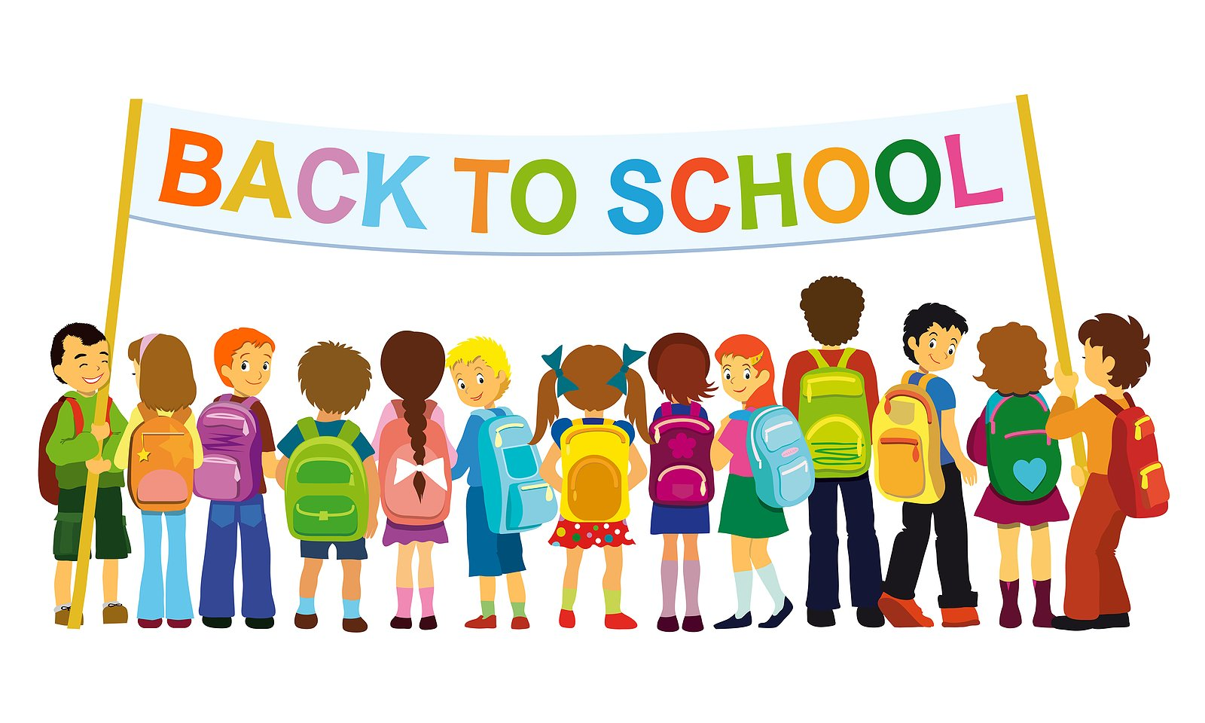
Questions to Ilana Shaffer at youthed@kolhadash.com or 773-209-8266

Members choose financial commitment — Trial Memberships offered — Jewish and Interfaith families fully participate

