A New Year’s Note from the KEFTY Board:
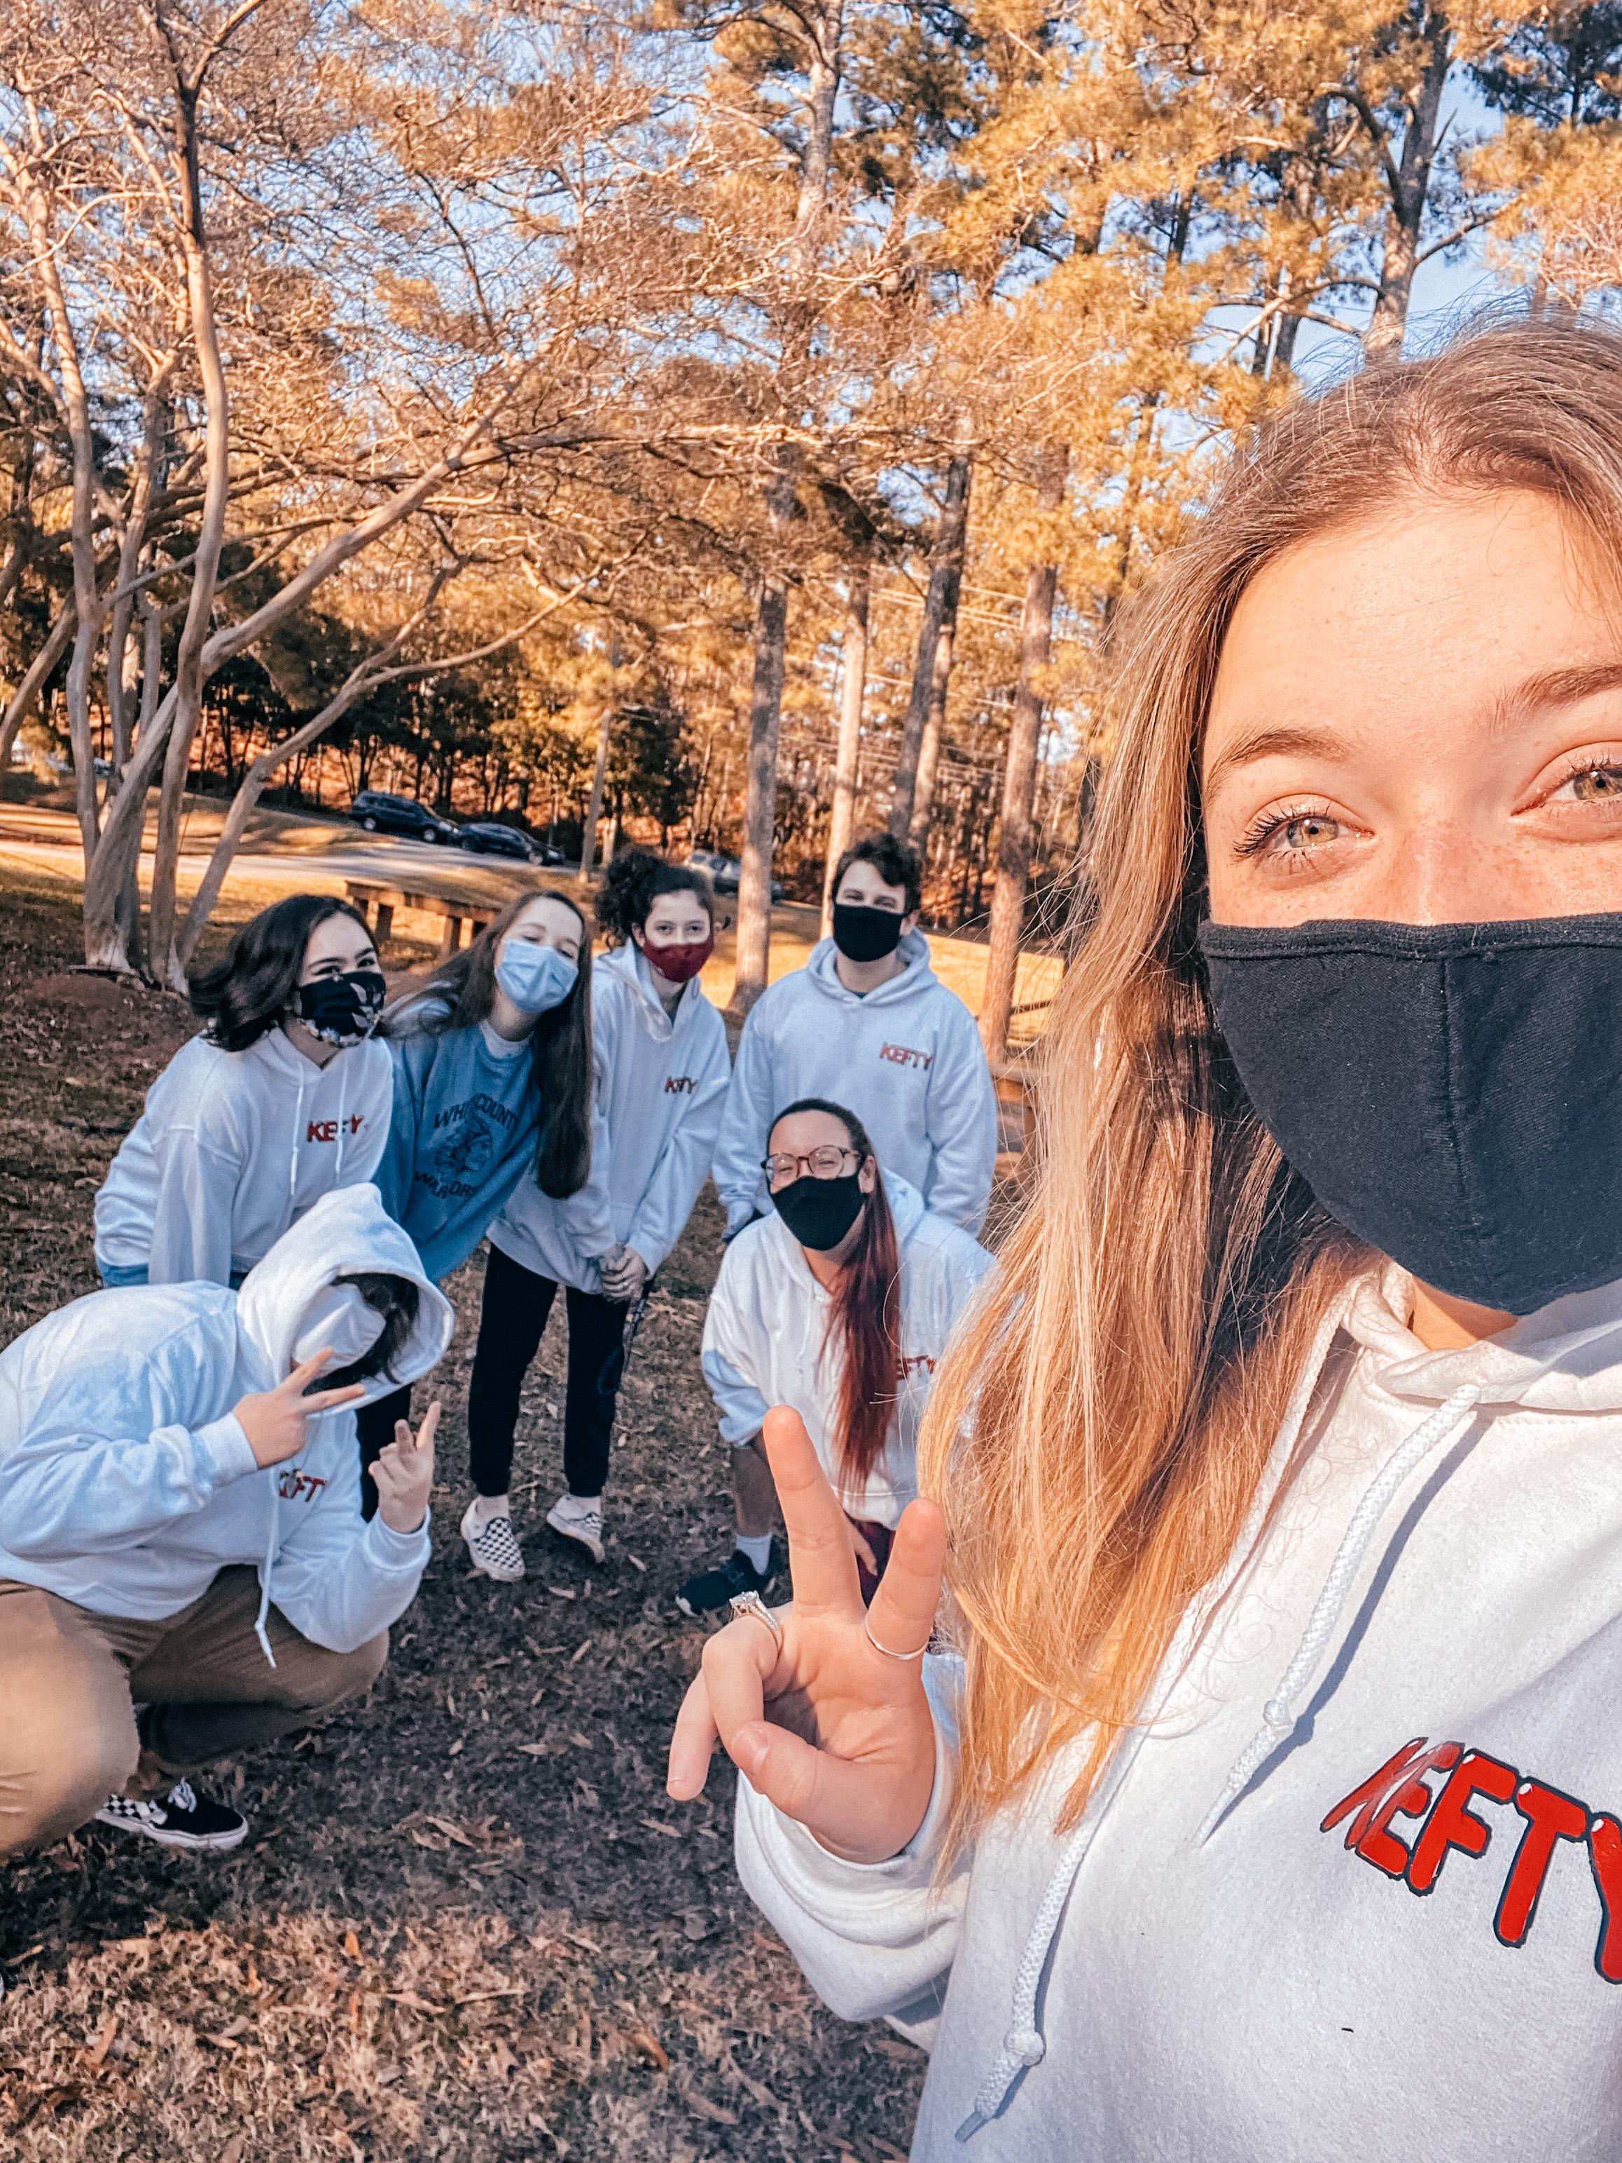
Max Ruth (President): I'm hopeful for 2021. With the vaccine, hopefully, things will get back to normal. This year, I'm looking forward to going to college and eating healthier this upcoming year. One thing that is important to me is Judaism. Judaism is a big part of my life and has led me to meet some of my best friends while allowing me to create some of my favorite experiences. I hope to go to a college where I can major in Jewish studies and become a rabbi or Jewish educator.

Lainey Weissman (Programming Vice President): Prior to the pandemic, my days followed the same pattern: waking up, going to school, doing homework, eating dinner, going to bed, and repeating. With COVID-19, these constant movements and social interactions are gone, leaving teenagers with the choice of whether or not to stay socially involved. Like many others, I often decided to fill my days with Netflix and naps, keeping some close friends on speed dial while only occasionally reaching out to others. This choice to distance myself from others (physically and socially) caused me to experience loneliness and low self-esteem, which took a toll on my overall mental health. I dismissed these feelings to keep going during the challenging times, but that just made it worse. In 2021, I look forward to prioritizing myself and my needs. Although coronavirus will still affect my daily interactions with people, I will not let my mask and bottles of hand sanitizer get in the way of practicing self-care and self-love.

Emma Hortin (Religious and Cultural Vice President): Going into 2021, I have feelings of apprehension, hope, and excitement. I’m apprehensive that 2021 will be similar to 2020, if not worse. I have hope that COVID-19 will be fixed by the vaccine and that the Civil Rights and Climate movements will cause change for the better for America. Finally, I am excited for my transition into adult and college life. 2021 is a big year in my life, and I am looking forward to what’s to come.

Carly Freiman (Communications Vice President): I am extremely excited for the New Year, but I’m also extremely hesitant to look forward to many things. Even though I am hesitant, I’m still looking forward to online KEFTY events and programs. Throughout this past year, all of the free time I’ve had has taught me a lot about what it means to be socially Jewish. I am now extremely active in Jewish activism and am looking forward to learning more while educating others on antisemitism in the new year.

Emma Davis (Membership Vice President): I am hopeful for a happy and healthy upcoming year because last year brought many extreme challenges and, in my opinion, this year can’t be any worse than 2020. I am looking forward to school, youth group, and board elections. Being Jewish as well as youth group, are extremely meaningful for me. Judaism has given my life a whole new meaning and reason to enjoy what I do in my life. That is why I joined KEFTY. KEFTY is one of the most important things in my life and being on board is even more important because it gives me a role in my community where I can give back.

Danny Sweet (Social Action Vice President): My thoughts going into the new year are focused on how this year is going to happen compared to last year and how people handle it. I'm looking forward to both new ways that we can do things virtually and when we can go out and do things normally again. One thing that is very meaningful to me is environmental conservation and ecological health. I just enjoy nature for its’ amazing and beautiful aspects and I hate to see it get destroyed by people for money.

Happy New Year,

KEFTY Board

