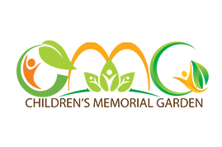
Inscribed Brick Order Form

Name
Address
City/State/Zip
Telephone
E-Mail

Check enclosed made payable to Temple Kol Emeth with Children’s Memorial Garden in the memo line in the amount of $ _______________________________
Pay by credit card (VISA or MasterCard only)
Number on credit card ______________________________________________
Expiration date ______________________________________________
Signature ______________________________________________
4”x 8” Brick $108 up to 18 Characters per Line 3 Lines Max
Please use a separate form for each brick ordered

8”x 8” Brick $216 up to 18 Characters per Line 5 Lines Max
Please use a separate form for each brick ordered
Inscribed bricks may be given for any and all memorable occasions: B’nai Mitzvahs, Births, Remembrances, or just because…

The Children’s Memorial Garden honors the memories of
the children in our community who were taken from us
too soon and for the children lost in the Holocaust.

It also serves to celebrate the joy and the promise
the children bring for a brighter future.
Mail this form with payment to:
Children’s Memorial Garden
1415 Old Canton Road
Marietta, Georgia 30062
For further information contact:
Janet Mills at: jcmills1@gmail.com

