Frequently Asked Questions about the Children’s Memorial Garden
Mission Statement
The mission of the Children’s Memorial Garden (https://www.kolemeth.net/childrensmemorialgarden.html) is to preserve the memory of our children and the children of the Holocaust who have met untimely deaths – who never reached the promise of adulthood. It will also serve to celebrate the joy and the promise the children bring for a brighter future – regardless of their length of stay with us.
The Children’s Memorial Garden features:
- Garden of Remembrance to honor the memories of these children
- An Amphitheater for life cycle events, youth and adult services, speakers and classes
- Garden of Life to celebrate life and hope for the future
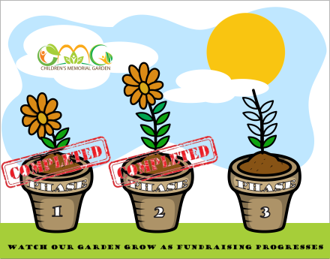
Contractor: Gibson Landscaping; Design Assistance: Gray Kiser, RAA Design and Lord · Aeck · Sargent
- Three Building Phases:
  - Phase 1 is complete
  - Phase 2 is complete
  - Phase 3 will commence in October of 2018
Sponsorship/Donation Opportunities
- Naming rights:
  - Three garden areas:
    - Amphitheater – generously sponsored by Janet & Tony Mills & family
    - Garden of Remembrance ($10k)
    - Garden of Life ($10k)
      - Garden of Life Fountain – generously sponsored by Dr. Morris Miehl
  - Ten benches ($3,600 each)
  - Trees ($360 each)
- Inscribed Brick Program
- Donations and Sponsorships
- In-kind donations (possibilities include: trees/shrubs, benches, signage, etc.)

Inscribed Brick Program
- Two Sizes (4” x 8” standard paver, 8” x 8” square paver) – 3 lines of print for the 4”x 8”, 5 lines of print for the 8”x 8”
  - Standard Brick ($108)
  - Square Brick (Amphitheater Floor Motif) ($216)
- Please use the Inscribed Brick Order Form
- Contact: Janet Mills, jcmills1@gmail.com
Donation Levels (inscribed on plaques in TKE Education Lobby)
- Master Gardener ($10,000 and above)
- Arborist ($5,000-$9,999)
- Landscaper ($2,500-$4,999)
- Green Thumb ($1,000-$2,499)
- Contact: Carolyn Shapiro, carolynshapiro@hotmail.com
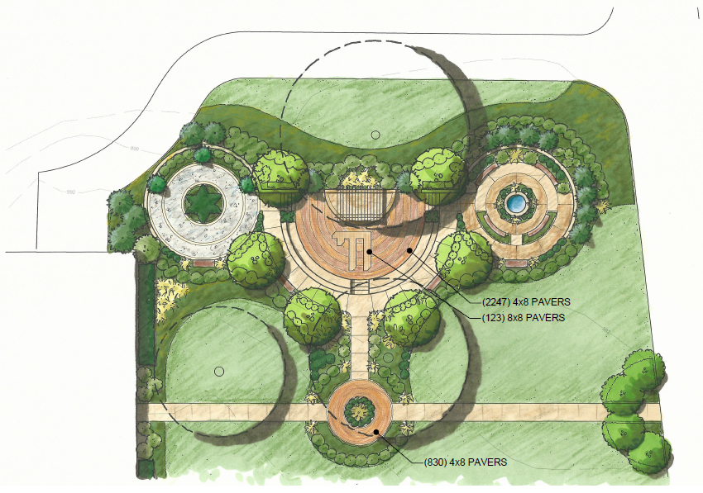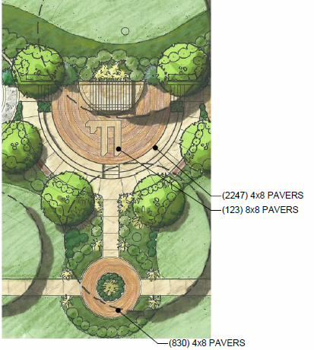

Contacts:
Chair: Michael B. Shapiro, mbshapir@bellsouth.net, 404-906-8827
Sponsorships/Donations: Carolyn S. Shapiro, carolynshapiro@hotmail.com, 770-633-5550
Inscribed Bricks: Janet Mills, jcmills1@gmail.com

