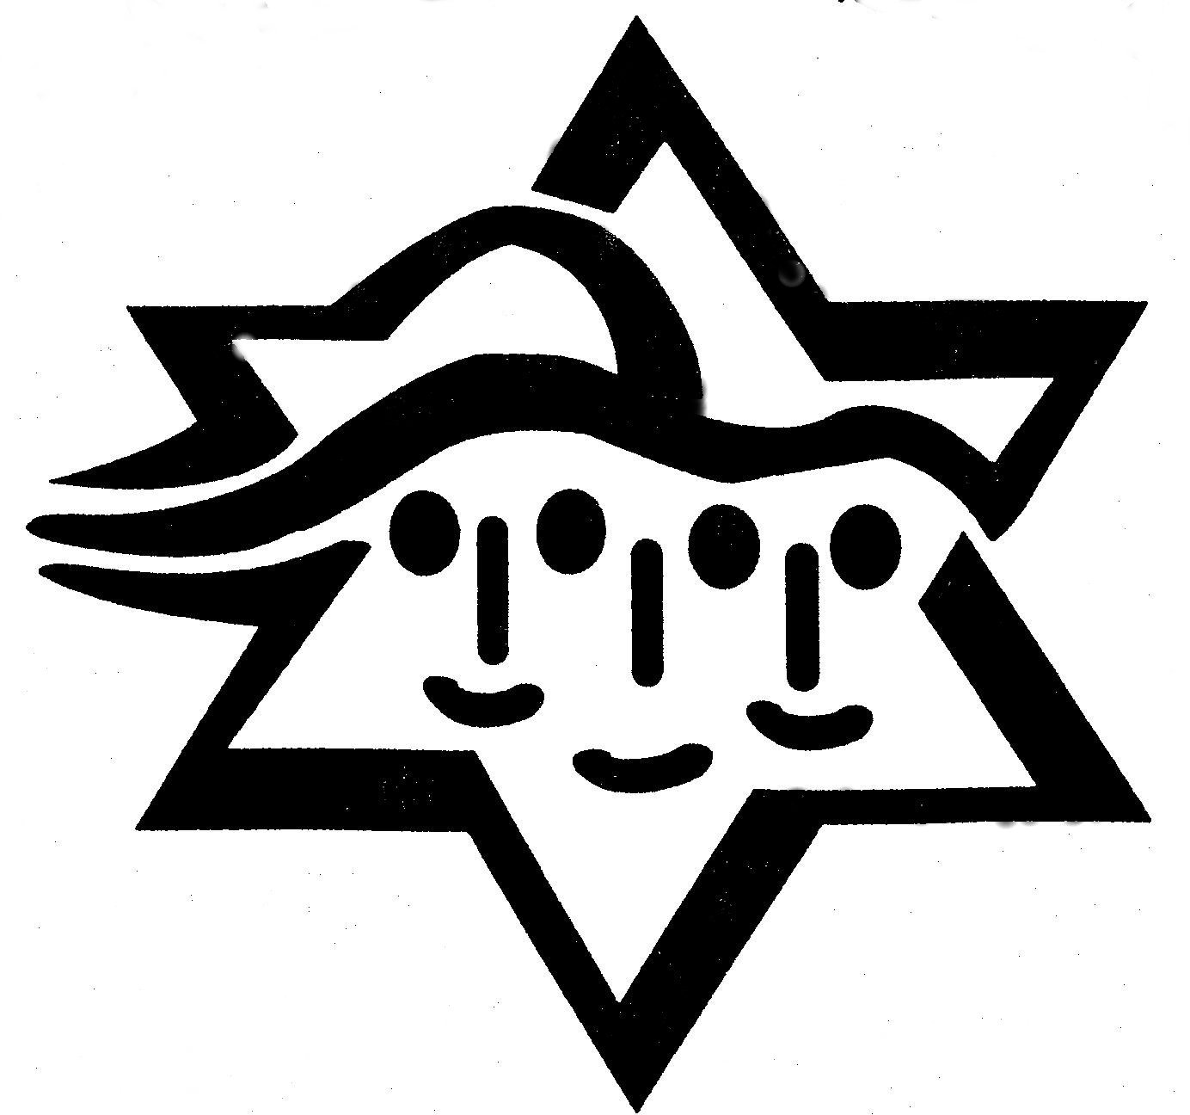

Gan (Kindergarten)

Week Of December 10th
It was so nice seeing our class families all together for the family education program last Sunday.. Then we shopped at the Hanukkah boutique and played dreidel. We learned that the Israeli dreidel is different than anywhere else in the world. In Israel the letters are Nun (Nes -miracle), Gimel (Gadol – great), Hey (Haya – was or happened), Pey (Po – here). A great miracle happened here. However outside of Israel the last letter Pey changes to a Shin (Sham – there), A great miracle happened there.

Week of December 3rd
This week in Gan we learned that when Chanukah falls on Shabbat we first light the Chanukah candles, before the Shabbat candles (after we light Shabbat candles we are not permitted to kindle any additional fire). Also we learned the miracle of Chanukah is that the oil which was supposed to last for one night, lasted for eight. December 10,2017is our family education program. We will meet in the Temple Israel social hall at 9:30am. The program will end by 11:00am. Looking forward to seeing you.

Week of November 19th
This week we started learning about Chanukah. We created a class Chanukah Menorah and dreidels. The Chanukah Menorah can be seen in our classroom. You will see the incredible dreidels during the Chanukah Assembly on December 17th. I wish you a happy and healthy Thanksgiving.

Dates to remember:
December 10: Family Education Program and Chanukah Boutique
December 17: TIRS Chanukah Assembly and Temple Israel Rededication

