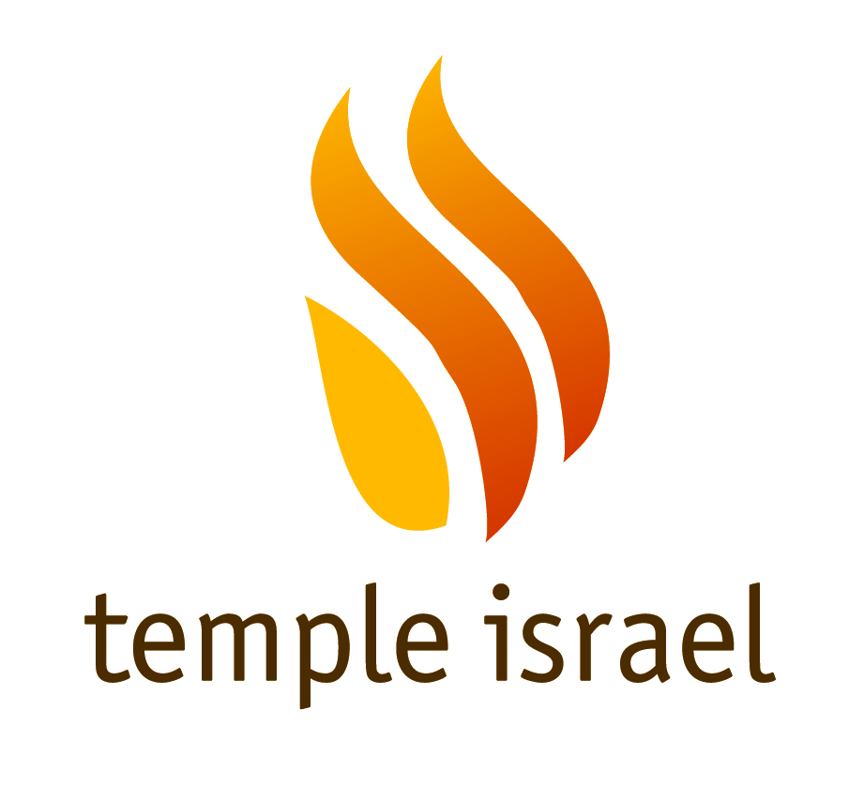

ENDOWMENT FUNDS

Aaron & Rhoda Gleiberman Simchat Torah Celebration Endowment Fund
– To subsidize the costs of annual Simchat Torah celebrations

Albert & Mary Kathleen Miller Endowment Fund
– To provide religious school scholarships and youth programming including trips, camp and Israel travel experiences

Alene & Samuel Strause Emergency Endowment Fund
– To provide emergency assistance for individuals and families

Ashendorf/Citron/Boxer Medical Endowment Fund
– To assist with medical expenses

Barbara & Jerry Levin Religious School Endowment Fund
– To provide religious school scholarships and financial assistance

Cissy Wollman Membership Scholarships Endowment Fund
– To provide financial assistance to subsidize the cost of Temple membership

David Silverman School Scholarship Endowment Fund
– To provide religious school scholarships and financial assistance

Doris & Albert Rousso Purim Endowment Fund
– To provide Purim programs and celebrations

Etta & Louis Greenspon Senior Citizen Endowment Fund
– To provide senior activity programs

Harold & Bette Wolfson Schapiro Senior Programs Endowment Fund
– To provide senior citizen programs

Harry & Micky Schwartz Education Endowment Fund
– To provide religious school scholarships and Israel travel experiences for children

Leonard & Ann Slesinger Education Endowment Fund
– To provide religious school scholarships and financial assistance

Continued….
Maurice & Rosa Weinstein Adult Education Endowment Fund
– To provide adult education programs

Michael Meiselman TI Operational Support Endowment Fund
– To provide annual operational support to Temple Israel

Michael Meiselman Legacy Program Endowment Fund
– To provide support for Temple Israel programming

Pearl & Ralph Kier Sukkot Endowment Fund
- To provide Sukkot celebrations

Shelton Gorelick Family Endowment Fund for Temple Israel
– To provide youth programming including trips, camp and Israel travel experiences

Sherman & Alyce Levine Social Action Endowment Fund
– To provide social action programming

Shirley & Sol Levine Religious School Teacher Education Endowment Fund
– To subsidize the costs of teacher education

Temple Israel Building Endowment Fund
– To maintain the Temple building

Temple Israel Education Endowment Fund
– To subsidize religious school and education related expenses

Temple Israel Endowment Fund
– To provide annual operational support to Temple Israel

Wendy & Frank Rosen Endowment Fund
– To provide Rabbinic programming

William & Patty Gorelick Membership Endowment Fund
– To provide financial assistance to subsidize the cost of Temple membership

TEMPLE ISRAEL FUNDS

Cantor Elias Roochvarg Music Fund
– To be used at the discretion of Cantor Shira Lissek to provide musical programs and activities.

Continued….
Celia Scher Holocaust Fund
– To support annual Yom Hashoah commemoration

General Fund
– To provide unrestricted operational support to the Temple

Huntingtowne Farms Elementary School Fox Fund
– To support the children at Huntingtowne Farms Elementary School

Kiddush Fund
– To offset Temple Israel’s ongoing Kiddush expenses and help B’nai Mitzvah families with the costs of Kiddush

Kristallnacht Fund
– To support annual Kristallnacht program or other Holocaust education programs

Madans Family Shivah Fund
- To provide comfort to mourners and visitors and foster meaningful experiences for shivah services held at the temple.

Membership Outreach Fund
- To provide for outreach to prospective, new and long-time Temple Israel members including bringing meals to ill or recently hospitalized individuals, programs for young adults and efforts to welcome new members to our community.

Pransky Family Camp Ramah Scholarship Fund
– To help religious school students attend Camp Ramah

Sadie Starr/Anita & Marvin Shapiro Silver Fund
– To purchase silver for the Social Hall and other items needed for the temple that can be enjoyed by the entire congregation

Sam Lerner Memorial Garden Fund
– To provide support for the Memorial Garden and associated programs

Senior Rabbi’s Tzedakah Fund
– To be used at Senior Rabbi's discretion

Shai Richardson Camp Scholarship Fund
– To help children attend a Jewish Camp

Social Action Fund
– To support social action programs including Room in the Inn and the Men’s Shelter

Continued….
Steinberger Yahrzeit Fund
– To offset the cost of the Book of Remembrance and assist families with the cost of memorial plaques

Stuart Ostrow Youth Fund
– To provide youth programs and activities

Sunday Morning Minyan Breakfast Fund
– To supplement the costs of breakfast

WoTI (Women of Temple Israel) Youth Program Fund
– To support youth programming

Updated 07/2019

