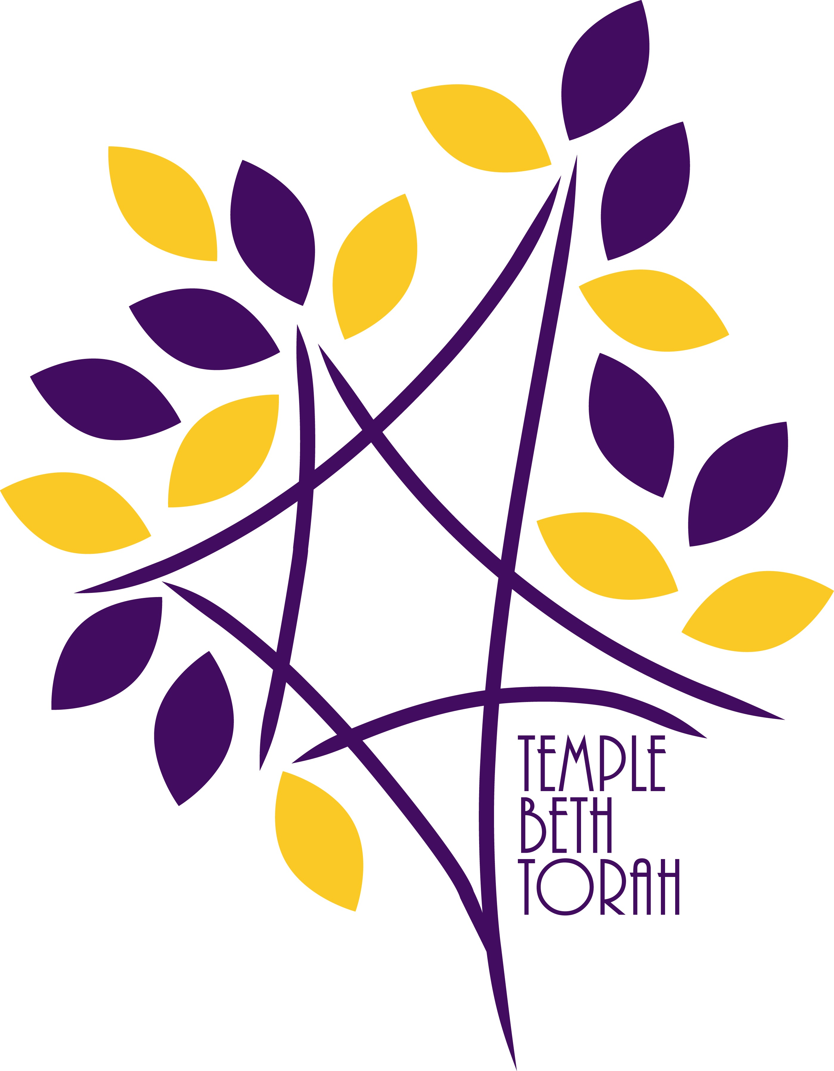Time for Memorial
Temple Beth Torah 900 Big Blue Trace Wellington, Florida

As we approach the Days of Awe, many of us begin
to think about our close family and friends who are no longer with us, but once blessed us by being such an important part of our lives.
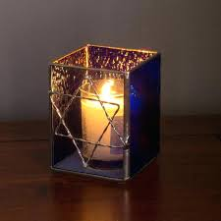

During our “Time for Memorial,” we invite you to come to the synagogue and, before the open Ark, light a candle
for your beloved, say the Mourner’s Kaddish,
and offer personal prayers.
Date: Thursday, September 13, 2018
Time: Anytime between 10:00 am and 4:00 pm
Place: Temple Beth Torah Sanctuary

