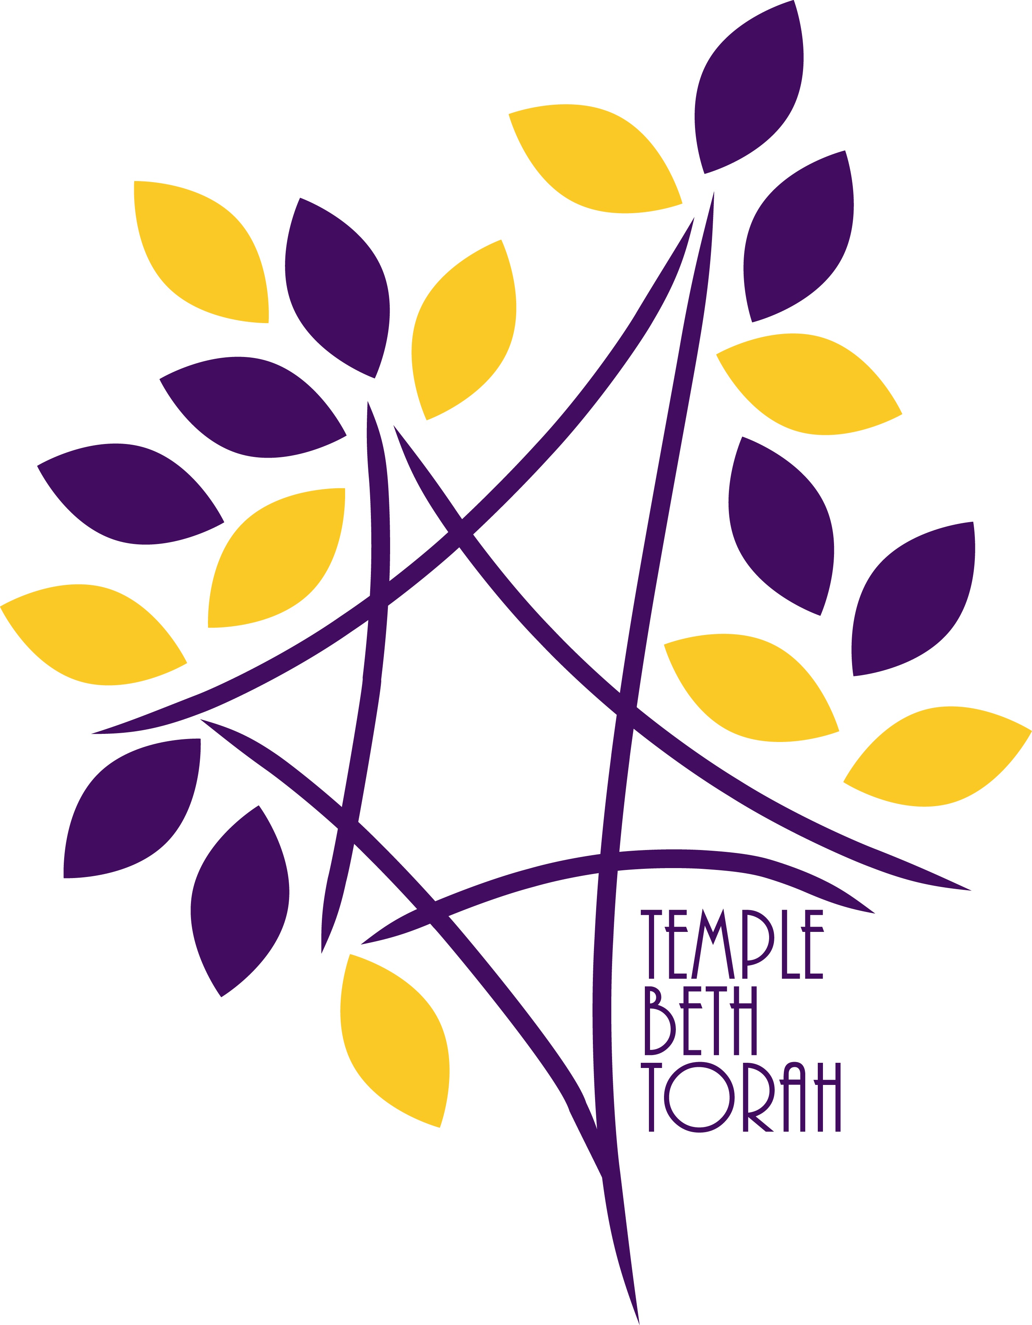

High Holy Day Greetings 5779

Our High Holy Day Program has a special section reserved for you to send holiday greetings to your friends and loved ones at Temple Beth Torah. This is a wonderful opportunity to both welcome the High Holy Days and support our synagogue’s fundraising efforts.

Please use this form to reserve your greetings. All greetings and payments must be received no later than August 24, 2018 to ensure inclusion in the publication. If you are purchasing a portion of a page (as opposed to one line) and require space in which to write your message, feel free to specify your sentiment on the back of this form.

You can also email your greetings to the temple office at administrator@templebethtorah.net.

Allow us to be the first to wish you and your loved ones a joyous, healthy and prosperous New Year!

please reserve space in the high holy day program for my greeting:

$18.00 Line Listing (_______________________________________and family)
$36.00 1/8 Page
$72.00 1/4 Page
$90.00 1/2 Page
$118.00 Full Page

Please make your checks payable to: Temple Beth Torah. All information must be received by August 24, 2018. For additional information, please call the Temple office at 793-2700.

