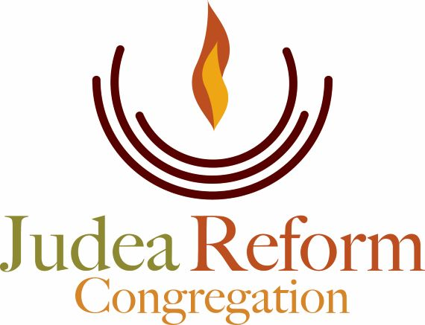

June 29th, 2022

Hello to the Judea Reform community!

I am honored and touched to be able to join you this year as your Rabbi-In-Residence. I have deep respect for Rabbi Soffer and the experiences I have had at JRC to date, and I look forward to the contribution I can make to your lives individually, as families, and as a community.

My passions are obvious from my bio – I care deeply for our bodily and physical well-being and its joyful expression, I am passionate about studying texts from our tradition in such a way as to pull their genius wisdom out to make sense for us today, and I am committed to an earth that is verdant, healthy, green and regenerative; one that teaches us majesty and awe, and inspires within us service and protection. To me these three elements comprise the circle of life.

I came to the Durham Triangle from Chicagoland in 2018 following my daughter, Sarah. I love it here. My partner, Michael, and I recently bought a home in Efland. We are in the design stages of a food forest complete with hens and a meditation labyrinth that will feature native and pollinator plants. Groundbreaking will begin at the completion of the Shmitah year, and you will be welcome to participate!

Regardless of where you are in the life cycle of years and experience, we will gather together to enhance our well being on many different levels. I look forward to sharing laughter and tears with you, to discovering insights with you, exploring challenges with you, and most of all, learning and growing with you.

With Blessings,

Rabbi Robin Damsky

